System to system communication using mixed mode allocation resource and transmission

LumaW.Jameel
AlNisour University College
Department of Technical Computer Engineering
luma.eng@nuc.edu.iq

Abstract
The mobile communication systems with optional system-to-system (S2S) links, user components (UCs) can work in either S2S mode or mobile mode for information transport. This paper produce mixed-mode S2S communication throughout that S2S links can work in many modes through resource multiplexing. among this framework, we tend to review the matter of increasing weighted S2S add rate beneath mobile rate constraints by optimizing mixed-mode allocation and resource allocation in term of emitted power and subchannel assignment. as a results of non-convex mobile rate constraints and binary constraints of subchannel allocation, this downside may be a non-convex mixed-integer downside that is typically hard to unravel. wetend to propose a ballroom dance approach by introducing energy-splitting variables such as mixed-mode allocation and resource allocation are decoupled and optimized severally. the following formula are distributive, desires little signal mixed and has little device complexity. We try to gift full numerical results to demonstrate the utility of our projected formula with relevance varied network parameters.
Index Terms:
- system-to-system communications
- Mode selection,
- allocation resource ,
- Successive convex approximation
- Dual decomposition.

INTRODUCTION:
In the growth of mobile wireless networks continues, short-range communication through system-to-system (S2S) relation was a key elect technology to spice up the performance of Long term Evaluation (LTE) systems. In S2S enabled mobile systems, user terminals (devices) would possibly communicate directly at intervals the licensed mobile system of measuring whereas the Basestation still maintains management on that direct relations in terms of relation setup and allocation resource. So S2S communication will share channel resources with mobile transmissions in S2S underlay structure, it not solely provides high-rate native communication, however along permits several economical spectral utilization and resource planning across the whole network.
In S2S enabled cellular networks, 2 mobile may work in systematic mobile type act by the Basestation or in S2S type act instantly. like call technique is thought as type various. relying the system quality service and power constraint on the channel system are desire, varied mode many methods are planned among the literature. So , generality works specialize in binary mode various, wherever every S2S link will entirely work in one type through that a binary type indicate indicator the choice of bound type. Throughout this paper, it have got a bent to ruminate mixed mode operation among that every and every S2S relation will multiple utilize modes over multiplexing resource . Once each S2S and mobile links need to have bound Quality Of Service objectives, mixed mode operation is in addition fascinating as a results of it combine blessings of various types. throughout the paper, we have got a bent to shall study best mixed-mode strategy so on satisfy multiple link desires that square measure inherent in S2S can mobile networks.
Allocation resource is type various and another vital topic of S2S communications, as results of its efficiency at interference arrangement. As Associate in Nursing example, the Basestation will apportion resources mobile to direct relations its unit of measuring manner apart therefore on shrink co-channel interference and thence up spectral potency. There unit of measuring form of this analysis experiment dedicated to allocation resource issues within the S2S context. Theory of games may possibly be a widespread mechanism that will be used an overview and extensively is accessible in. varied analysis experiment thought-about mixed vary nonlinear programming, rejection interference and third resource sharing. Moreover, joint type various and allocation resource in S2S underlay has place along been mature with total power consumption of the target was minimizing or device add average was maximizing. Since S2S relations typically with abundant larger channel gain is larger than mobile relations , a mobile relation average is in addition sacrificed to spice up the S2S average once entirely device add average is of interest. So , matter mode in might finish in essential loss of mobile servant performance, that but typically higher granted priority than S2S relations in good devices . To make sure mobile communication was prioritized, it's further vital minimum Quality Of Service desires is enforce for mobile servant satisfaction before optimizing S2S average. Moreover, rather than specializing in binary mode various, we've got an inclination to ought to exploit ways in which within which to require edges of mixed-.mode process for pleasant differentiated mobile and S2S relation desires.
at this experiment it is a bent to review associate improvement draw back include allocation mixed-mode and allocation resource for S2S enabled mobile networks. The experiment assumes a S2S relations can resources multiplexing therefore it is work in many .modes. The optimization of the sub channel is the objective of the work allocation for each S2S relation, still the result of resource fraction of the radio and conjointly the power transmission for every type so the weighted S2S add average is maximize at a lower place planned mobile average bonds. the most contributions of the experiment are summary as:
1. it will exploit the benefits of mixed-.mode S2S operation by resource partition of radio and management power. The analysis display S2S mixed-mode operation supply larger mobile-average unnatural S2S relation performance.
2. it will have a tendency of the type joint and allocation resource to study S2S can mobile networks. Not like the other work that take into account allocation power on basis subcarrier, the experiment optimizes resource division of the radio and allocation power in several types so as to boost of the S2S network performance.
3. it will have a tendency to approach the joint improvement downside by introducing splitting energy variables specified allocation type and allocation resource is optimized and decoupled severally. The technique considerably reduces step quality of the improvement joint downside, so facilitating its utilization. We have a tendency to more discuss a implementation distributed rule with sign overhead is low.
Existing Method:
It will take into account a LTE. mobile network within which mobile servant equipments (MSEs) in every area unit cell orthogonal resource.(RB) assigned block bits for transmission or communications downlink with the .ENB(evolved NodeB). It is show in Fig.1, the pool of the resource cell contains the transmission and. downlink atomic number 37 bit of MSEs that a unit area in communication steady standing and has low average necessities.
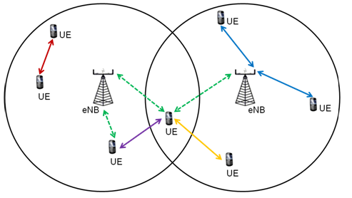
Fig.1:S2S Mode
the pool of the cell resource contains the uplink and downlink RB bits of MSEs that are in communication steady status and have average low data requirements. Let J = f1; ;Jg be the set of MSEs. The pool of resource can be indicate as K = .f1; 2; ; 2j 1; 2j; ; Kg, where .2j 1 and 2jindicate the transmission and downlink atomic number 37 bit of MSE j severally and K = .2J. This coding place to each FDD(Frequency.-division. duplex) and TDD(time. Division. duplex )mobile devices so each e .non-overlapping guarante allocation resource among MSUEs. Also, we tend to take into account common channel state across every atomic {number 37|metallic element|metal} bit by choosing a number of resource blocks is little enough for every bit.
It have a tendency to assume that every rubidium bit to limit interference between S2S communication and mobile device it share by at the most one S2S relations Denote I = f1; ;Ig as the .set of S2S relations. Between S2S relations and rubidium bits it is fixed pairing(i; k), the SEs and therefore the .ENB is represents dedicated. S2S communication wherever the S2S system communicate directly while mobile transmission is not co-channel. In Underlay S2S type (m. = 4), the direct relation and therefore the mobile relation transmit at the same time.we have a tendency to be M= f1,.lg,4g because the assortment of all the types. What is more, the tuple. (i; k;m) is subscript employed as throughout the work to point variables in type m once rubidium bit k is allotted to S2S relation i. Let( rC) .ikm and r(D). ikm be the mobile and S2S relation average, severally. Counting as or not rubidium bit k is mobile transmission or resource downlink, the channel vectors.wikm and vikm are transmited normalized and precoder receive of the .ENB. While not loss of generality, we have a tendency to assumed unit noise variance. Pikm is that the power transmission of S2S whereas Pk and Pe be power transmission of the MSE on rubidium bit k and therefore power transmission of the .ENB, severally. It have a tendency to specialize in S2S communication optimizing parameters and minimum disruption assumption to infrastructure existing mobile. Therefore, Pkand letter area unit assumed constants that area unit specific in keeping with the quality mobile power management protocol..
The sensible mobile networks, communications of S2S are thought-about as associate degree add-.on that shall not practicality cause severe obtrusion to the prevailing mobile infrastructure. This characterized will be constraint as minimum average necessities [1], most outage allowable chance [2] or most interference tolerant level of mobile relations [3]. This experiment, we'll think about mobile Quality Of Service implemented with minimum mobile average necessities. The targat of S2S communication is thence to maximise S2S rate beneath mobile relation average constraints. Mentioned on top of, among the four types, the Doctor of Education type and therefore the Dedicated S2S type solely contribute to S2S average, so not possible of there in terms of having minimum mobile average necessities. yet, the S2S average will be utilizing considerably magnified by the 2 types. At this area , the Pure mobile type average by forbidding S2S communication used to maximizes mobile relation. The underlay S2S type will fulfill mobile .QoS necessities whereas nonzero S2S average is achieving, however the S2S relation showing is restricted by cochannel interference. The performance is optimize mobile-average strained S2S relation, the advantages is necessary to mix of various types. The concept will exploit with additional details within the remainder of the work.
The important issue of sanctioning mixed-mode S2S process is sensible implementations in existing .LTE devices . The drawback at every atomic number will be resolved by segmenting 37 specified distinct using RBs for various types. In .LTE devices, the resources of radio are allotted to SEs during a 2 dimensional block that consists of 1 sub frame within the domain time and twelve subcarriers within the domain frequency. A period of 1ms is incorporate every subframe. Let Nk is the amount of atomic number 37 pairs in atomic number 37 bit k and Xikm is the atomic number of fraction is 37 bit k allotted to S2S relation i for type m. Then dNkXikmatomic number 37 pairs are going to be utilized by corresponding SEs and the ENB. to control in type m. The allocation mode will be enforced over frequency.-division multiplexing. (FDM), time.-division multiplexing. (TDM) or the 2dimensional across plane.
The atomic number 37 combine based mostly mode allocation will be enforced effectively while not extra communication overhead by making labeling straightforward protocols. As Fig. three as associate example. The subcarriers and type allocating by categorization unendingly, the S2S and mobile transmitter find the beginning subcarrier at the same time of every type and process within the corresponding type.
Disadvantages:
• A selection between LTE transmission and downlink for S2S communication (with implications for interference, capacity, telephone complexness and regulation).
• A selection between OFDMA and SC-FDMA for S2S communication (with consequences for telephone complexness in particular).
• A selection between static or dynamic allocation of radio resources for S2S discovery and communication.
• Completely different propagation characteristics for S2S communication (where each finishes of the relation area unit low and mobile) compared with ancient mobile networks (where one end of the link is mostly high and fixed).
Proposed Method:
In this work tend to formulate the joint type and allocation resource downside To address the multi-objective nature of S2S underlay device with maximizing the target weighted S2S total average below mobile average constraints. It is tend to utilize ikbecause the indicator pairing between S2S relation i and metal bit kfurther, metallic element nine zero is that S2S relation weight i, which might be specific in step with device fairness and priority necessities.Outline fXikm; Pikm;Wikm; Vikm and fikg because the assortment over all of variables the index. sets. The mixed type allocation resource downside is subedit For feasibleness concern, it's supposed the mobile average is lager than RK in Pure mobile type. That is 5d is total constraint energy of every S2S transmitter. total of all resource. fractions of radio in several types can't be bigger than one. Every metal regulates bit will solely be use again at the most one S2S relation. over the binary bands of f_ikg, downside may be a combinatorial downside with IK potential pairings between metal bits and S2S relations. device quality in mobile devices is prohibitively large wherever range of metal chunks and also sometimes the number of S2S relation terribly giant. So , the mobile average bonds are no convex, that produce downside (5) typically untamed.
The proving Proposition. one in the main end is minimize of fD for ninety one two fifty-two should be one in every of the 2 transition points in Fig. 2.
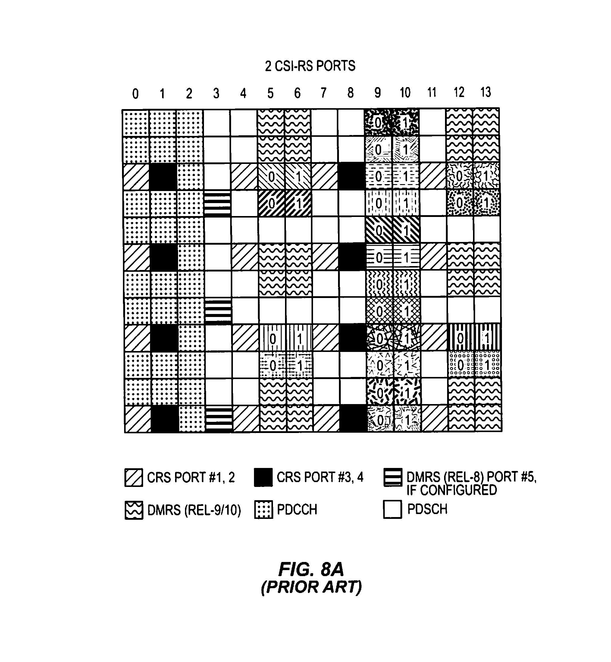
Fig.2:resource blocks
Proposition one any indicates that the twin answer are going to be one in every of the 3 transition points. So , the maximal worth can take a minimum for optimum answer of the twin downside. As so as, at 2 types are going lest for optimum answer to be active of the gibbous be similar to downside. it result different totally from the “winner.-takes.-all” strategy projected in Lemma. one of, in the main over to the mobile average bonds. The benefits of multiple types and mixed-type allocation resource is combine so will higher the multi-objective serve nature of downside. The SCA.. (Service Component Architecture) algorithmic program. through evolves the optimal points and every one minima native arrived by the SCA. algorithmic program can have constant property, mixed-type will be the allocation mode downside optimum answer.
Different from during which the speed operate admits closed type, evaluating the operate worth Qik(_) in our drawback needs SCA. Repetition. So, the key issue to scale back the machine complexness analysis. Consequently, we have a tendency the Following Fitting. Algorithm is propose: initio, it has a tendency to suppose uniform allocation energy across all metal bits. make the energy depends on the quantity of metal bits allotted to every S2S relation, it has a tendency to set the metal allocation bit by inspecting the target worth of drawback. determination, metal bit k are going to be allotted to S2S relation i if and providing it ends up in the weighted S2S total average to biggest gain. Make Si denote the group of presently allotted metal bits to S2S relation i and jSij its cardinality,
The Fitting algorithmic program on top of is especially supported the curve fitting assumption Qik(Eik) = log (1 + cikEik). The correct expression of Qik(Eik) rely on parameters and should not follow this type if over one type contributes to the S2S relation average. Yet, because of interference mutual mitigation done by optimized Block Resource bit allocation, the Underlay S2S type is probably going to be controlling within the optimum type allocation. So, the curve is fit near correct perform curve. Within the next part, it has show that the planned algorithmic program acts enough good in sensible S2S underlay device. With a same time, machine is low overhead for time period network readying makes it applicable.
In this segment, the implementation procedures is discuss of the projected proper rule. The Baseststionmaintains management of S2S relations, the rule is enforced distributive with small communication overhead victimization uniform LTE. downlink and channel transmission, ENB. can acquire f^Qik(Ei)gk2K from every S2S relation, that is set domestically by resolution the mode allocation. whereas theS2S relation CSI is calculable at every S2S transmitter domestically, the mobile relation CSI parameters. r(C) one ; b1; b2; b3;Rk of every atomic number 37 bit is no heritable from the ENB. on uniform LTE channels. Downlink. for computing and aggregation the communication is overhead and Qik(Ei) is 6IK in terms of the amount transmitted of real quantities. A communication overhead is more miniature during a lot of stable mobile communication setting so a ENB. solely must signal the CSI. info of these MSEs that recently enter pool of resource and of these try important changes.
After atomic number 37 bit allocations, ENB. has to pass the result to S2S relations, every of which might then severally water-filling implement formula to optimize the allocation energy across the atomic allotted number 37 bits. the sign overhead of passing atomic number 37 bit allocation result's K, which be accomplished through uniform LTE. downlink channels.
The energy across optimized every allotted atomic number 37 bit, S2S2 relations will additional decide the best fraction resource and power transmission of every type. The fraction resource result's then transferred. to the ENB., UN agency additional passes the corresponding MSE data, the resource multiplexing will coordinate for mixed-mode process. The ENB. Passing data is a relay data between S2S relation and MSEs. the sign overhead is 6K since solely 3 fractions resource given to told the total bonds Contrast with centralized implementation. wherever the ENB. all variables are optimizes, the implementation distribution taking advantage of native process of less sign overhead by at the S2S relations. Moreover, it additionally the procedure shift the load of optimizing allocation mode and allocation of energy from the ENB. to S2S relations, that permits quicker optimization of the device parameters.
At this segment, it has a tendency to gift the execution of Fitting rule planned to resolve the atomic number 37 bit and allocation of energy. Outline of the rule it given in. For comparison, we have a tendency to additionally implement the subsequent algorithms:
• Greedy rule: every atomic number 37 bit is appointed to the S2S relation with energy is smaller than i ^Qik(Ei).
Allocation. is enforced as follow.
•Iterative Allocation of Energy (AE) rule: The atomic number 37 bit allocation follows Fitting rule. The allocation energy is made by finding victimization inside purpose .Algorithm.
• Allocation of Joint (AJ) rule: every atomic number 37 bit is allotted to S2S relation which is maximum. The allocation of energy hounds the repetitious Semitic deity rule.
The 3 algorithms follow identical implementation procedures in unless mechanism for rubidium allocation of trunk so they need identical sign overhead because the Fitting rule. The machine complexness of the algorithms is compared. As Qik(_) doesn't admit a closed kind, it's important to cut back the amount of Qik(_) evaluations once determination.it provides the complexness of every rule in terms of the amount of Qik(_) evaluations. The Greedy. base and also the rule of Fitting have linear time for each complexness with relation to variety of S2S relations (I) and also the number of rubidium bits (K) so a solely got to confirm the worth Qik(Ei) for a given pairing (i; k). at opposite side, Qik(_) must be rated throughout every iteration for every rubidium bit. Therefore, the machine and sign overhead of the repetitive Semitic deity rule and also the Joint Allocation rule
1) Performance and complexness Comparison: the results show eleven of the allocation of resource drawback with bismuth = one for all. i two I. At SEs the radius two hundred m with I = K = twenty for uniformly generated in a very cell. 2 SEs the distance smaller than fifty m are known as a S2S relation. A vector of channel are generated equally, the Fitting algorithmic program achieves shut S2S add average performance to repetitive Ea algorithmic program and also Allocation of joint algorithmic program, whereas demand considerably less process time. The Greedy. algorithmic program conjointly has much lower process complexness. however, it's smaller S2S add average compared with the other 3 algorithms.
2) Measured add average: it has a tendency to value measured S2S add average with regards to S2S relation distance and therefore variety of Rb bits within cell. indicate Qi = maxk ^Qik(Ei). Comparing the projected Fitting formula with the Allocation of Joint formula for subsequent 3 weight policies:
- Equal weight
- Rate Inverse weight
- Rate Proportional weight
The 3 weight policies represent completely different trade-off between right and potency. The average-inverse weight attaches higher values to S2S relations with smaller average. So, additional truthful than the opposite 2 policies. however, it's the smallest amount economical .On the contrary the weighted S2S Sum average is maximum, the Rate-proportional weight provides higher average to S2S relations with larger average, that results in the larger weighted S2S add rate at the price of right. the weighted S2S add average drops with the S2S relation distance that demonstrates the advantage of short-range S2S communications., we have a tendency to fix the S2S relation distance to be fifty m and value the effect of the amount of Rb bits on S2S relation performance. Naturally, additional resources because larger weighted S2S add average, so maintained the Fitting formula in each figures shut performance to the Allocation of joint formula. the lustiness of the Fitting is demonstrate at formula in varied applications.
We solve the total turnout optimization drawback within the utilize type . In utilize type, reduce the matter to finding the optimum powers that may maximize total turnout objective whereas meeting individual minimum average necessities. It has a tendency to extend the case of tactic of 2 transmitters. to 3 transmitters. the ability allocation drawback is resolve during a two-tier. mobile network. We have a tendency to gift a geometrical illustration of the matter at case of 3 transmitters (i.e., DTx, MBS. and FAP.) and gift a near-optimal. answer approaching that of complete study.
First condition was actually verified in [4], and so it's legendary that a minimum of one among the powers is at its most once increasing total average. So, on the boundary of the ability region the solely states is optimum solutions exist, which has higher dimensional edges is incorporates vertices yet Associate it contain an infinite range of points at Nursing faces [5]. the optimum answer provided by the spare set of point to get the finite value. it's been well-tried of 2 transmitters which is optimum power on vertices of the ability region or on the corners region [6], [7], a undeniable fact that depends on the total convexity average operate for 2 powers. So, it's renowned that normally, is non-convex at the total average expression. in (6)with relation to impulsive mixtures of varied powers. So, the optimum powers might not essentially repose on the vertices of the ability region for impulsive range of transmitters, resulting in a probably infinite set of points to check.
Points of face for maximize on power: There exist tops is repose on a face of the cube. and area unit shaped from the intersection. of 2 planes, There area unit 9 such tops. (three.. faces with. 3 ways. of selecting 2 intersect ant planes for every face.). These tops may be. found by finding 2 plane. equations at the same time with the facility akin to the third. face maximized. In general, it's troublesome to spot specifically that of those 9 points could also be optimum for a given interference state of affairs. Thus, we'd like to check all 9 tops.
Edge points with most powers favorable all thresholds: think about the case wherever the 3 planes area unit orthogonal. during this study, the facility region includes the highest cube corner, wherever maximize all 3 powers area unit, and 3 alternative corner points wherever the planes cross the perimeters of the cube, that we tend to shall label as edge points. Since at power region the highest corner reposes, it is mean maximizes all powers area unit, all 3 SINRs. are area unit larger than their minimum thresholds min r .For the remainder of this part. There area unit four such points. Note that a similar SINR state of affairs will occur even once the planes don't seem to be perpendicular.4 The finesse of this state of affairs is that the highest corner. is among the region spanned by the planes, which every plane solely intersects one amongst the most power edges. of the cube.
Edge points with most powers favorable 2 thresholds: to see this state of affairs, imagine tilting the planes pivoted at Q to make new power regions. As an example, if we have a tendency to tilt solely the FAP plane upwards, it'll eventually withstand prime the highest corner and see the opposite 2 top edges[8]. These 2 extra edge points boost the present 2(A and C) edge points to provide a complete of 4 edge points. on the cube’s. edges. Since the highest corner purpose can currently be beneath the FAP.. plane, this behold that 0E nine min E . Similar arguments will be created for the opposite 2 planes, wherever there are a complete of 4 corner. points within the power. region, every case akin to one 0r that's but its individual threshold.[9].
Edge points with most powers favorable one threshold: For eventualities wherever 2 or fail to reach their thresholds and just one is met, the 2 planes are atilt specified the corner aim repose outside each their possible regions, as wherever the FAP (femtocell. access point) and MBS (macrocell. base station) planes repose higher than and to the left of the highest corner severally [10], the possible region can meet one among the 3 corner edges. at 2 points. The most MBS power edge being intersected at 2 points A and B by the S2S and FAP. planes severally. Note that the MBS. plane additionally intersects. a similar edge; however that time of intersection is outside the ability region. Thus, we tend to get 2 points, every resembling a collection of conditions.
If mode choice decides that the S2S try will transmit exploitation either dedicated or mobile type[11], time and/or frequency resources should be allotted. we tend to create the subsequent assumptions for resource sharing in each dedicated S2S and mobile type: (i) since mobile frequencies square measure used, there's a minimum rate guarantee for every user, together with the DRx, (ii) there square measure enough resources. to fulfill all users’ minimum average needs, and (iii) at any one time, one transmitter will solely work in either transmission or downlink., i.e. duplex.

Advantages:
• Mixed model structure structures optimize worker expertise and resources and work well for firms that square measure project-based.
• This structure will improve lines of communication and supply flexibility for engaged on multiple comes[12].
• Staff engaged on special comes still have links to their practical departments and might refer back to the opposite members of their departments for consultation and recommendation.
Conclusion
In this paper, we've got a bent to review the matter mode of joint and allocation of resource for mixed-mode S2S enabled mobile networks, where S2S relations can multiplex accessible resources such as they will work in various types to satisfy multiple Quality Of Service wants implemented by the system. we've got a bent to approach the joint improvement draw back through a pair of steps. inside the beginning, the most effective fraction of resource and allocation of power for varied types square measure optimized for a tough and quick pairing between S2S relations and mobile resources. inside the second step, we've got a bent to review the joint element bit and energy allocation draw back, which could be cast as a typical allocation of resource draw back for mobile transmission, whereas the speed functions do not have closed forms[13]. Lagrangian twin decomposition methodology is employed to unravel the problems in every steps, where sequent lent form approximation is adopted for the no plan convex allocation mode draw back inside the beginning and a reduced quality formula is planned for enabling distributed and far doable[14].
Future Scope:
There square measure varied fascinating further options and directions for future. analysis work. Energy potency might be used rather than total average as associate degree objective, which might be notably relevant for transmission situations, whereas imperfect CSI. may be a sensible issue which will even be thought of.

References:
[1] L. Wei, R. Hu, Y. Qian, and G. Wu, “Enable device-to-device communications underlaying cellular networks: challenges and research aspects,” IEEE Commun. Mag., vol. 52, no. 6, pp. 90–96, Jun. 2014.
[2] A. Asadi, Q. Wang, and V. Mancuso, “A survey on device-to-device communication in cellular networks,” IEEE Commun. Surveys Tuts., vol. 16, no. 4, pp. 1801–1819, Fourth quarter 2014.
[3] D. Feng, L. Lu, Y. Yuan-Wu, G. Li, S. Li, and G. Feng, “Device-to-device communications in cellular networks,” IEEE Commun. Mag., vol. 52, no. 4, pp. 49–55, Apr. 2014.
[4] E. Hossain, L. B. Le, and D. Niyato, Radio Resource Management in Multi-tier Cellular Wireless Networks. Wiley, 2013.
[5] V. Chandrasekhar, J. G. Andrews, T. Muharemovict, Z. Shen, and A. Gatherer, “Power control in two-tier femtocell networks,” IEEE Trans. Wireless Commun., vol. 8, no. 8, pp. 4316–4328, Aug. 2009.
[6] X. Ge, T. Han, Y. Zhang, G. Mao, C.-X. Wang, J. Zhang, B. Yang, and S. Pan, “Spectrum and energy efficiency evaluation of two-tier femtocell networks with partially open channels,” IEEE Trans. Veh. Technol., vol. 63, no. 3, pp. 1306–1319, Mar. 2014.
[7] F. Malandrino, C. Casetti, and C.-F.Chiasserini, “Toward D2D-enhanced heterogeneous networks,” IEEE Commun. Mag., vol. 52, no. 11, pp. 94–100, Nov. 2014.
[8] H. Tang, Z. Ding, and B. C. Levy, “Enabling D2D communications through neighbor discovery in LTE cellular networks,” IEEE Trans. Signal Process., vol. 62, no. 19, pp. 5157–5170, Oct. 2014.
[9] X. Lin, J. G. Andrews, and A. Ghosh, “Spectrum sharing for device-to-device communication in cellular networks,” IEEE Trans. Wireless Commun., vol. 13, no. 12, pp. 6727–6740, Dec. 2014.
[10] H. ElSawy, E. Hossain, and M.-S.Alouini, “Analytical modeling of mode selection and power control for underlay D2D communication in cellular networks,” IEEE Trans. Commun., vol. 62, no. 11, pp. 4147–4161, Nov. 2014.
[11] K. Doppler, C.-H.Yu, C. B. Ribeiro, and P. Janis, “Mode selection for device-to-device communication underlaying an LTE-Advanced network,” in Proc. IEEE WCNC, Apr. 2010.
[12] H. Min, J. Lee, S. Park, and D. Hong, “Capacity enhancement using an interference limited area for device-to-device uplink underlaying cellular networks,” IEEE Trans. Wireless Commun., vol. 10, no. 12, pp. 3995–4000, Dec. 2011.
[13] D. Feng, G. Yu, C. Xiong, Y. Yuan-Wu, G. Y. Li, G. Feng, and S. Li, “Mode switching for energy-efficient device-to-device communications in cellular networks,” IEEE Trans. Wireless Commun., vol. 14, no. 12, pp. 6993–7003, Dec 2015.
[14] H. Tang and Z. Ding, “Mixed mode transmission and resource allocation for D2D communication,” IEEE Trans. Wireless Commun. vol. 15, no. 1, pp. 162–175, Jan 2016.

