

**The value of ultrasound in diagnosis of planter fasciitis**

A Thesis

Submitted to the Iraqi Board for Medical Specializations in partial fulfillment of the requirements for the degree of fellowship in Diagnostic Radiology

By

**Dr. Noor Jalal Al-deen Ameen**

M.B.Ch.B.

Supervised by

**Prof. Mohammed Abd Kadhim Al-Jiboori**

**M.B.Ch.B. F.I.B.M.S., consultant radiologist**

**2019 A.D. 1440 A.H.**





*Thesis submitted to the Iraqi Board for Medical Specializations in partial fulfillment of the requirements for the degree of fellowship in Diagnostic Radiology*

***Dr. Noor Jalal Al-deen Ameen***

*M.B.Ch.B.*

*I certify that this thesis was prepared under my supervision at the Scientific Council of Diagnostic Radiology in partial fulfillment for the degree of fellowship of the Iraqi Board for Medical Specializations in Diagnostic Radiology.*

**Prof. Mohammed Abd Kadhim Al-Jiboori**

M.B.Ch.B. F.I.B.M.S., consultant radiologist

We the examining committee after reading this dissertation (**The value of ultrasound in diagnosis of planter fasciitis**)and examining the candidate (**Dr. Noor Jalal AL-deen Ameen )** in its contents find that it meets the standards and requirements as a dissertation in partial fulfillment for the degree of fellowship of the Iraqi Board for Medical Specialization in Diagnostic Radiology.

**Prof. Raad H. Abedtwfeq**

Acting chairman of the scientific council of the Iraqi Board of Radio-Diagnosis-Radiology

D.M.R.D. - F.I.B.M.S.-R.D

(Chairman)

|  |  |
| --- | --- |
| **Dr. Mohammed M. Jawad Al-Khalesi**  F.I.B.M.S  Consultant Radiologist | **Dr. Haider Qasim Al-** **Mosawi**  D.M.R.D.-F.I.B.M.S.(Rad.)  Professor Radiologist |

*I, the chairman of the Scientific Council of Diagnostic Radiology, certify that this thesis was prepared by the candidate and submitted to our Council.*

**Prof. Raad H. AbedTawfeq**

Professor in Radiology

Acting Chairman of the Scientific Council

of the Iraqi Board of Radio- Diagnosis

D.M.R.D- F.I.B.M.S.-R.D

***Dedication****:*

*To my husband, Saif, who has been a constant source of support and encouragement during the challenges of life…*

*I am truly thankful for having you in my life.*

*To my parents, who have always loved me unconditionally and whose good examples have taught me to work hard for the things that I aspire to achieve…..*

*To my sister, brother and my sweet boys…*

*With all my love, appreciation and respect*

***Acknowledgement***

*Firstly, I would like to express my sincere gratitude to my supervisor* ***Prof. Mohammed Abd Kadhim Al-Jiboori*** ***M.B.Ch.B. F.I.B.M.S., consultant radiologist*** *for his continuous support, patience, motivation and immense knowledge. His guidance helped me in my research and writing of this thesis. I could not have imagined having a better supervisor and mentor..*

*Besides my supervisor, I would like to thank the rest of my thesis committee for their insightful comments and encouragement.*

*My sincere thanks also goes to* ***Dr. Noor Abbas Hummadi CABHS (Rad.) lecturer, specialist radiologist****, and* ***Dr. Noor Kathem Nee’ma; specialist radiologist at Al-Imamain Al-kadhmain medical city*** *for their help and support.*

*Finally, I deeply appreciate the kindness of the working staff of MRI units in Al-Imamain Al-Kadhmain medical city for their cooperation in facilitating the examination of patients.*

**Abstract**

**Background**: planter fasciitis is the most common painful heel condition caused by inflammation at the insertion of the planter fascia on the medial process of the calcaneal tuberosity…it is usually clinically diagnosed but radiological imaging used for confirmation of the diagnosis and exclusion of the other conditions (such as foreign bodies, PF rupture, calcaneal bursitis….etc.) that may have same clinical presentation.

**Aim of the study:** to assess the value of ultrasonography in the diagnosis of planter fasciitis as compared to MRI study

**Patients and Method:** In across sectional study of 34 patients(16 men and 18 women) with suspected unilateral or bilateral plantar fasciitis, 46 symptomatic heels were examined by both high-resolution ultrasound and magnetic resonance imaging (MRI) protocol to assess the different signs;11 healthy volunteers (22 heels) acted as controls.

**Results:** in symptomatic feet, the plantar fascia was thickened. The thickness of the plantar fascia in symptomatic feet was (3.5–7.5 mm in range; mean 5.5mm ± 1.3) measured by ultrasound which was significantly thicker than in the control group (2–2.8 mm in range; mean 2.4mm± 0.07); *P* < 0.05.

Other sonographic signs used for the diagnosis of plantar fasciitis in the study were compared to MRI findings. The diagnostic accuracy was 78.2% for abnormal intrinsic echogenicity within the plantar fascia, 73.9% for focal thickening ,60.8% for subcutaneous edema around the plantar fascia, and the lowest diagnostic accuracy of ultrasound was in detection of associated calcaneal spur (56.5%). The findings were compared and discussed in relation to other thesis.

**Conclusion:** ultrasound is a useful tool in the diagnosis of planter fasciitis with a reliable diagnostic accuracy comparable to that of MRI. MRI may be reserved for more complicated cases.

**Key words:** plantar fasciitis, ultrasound, MRI.

**LIST OF CONTENTS**

|  |  |
| --- | --- |
| **Subject** | **Page No.** |
| Dedication | I |
| Acknowledgement | II |
| Abstract | III |
| List of contents | IV |
| List of tables | V |
| List of figures | VI |
| List of graphs | VII |
| List of abbreviation | VIII |
| **Chapter one** |  |
| 1.Introduction | 1 |
| **Chapter two** |  |
| 2. Patients and methods | 17 |
| **Chapter three** |  |
| 3. Results | 21 |
| **Chapter four** |  |
| 4. Discussion | 30 |
| **Chapter five** |  |
| 5.1 Conclusions | 34 |
| 5.2 Recommendation | 35 |
| **References** | 36 |
| **Abstract (Arabic)** |  |
| **Title of the dissertation(Arabic)** |  |

**LIST OF TABLES**

|  |  |  |
| --- | --- | --- |
| **Table No.** | **Title** | **Page No.** |
| **1** | Age and sex distribution of the patients | 21 |
| **2** | Thickness of plantar fascia measured by ultrasound and MRI in symptomatic and control groups | 23 |
| **3** | Incidence of different diagnostic signs in ultrasound and MRI | 24 |
| **4** | Diagnostic accuracy of ultrasound for different diagnostic signs compared to MRI | 24 |
| **5** | Other incidental pathological findings by MRI that may be partially responsible for patient complaints | 25 |
| **6** | Clinical association with the symptomatizing patients | 25 |

**LIST OF FIGURES**

|  |  |  |
| --- | --- | --- |
| **Figure No.** | **Title** | **Page No.** |
| **1.** | Anatomy of planter fascia | 2 |
| **2.** | Medial planter calcaneal region, most common site of pain in PFS. | 5 |
| **3.** | Lateral Plain x-ray of foot (magnifying view) showing the calcaneal spur | 7 |
| **4.** | US of Normal Plantar fascia | 9 |
| **5.** | Longitudinal ultrasound scan showing normal and abnormal planter fascia | 9 |
| **6.** | MRI of normal PF | 11 |
| **7.** | MRI of Planter fasciitis | 11 |
| **8.** | Patient position during ultrasound examination | 18 |
| **9.** | Normal PF MRI and US of control group | 22 |
| **10** | Images of patients included in the study showing PFS (patient No.1) | 26 |
| **11** | Images of patients included in the study showing PFS( patient No.2 ) | 27 |
| **12** | MRI of a patient with ankle ganglion cyst | 28 |
| **13** | MRI of a patient with pre-achilles bursitis | 28 |
| **14** | MRI of a patient with talar a vascular necrosis | 29 |

**LIST OF GRAPHS**

|  |  |  |
| --- | --- | --- |
| **Graph No.** | **Title** | **Page No.** |
| 1 | Sex distribution. | 21 |
| 2 | Diagnostic accuracy of ultrasound for different diagnostic signs compared to MRI | 24 |

**LIST OF ABBREVIATIONS**

|  |  |
| --- | --- |
| **Symbol** | **Notation** |
| F | Female |
| Fig | Figure |
| M | Male |
| MRI | Magnetic resonance imaging |
| PF | Planter fascia |
| PFS | Planter fasciitis |
| Pt. | Patient |
| SPIR | Spectral pre-saturation with inversion recovery |
| US | Ultrasound |

**INTRODUCTION**

**Planter fascia anatomy**

Plantar fascia (PF) is a thickened fibrous sheet of connective tissue. It acts as a static and dynamic stabilizer of the longitudinal arch of the foot and as a dynamic shock absorber. (1)

The plantar aponeurosis is a strong fibrous structure with three components: central, lateral, and medial .The central bundle is the thickest and the strongest and has a glistening appearance. It is triangular in shape with a proximal apex originating from the posteromedial calcaneal tubercle and a distal base. It narrows slightly and then gradually enlarges as it progresses anteriorly. The fibers divided, at mid metatarsal level, into five longitudinally oriented bands that diverge, just proximal to the level of the metatarsal heads, each band divides into three components, one superficial and two deep. (2)

The superficial fibers insert subcutaneously in the distal segment of the ball of the foot. The deep fibers reach the depth in the form of two sagittal septa around each flexor tendon. The lateral bundle of the plantar aponeurosis is thin anteriorly and thick posteriorly. It originates from the lateral margin of the medial calcaneal tubercle, extends in the direction of the cuboid, then divides into a lateral component (inserts on the base of the fifth metatarsal) and a medial deep component (that extends to the plantar plate of the fourth toe). The tendon of the abductor digiti quinti passes through the bifurcation of this aponeurosis the medial bundle of the plantar aponeurosis is thicker anteriorly and thin posteriorly. It forms the covering fascia of the abductor hallucis and medially continues with the dorsal aponeurosis of the foot, the inferior arm of the inferior extensor retinaculum, and the flexor retinaculum. (2)

The mean maximal thickness of the normal planter fascia has been reported as 4.0 mm in its central bundle, 2.3 mm in its lateral bundle and 0.6 mm in its medial bundle.(3)

Histologically the plantar aponeurosis contains collagen type I fibers arranged in a particular network of bundles. (4)

These large fibrous bundles are embedded within a matrix of loose connective tissue containing type III collagen and a few elastic fibers (3) .It is a tough tendinous (rather than a fascial) layer of the plantar aspect of the foot. This highly complicated combination of fibers, having different biomechanical properties during the application of stress to the plantar aponeurosis, provides an increased modulus of elasticity during weight-bearing. (4)

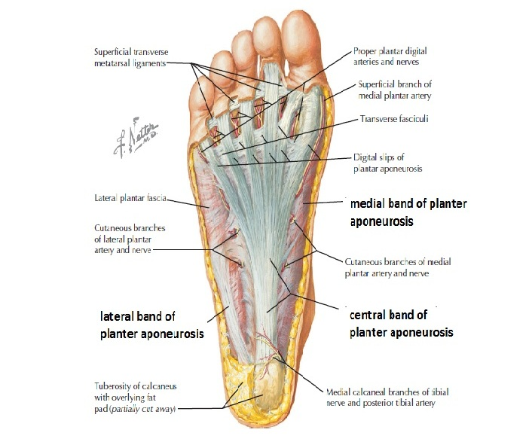

**Figure (1) Anatomy of planter fascia. (5)**

**Planter fasciitis**

**Definition**

Painful heel condition that can affect both sedentary and active individuals, it is most often seen in the adult population it may Associated with a contracture of the gastrocnemiu- soleus complex. (6)

**Epidemiology**

Plantar fasciitis (PFS) is the most common type of PF injury, that occur in men and women in a relatively equivalent ratio as well as in both athletic populations and individuals who live more sedentary lifestyle. (7)

Planter fasciitis estimated to affect 10% of the general population during middle age.(8) also 8% of foot injuries in runners are related to PFS. (9)

**Pathology**

Planter fascia stiffens and becomes less pliable with age. (10) the etiology and dysfunction of the planter fascia is multifactorial, but most commonly it is a result of micro-trauma (micro-tears) due to repetitive overload placed on the connective tissue in the plantar region. with time, the micro-tears cause structural fatigue and weakening of the connective tissue, resulted in an inflammatory response, pain and discomfort. (11)

Although it is more commonly seen in individuals between the ages of 40-70 years, the most notable medical conditions associated with plantar fasciitis, are sero-negative spondyloarthropathies and rheumatoid arthritis. (3)

90% to 95% of patients will get improvement within a year regardless of the specific treatment offered. (6)

**Diagnosis**

**1. Clinical features:**

This is a painful and an annoying condition that limits function. There is pain and tenderness in the sole of the foot, mostly under the heel, with walking or standing.

The condition usually begins gradually, without any clear incident or injury but sometimes there is a history of sudden increase in sporting activity, tightness of the Achilles tendon may be an associated factor. The pain is usually worse when first getting up in the morning, with getting downstairs or when first getting up after a period of sitting – the typical start-up pain and stiffness. At times The Pain can be very sharp, or it may change to a chronic background ache as the patient walks about. The condition can take 18–36 months or may be longer to resolve, but generally it is self-limiting, given time. (10)

The associated factors with plantar fasciitis fall into three major categories:

* Degenerative factors: associated with plantar fasciitis include age-related increases in foot pronation and decrease in the heel fat pad.
* Mechanical causes: include overuse syndromes (involving in competitive sports causing repetitive application of tension to the aponeurosis), various foot (congenital and acquired) deformities, tight Achilles tendon or limited dorsiflexion, obesity, leg length discrepancy, and externally rotated lower extremity.
* Systemic factors: include various rheumatoid disorders, especially gout, rheumatoid arthritis and sero-negative spondylo-arthropathies. (4)

**2. Physical examination**

On physical examination, patients may walk with their affected foot in an equine position to avoid placing pressure on the painful heel. Palpation of the medial plantar calcaneal region will cause a sharp, stabbing pain, Passive ankle/first toe dorsiflexion can elicit discomfort in the proximal plantar fascia. (12)

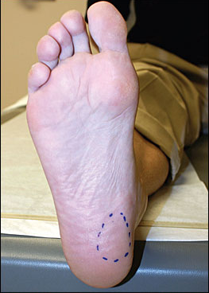

**Figure (2) medial planter calcaneal region, most common site of pain in PFS. (12)**

**3. Investigations:**

These investigations are not indicated unless there are inflammatory disease features ( seronegative arthropathy )

Blood tests:

1. CRP.
2. ESR.
3. WBC count.
4. Platelets level count. (10)

**4. Imaging**

**4.1 plain radiographs**

Plain radiography (x-ray) is cost-effective, widespread, and panoramic, thus often representing the imaging modality (as a first choice) for the evaluation of painful heel. But, plain radiography should not be used to make a diagnosis of plantar fasciitis without knowledge of clinical history or physical examination findings. (13)

A plain lateral x-ray can help to exclude a stress fracture and will often show soft tissues calcifications around the heel or osteophytes on the anterior part of the calcaneum (i.e. heel spurs) but, whether or not the calcaneal spurs is presented, it is not helpful in diagnosing plantar fasciitis as 50% of patients with plantar fasciitis and up to 19% of those without plantar fasciitis have heel spurs. (14)

The ‘spur’ is, infact , a bony ridge that looks sharp and localized in the two-dimensional x-ray image; it is an associated, not a causative, finding in plantar fasciitis. The Patients, and sometimes doctors, can become restricted on the idea that a bony spur causing the symptoms by digging into the plantar fascia, and cannot believe how the condition could possibly resolve whilst the spur remains – but it can and does get better. (10)

Calcifications and Plantar calcaneal spurs within the planter fascia are uncommon findings in patients with plantar fasciitis. (13)

In the literature, a considerable attention paid on the significance of calcaneal spurs as a cause of plantar fasciitis and nowadays their importance in terms of the diagnosis and prognosis of plantar fasciitis is arguable.

Calcaneal spurs associated with plantar fasciitis include those located within the plantar fascia However; These are very uncommon, because the most common site of plantar calcaneal spurs is in the abductor hallucis and flexor digitorum brevis origins, deep below the PF Therefore, evidence of calcaneal spurs on x-ray is not a pathognomonic sign of plantar fasciitis. Plain X-ray is useful in overviewing pathological and anatomical changes of the bone and soft tissues. Radiopaque foreign material, such as metals, may be easily seen. (15)

In the case of infectious fasciitis, plain radiography shows soft-tissue swelling and blurring of soft-tissue planes. Associated osteomyelitic changes in bone morphology can also be detected and mainly include lytic lesions, osteopenia, loss of trabecular architecture, periosteal reaction and new bone apposition. (16)



**Figure (3) Lateral Plain x-ray of foot (magnifying view) showing the calcaneal spur. (10)**

**4.2 Ultrasonography:**

Before more than 30 years ago, it has been proven that ultrasound is an excellent modality to assess musculoskeletal pathologies through the production of high quality spatial resolution sonograms, especially at the more superficial structures of the body and in areas of hypo-echogenicity. (17)

Hypo-echoic areas seen where a focal inflammation and diffuse tissue changes are present, thus causing a decrease in transmission of sound waves back to the transducer head. (18)

On ultrasound, normal planter fascia shows a fibrillar pattern similarly to ligaments, due to the hyper-echoic appearance of type I collagen fiber bundles embedded within a background of hypo-echoic matrix. (19)

Ultrasonographic characteristics of plantar fasciitis include:

* Loss of fibrillar pattern.
* Increased thickness over 4 mm (measured the max. thickness about 15 mm from the calcaneal insertion),
* Peri-fascial fluid collections
* Calcifications within the PF

Hyperemia is a well-known feature of tendinopathy due to neurovascular growth that may contribute to pain. It can be assessed using Doppler ultrasound. Similarly, Doppler ultrasound can identify hyperaemia in the PF, near its proximal insertion and in the perifascial soft tissue, in patients with plantar fasciitis. (20)

As Compared to other validated and reliable tests that are capable of visualization of soft tissue pathology, US offers an easier administration ,a much more cost effective test, , a faster process to achieve the results, a non-invasive approach, a better patient tolerance, and enhanced ability to display enthesopathy associated with inflammation. On sonographic images, Enthesopathy is visible at sites of muscular or tendon attachment where complete or partial ruptures may be present. (17) Fig.(4,5)

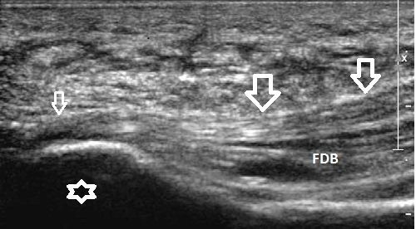

**Figure (4) Normal Plantar fascia. : plantar fascia in its long axis. The fascia (*arrows*) arises from the medial tubercle (*asterisk*) of the calcaneal tuberosity, the origin of the planter fascia ( small arrow ) , FDB (flexor digitorum brevis muscle ). (21)**

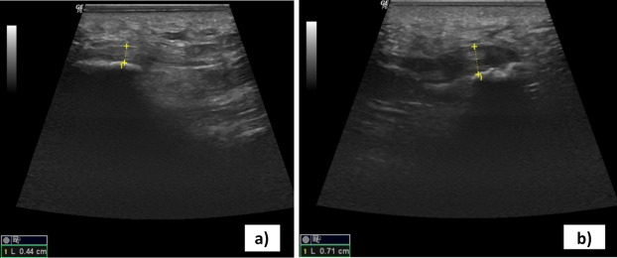**Figure (5) A longitudinal ultrasound scan showing : a) a normal planter fascia with normal thickness and fibrillar pattern ,b) planter fasciitis ; the PF is thickened , hypo-echoic with loss of normal fibrillar pattern. (22)**

**4.3 MRI**

Magnetic resonance imaging (MRI) has been reported as a reliable and validated modality of choice to effectively diagnose planter fasciitis . MRI's are being used to assess and differentiate any abnormalities in the thickness of the plantar fascia. although , it may be expensive and time consuming and may have many contraindications and precautions that accompany the test, thereby eliminating its availability to a large population. (7)

The planter fascia is homogeneously hypo-intense on both T1-weighted and fluid-sensitive sequences in healthy individuals.

MRI findings of plantar fasciitis include:

* Planter fascia thickening, most commonly at its calcaneal origin.
* Intra-substance areas of intermediate signal on T1-weighted sequences and increased signal on fluid-sensitive sequences.
* Adjacent soft tissue edema.
* Bone marrow edema of the calcaneal attachment of the planter fascia suggestive of enthesopathy

MRI is regarded as the most sensitive imaging modality for diagnosing plantar fasciitis.It enables to determine the exact location and extent of the inflammatory alteration within the planter fascia as well as to detect the signal changes within adjacent soft tissue or bone marrow. (3) Fig. (6,7)

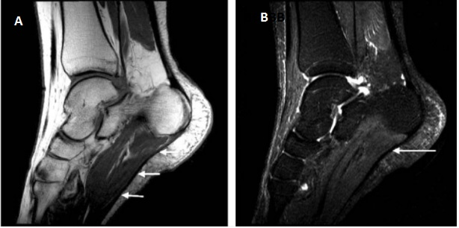

**Figure (6) MRI of normal PF(A) Sagittal T1-weighted and (B) sagittal fat-suppressed images of the normal plantar fascia (arrows). The fascia is low signal on most MR sequences demonstrating little of its internal structure. (23)**

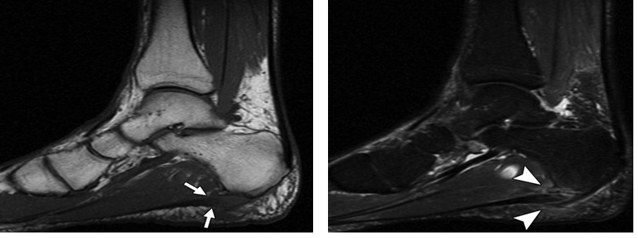**Figure (7) MRI of PFS, Sagittal T1-weighted image (A) and T2-weighted image with fat-saturation (B) show plantar fascia thickening (*arrows*, B) and edema (*arrowheads*, A) along calcaneal insertion of plantar fascia, with reactive bone marrow edema. Findings are consistent with plantar fasciitis. Also noted is small calcaneal bone spur, nonspecific finding. (3)**

**5. Basics of Ultrasound**

Ultrasound (US) is an imaging technology that uses high-frequency sound waves to characterize tissue. It is a useful and flexible modality in medical imaging, and often provides an additional or unique characterization of tissues, compared with other modalities such as conventional radiography or CT. Ultrasound relies on properties of acoustic physics (compression/rarefaction, reflection, impedance, etc..) to localize and characterize different tissue types. The frequency of the sound waves used in medical ultrasound is in the range of millions of cycles per second (megahertz, MHz). In contrast, the upper range of audible frequencies for human is around 20 thousand cycles per second (20 kHz). An ultrasound transducer sends an ultrasound pulse into tissue and then receives echoes back. The echoes contain spatial and contrast information. The concept is analogous to sonar used in nautical applications, but the technique in medical ultrasound is more sophisticated, gathering enough data to form a rapidly moving two-dimensional gray-scale image. (24)

**6. Basics of magnetic resonance imaging:**

Magnetic resonance imaging (MRI) is a modality of imaging that uses non-ionizing radiation to create useful diagnostic images. MRI was initially called Nuclear Magnetic Resonance (NMR) imaging after its early use for chemical analysis. The "Nuclear" was no longer in use about 25 years ago because of fears that people would think there was something radioactive involved, which there is not. NMR was discovered simultaneously by two physicists, Felix Bloch and Edward Mills Purcell, just after the end of 2nd World War. Bloch trained in quantum mechanics and was involved with atomic energy and then radar counter-measures. At the end of the war, he returned to his earlier work in the magnetic moment of the neutron. Purcell was involved with the development of microwave radar during the War then pursued radio waves for evaluation of molecular and nuclear properties. They received the Nobel Prize in Physics in 1952 for this discovery. MRI, the use of NMR to produce 2D images was accomplished by Paul Lauterbur, imaging water and Sir Peter Mansfield who imaged fingers of a research student, Dr Andrew Maudsley in 1976. Maudsley continues to make a significant contribution to MRI R&D. Raymond Damadian obtained human images a year later in 1977. Lauterbur and Mansfield received the Nobel Prize in Physiology or Medicine in 2003 for their development of MRI. (24)

Since 1985’s, it have been witnessed an explosion of information regarding the role of magnetic resonance (MR) imaging in assessing pathologic conditions of the ankle and foot. MR imaging has revitalized the study of musculoskeletal disease in this anatomic area due to its high soft-tissue contrast resolution and multi-planar capabilities. It provides a noninvasive tool for the diagnosis of related injuries, which are often difficult to diagnose with alternative modalities. MR imaging is particularly advantageous for assessing soft-tissue structures around the ankle such as tendons, ligaments, nerves, and fascia and for detecting occult bone injuries.

Routine foot MR imaging is performed in the oblique axial plane (ie, parallel to the long axis of the metatarsal bones), oblique coronal plane (ie, perpendicular to the long axis of the metatarsals), and oblique sagittal plane The patient is supine with the foot in about 20° of plantar flexion. An extremity surface coil is used to enhance spatial resolution. A wrist coil or other small dedicated coils are often used to evaluate the distal foot. (25)

**Differential diagnosis**

A variety of disorders may also affect the plantar aponeurosis, that causing heel pain & almost have the same clinical presentation of planter fasciitis. These including: Traumatic and corticosteroid-induced rupture, enthesopathy, rheumatologic and infectious processes and plantar fibromatosis.6 these diagnoses must be correlated to appropriate age groups and gender, specifically when the pain is bilateral.

Infection, chronic post-traumatic causes, vascular insufficiency, calcaneal stress fractures, nerve entrapment syndromes, calcaneal spurs, calcaneal bursitis, inappropriate footwear and fat pad atrophy are other potential causes of heel pain. (4)

**Management**

Non-operative treatment

* anti-inflammatory medications (either orally or topically)
* Plantar fascia specific stretching protocols and Achilles tendon (heel cord) stretching are the key to (effective) non-operative management. (6)
* analysis of causative factors such as (footwear, sports and exercise factors) can help the patient to overcome the condition
* keeping the foot up in a planti-grade position; overnight Night splints have been tried, preventing stiffening in the Achilles and plantar fascia.
* A physiotherapist can help to educate the patient about the condition and its likely progress, and can emphasize the need for a regular stretching regime for 8–12 weeks, supplemented with local massage (for instance with a foot roller, efficacy, and trials have been hampered by poor compliance.
* Podiatric assessment of the hind foot biomechanics may identify predisposing factors such as plano-valgus hind foot alignment, which can be corrected with orthotics.
* Cortisone injections may relieve pain but are associated with attenuation or rupture of the plantar fascia, fat atrophy (which will often immediately ease the symptoms, but leads to a painful flatfoot and impairs sporting). (10)
* Platelet rich plasma injections and low-intensity extracorporeal shock wave therapies (ESWT) have demonstrated success in limited studies. (6)

**Operative treatment**

Limited release of the plantar fascia (medial half) may be necessary in refractory cases.

A Complete release can place the longitudinal arch of the foot at risk, overload the lateral column, and lead to dorsolateral foot pain and metatarsal stress fractures (which worse the condition). (6)

**Aim of the study**

To assess the value of ultrasound in the diagnosis of planter fasciitis in comparison to MRI.

**PATIENTS AND METHODS**

**Data collection:**

This cross sectional analytic study was conducted in the radiology department of Al- Imamain Al-Kadhmain medical city / Baghdad / Iraq, between October 2017 and December 2018.the study included 34 patients referred from the rheumatology department outpatients suffering from heel pain with high clinical suspension of planter fasciitis .there were 16 male and 18 female and the age range of the patients was 27-65 years with the mean age of 44.38±8.9 years.

An informed oral consent was taken from all patients included in this study

**Inclusion criteria:**

Patients complaining from heel pain (acute on chronic) that was worst at the morning with tenderness along the medial calcaneal tuberosity, suggestive of planter fasciitis

**Exclusion Criteria:**

1. Patients with history of local inflammation, trauma , and heel surgery.
2. Patients with any contraindication to MRI .
3. Presence of any significant deformity or mass lesion that can prevent proper ultrasound or MRI examination .

The total number of examinations was 68 heels divided into 2 groups:

Symptomatic group: include 46 heels with planter fasciitis ( 22 patients have unilateral complain and 12 patients with bilateral complain )

Control group: include 11 volunteers ( 22 heels ) with no history of planter fasciitis

**Examination:**

**1.Ultrasound examination :**

All ultrasound examinations were performed by using linear array transducer 11L (12mHz) using sophisticated ultrasound system (voluson E6,GE, USA ).

The examination was performed in the prone position with the patient’s feet in dorsiflexion position and hanging over the edge of the table. Ultrasound scan was done for both heels with a slight medial inclination toward the attachment of the plantar fascia to the os calcanium for better visualization of the long axis of the plantar fascia fibers.

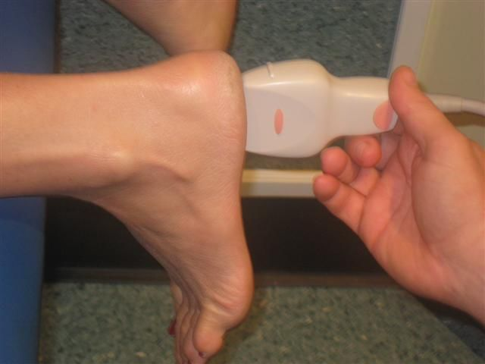

**Figure( 8) patient position during ultrasound examination**

The focus and gain were adjusted for good penetration of the thick skin of the heel.

The US examination was performed for:

* maximum thickness of the plantar fascia.( measured about 1.5 – 2 cm from the calcaneal attachment)
* presence of focal thickening
* echogenicity and homogenicity of the plantar fascia,
* presence or absence of subcutaneous edema, adjacent fluid collection and/or calcification
* Incidental pathological findings such as associated calcaneal spur.

**2. MRI examination ;**

All patients were examined by MRI using a 3 Tesla closed superconducting magnet (Achieva, Philips, Netherlands) with a dedicated ankle coil.

The patients were examined using the fallowing sequences:

* Sagittal T1 weighted sequence , the average parameters were : TR 500, TE 20 slice thickness 3 mm , gap 10%, 20 cm field of view , matrix 476 x 534 , flip angle 900
* sagittal T1wieghted with fat saturation (SPIR)sequence , the average parameters were : TR 500, TE 20 slice thickness 3 mm , gap 10%, 20 cm field of view , matrix 444 x 504 , flip angle 900 , IR delay 400 ms
* coronal proton density weighted (PD) sequence , the average parameters were : TR 3500, TE 30 slice thickness 4 mm , gap 10%, 16 cm field of view , matrix 380 x 224
* coronal proton density weighted fat suppression (PD-fat sat) sequence , the average parameters were : TR 2354, TE 30 slice thickness 2.5 mm , gap 10%, 15 cm field of view , matrix 380 x 224

All MRI images interpreted independently by specialist radiologist.

The plane of images was slightly inclined medially. Intravenous contrast (gadolinium) injection was not used in the examination.

The total number of examinations was 68 heels. In bilateral cases both sides were examined separately using the same protocol (controlled group included in MRI examination)

A systematic approach was used:

1. The maximum thickness of the plantar fascia( measured about 1.5-2 cm from the calcaneal insertion )
2. Presence or absence of focal thickening.
3. Abnormal signal intensity.
4. Calcification.
5. Adjacent subcutaneous edema

**Statistical analysis:**

Data were analyzed with SPSS v20 statistical package. Mean & standard deviation were used for calculation of normal & abnormal categorical variables such as age, sex, thickness measured by ultrasound & MRI. Kappa statistics were used for determination of agreement for ultrasound and MRI categorical variables. Paired t-test was used for determination of significant differences in thickness for diseased patients in both ultrasound and MRI. A P – Value of less than 0.05 was considered to be statistically significant.

**RESULTS**

The total number of patients were 34 (16 men and 18 women) with an age ranged from 27 to 65 years (mean 44.38±8.9 years) distributed as shown in table (1) and graph (1)

**Table (1); age and sex distribution of the patients:**

|  |  |  |  |  |  |  |
| --- | --- | --- | --- | --- | --- | --- |
| **Age of patients** | **Male** | **%** | **Female** | **%** | **Total** | **%** |
| 27-37 | 2 | 5.88 | 3 | 8.82 | 5 | 14.7 |
| 38-47 | 8 | 23.5 | 10 | 29.4 | 18 | 52.9 |
| 48-65 | 6 | 17.64 | 5 | 14.7 | 11 | 32.4 |
| Total | 16 | 47.1 | 18 | 52.92 | 34 | 100 |

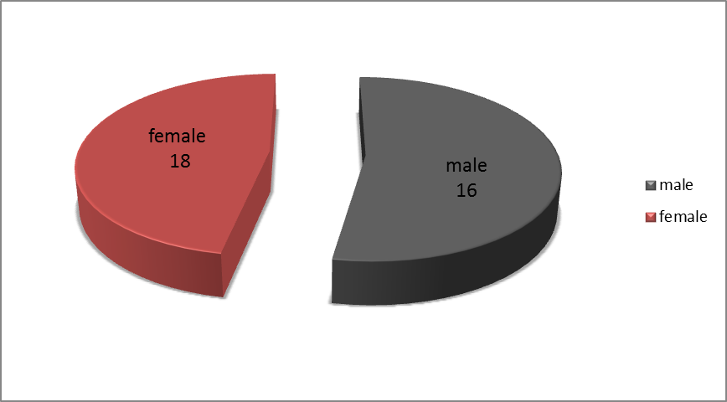

**Graph (1): Sex distribution.**

The plantar fascia thickness in symptomatic feet was (3.5–7.5 mm in range; mean 5.5±1.3) measured by ultrasound and (3.2 –6.9 mm in range; mean 4.95±1.1) measured by MRI.

The plantar fascia in symptomatic feet was significantly thicker than in the control group (2–2.8 mm in range; mean 2.4±0.07),( 2.2-2.9 mm in range ;2.7±0.05 mm) measured by ultrasound and MRI respectively; *P* < 0.05 (Table 2).Fig.(9)

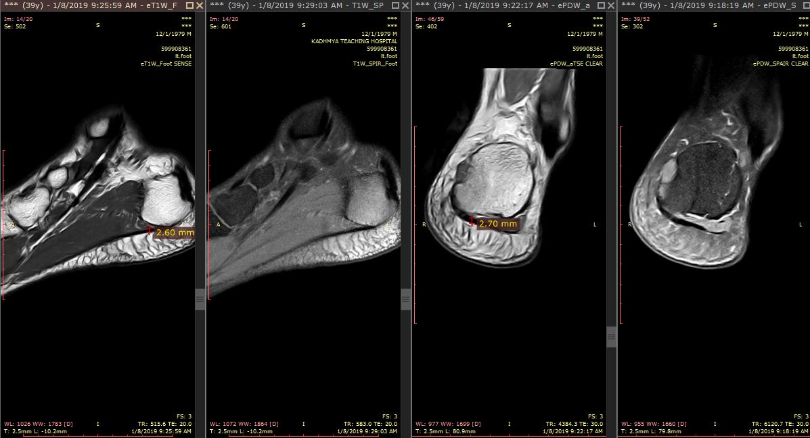

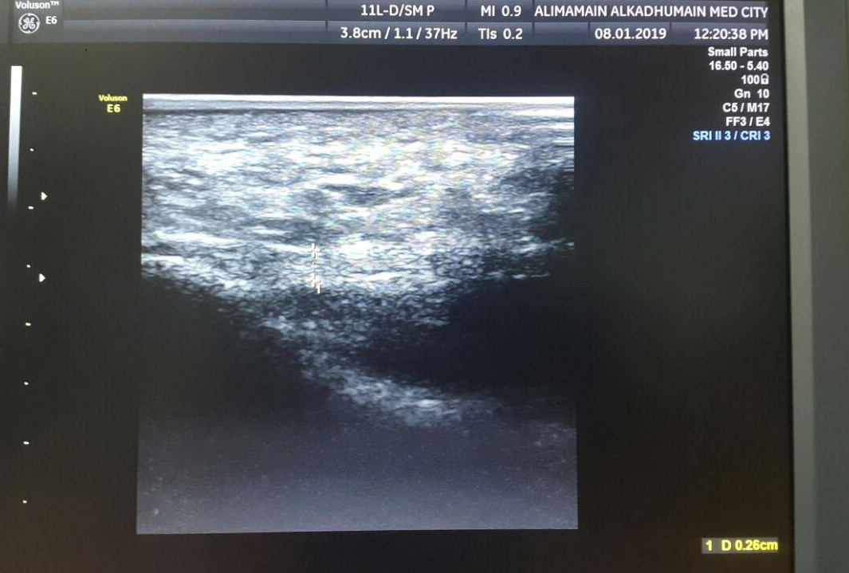

**Figure (9) A 28-year-old male of the control group with normal planter fascia. (a) Sagittal T1-weighted,T1-SPIR ,coronal PD& coronal PD fat-sat MRI examination showing normal PF thickness (0.27cm) with normal hypo-signal intensity (b) Sagittal ultrasound examination showing normal PF thickness (0.26 cm) with fibrillar echogenic pattern of normal PF**

**Table 2: Thickness of plantar fascia measured by ultrasound and MRI in symptomatic and control groups**

|  |  |  |
| --- | --- | --- |
|  | Ultrasound | MRI |
| Symptomatic group (46 heels) | 3.5–7.5 mm in range ;  mean 5.5±1.3mm | 3.2-6.9 mm in range;  mean 4.95±1.1mm |
| Control group*(22 heels) | 2-2.8 mm in range;  mean 2.4±0.07mm | 2.2-2.9 mm in range ;  2.7±0.05 mm |

*P < 0.05. *r (for US) = 0.854 *r (for MRI) =0.798

On ultrasound examination 41of the symptomatic heels showed abnormal focal low echogenicity in the plantar fascia and 35of the same group showed abnormal signal intensity within the plantar fascia on MRI examination. When MRI was considered as a reference, the statistical diagnostic accuracy of ultrasound was 78.2%.

Thirty sex of the symptomatic heels showed abnormal focal thickening in the plantar fascia and 36 of the same group showed abnormal thickening within the plantar fascia on MRI examination. When MRI was considered as a reference, the statistical diagnostic accuracy of ultrasound was 73.9%.

In symptomatic heels, Edema around the plantar fascia and/or in the adjacent soft tissues was detected by ultrasound in 10 cases and by MRI in 24 cases. With MRI considered as a reference, the statistical diagnostic accuracy of ultrasound was 60.8%.

Bony calcaneal spurs were detected in 4 cases by ultrasound and 24 by MRI (statistical diagnostic accuracy 56.5%). (Tables 3 and 4).

**Table 3 Incidence of different diagnostic signs in ultrasound and MRI**

|  |  |  |  |  |  |  |
| --- | --- | --- | --- | --- | --- | --- |
| NO. | Diagnostic signs | MRI  only | Ultrasound  only | Both  positive | Both  negative | Total |
| I | Focal thickening | 6 | 6 | 30 | 4 | 46 |
| II | Abnormal signal or echogenicity | 2 | 8 | 33 | 3 | 46 |
| III | Subcutaneous  Edema | 16 | 2 | 8 | 20 | 46 |
| V | Calcaneal spur | 20 | 0 | 4 | 22 | 46 |

**Table 4 Diagnostic accuracy of ultrasound for different diagnostic signs compared to MRI**

|  |  |  |
| --- | --- | --- |
|  | Ultrasound statistics | Diagnostic accuracy |
| I | Focal thickening | 73.9% |
| II | Intrinsic abnormal signal | 78.2% |
| III | Subcutaneous edema | 60.8% |
| IV | Calcaneal spur | 56.5% |

**Graph (2) Diagnostic accuracy of ultrasound for different diagnostic signs compared to MRI**

Other incidental pathology detected by MRI but not by ultrasound, although it might contribute to the etiology, is summarized in Table 5

**Table 5 Other incidental pathological findings by MRI that may be partially responsible for patient complaints**

|  |  |
| --- | --- |
| Pathological finding | No. of cases |
| Stress or occult fracture of talar neck | 1 |
| Ankle and/or subtalar joint fluid | 6 |
| Ganglion cyst | 2 |
| Pre-Achilles bursitis | 3 |
| Coalition of the tarsal bones | 3 |
| Avascular necrosis of talar dome | 1 |

Twenty two of our patients were overweight (47.8%), 10 were athletes (21.7%), 14 were diabetic (30.4%) and 18 had histories of prolonged weight-bearing (39.1%), clinical associations in the symptomatic group are summarized in Table 6

**Table 6 precipitating factors in symptomatic patients**

|  |  |  |  |  |
| --- | --- | --- | --- | --- |
| Clinical diagnosis | Positive | Negative | Total | % |
| Long distant runners | 10 | 36 | 46 | 21.7 |
| Diabetes mellitus | 14 | 32 | 46 | 30.4 |
| Long standing | 18 | 28 | 46 | 39.1 |
| Overweight | 22 | 24 | 46 | 47.8 |

Figure (10, 11) shows some images of patients with PFS. included in the study.

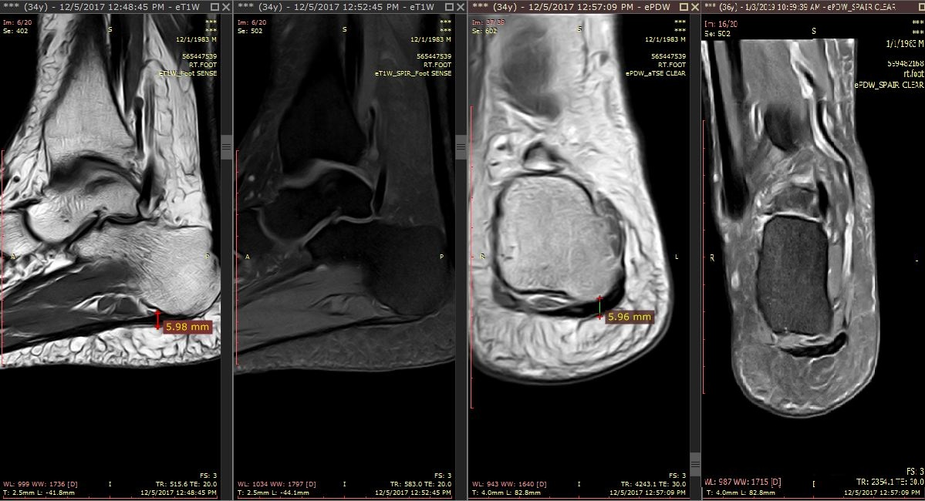

A

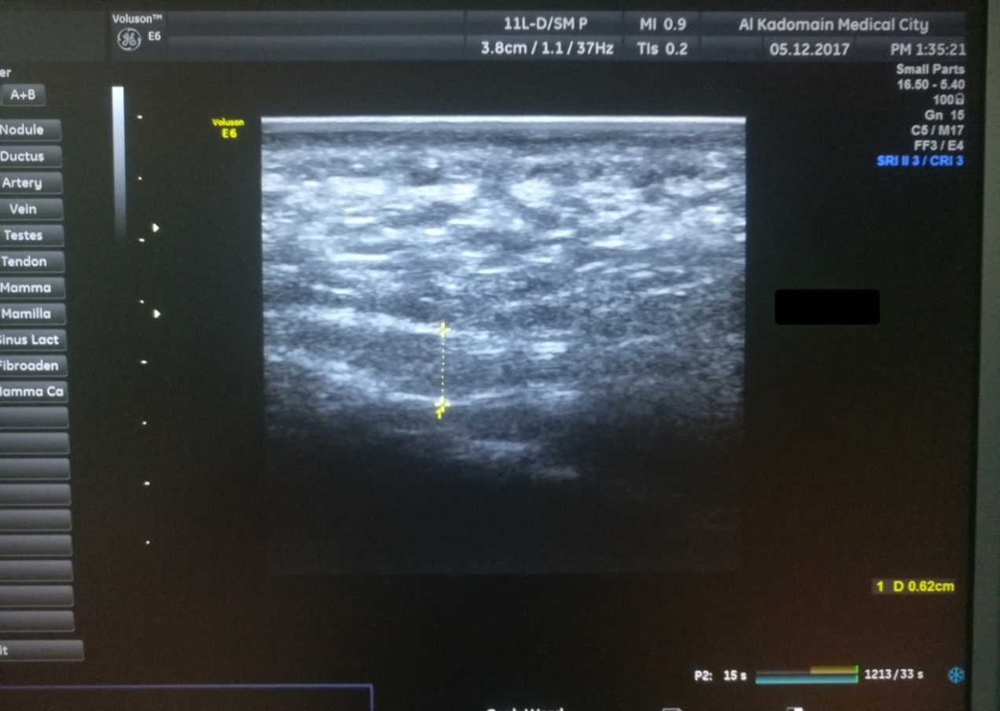

B

**Figure (10) patient No.1/ A 34-year-old male patient with unilateral right plantar fasciitis. (a) Sagittal T1-weighted,T1-SPIR ,coronal PD& coronal PD fat-sat MRI examination showing focal thickening (0.59 cm) with abnormal bright signal intensity (b) Sagittal ultrasound examination showing focal thickening (0.62 cm) with abnormal hypo-echoic echogenicity within the plantar fascia Associated subcutaneous edema**

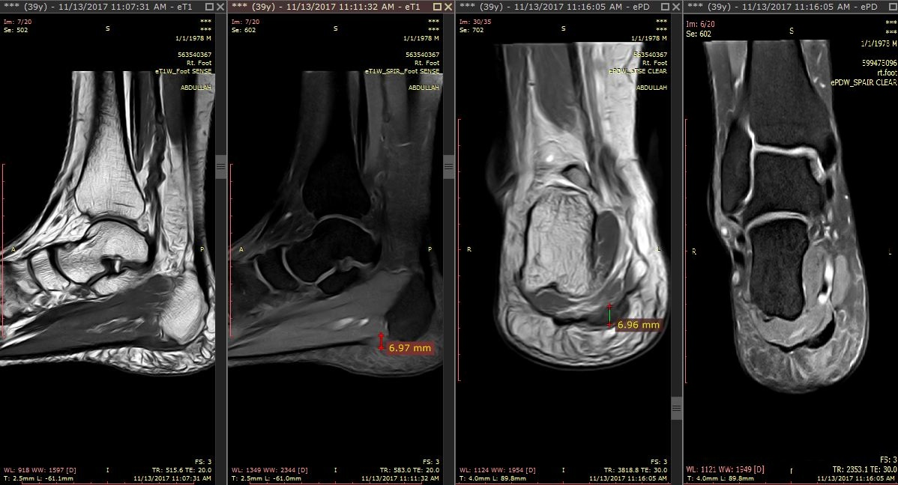

A

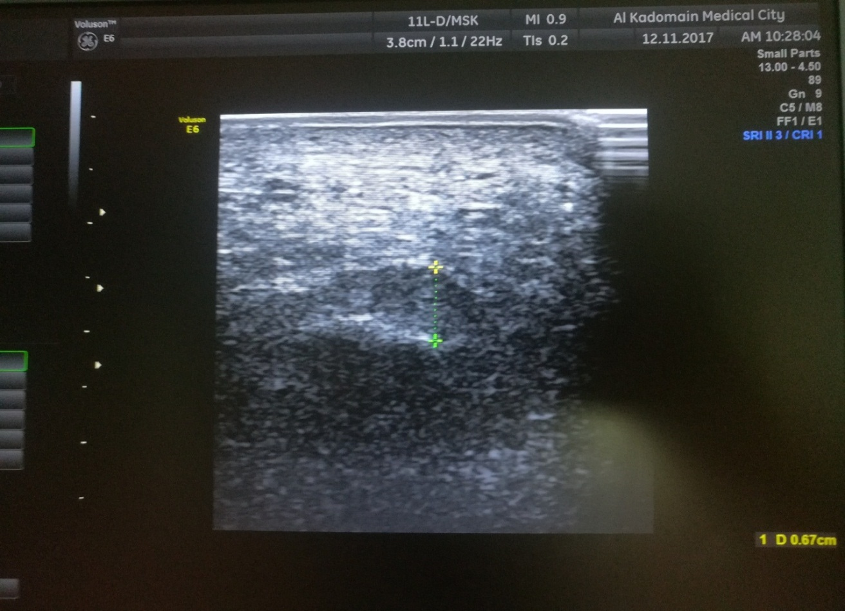

B

**Figure (11) patient No.2 /A 40-year-old male patient with unilateral right plantar fasciitis. (a) Sagittal T1-weighted,T1-SPIR &coronal PD & coronal PD-fat sat MRI examination showing focal thickening (0.69cm) with abnormal bright signal intensity and a calcaneal spur ( lying intramuscularly ,deep to the planter fascia ) (b) Sagittal ultrasound examination showing focal thickening (0.67 cm) with abnormal hypo-echoic echogenicity within the plantar fascia associated with sub cutaneous edema**

Figure (12, 13, and 14) shows some of the incidental pathological findings by MRI that may be partially responsible for patient complaints.

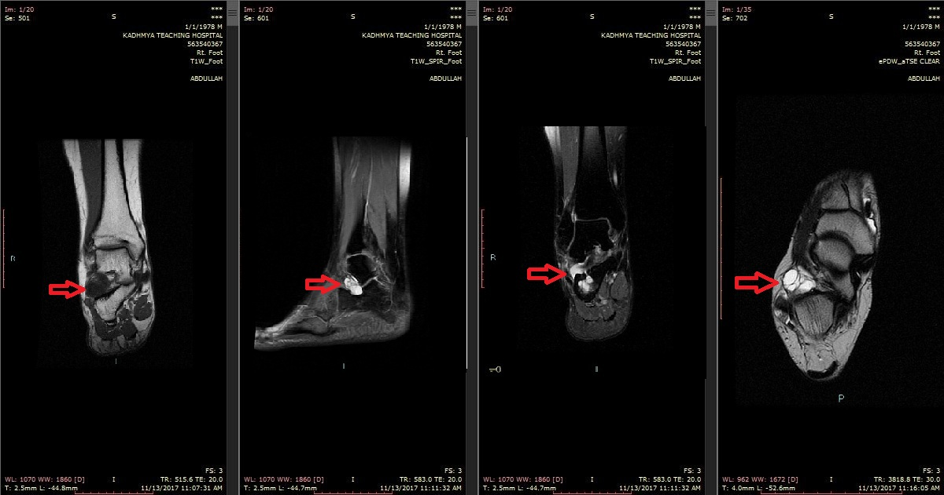

**Fig. (12) MRI study of 41 yrs. Old Pt. with ganglion cyst(red arrow)( coronal T1W,T1-SPIR,sagittal T1-SPIR and axial PDW) showing a well-defined lesion with abnormal SI ( hyper intense in PDW and T1-SPIR sequences ,and hypo intense SI in T1W sequence) seen in the lateral compartment of the hind foot.**

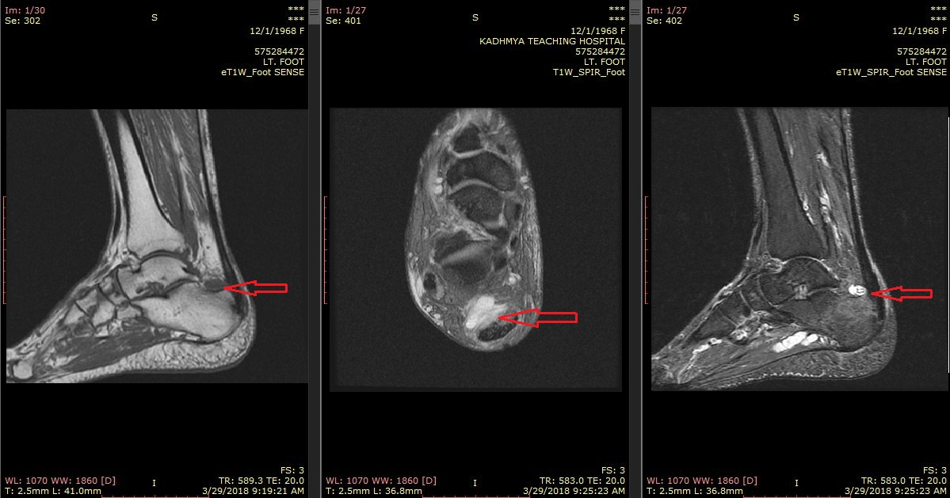

**Fig. (13) MRI study of 51 yrs. Old Pt. with pre Achilles bursitis (red arrow)(sagittal T1W, T1-SPIR and axial T1-SPIR,) showing a well-defined lesion with abnormal SI (hyper intense in T1-SPIR sequence ,and hypo intense SI in T1W sequence) seen in the posterior compartment of the hind foot, anterior to the Achilles tendon .**

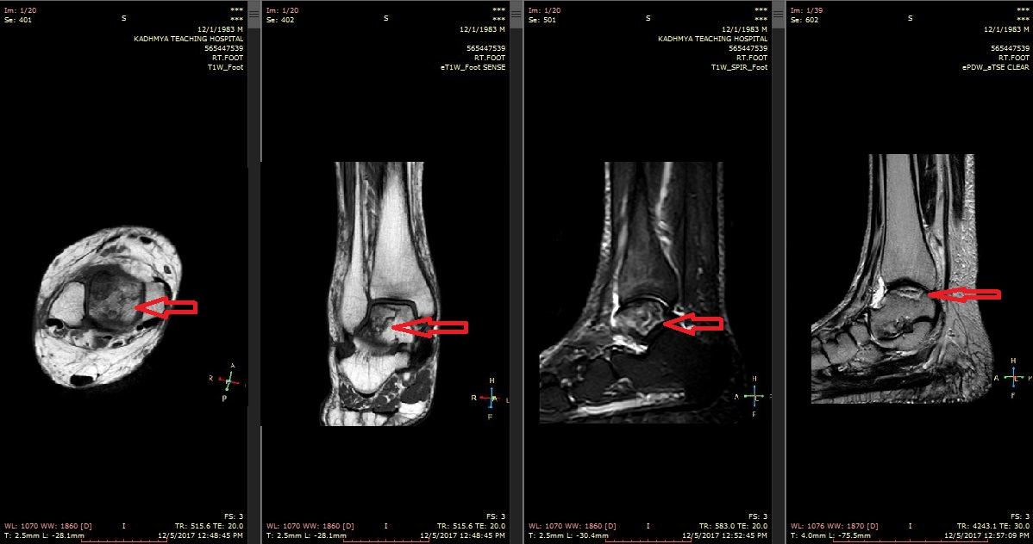

**Fig. (14) MRI study of 36 yrs. Old Pt. with a vascular necrosis of the talus (red arrow) (T1W (axial and coronal),sagittal T1-SPIR and PDW axial T1-SPIR,) showing a serpiginous heterogeneous SI involving the superior part of the talus with mild joint effusion.**

**DISCUSSION**

Plantar fasciitis is the most common diagnosis in patients with heel pain, a repeated trauma produces micro-tears to some fibers of the plantar aponeurosis, mostly near to the site of its attachment, that are accompanied by a local inflammatory reaction.

Not surprisingly, that plantar fasciitis is a common cause of heel pain in athletes and obese patients, apparently due to the trauma of repetitive traction on the plantar fascia. (4)

In the diagnosis of plantar fasciitis, the appropriate diagnosis can generally be made on a clinical history and physical examination, diagnostic imaging is not used routinely; but it should be considered if another diagnosis is highly suspected as some patients may not have the typical features or may be refractory to initial conservative treatment, and confirmation of the diagnosis may be needed. (4)

The total number of patients in this study was 34 with slight female predilection (18 female and 16 male) these results were similar to that reported by Ozdemir et al (2005). (26)who stated that plantar fasciitis is more common in Females, Cardinal et al(1996).(27) (15 patients, 9 females and 6 males), Ashraf et al (2010).(28) ( 80 pts,50 F and 30 M) and Sabir et al (2005). (29)  ( 77 pt., 66 F and 11 M).

Age of the patients ranged from 27 to 65 years with a mean of 44.38 ± 8.9 years. These results were in agreement with that of Sabir et al(2005).(29) reported the range of age (26 -76, 45.9 mean ± 11.8 years), Cardinal et al (1996). (27) (30-74 mean 45years) and Ashraf et al (2010). (28) (20-60 mean 37.11 ± 6.3).

By ultrasound, increased thickness of plantar fascia was constant finding in patients with the clinical diagnosis of plantar fasciitis. In this study, the results showed that the range of the proximal planter fascia thickness for patients group was (3.5–7.5 mm; mean 5.5mm ± 1.3) , these results were close to that reported by ABDEL‐WAHAB et al(2008). (4) (3.0 -7.0 mm in range ; 4.9 ± 1.3) , Ashraf et al (2010). (28) ( 4.2-8.1 mm in range; 5.6 mean ± 1.2) , Cardinal et al(1996). (27) ( 3.2 – 6.8 mm in range ; 5.2 ± 1.13) and Sabir et al (2005). (29) (4.9mm mean ± 0.9mm) .

However it was higher than the results of Ozdemir et al (2005). (26) ( 2.9 mm mean ± 0.6) , and Akfirat et al(2003). (30) ( 4.7 mm mean ± 1.5) This difference might be attributed to the higher percentage of obesity in our patients which was 47.8 % (compared to 27.9% in Ozdemir et al. (26) and 28.4 % in Akfirat et al. (30) ) .

The proximal planter fascia thickness for control group was (2–2.8 mm in range; mean 2.4mm± 0.07) measured by ultrasound, these results were similar to the results of Cardinal et al(1996). (27) (mean 2.6mm ±0.48) and Ozdemir et al (2005). (26) (2.5 mm mean± 0.6)

However it was lower than Ashraf et al. (28) (mean3.5mm±0.22), Akfirat et al(2003). (30) (mean3.6 mm±0.6) and Sabir et al(2005). (29) ( mean3.2 mm±0.4) .This difference might be attributed to the younger age in our control group ( mean age 24.53 years±3.5)

In current study there was a statistically significant difference (p<0.05) between patients group and the control group regarding proximal planter fascia thickness measured by ultrasound and this difference was similar to that reported by Ashraf et al. (28) ,Cardinal et al. (27) and ABDEL‐WAHAB et al (4)

Hypoechogenicity of the plantar fascia was a frequent sonographic finding. It relate to an underlying process of micro tears or oedema in the plantar fascia. (31)

In the current results the percentage of hypo echogenicity was 78.2% .this finding was close to that reported by Ashraf et al(2010). (28) ( 84%) , Cardinal et al(1996). (27) (84 %) and Genic et al(2005). (32) ( 73%)

However this result was higher than that of Sabir et al(2005). (29) ( 38.6%) and Ozdemir et al(2005). (26) ( 41%) This difference can be explained by higher percentage of obesity in our patients or due to the difference in the total number of patients between our study and these studies.

About 56.5% of current patients have a calcaneal spur , this was in agreement with Ashraf et al(2010). (28)( 57%), Ozdemir et al(2005). (26) ( 51%) and ABDEL‐WAHAB et al(2008). (4)(55%), however calcaneal spur was not identified by Cardinal et al(1996). (27) , this is most probably due to old generation of ultrasound equipment-used in this study .

About 60.8% showing subcutaneous edema. This finding was much higher than that reported by Akfirat et al(2003). (30) ( 10%) , Ozdemir et al(2005). (26) ( 2.5%) and Cardinal et al(1996). (27)( not identified ) , and this great difference can be explained by low percentage of obesity in their studies, difference in total number of patients and old gneration of US equipment used in their studies.

In the correct clinical circumstances, MRI is of particular value in differentiating plantar fasciitis from other causes of plantar heel pain that may contributed in the patient complain .it also have the advantages of larger field of view than ultrasound and has a multi-planar capability useful in the diagnosis of other causes of hind foot pain. (33)

In this study, our sonographic examinations were concentrated only on the diagnostic criteria of plantar fasciitis by assessment of the sonographic signs with no attempt made to look for associated causes of hind-foot pain. However, MRI has a wide window and other pathologies were seen in association with plantar fasciitis, including ankle and sub-talar joint effusion (6 cases), a vascular necrosis of the talar dome (1 case), coalition of the tarsal bones (3 cases), pre-Achilles bursitis (3 cases), ganglion cysts (2 cases) and occult fracture of the talar neck (1 case). However, the contribution of these findings to patient complaints could not be evaluated.

The development of high-resolution ultrasound technology has enhanced the value of ultrasonography as a diagnostic imaging tool for the assessment of various joint and soft tissue pathologies and often it has a complementary relationship with MRI. (29) Although Ultrasound has a narrower field of view and is more operator-dependent but it is inexpensive, quick, convenient, readily accessible, the greater spatial resolution and, most importantly, the benefit of real-time imaging that assists direct localization of patient symptoms with the ability to palpate, compress and assess dynamically specific structures, also ultrasound offers multi-planar capabilities, the ability to compare easily with the contralateral side at the same time which is possibly of more clinical value in the assessment of plantar fasciitis, particularly in longitudinal parametric studies and in sports medicine.It also have the opportunity for image-guided biopsies, aspirations and injections. (34)

**CONCLUSIONS AND RECOMMENDATIONS**

**Conclusions**

Ultrasonographic diagnosis of planter fasciitis is a useful tool (about 80% sensitive and 88% specific) with a reliable diagnostic accuracy comparable to that of MRI and it could be the easy initial imaging modality for confirmation of clinically suspected plantar fasciitis. MRI may be kept for cases where a diagnosis of plantar fasciitis does not confidently explain the clinical presentation and when complex pathology is suspected.

**Recommendations**

We recommended:

1. Ultrasound as a first line ,straightforward imaging modality in diagnosis of planter fasciitis
2. MRI study to evaluate cases with negative or equivocal ultrasound findings
3. To encourage future researchers to use more sophisticated new advances like elastogram in diagnosis of planter fasciitis

**REFERENCES**

1. Ross A. Adams’s outline of orthopedics (14th Edition). The Journal of Bone and Joint Surgery British volume. 2010;(6):904-904.
2. Sarrafian S. Anatomy of the foot and ankle. 3rd ed. Philadelphia: Lippincott; 2011.p486-488.
3. Draghi F, Gitto S, Bortolotto C, Draghi A, Ori Belometti G. Imaging of plantar fascia disorders: findings on plain radiography, ultrasound and magnetic resonance imaging. Insights into Imaging. 2016;8(1):69-78.
4. ABDEL-WAHAB N, FATHI S, AL-EMADI S, MAHDI S. High-resolution ultrasonographic diagnosis of plantar fasciitis: a correlation of ultrasound and magnetic resonance imaging. International Journal of Rheumatic Diseases. 2008;11(3):279-286.
5. THOMPSON J. Netter's concise orthopedic anatomy, updated edition. Amsterdam: Elsevier; 2015.p362.
6. Miller M, Thompson R. Miller's review of orthopedics. 7th ed. Philadelphia, Pa.: Elsevier; 2016.p535.
7. de Miguel E, Cobo T, Munoz-Fernandez S, et al. Validity of enthesis ultrasound assessment in spondyloarthropathy. Ann Rheum Dis. 2009;68(2):169–174.
8. Ultrasonographic evaluation of low energy extracorporeal pulse activated therapy (EPAT) for chronic plantar fasciitis. Fuß & Sprunggelenk. 2012;10(3):198.
9. McMillan AM, Landorf KB, Gilheany MF, Bird AR, Morrow AD, Menz HB. Ultrasound guided corticosteroid injection for plantar fasciitis: randomised controlled trial. BMj. 2012 May 22;344:e3260.
10. Solomon L, Warwick D, Nayagam S, Apley A. Apley's system of orthopaedics and fractures. 9th ed. London: Hodder Education; 2010.p618.
11. Gibbon WW, Long G. Ultrasound of the plantar aponeurosis (fascia) Skeletal Radiology. 1999;28(1):21–26.
12. Levenets V, Osadchaya L. The diagnosis and treatment of plantar fasciitis. ORTHOPAEDICS, TRAUMATOLOGY and PROSTHETICS. 2009;0(3):80.
13. Osborne H, Breidahl W, Allison G. Critical differences in lateral X-rays with and without a diagnosis of plantar fasciitis. Journal of Science and Medicine in Sport. 2006;9(3):231-237.
14. Thomas M, Roddy E, Zhang W, Menz H, Hannan M, Peat G. The population prevalence of foot and ankle pain in middle and old age: A systematic review. Pain. 2011;152(12):2870-2880.
15. Johal K, Milner S. Plantar fasciitis and the calcaneal spur: Fact or fiction?. Foot and Ankle Surgery. 2012;18(1):39-41.
16. Zhou B, Zhou Y, Tao X, Yuan C, Tang K. Classification of Calcaneal Spurs and Their Relationship With Plantar Fasciitis. The Journal of Foot and Ankle Surgery. 2015;54(4):594-600.
17. Radwan A, Wyland M, Applequist L, Bolowsky E, Klingensmith H, Virag I. Ultrasonography, an effective tool in diagnosing plantar fasciitis: a systematic review of diagnostic trials. International journal of sports physical therapy. 2016 Oct;11(5):663.
18. Li Z, Xia C, Yu A, Qi B. Ultrasound-versus palpation-guided injection of corticosteroid for plantar fasciitis: a meta-analysis. PLoS One. 2014 Mar 21;9(3):e92671.
19. Gitto S, Draghi F. Normal sonographic anatomy of the wrist with emphasis on assessment of tendons, nerves, and ligaments. Journal of Ultrasound in Medicine. 2016 May;35(5):1081-94.
20. Abul K, Ozer D, Sakizlioglu SS, Buyuk AF, Kaygusuz MA. Detection of normal plantar fascia thickness in adults via the ultrasonographic method. Journal of the American Podiatric Medical Association. 2015 Jan;105(1):8-13.
21. Bianchi S, Martinoli C. Foot. InUltrasound of the musculoskeletal system 2007 (pp. 835-888). Springer, Berlin, Heidelberg.
22. Baz AA, Gad AM, Waly MR. Ultrasound guided injection of platelet rich plasma in cases of chronic plantar fasciitis. The Egyptian Journal of Radiology and Nuclear Medicine. 2017 Mar 1;48(1):125-32.
23. McNally EG, Shetty S. Plantar fascia: imaging diagnosis and guided treatment. InSeminars in musculoskeletal radiology 2010 Sep (Vol. 14, No. 03, pp. 334-343). © Thieme Medical Publishers.
24. Kremkua FW. Sonography principles and instruments. Saunders. ISBN: 143770980X
25. Rosenberg ZS, Beltran J, Bencardino JT. MR imaging of the ankle and foot. Radiographics. 2000 Oct;20(suppl_1):S153-79.
26. Ozdemir H, Yilmaz E, Murat A, Karakurt L, Poyraz AK, Ogur E. Sonographic evaluation of plantar fasciitis and relation to body mass index. European journal of radiology. 2005 Jun 1;54(3):443-7.
27. Cardinal E, Chhem RK, Beauregard CG, Aubin B, Pelletier M. Plantar fasciitis: sonographic evaluation. Radiology. 1996 Oct;201(1):257-9.
28. Ashraf Ismail Khalifa, RagyTantawyAmeen and Abdelaziz Abdelhameed. High resolution ultrasonography versus plain x-ray in diagnosis of plantar fasciitis. 2010, April; AAMJ, Vol. 8, N. 2.
29. Sabir N, Demirlenk S, Yagci B, Karabulut N, Cubukcu S. Clinical utility of sonography in diagnosing plantar fasciitis. Journal of ultrasound in medicine. 2005 Aug;24(8):1041-8.
30. Akfirat M, Sen C, Günes T. Ultrasonographic appearance of the plantar fasciitis. Clinical imaging. 2003 Sep 1;27(5):353-7.
31. Tsai WC, Chiu MF, Wang CL, Tang FT, Wong MK. Ultrasound evaluation of plantar fasciitis. Scandinavian journal of rheumatology. 2000 Jan 1;29(4):255-9.
32. Genic H, Saracoglu M, Nacir B, Erdem HR, Kacar M (2005): Long term ultrasonographic Follow up of plantar fasciitis treated with steroid injection; Joint Bone Spine, 72: 61-65.
33. Blankenbaker DG, De Smet AA. The role of ultrasound in the evaluation of sports injuries of the lower extremities. Clinics in sports medicine. 2006 Oct 1;25(4):867-97.
34. Finlay K, Friedman L. Ultrasonography of the lower extremity. Orthopedic Clinics. 2006 Jul 1;37(3):245-75.



**تقييم دور الموجات فوق الصوتية في تشخيص التهاب اللفافة الأخمصية**

أطروحة

مقدمه الى المجلس العراقي للاختصاصات الطبية كجزء من متطلبات منح شهادة زميل المجلس العراقيللاختصاصات الطبية في اختصاص الأشعة التشخيصية

مقدم البحث

**نور جلال الدين أمين**

بكالوريوس طب و جراحة عامة

**بإشرافالاستاذ الدكتور**

**محمد عبد كاظم الجبوري**

**زميل المجلس العراقي للاختصاصات الطبية**

**استشاري الأشعة التشخيصية**

**2019 م 1439 هـ**

**الخلاصة**

**خلفية البحث**: التهاب اللفافة الأخمصية هو أكثر الحالات المؤلمة شيوعًا التي يسببها الالتهاب عند منطقة اتصال اللفافة الاخمصية في الحدبة الأنسية للعظم العقبي… وعادة ما يتم تشخيصها سريريًا ولكن التصوير الإشعاعي يستخدم لتشخيص واستبعاد الحالات الأخرى التي قد يكون لها نفس العرض السريري.

**الهدف من الدراسة**: تقييم دقة الموجات فوق الصوتية في تشخيص التهاب اللفافة الأخمصية مقارنة مع المعلومات التي يقدمها التصوير بالرنين المغناطيسي.

**المرضى والطرق**: في دراسة استطلاعية لـ 34 مريضا (16 رجلا و 18 امرأة) مع التهاب اللفافة الأخمصية الأحادية أو الثنائية المشتبه فيها ، تم فحص 46 كعب بواسطة كل من التصوير بالموجات فوق الصوتية والتصوير بالرنين المغناطيسي (MRI) لتقييم العلامات المختلفة .11 من المتطوعين الأصحاء (22 كعب) الذين اعتبروا كحالات مسيطر عليها

**النتائج**: في المرضى المشخصين سريريا بألتهاب اللفافة الأخمصية ، كانت اللفافة الأخمصية سميكة, سماكة اللفافة الأخمصية في الأقدام المصابة (3.5-7.5 ملم في المدى ؛ متوسط 5.5 ملم ± 1.3) مقاسة بواسطة الموجات فوق الصوتية التي كانت أثخن بشكل كبير من مجموعة الحالات المسيطر عليها ( 2-2.8 ملم في المدى؛ متوسط 2.4 ملم±0.07 )

  تم مقارنة العلامات الاخرى المستخدمة لتشخيص التهاب اللفافة الأخمصية مقاسة بواسطة الموجات فوق الصوتية في الدراسة إلى نتائج التصوير بالرنين المغناطيسي. كانت دقة التشخيص 78.2٪ للأشارات الغير طبيعية ناقصة الصدى داخل اللفافة الأخمصية، 73.9٪ للسماكة ، 60.8٪ للوذمة تحت الجلدية حول اللفافة الأخمصية، ، وكانت أدنى دقة تشخيصية للموجات فوق الصوتية في الكشف عن نتوء العظم العقبي (56.5٪). وتمت مناقشة النتائج ومقارنتها بأطروحات أخرى .

**الاستنتاج**: الموجات فوق الصوتية هي طريقة يمكن الاعتماد عليها في تشخيص التهاب اللفافة الأخمصية مقارنة مع التصوير بالرنين المغناطيسي .و قد يتم التصوير بالرنين المغناطيسي للحالات أكثر تعقيدًا.