Design an Optimum Highway Route using Remote Sensing Data and GIS-Based Least Cost Path Model, Case of Minya-Ras Ghareb and Minya-Wahat-Bawiti Highway routes, Egypt

Abdallah Wahdan a, Hala Effat b , Nasser Abdallahc , Khaled Elwand*

*a,c Department of Public Works, Faculty of Engineering, Al-Azhar University, Cairo, Egypt*

*b,d Department of Environmental Studies and Land-use, National Authority for Remote Sensing and Space Sciences, Cairo, Egypt*

*aEmail:* [*drabdallahwahdan@gmail.com*](mailto:drabdallahwahdan@gmail.com) *bEmail:* [*haeffat@yahoo.com*](mailto:haeffat@yahoo.com)

*cEmail:* [*n_gonah@yahoo.com*](mailto:n_gonah@yahoo.com)

**Abstract**

The traditional method of aligning highways is a tedious, time-consuming process, and needs a lot of manual work, expensive consuming and complicated process, where numerous environmental issues need to be addressed. The problem is exacerbated where the alignment is influenced by the location of services, existing roads, and buildings. Therefore, there is a great need to adopt new technologies that save time and money in designing and assessment of highway paths. Remote Sensing and GIS make the highway alignment most appropriate avoiding vulnerable high-risk zones such as sand dunes, stream crossing, fault zones, etc….in addition to considering environmental protection constraints and cost savings. It needs less manpower, less time consuming and less cost. In this context, a survey was conducted to determine the factors that affect the process of choosing the path of roads through the previous literature and a panel of experts. Minya Ras**-**Gharib road in the Eastern Desert of Egypt and Minya Wahat Bawiti road in the Western Desert of Egypt as a case study. Remotely sensing techniques, Landsat 8 and digital elevation models were used to produce land use maps, sand dunes, existing roads, slopes, and flood sites. In addition, thematic maps such as rock type, faults, protectorates. Cost factors were determined and cost surface for each factor was established, standardized, weighed and aggregated based on previous literature. A pairwise comparison is used to determine the weight of factors. These weighted factors /criteria maps were combined to create the least cost surface map. Four visions were modeled: an economic vision, an environmental vision, an equal vision, and economy only vision. A comparison was made between the four-route using the DEFINITE software. The equal**-**weights route was the best route. A comparison was made between the equal-weight route and the existing route.

------------------------------------------------------------------------

* Corresponding author.

E-mail address: e.khattab46@yahoo.com

The results of the comparison show that the recommended route save about 48% for the road of Minya Ras Gharib and save about 33 % for the road of Minya Wahat Bawiti compared to the existing road**,** in addition to saving the time, effort and cost.

***Keywords:*** GIS; MCDA; LCP; Route Selection.

1. **Introduction**

The traditional method of aligning highways is a tedious, time-consuming process that requires a lot of manual labor, and costly, because of the many variables that need to be considered. In addition, Routes for features like roads, pipelines, or railways often affected by political, social, physical, environmental, economic, and restrictive factors [1]. The problem is exacerbated where the alignment is influenced by the location of services, High stream order, sand dunes, existing roads, and buildings. Therefore, there is a great need to adopt new techniques that save time and money in design and track the highway for evaluation to achieve the best results for finding the optimum route.

Remote Sensing (RS) and Geographic Information Systems (GIS) are increasingly used in civil engineering applications. Transport and highway engineering are one of the fields affected by developments in RS & GIS aspects, as spatial variables, including environmental, topography, built-up areas, economical and geology related variables, can be easily modeled [2]. Experience shows that GIS Based-Least Cost Path (LCP) analysis is an efficient tool for solving optimization tasks with spatially distributed linear objects such as railways, roads, and pipelines [3]. In addition, LCP Analysis permits decision makers, designers, and road planners to search out the economic route between any two sites (source and destination) within the cost surface, which can be calculated by combining multiple criteria [4].

LCP analysis model most appropriate paths depend on suitable data on rock type, land use, land topography, and drainage. In addition, there are issues such as land value, ownership, social and economic impacts, and identification of environmentally sensitive areas [1].

This procedure can be easily carried out using remotely sensed data, GIS Based LCP analysis, and Spatial Multi-Criteria Evaluation (SMCE) and is therefore widely used to support decision makers in the planning and design of different types of linear infrastructure, from roads to pipelines [4]. In addition, RS and GIS make the highway alignment more appropriate avoiding vulnerable high-risk zones such as sand dunes, stream crossing, fault zones, etc. In addition to considering environmental protection constraints and cost savings. It needs less manpower, less time consuming and less cost.

1. **Literature Review**
   1. ***RS and GIS in Civil Engineering***

RS and GIS techniques are becoming irreplaceable tools for resolving several issues associated with civil engineering and terrain. RS observations provide data on Earth resources in spatial form, where geographic information systems link different types of spatial data and their characteristics data for use in various areas of civil engineering. Different topics, specifically terrain, geology, hydrological drainage, land use, etc., may be derived from remote sensing information. All of the above thematic data may be combined with their options to solve several civil engineering issues. Some of the present uses of GIS and remote sensing in civil projects are housing, sanitation, energy, water system, effluent disposal, urban growth, irrigation project design and planning, new road alignment then forth. For this RS and GIS are used to generate development models by integrating the information on natural resources, demographic and socioeconomic data in a GIS domain with satellite data. Mapping of landslides in mountainous areas that as a result of significant losses may be created and land-prone areas may be identified.

Civil engineering interests with the development and sustainability of infrastructure projects. The profession covers many areas of interest and a wide range of experiences. GIS applications play a vital role in various civil engineering areas such as transport, water, sewage, and surveying, including cutting or packing calculations, hydrology analysis, soil analysis, traffic impact studies, environmental impact assessment, regression analysis, corrosion control and emissions Aerobic, and pollution. Support decision-making in GIS with high-level planning tools for lower cost guidance, site location, environmental impact assessment, cost analysis, data modeling, visualization, overlapping overlay and analysis of cost/cost alternatives [5].

* 1. ***Multi-Criteria GIS Analysis***

The utilization of GIS-MCDA choices gives the likelihood of prioritization joining spatial gauges from various areas and points of view is portrayed, and at last aides in settling on far reaching choices [6]. The information required depends on the nature of a spatial decision problem. There are several characteristics of spatial decision problems are evaluated on the basis of multiple criteria. The spatial multi-criteria decision making (SMCDM) involves analysis of geographical events supported criterion values and therefore the decision maker’s preferences to a group of analysis criteria. The large number of factors necessary causes difficulties in making spatial decisions, difficulties in attempting to acquire and process data to obtain information for making decisions. Therefore, using GIS and MCDM techniques to support the decision maker achieves greater effectiveness and efficiency of solving spatial decision problems. The combination of GIS capabilities with MCDM techniques provides the decision maker with support in all stages of decision making, that is, in the intelligence, design and choice phases of the decision making process [7].

The overall framework for decision-making in route planning is based on the following steps:

* *Intelligence:* The identification of problems for decisions. According to defined problems to evaluate criteria and generate criteria maps based on GIS functions.
* *Design:* Evaluate the relative importance of given criteria based on one of the MCDM methods.
* *Choice:* Evaluation alternative options and making decisions of problems by applying the corresponding multi-criteria decision rules.

MCDM issues involve the determination of the relative importance of the criteria. this can be typically achieved by assigning a weight to each criterion. A weight may be defined as a value assigned to an evaluation criterion that indicates its importance relative to other criteria under consideration [7]. There are several the weight assessments techniques can be used in spatial multi-criteria decision analysis. Which method should be used depends on a particular decision situation? Among the known techniques for the development of weights, one of the most promising is pairwise comparisons method. The pairwise comparison method was developed by [8] in the context of a decision-making process known as the Analytical Hierarchy Process (AHP).

It involves pairwise comparisons to create a ratio matrix of criteria and to produce the relative weight for each criterion. Particularly, the weights are determined by normalizing the eigenvector associated with the maximum eigenvalue of the ratio matrix.

Since the MCDA technique appears to be better for road path selection wherever several criteria should be considered and cover all concerned aspects and alternatives associated with road construction. In addition, the previously mentioned privileges of the AHP in solving complex spatial problems constitute the basic motivation behind the current research.

* 1. ***Overview of Previous RS & GIS Studies in Route Selection***

There are many previous studies that have used GIS and MCDA in the choice of routes in general and road routes in particular. Some of these studies the difference was in the criteria based on the choice of the route. In others, the difference was in the route goal. In others, it is based on the evaluation and the choice between multiple alternatives. On the other hand, the problem was in the design and then attempt to create a better alternative by taking different criteria. One of these studies:

[9], used the LCP analysis to determine the least cost pipeline path using remote sensing data and GIS. [10], developed a decision-assistance tool to evaluate multiple criteria for route alignments using GIS. Possible alignments are evaluated supported community confusion, environmental, geotechnical, and geometric criterion. [11], developed a system supported the integration of the LCP and AHP and its application in the choice of the corridor of the interstate highway connector in the southeastern United States.[12], used RS and GIS to choose the optimal route to determine the optimum alignment for a road project in the Himalayas. [13], proposed a GIS-based raster model to determine the alignment of natural gas pipelines and develop an interface on ArcGIS 9.2 for this model. [1], utilized GIS tools to develop LCP for a corridor to link the three cities (Taba City, Nekhel City, and El Shatt City) in the desert environment of the Sinai Peninsula. Economic and Environmental variables were coordinated through a spatial multi-criteria display utilizing the AHP. [14], used multi-criteria GIS approach for selecting an optimum path route in Assir region in Kingdom of Saudi Arabia (KSA), based on all possible selected alternatives along with their corresponding criteria factors and weights, in order to develop a suitable model for best pathfinding.

1. **Methodology**

The basic purpose of this research is to design a simple model for optimal and least cost highway route. First, the variables which have to be used in the model were defined. These variables are the criteria data layers. These layers were weighted and aggregated to produce the weighted cost map. This weighted map will act as a resistance surface to move from origin to destination points of the route ends. Figure (1) state in brief, the methodology steps embrace criteria identification, data preparation, Weighted Linear Combination (WLC), and decision-making method. Every step carried out is in brief mentioned in the following subsections.

* 1. ***Criteria Identification***

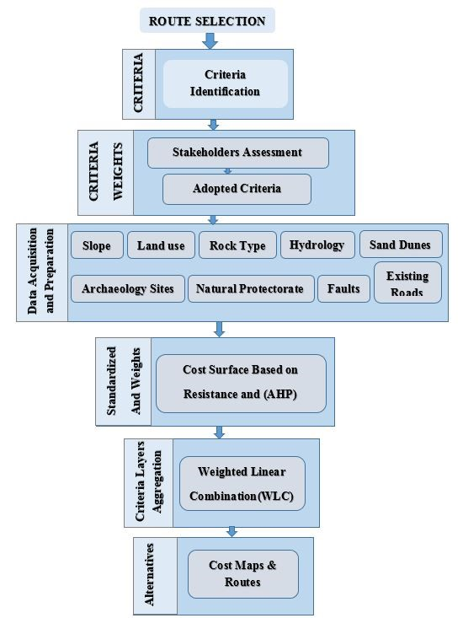The aim of this step is to identify data sets needed for proper route selection. The identification involves evaluation of user data in the knowledge-based (panel of Egyptian experts throw questionnaire) along with a literature review. The aim is to improve the current practices, not only by automating existing tasks but also by introducing and considering other important factors that may be ignored in the current system. A questionnaire survey was carried out to collect information about criteria affect route allocation. The questionnaire was carefully designed and tested in order to ensure its effectiveness. Thirty (30) engineers in design, construction, GIS, and urban planning fields participated in such questionnaire.

The criteria included the slope, land use, hydrology, geology, faults, natural protectorates, archaeological sites, and sand dunes data. Such criteria were used Multi-Criteria Evaluation (MCE) model to develop the highway LCP. The LCP is performed by assigning weighted cost factors associated with the crossing of the slope, stream, faults, rock, agriculture land, urban, protectorates, sand dunes; developing a cumulative weighted cost surface; and then calculating a path of least resistance across that surface. The criteria and decision rules are shown in Table (1).

* 1. ***Study Area Selection***

To verify the proposed methodology, it was necessary to select a study area that included the factors summarized by literature review and the questionnaire. Since, all these factors cannot be available in one region, two regions were selected for the current application. Minya-Ras Ghareb road, located in the Eastern Desert was selected for the first study area. In October 2016, a flood event caused the destruction of Minya –Ras Ghareb road.

Figure : General Methodology for Route Selection (Authors)

This road passes through high terrain and high stream order and various rock types. This was a reason for conducting a route assessment for such a road. The second study area is Banymazar- Wahat-Bawiti road, located in the Western Desert. The western desert is characterized by sand dunes, some urban areas, and agriculture reclamation lands. Figure (2) depicts the two locations.

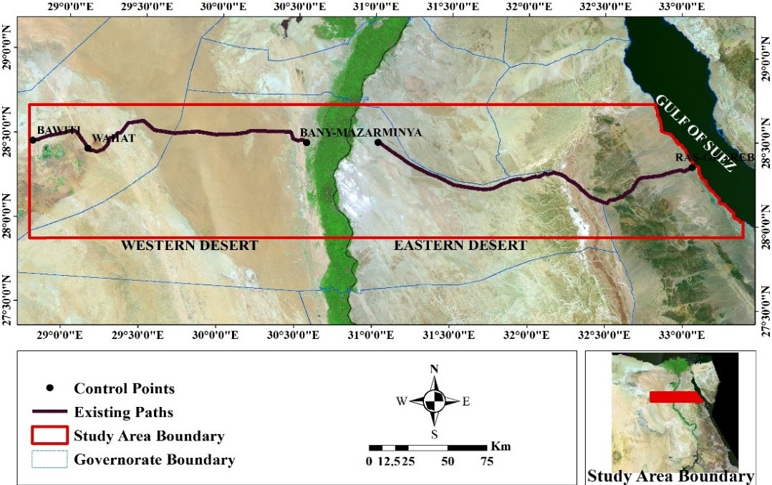**Table 1:** The defined Criteria and Decision Rules for Route Selection

|  |  |  |
| --- | --- | --- |
| **Alternative** | **Criteria** | **Decision rules** |
| Economy | Slope | Maximizing route length in flat and mild slopes to reduce cut and fill costs. |
| Land Use | Minimizing route length in agriculture, and urban areas to avoid land acquisition. |
| Faults | Faults are considered a constraint in routing a highway and should be avoided to reduce cost. |
| Rock Type | Minimizing route length in Rock areas to avoid high amounts of cut and fill costs. |
| Hydrology | Minimizing route length intersecting stream networks to avoid flood protection constructions. |
| Sand Dunes | Minimizing route length intersecting sand dunes to avoid the risk of dunes encroachment on the highway. |
| Environmental | Agriculture Distance | Maximizing route distance from agricultural areas to avoid loss of rural lands. |
| Stream Distance | Maximizing route distance from water stream networks to preserve the water resource. |
| Sand Dunes | Far from sand dunes areas to avoid problems that may be caused by dunes encroachment on driving and road safety. |
| Archaeology sites | Such sites should not be crossed by the highway. |

* 1. ***Data Acquisition and Preparation***

**Figure 2:** The location map of the study area in a satellite image. using ArcGIS map (ver. 10.2)

RS is an important tool for obtaining data without direct contact and plays an important role in obtaining land uses such as cultivated land, urban areas, water bodies and sand dunes are obtained from analysis and interpretation of satellite imagery and maps covering the study area at totally different scales as shown in Table (2).

Table 2: Data sources and derived item

|  |  |  |  |
| --- | --- | --- | --- |
| **Data** | **Date** | **Source** | **Derived Item** |
| Shuttle Radar Topography Mission (SRTM) Data | March 2018 | SRTM GDEM http://www.gdem.SRTM.ersdac.or.jp | Extraction of Digital Elevation Model (DEM), slope, and stream network. |
| Landsat 8 (OLI) Images | June 2018 | Landsat 8(OLI) | Extraction of the Land cover map, sand dunes |

The original data available and also the converted formats as follows:

* The SRTM elevation data for the research area acquired in April 2018 was downloaded from (http://earthexplorer.usgs.gov) website. The Downloaded data was then projected to Universe Transverse Mercator (UTM) coordinate system zone 36 N, using ArcMap. DEM is produced from the elevation data (resolution of DEM is 30m x 30m). Then, the slope map, and stream network derived from the DEM using ESRI special Analyst modules for used as input to the least cost pathway analysis as shown in Figure (3).
* The study area was covered by eight Landsat 8 (OLI/TIRS) satellite scenes during 2018. These images were collected and processed. Image pre-processing is applied to attenuate unwanted contrast/noise and enhance the desired options using different functions of ENVI 5.3 software. All bands were layer stacked except the Aerosol band (band 1) and therefore the thermal bands (bands 10 and 11). Radiometric correction of the satellite images (normalization) takes into consideration the measurable, aerosol, and temporal surface reflection and absorption, and so uses the mosaic to assemble multiple images into one composite image in Figure (4). Then, from the mosaic dataset the study area image was extracted by clipping the mosaic using a polygon shape for the area of interest. Finally, the maximum likelihood classifier was done for supervised classification to extract a Land-cover / Land-use map. The maximum likelihood” classifier was used using ESRI ArcGIS 10.2 and ENVI 5.3. After classification, a major 3 × 3 filters applied to remove anomalous pixels from the matrix. In this research area, there were Six classes LULC categories were identified: urban areas, loose sand and sand dunes, bare rock, agriculture, natural vegetation, water. All data in the study area were projected in WGS_1984 No. 36N International area (UTM). The classification result was converted from raster to vector format and stored in a geographic info created in ArcGIS10.2 software. The obtained data indicate that the Land Use/Land cover categories include urban areas, loose sand and sand dunes, bare rock, agriculture, natural vegetation, and water as shown in Figure (5a).
* The Egyptian Geological Survey, Mining Authority, The National Authority for Remote Sensing and Space Science (NARSS) and UNESCO, (2006) Geologic map scale 1: 250,000 was used to digitize the faults and to extract the rock type classes as shown in Figures (5b, 5c).
* The natural protectorates map was obtained from the Egyptian Environmental Affairs Authority (EEAA) as part of a report published in 1998. Such digitizing map was converted to a feature class as shown in Figure (5-d).
* The archaeological sites layer was obtained from the General Organization for Physical Planning (GOPP, 2007) as shown in Figure (5-d).

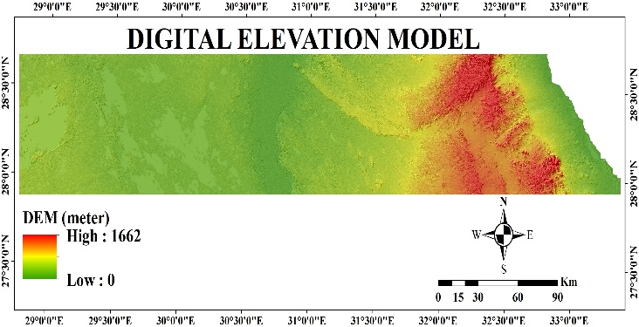

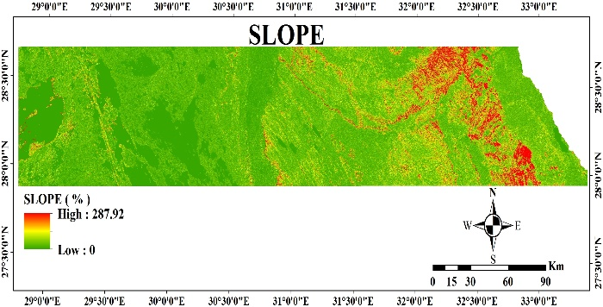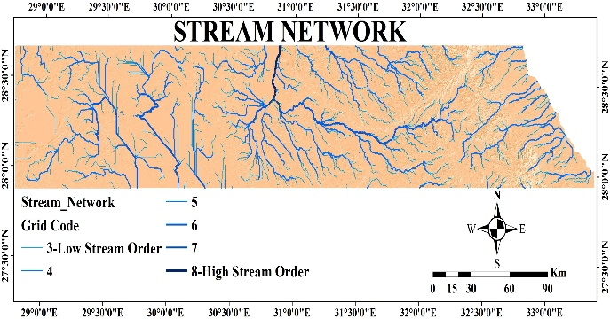

**(b)**

**(c)**

**(a)**

**(d)**

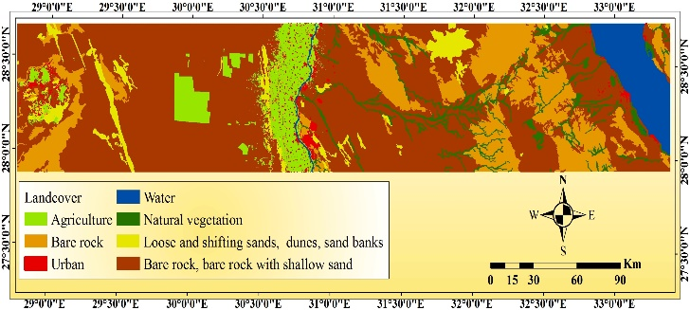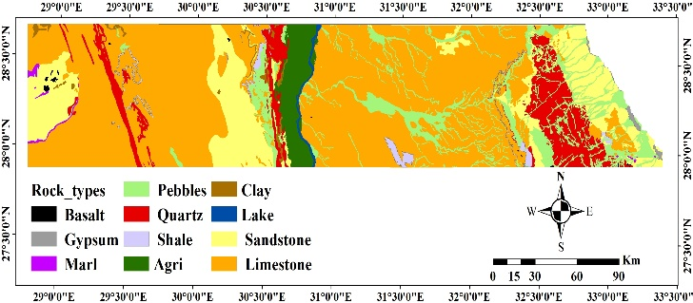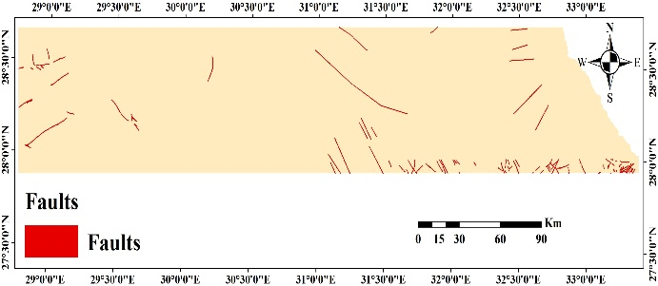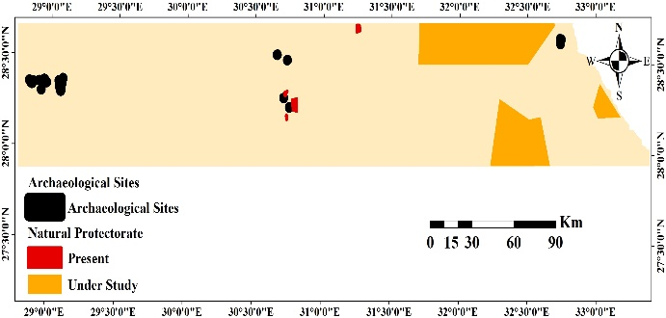

**(c)**

Figure 3: Available DEM (a) and its data sources (b and c)

**(c)**

**(b)**

**(a)**

**Figure 5:** Available data sources. (a) Landcover map. (b) Rock type map. (c) Faults map. (d) Protectorates map.

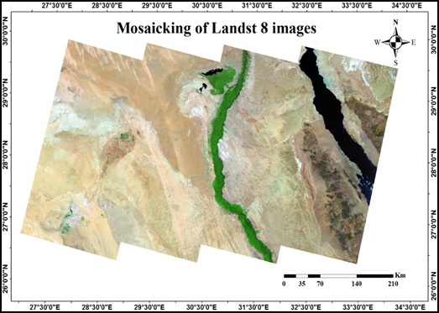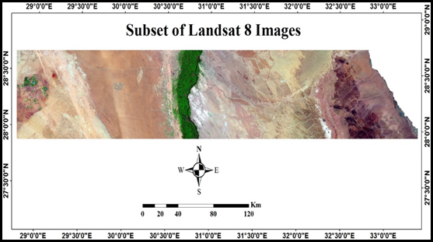

**Figure 4:** (a) Mosaicking and (b) subset of Landsat images 2018

**(a)**

**(c)**

* 1. ***Corridor and Path Analyses***

Arc GIS 10.2 Spatial Analysis Module is implemented to extract the corridor and the optimal route as shown in Figure (6). The Alternatives by two criteria themes were created, the Economic and the Environmental themes. standardization and weights were applied in a Multi-Criteria Evaluation to create two sub-models for each theme. The two sub-models were aggregated in various priority weights to produce four alternatives.

* + 1. *Creating Cost Surface (Standardization) of the criteria maps*

Cost surface values ​​are calculated, expressed in terms of a cost scale (standardization to a cost-scale). These values ​​often have a proxy least-cost meaning relative to moving across the landscape. Economic and environmental factors are rated based on a proxy evaluation (cost scale) that ranges from 1to 9, where (1) is the most desirable value and (9) is the least desirable value. These values assumed to anticipate the cost crossing the highway. Such an evaluation scale is one of the requirements of Weighted Overlay tool.

The process of creating cost-surfaces is implemented for finding an optimal highway route based on a set of given criteria. The resulting route called the LCP. Based on the selected cost criteria, the route should minimize the length, construction costs and travel time.

Table (3), Figure (7) shows the standardized values for the economy theme and attributes. Standardization was performed in Esri ArcGIS 10.2 software using reclassify tools.

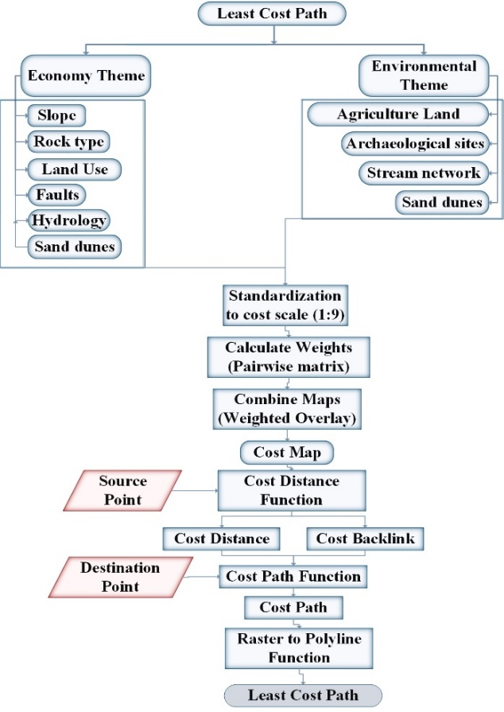

**Figure 6**: Flow Chart of Route Creation in Arc GIS

**Table 3:** Standardized Economy Values

Figure 7:Standardized Economy Maps. (a) Cost of slopes. (b) Cost of landuse. (c) Cost of faults. (d) Cost of Streams. (e) Cost of sand dunes. (f) Cost of rock types

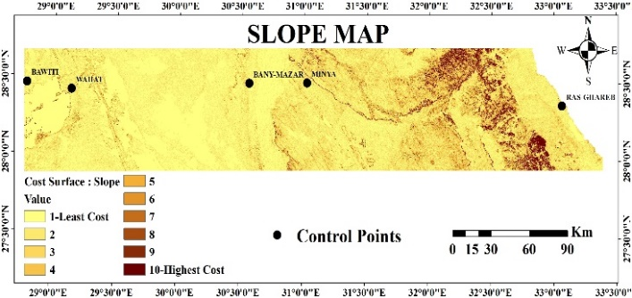

**(a)**

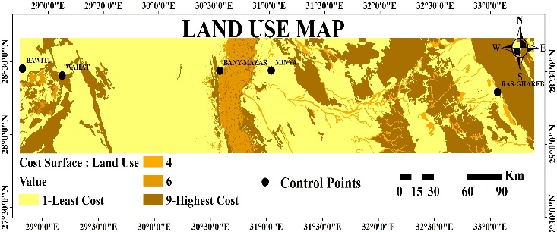

**(b)**

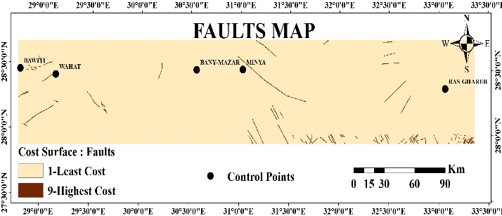

**(c)**

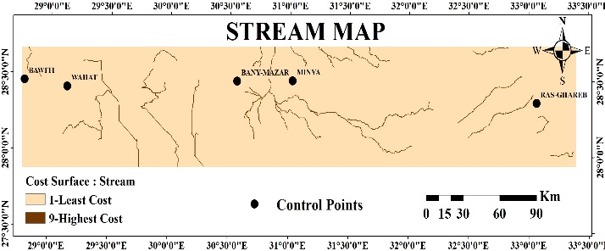

**(d)**

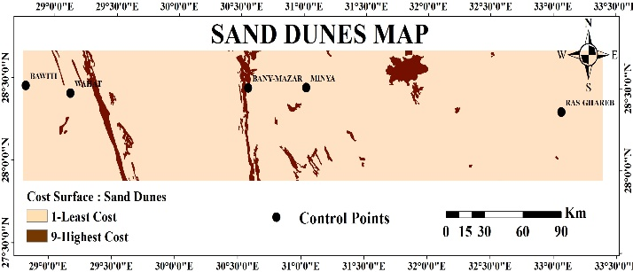

**(e)**

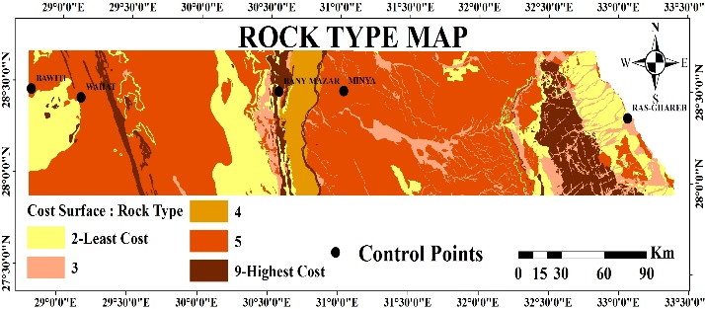

**(f)**

|  |  |  |  |
| --- | --- | --- | --- |
| **Standardized Economy Values** | | | **Cost value** |
| **EconomyTheme** | Slope (%) [3] | 0–3 | 1 |
| 3-5 | 2 |
| 5-8 | 3 |
| 8-10 | 4 |
| 10-15 | 5 |
| 15-18 | 6 |
| 18-20 | 7 |
| 20-25 | 8 |
| >25 | 9 |
| Land use [1] | Water, Sand dunes, Urban, Mountainous rocks | 9 |
| Agriculture | 6 |
| Natural Vegetation | 4 |
| Bare Rock with shallow sand | 1 |
| Faults [1] | Fault | 9 |
| No faults | 1 |
| Hydrology | Stream | 9 |
| No streams | 1 |
| Sand dunes | Sand dunes | 9 |
| No sand dunes | 1 |
| Rock type [15] | Basalt, Quartz, Lake | 9 |
| Gypsum, Lime Stone | 5 |
| Pebbles | 3 |
| Clay, Shale, Marl, Sand Stone | 2 |
| Agriculture | 4 |

Table 4 shows the standardized values for the environmental theme attributes. All the numbers converted to maps after defining all the standardized values, as shown in Figure (8).

**Table 4** Standardized Environmental Values

|  |  |  |  |
| --- | --- | --- | --- |
| **Standardized Environmental Values** | | | **Cost Value** |
| **Environmental Theme** | Proximity to Agriculture (km)  [14] | 0-0.1 | 9 |
| 0.1-0.2 | 6 |
| 0.2-0.3 | 3 |
| >0.3 | 1 |
| Proximity to Streams (km)  [14] | 0-1 | 9 |
| 1-2 | 6 |
| 2-3 | 3 |
| >3 | 1 |
| Protectorate  [1] | Present | 9 |
| Under Research | 5 |
| No | 1 |
| Proximity to Sand Dunes (km) | 0-0.1 | 9 |
| 0.1-0.2 | 6 |
| 0.2-0.3 | 3 |
| >0.3 | 1 |

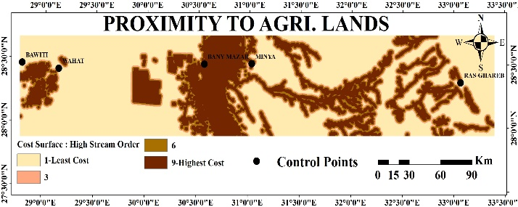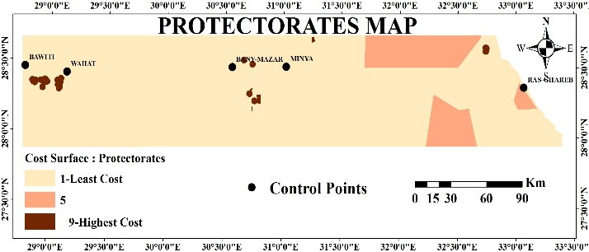

**(a)**

**(b)**

**(d)**

**(c)**

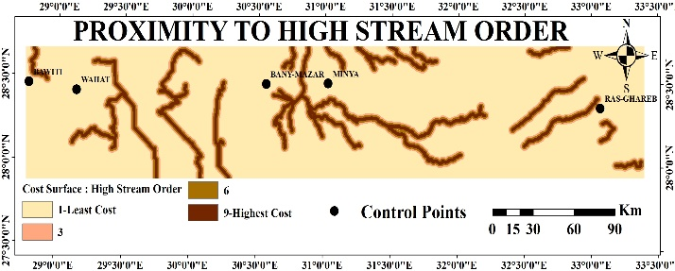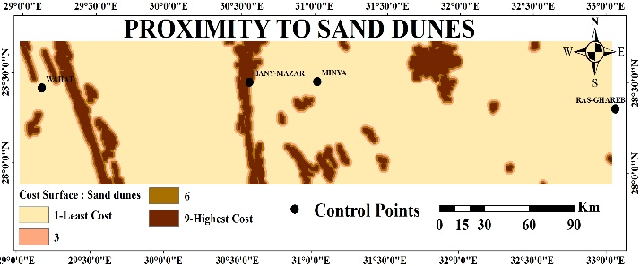

**Figure 8:** Standardized Environmental Maps. (a) Cost of proximity to agricultural land. (b) Cost of proximity to streams. (c) Cost of protectorates. (d) Cost of proximity to sand dunes.

* + 1. *Weighting*

The estimation of relative weights to each criterion is a major step in evaluating the decision-making process. The weighting of the criteria can be determined as a value assigned to the evaluation criteria that determine their priority for other considered criteria. A specific weight must be determined between all the criteria factors in each alternative because they have different priorities according to the goals and objectives. AHP method is a powerful method in determining weights by comparing each factor with another corresponding, which is better to have a relative weight than to give absolute weight without any comparison [16]. The AHP evaluation was developed in three steps:

The first step is to develop the matrices comparison matrix. The team of experts for this study (and questionnaire) was the basis for determining the relative importance of the selected criteria using the Saaty scale. The second step is to normalize the advanced pairing matrix from the previous comparisons; the final step is calculating the weight of each factor, which considered in calculating eigenvector of the comparison matrix [17]. The weighting method can be calculated as illustrated briefly in the full example in Table (5) and Table (7) which shows full calculation step for the economy and the environmental objectives. Firstly, the factors compared to each other. The next step is to define each attribute factor weight. This factor is the principle Eigenvectors of the resulted matrix from multiplying the pairwise matrix itself. This will be followed by obtaining each row sum and normalizing it by the sum of all rows to finally yield the actual factor weight for each attribute.

**Table 5:** AHP Weighting full example: Economy Weighting

|  |  |  |  |  |  |  |
| --- | --- | --- | --- | --- | --- | --- |
| *Pairwise comparisons* | | | | | | |
| **Factors** | **Slope** | **Land use** | **Faults** | **Rock Type** | **Stream** | **Sand dunes** |
| **Slope** | 1 | 9/7 | 9/3 | 9/5 | 9/4 | 9/3 |
| **Land use** | 7/9 | 1 | 7/3 | 7/5 | 7/4 | 7/3 |
| **Faults** | 3/9 | 3/7 | 1 | 3/5 | 3/4 | 3/3 |
| **Rock Type** | 5/9 | 5/7 | 5/3 | 1 | 5/4 | 5/3 |
| **Stream** | 4/9 | 4/7 | 4/3 | 4/5 | 1 | 4/3 |
| **Sand dunes** | 3/9 | 3/7 | 3/3 | 3/5 | 3/4 | 1 |
| **SUM** | 3.68 | 4.43 | 10.33 | 6.20 | 7.75 | 10.33 |

Based on [8],[1]By summing each column and then dividing each cell with its column sum, the normalized decision matrix can be derived. The weight of each layer is equal to the average of the sum of row elements. Before using the weights, the decision maker’s preferences need to be checked to test their consistency. The eigenvector of the evaluation matrix is calculated by multiplying the weights of each layer with the original decision matrix and summing the values over the rows, then dividing the sum of each row by the weight of the corresponding layer. Consistency Index (𝐶𝐼) is computed by subtracting the number of criteria (n) from 𝜆𝑚𝑎𝑥 and dividing the result with (n-1). Consistency Ratio (𝐶𝑅) is equal to the division of the Consistency Index (𝐶𝐼) by the Random Index (𝑅𝐼). 𝐶𝑅 is less than 0.10 as shown in Table (6) and Table (8).

**Table 6:** Normalized pairwise AHP comparison matrix and relative weights

|  |  |  |  |  |  |  |  |
| --- | --- | --- | --- | --- | --- | --- | --- |
| **Factors** | **Slope** | **Land use** | **Faults** | **Rock Type** | **Stream** | **Dunes** | **Weighting** |
| **Slope** | 0.27 | 0.29 | 0.29 | 0.29 | 0.29 | 0.29 | 28.7 |
| **Land use** | 0.21 | 0.23 | 0.23 | 0.23 | 0.23 | 0.23 | 22.3 |
| **Faults** | 0.09 | 0.10 | 0.10 | 0.10 | 0.10 | 0.10 | 9.6 |
| **Rock Type** | 0.15 | 0.16 | 0.16 | 0.16 | 0.16 | 0.16 | 16 |
| **Stream** | 0.12 | 0.13 | 0.13 | 0.13 | 0.13 | 0.13 | 12.8 |
| **Dunes** | 0.16 | 0.10 | 0.10 | 0.10 | 0.10 | 0.10 | 10.7 |
| **SUM** |  | | | | | | 100% |

**Table 7:** AHP Weighting for environmental vision

|  |  |  |  |  |
| --- | --- | --- | --- | --- |
| ***Pairwise comparisons*** | | | | |
| **Factors** | **Proximity to** | | | **Protectorates** |
| **Stream** | **Dunes** | **Agriculture** |
| **Proximity to Stream** | 1 | 5/3 | 5/5 | 5/7 |
| **Proximity to Sand dunes** | 3/5 | 1 | 3/5 | 3/7 |
| **Proximity to Agriculture** | 5/5 | 5/3 | 1 | 5/7 |
| **Protectorates** | 7/5 | 7/3 | 7/5 | 1 |
| **SUM** | 4 | 6.67 | 4 | 2.86 |

**Table 8:** Normalized pairwise AHP comparison matrix and relative weights

|  |  |  |  |  |  |
| --- | --- | --- | --- | --- | --- |
| **Factors** | **Proximity to** | | | **Protectorates** | **Weighting** |
| **Stream** | **Dunes** | **Agriculture** |
| **Proximity to Stream** | 0.25 | 0.25 | 0.25 | 0.25 | 25.0% |
| **Proximity to dunes** | 0.15 | 0.15 | 0.15 | 0.15 | 15.0% |
| **Proximity to Agriculture** | 0.25 | 0.25 | 0.25 | 0.25 | 25.0% |
| **Protectorates** | 0.35 | 0.35 | 0.35 | 0.35 | 35.0% |
| **SUM** |  | | | | 100% |

* + 1. *Creating a suitability cost surface and modeling for highway route selection*

After creating cost surfaces, we need to calculate how suitable cell, is to travel through, or how much it will cost to travel through each cell. A spatial Multi-Criteria Evaluation Model was conducted using the Esri ArcGIS Model Builder and based on Equation 1 [3].

Suitability cost surface = ∑ [cost surface (Cn) * weight (Wn)] Equation 1

Where: Cn – characterize raster cell,

Wn–weight derived from AHP pairwise comparison

The output cost maps related to the two alternatives used in this research are presented in Figure (9).

**(b)**

**(a)**

**Figure 9:** Weighted maps. (a) Economy Theme. (b) Environmental Theme. ( ArcGIS map ver. 10.2)

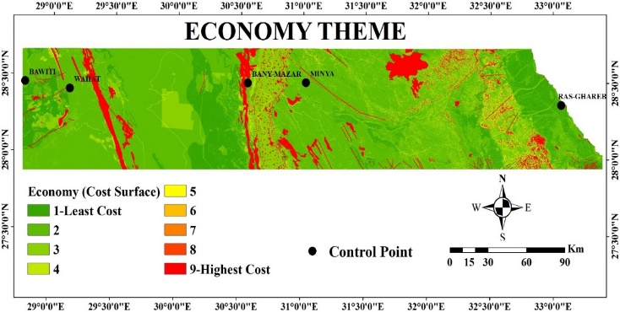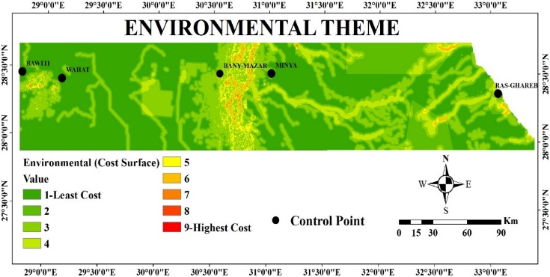

Using the suitability cost surface, cost distance and cost path process the LCP were modeled. The accumulated cost of traveling from any destination back to the origin was calculated using the suitability and cost surface. The last process calculated paths through the landscape from the destination stations along the least costly path back to the starting station.

1. **Results and Discussion**

In highway alignment projects, several alternatives with different priorities should be investigated in order to obtain a broader overview output result. In terms of choosing the best path, these alternatives are identified along with the corresponding relative weights mainly by experts and decision makers. In this research, the four alternatives and their weights are discussed in Table (9). The corresponding output result for the final suitable path for each case is illustrated in Figure (10). The final cost surface maps and LCP maps for the four visions were obtained using the ArcGIS sum Weight Tool.

|  |  |  |
| --- | --- | --- |
| **Research Case** | **Alternatives** | |
| **Economy** | **Environmental** |
| **I- Economy Vision** | 0.7 | 0.3 |
| **II- Environmental Vision** | 0.3 | 0.7 |
| **III- Equal Vision** | 0.5 | 0.5 |
| **IV – Economy Only Vision** | 1.0 | 0 |

**Table 9:** Assigned Weights for Multiple Research Cases

* 1. ***Comparison of the four routes alternatives for Minya Ras-Ghareb Road***

**(b)**

**(d)**

**(c)**

**(a)**

**Figure 10:** Final Suitability Paths. (a) Economy vision. (b) Environmental vision. (c) Equal vision.

(d) Economy only vision.

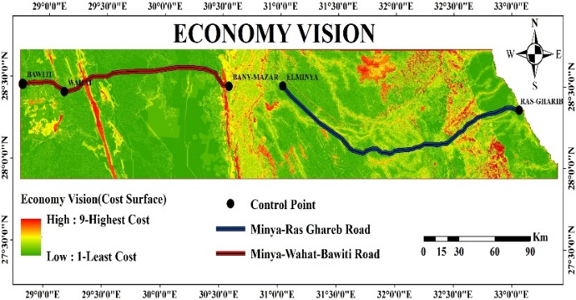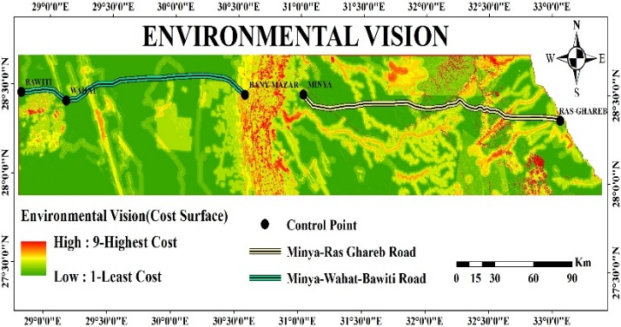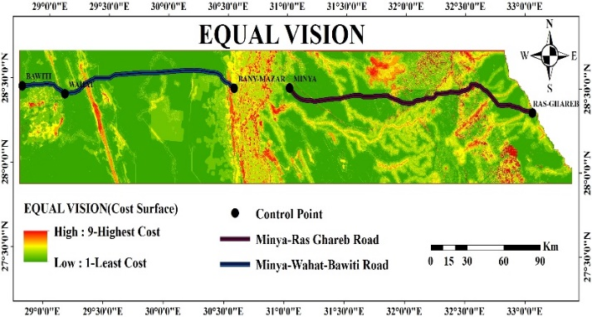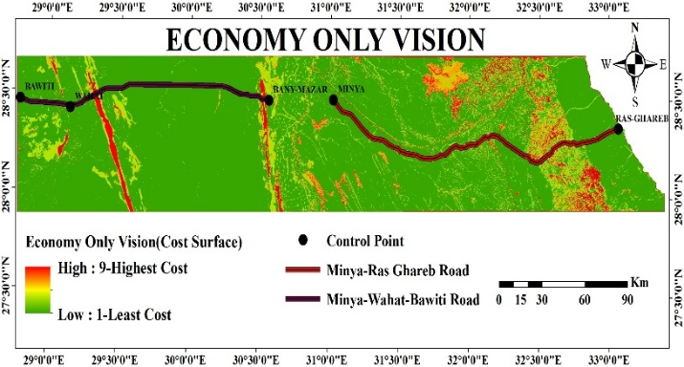

The comparison contains seven main evaluation criteria; slope, rock type, stream network, fault zones, protectorates, and route length, which describes the main two aspects (economy, environment).

The evaluation criteria for optimum project cost implies that the preferred path should minimize road construction, minimizing route length through the steep slope > 15%; minimizing route length in rock areas to avoiding cuts in the rocks; minimizing route length intersecting stream networks, minimizing route length intersecting faults, minimizing the route length. For the pollution aspect, the path should maintain a distance from the stream and protectorates areas. All these conditions were investigated to reach the best path among all output cases, as listed in Table (10).

**Table 10:** Different Criterion Based on Multiple Research Cases

|  |  |  |  |  |
| --- | --- | --- | --- | --- |
| Attribute | MCDA-Case Research | | | |
| Economy | Environmental | Equal | Economy Only |
| Slope Crossing (>15%) (m) | 4,448 | 16,018 | 6,887 | 2,094 |
| Basement Rock Crossing (m) | 15,950 | 25,792 | 6,556 | 11,019 |
| Length of road(m) crossing Stream buffer zone 300m | 1911 | 1004 | 907 | 3,739 |
| Length of road(m) crossing fault buffer zone 500m | 0 | 1,267 | 675 | 440 |
| Proximity to stream | 16417 | 10,111 | 9,349 | 124,664 |
| Protectorates Crossing (m) | 29,799 | 3,059 | 3,348 | 30,738 |
| Route Length(m) | 225,017 | 209,322 | 216,078 | 226,285 |

A DEFINITE software was used for the comparisons investigated to reach the best path among all output cases[18]. A spatial cost is defined as a criterion that contributes negatively to the output; the lower the value, the higher it's. it's an advantage for the spatial cost to be low [1].

The effects of the relative weights were calculated using a pairwise comparison matrix (9) (a value above 0.1 is an indication of inconsistencies in the pairwise comparison tab; inconsistency value is 0.08 for the weights calculation). Figure (11) shown a simple graph for the result of the multi-criteria evaluation using the effect table and the calculated weights. On the X-axis are all alternatives, and on the Y-axis the value of the ranking. The bar length indicates a preference for the alternative, where higher bars correspond to better alternatives.

**Table 11:** Weights of the evaluation criteria using pairwise comparison matrix

|  |  |  |  |  |  |  |  |  |
| --- | --- | --- | --- | --- | --- | --- | --- | --- |
| **Criteria** | **Slope Crossing** | **Rock Crossing** | **Stream Crossing** | **Faults** | **Prox. to Stream** | **Prot. Crossing** | **Route Length** | **Weight** |
|
| **Slope Crossing>15%** | 1 | 1.8 | 2.25 | 3 | 2.25 | 1.5 | 2.25 | 0.25 |
| **Rock Crossing** | 0.56 | 1 | 1.25 | 1.67 | 1.25 | 0.83 | 1.25 | 0.14 |
| **Stream Crossing** | 0.44 | 0.8 | 1 | 1.33 | 1 | 0.67 | 1 | 0.11 |
| **Faults** | 0.33 | 0.6 | 0.75 | 1 | 0.75 | 0.5 | 0.75 | 0.08 |
| **Proximity to Stream** | 0.44 | 0.8 | 1 | 1.33 | 1 | 0.67 | 1 | 0.11 |
| **Protectorates Crossing** | 0.8 | 1.2 | 1.5 | 2 | 1.5 | 1 | 1.5 | 0.17 |
| **Route Length** | 1 | 0.8 | 1 | 1.33 | 1 | 0.67 | 1 | 0.13 |

The ranking for each cost criteria was explained as follows:

* According to the criterion of ‘‘cost of steep slope crossing >15%’’ the economy only route scores best (0.87). The economy route is ranked the second best. The equal route is ranked the third best. The environmental route ranks the last.

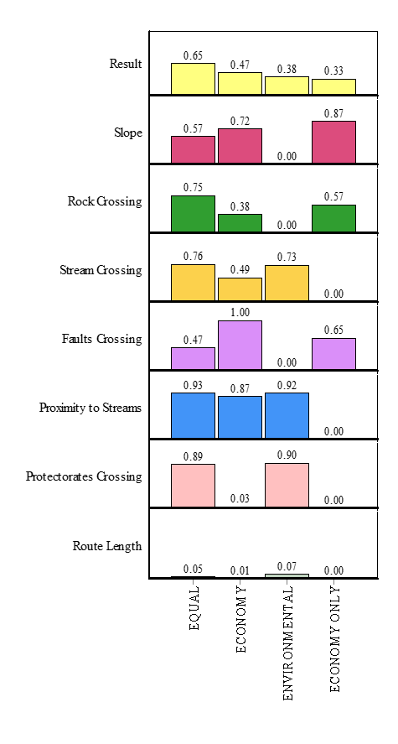

**Figure 11:** Analysis of testing the weights of the evaluation criteria on ranking of the three route alternatives using DEFINITE software

* For the criterion of ‘‘cost of rocks crossing’’ the equal route scores best (0.75). The economy only route ranks the second best. The economy route and the environmental route rank the last
* For the criterion of ‘‘cost of stream crossing’’ the equal-weight route scores best (0.76). The environmental route ranks the second best. The economy route ranks the third best. The economy the only route ranks the last.
* For the criterion of ‘‘cost of faults crossing’’ the economy route scores best (1.0). The economy only route ranks the second best. The equal route ranks the third best and the environmental route ranks the last.
* For the criterion of ‘‘proximity to stream’’ The equal route scores best (0.93), the environmental route only ranks the second best. The economy route ranks the third best. The economy only route ranks the last.
* For the criterion of ‘‘protectorates crossing’’ the environmental route scores best (0.90). The equal route ranks the second best, the economy route ranks the third best. The economy the only route ranks the last.
* For the criterion of ‘‘Route Length’’ the environmental route scores best (0.07). The equal route ranks the second best, the economy route ranks the third best. The economy only route ranks the last one.

A multi-criteria evaluation resulted in ranking the equal-weights route as first (0.65) as shown in Figure (11). The economy route alternative ranks second (0.47). The environmental route alternative ranks third (0.38) while, the economy only route alternative ranks last one (0.33).

* 1. ***Comparison of the Equal Route with Existing Route for Minya-Ras Ghareb Road***

Accordingly, for employing the results in the evaluation of the current status, a further assessment and comparison between the modeled and the existing roads were conducted as shown in Figure (12). This assessment is based on the evaluation criteria as depicted in Figure (13) and Table (12).

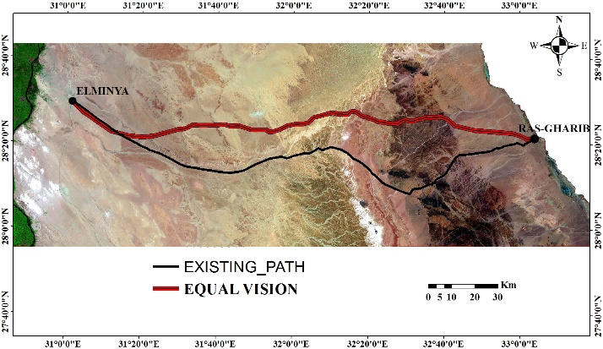

**Figure 12:** Equal Vs Existing Road Path Minya-Ras Ghareb Road) using ArcGIS map (ver.10.2)

**Table 12:** Comparison among Road Specifications

regarding Different

|  |  |  |
| --- | --- | --- |
| **Attribute** | **Comparison** | |
| **Equal** | **Existing** |
| **Rock Crossing(m)** | 6,556 | 17,816 |
| **Stream Crossing(m)** | 907 | 43,785 |
| **Faults Crossing(m)** | 675 | 898 |
| **Route Length(m)** | 216,078 | 224,000 |



**Figure 13:** Analysis of testing the weights of the evaluation criteria on ranking of the Equal Vs Existing Road Path using DEFINITE software

From Table (12), and Figure (13), the equal alternative satisfies most of the selected criteria factors concerning the least cost path. This leads to a significant reduction in the total cost when compared with the existing one, concerning the route length, which is shorter by nearly 8 km. For the rock crossing criterion, the equal path scores about 63 %. For “Faults crossing” criterion, the equal path scores about 32%. While, for “stream crossing” the equal path scores about 98%. A multicriteria evaluation resulted in ranking the equal-weight route the first. Such route costs less by 48 % than the existing road. In addition, the equal-weights path is more protected from environmental hazards such as high stream order, which is not given sufficient importance in choosing the path of the existing road. Neglecting such environmental factors may lead to the destruction of the road. Example of which, is the October 2016 flood event which caused the destruction of Minya –Ras Ghareb road.

* 1. ***Comparison of the four routes alternatives for Minya-Wahat - Bawiti Road***

By the same methodology mentioned in section 4.1. All conditions were investigated to reach the best path among all output cases, as listed in Table (13). Also, the effects of the relative weights were calculated using a pairwise comparison matrix in Table (14)

**Table 13:** Different Criterion Based on Multiple Research Cases

|  |  |  |  |  |
| --- | --- | --- | --- | --- |
| **Attribute** | **MCDA-Case Research** | | | |
| **Economy** | **Environmental** | **Equal** | **Economy Only** |
| **Slope Crossing >15%) (m)** | 485 | 641 | 461 | 402 |
| **Rock Crossing(m)** | 6,705 | 7,314 | 7,132 | 6,700 |
| **Stream Crossing(m)** | 784 | 784 | 784 | 984 |
| **Faults Crossing(m)** | 0 | 503 | 0 | 0 |
| **Proximity to stream** | 11,540 | 11,950 | 11,561 | 9,129 |
| **Proximity to Agriculture land(m)** | 12,308 | 4,171 | 5,478 | 67,757 |
| **Sand dunes Crossing (m)** | 7,199 | 8,156 | 7,530 | 7,335 |
| **Route Length(m)** | 185,246 | 183,882 | 184,597 | 180,206 |

**Table 14** Weights of the evaluation criteria using pairwise comparison matrix

|  |  |  |  |  |  |  |  |  |  |
| --- | --- | --- | --- | --- | --- | --- | --- | --- | --- |
| **Factors** | **Slope** | **Rock Crossing** | **Stream Crossing** | **Faults Crossing** | **Prox. to Stream** | **Prox. to agri. land** | **Sand dunes Crossing** | **Route Length** | **Weight** |
| **Slope** | 1.00 | 1.80 | 2.25 | 3.00 | 2.25 | 1.29 | 3.00 | 2.25 | 0.22 |
| **Rock Crossing** | 0.56 | 1.00 | 1.25 | 1.67 | 1.25 | 0.71 | 1.67 | 1.25 | 0.12 |
| **Stream Crossing** | 0.44 | 0.80 | 1.00 | 1.33 | 1.00 | 0.57 | 1.33 | 1.00 | 0.10 |
| **Faults Crossing** | 0.33 | 0.60 | 0.75 | 1.00 | 0.75 | 0.57 | 1.00 | 0.75 | 0.08 |
| **Prox. to Streams** | 0.44 | 0.80 | 1.00 | 1.33 | 1.00 | 0.57 | 1.33 | 1.00 | 0.10 |
| **Proximity to agri. land** | 0.80 | 1.40 | 1.75 | 1.75 | 1.75 | 1.00 | 2.33 | 1.75 | 0.17 |
| **Sand dunes Crossing** | 1.00 | 0.60 | 0.75 | 1.00 | 0.75 | 0.43 | 1.00 | 0.75 | 0.09 |
| **Route Length** | 1.33 | 0.80 | 1.00 | 1.33 | 1.00 | 0.57 | 1.33 | 1.00 | 0.12 |

Figure (14) shown a simple graph for the result of the multi-criteria evaluation using the effect table (13) and the calculated weights table (14).

The ranking for each cost criteria was explained as follows:

* According to the criterion of ‘‘cost of steep slope crossing >15%’’ the economy only route scores best (0.37). The equal route ranks the second best. The economy route ranks the third best. While, the environmental route ranks the last.
* For the criterion of ‘‘cost of rocks crossing’’ the economy route and the economy only score best (0.08). While, the equal route ranks the third and the environmental route rank the last.
* For the criterion of ‘‘cost of stream crossing’’ the economy, the equal and the environmental routes scores best (0.2), the economy only route ranks the last.
* For the criterion of ‘‘cost of faults crossing’’ the economy only route, the economy and the equal routes scores best (1), and the environmental route ranks the last.
* For the criterion of ‘‘proximity to stream’’ The economy route, the environmental route, and the equal route scores best (0.88), the economy the only route ranks the last.

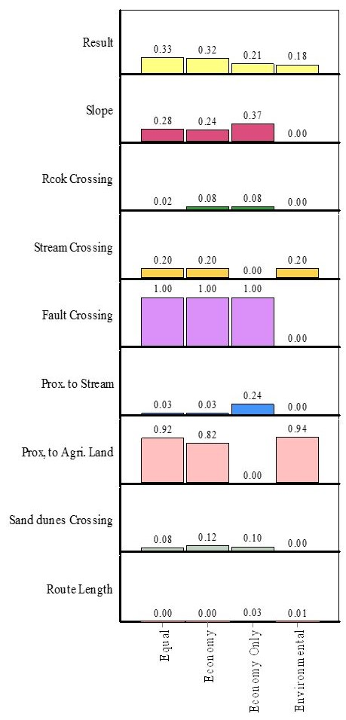

**Figure 14:** Analysis of testing the weights of the evaluation criteria on ranking of the three route alternatives using DEFINITE software

* For the criterion of ‘‘protectorates crossing’’ the environmental route, and the equal route scores best (0.89), the economy route ranks the second best, the economy the only route ranks the last.
* For the criterion of ‘‘Route Length’’ the environmental route, and the equal route scores best (0.05), the economy route ranks the second best, the economy the only route ranks the last.

A multi-criteria evaluation resulted in ranking the equal route as first (0.33) as shown in Figure (14). The economy route alternative ranks second (0.32). The economy only routes alternative ranks third (0.21). While, the environmental route alternatives rank last one (0.18).

* 1. ***Comparison of the Equal Route with Existing Route for Minya-Wahat-Bawiti Road***

Furthermore, for convenience and completeness, where this research focuses on finding the best path as an alternative or comparison to an old road, there was another assessment of the output pathways. This assessment is based on the evaluation of all research cases to be compared to the existing path, with respect to all available features as shown in Figure (15). Both Figure (16) and Table (15) investigate this assessment the equal alternative.

**Table15** Comparison among Road Specifications

regarding Different

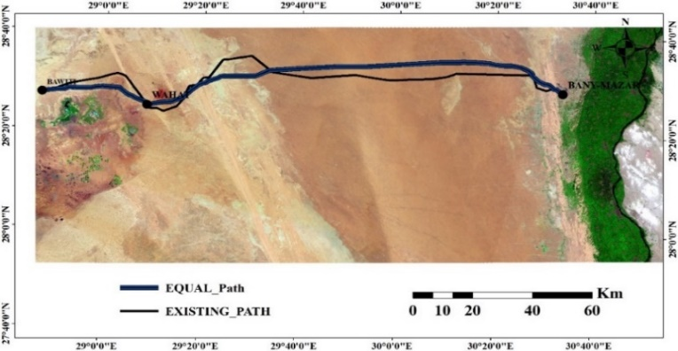

**Figure 15:** Equal Vs Existing Road Path Minya-Wahat-Bawiti Road) using ArcGIS map (ver.10.2)

|  |  |  |
| --- | --- | --- |
| **Attribute** | **Comparison** | |
| **Equal** | **Existing** |
| **Slope Crossing (>15%) (m)** | 461 | 318 |
| **Rock Crossing(m)** | 7,132 | 12,553 |
| **Stream Crossing(m)** | 784 | 1,473 |
| **Faults Crossing(m)** | 0 | 1,621 |
| **Proximity to stream** | 11,561 | 16,118 |
| **Proximity to Agriculture land(m)** | 5,478 | 44,948 |
| **Sand dunes Crossing (m)** | 7,530 | 13,479 |
| **Route Length(m)** | 184,597 | 197,988 |

at the end of the paper, and numbered

**Acknowledgements**

These and the Reference headings are in bold. Text below continues as normal.

From Table 15, and Figure 16, the equal alternative satisfies most of the adopted criteria factors concerning short path selection. This leads to a significant reduction in the total cost when compared with the existing one, concerning the route length, which is shorter by nearly 13.39 km; with regarding “rock crossing” the equal path saving about 43%, while, with regarding “Faults crossing” the equal path saving about 100%, and with regarding “stream crossing” the equal path saving about 47%.

A multi-criteria evaluation resulted in ranking the equal route saving about 33 % than the existing road.

1. **Conclusions and recommendations**

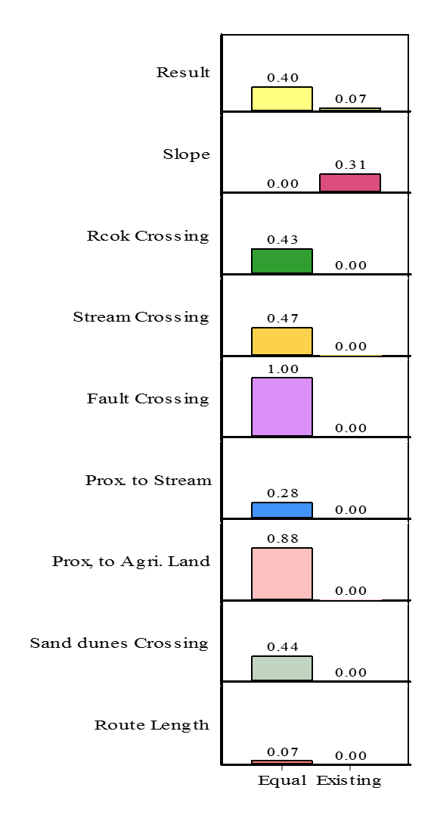

**Figure 16:** Analysis of testing the weights of the evaluation criteria on ranking of the Equal Vs Existing Road using DEFINITE software

This research focused on the use of RS and GIS based multi criteria decision analysis to design a model for optimal path selection, based on all possible criteria alternatives with corresponding factor weights.

The use of remotely sensed data integrated with spatial multi-criteria evaluation in this research proved the high ability to scan a very large area within less time consuming and less cost. Thus, extracting an updated land use map that is used in many environmental, spatial, planning and spatial modeling issues.

In addition, RS and GIS based- MCDA make the highway alignment most appropriate avoiding vulnerable high-risk zones such as sand dunes, stream crossing, fault zones, etc….in addition to considering environmental protection constraints and cost savings. It needs less manpower, less time consuming and less cost. As well as the possibility of applying this methodology to any linear infrastructure after some minor adjustments.

The environmental factors should be given high weight because of their very high impact on the road. This effect may lead to the destruction of the entire road, such as what happened in Minya Ras Ghareb road as a result of the floods. Also, in Minya-Wahat road which covered with high sand dunes.

Utilizing this model, a designer can rapidly assess alternative alignments and locate the best path with least total road cost. Further detailed studies are recommended for using LCP in route planning and field investigations are a necessity prior to the final decision making. Some improvements in the route design are required to satisfy more detailed development criteria. The resolution and currency of data directly affect the accuracy of the outputs. The DEM layer will be generated from LiDAR data, which will be high resolution and contemporary. The DEM will be more sensitive on the small elevation changes.

**References**

[1] H. A. Effat and O. A. Hassan, “Designing and evaluation of three alternatives highway routes using the Analytical Hierarchy Process and the least-cost path analysis, application in Sinai Peninsula, Egypt,” *Egypt. J. Remote Sens. Sp. Sci.*, vol. 16, no. 2, pp. 141–151, 2013.

[2] E. Basheer and S. Dawwas, “GIS as a Tool for Route Location and Highway Alignment,” 2005.

[3] A. Djenaliev, “Multi-criteria decision making and GIS for railroad planning in Kyrgyzstan,” 2007.

[4] S. Bagli, D. Geneletti, and F. Orsi, “Routeing of power lines through least-cost path analysis and multicriteria evaluation to minimise environmental impacts,” *Environ. Impact Assess. Rev.*, vol. 31, no. 3, pp. 234–239, 2011.

[5] E. ArcGIS, “Version 10,” *Redlands ESRI*, 2010.

[6] A. Laskar, “Integrating GIS and multicriteria decision making techniques for land resource planning,” 2003.

[7] J. Malczewski, *GIS and multicriteria decision analysis*. John Wiley & Sons, 1999.

[8] T. L. Saaty, “The Analytic Hierarchy Process. McGraw-Hill, New York, NY.,” 1980.

[9] S. C. Feldman, R. E. Pelletier, E. Waker, J. C. Smoot, and D. Ahl, “A Prototype for Pipeline Routing Using Remotely Sensed Data and Geographic Information System Analysis Commercial Remote Sensing Of&amp;e, Stennis Space Cen- ter, Mississippi *Lockheed Stennis Operations, Stennis Space Center, Mississippi,” vol. 53, pp. 123–131, 1995.

[10] S. Sadek, M. Bedran, and I. Kaysi, “GIS Platform for Multicriteria Evaluation of Route Alignments,” *J. Transp. Eng.*, vol. 125, no. 2, pp. 144–151, Mar. 1999.

[11] K. Bailey, “Development and application of a GIS/ multi-criteria corridor evaluation methodology,” 2003.

[12] E. Saha, A. K., Arora, M. K., Gupta, R. P., Virdi, M. L., and Csaplovics, “‘GIS-Based route planning in landslide-prone areas.,’” *Int. J. Geogr. Inf. Sci.*, vol. 19, 2005.

[13] V. Yildirim, “Development of a raster based dynamic model with geographical information system for the determination of natural gas transmission pipelines.” PhD thesis, Karadeniz Technical University, Trabzon, Turkey, 2009.

[14] M. Diefallah, A. Ragab, A. Ragheb, and A. Abdelkarim, “A Case Study for Best Path Selection Using Integrated GIS-Multicriteria Decision Approach,” *Surv. L. Inf. Sci.*, vol. 76, no. 2, pp. 83–96, 2017.

[15] U. Abdelaziz, “Rural highway alignment selection by implementation of a gis methodology and multi-criteria decision making,” 2013.

[16] I. Shaker, H. Effat, A. Ragab, and A. Hamdy, “Multi Criteria Geographic Information System Analysis for Sustainable Development in North Sinai - EGYPT,” vol. 6, no. 4, pp. 141–155, 2016.

[17] E. Triantaphyllou and S. H. Mann, “Using the Analytic Hierarchy Process for Decision Making in Engineering Applications : Some Challenges,” *Inter’l J. Ind. Eng. Appl. Pract.*, vol. 2, no. 1, pp. 35–44, 1995.

[18] Janssen, R., Herwijnen, M., “Decision Support for Discrete Choice Problems: The Definite Programs. Institute of Environmental Studies. Vrije Universiteit, Amsterdam, The Netherlands (Email: DEFINITE@ivm.vu.nl).,” 1994.