Characterization of Lateritic Banka Gravelous (West Cameroon) for their use in Road Geotechnical.

KEYANGUE TCHOUATA Jules Hermann, Ecole de Géologie et d’Exploitation Minière (EGEM), Université de Ngaoundéré P.O.Box 115 Meiganga Cameroun, e-mail : keytchjmann@yahoo.fr
GOUAFO Casimir, Institut Universitaire Fotso Victor de l’Université de Dschang P.O.Box 134 Bandjoun Cameroun, e-mail : casimirgouafo@yahoo.fr, Laboratoire d’Ingénierie des Système et de l’Environnement (LISIE) IUT/FV, Bandjoun Université de Dschang, Cameroun

NGAPGUE François , Institut Universitaire Fotso Victor de l’Université de Dschang P.O.Box 134 Bandjoun Cameroun, e-mail, Université de Dschang, Cameroun
DJAMBOU-TCHIADJEU Cédric, Ecole de Géologie et d’Exploitation Minière (EGEM), Université de Ngaoundéré P.O.Box 115 Meiganga Cameroun, e-mail :

KAMDJO Grégoire, Institut Universitaire Fotso Victor de l’Université de Dschang P.O.Box 134 Bandjoun Cameroun, e-mail : kamdjog@yahoo.fr, Laboratoire d’Ingénierie des Système et de l’Environnement (LISIE) IUT/FV Bandjoun, Université de Dschang, Cameroun

Abstract

In Cameroon, as in most tropical countries, the use of lateritic gravel in road construction is of great interest because of its abundance. The locality of Banka located in the department of Haut-Nkam (West-Cameroon) abounds several lateritic zones with little known characteristics. These lateritic materials are however very popular in the locality for their main use in the periodic maintenance of unpaved roads. The geotechnical identification tests carried out on 18 samples taken from the Banfeko, Bakoye and Ketcho sites have shown that the density values of the solid grains are greater than 2.57 g / cm³. The values of the plasticity indices are between 17.89 and 25.38 and those of consistency between 1,56 and 2.12 for these gravelly lateritic plastic consistency to firm.
Granulometric analysis shows that the fines are less than 35%. The optimum water content values for compaction with modified Proctor energy are between 11% and 14% and those for dry optimum densities around 2.1. The values of the CBR lift index are between 31 and 51.92. These soils are subclass B6 according to the GTR and subclasses A-2-7 (1) and A-2-7 (2) according to the HRB.
The particle size curves of the various samples analyzed are relatively well inscribed in the reference spindles of the materials recommended by the CEBTP for the road construction as a base course and as a base layer for these soils of the S5 lift class. But their use as a base layer requires an improvement of the bearing capacity, because the value of the CBR remains less than 80 to 95% of the modified Proctor optimum
Key words: lateritic gravelly, granulometry, CBR lift index, Banfeko, Bakoye, Ketcho.
.

Introduction

Lateritic soils are important materials, in the road building industry in the tropics. In Cameroon, this abundant resource covers about 70% of the national territory (SIKALI et al., 1986). It is important, however, to use it rationally to increase yields, in economic investments, on the one hand, and to preserve this natural, yet non-renewable resource on the other. The fact is that we observe in this country, a rapid deterioration of roads, due either to a lack of implementation, or to a lack of quality of materials, or to a particular local condition, which leads into one or the other case, overconsumption of lateritic materials. This article is particularly interested in the geotechnical properties of lateritic soils used for road embankments. The main objective of this work is to determine, the physical characteristics of the lateritic soils of the locality of Banka, with a view to a better use, in building works, and public works. This work will allow to create a database of use of this heritage of development, and how to improve this material.
2. Location and sampling
2.1. Location

Administratively, the district of Banka is located in the Department of Upper Nkam, region of West Cameroon. It covers an area of 203 km². Figure 1 shows the location of the different study sites.

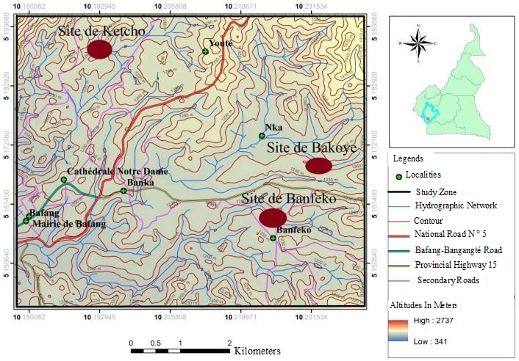
Extract from the Geological Map of Cameroon, 1972
Figure 1: Site Map of Sites in the Study Area

2.2. Sampling
In order to minimize, the errors of various origins, which can influence the results, the sampling was made, in several successive stages, in the different zones, selected for the study
:
- - In situ, the extent of each loan, was determined by the technique of the double step, so that of Banfeko, extends over nearly 30 000 m2, that of Bakoye, about 28 700 m2, and that of from Kocho, about 29,140 m2. In view of these results, it was considered that these different borrowings, have almost the same extent, and identical meshes, 100 m x 90 m, were made.
- Then, 18 sampling points, were determined, at the rate of 06 points per loan. Using a conventional pick, shovel, and polystyrene bags, representative samples were collected, and tagged; overall, the sampling was done in such a way that, the resulting soil, a mixture in which, blocks with a maximum diameter greater than 50 mm, were discarded, with reference to the standard criteria of (Ghogue, 2009 ).
Table 1 accurately shows GPS coordinates, central points, sample sites, or sample collection loan.

Table 1: GPS coordinates of the central points of the sampling sites
Sites  sampling | N | E | Average altitude (m) | Number  samples
Banfeko | 05.15955 | 10.22198 | 1315 | 6
Bakoye | 05.16220 | 10.23300 | 1258 | 6
Ketcho | 05.18620 | 10.20115 | 1282 | 6
Total |  |  |  | 18

Experimental method

After the sampling campaign, in the field, the samples were analyzed at the laboratory of Sol Solution Central Africa in Cameroon. Following laboratory analyzes, the results obtained were processed using software, Microsoft Word and Excel. Laboratory tests include natural moisture content, particle size analysis, density, Modified Proctor assay, CBR assay and Atterberg limits.
The natural water content, was determined by successive weighings before and after sample stoving at 105 ° C according to the standard (NF P 94-050, 1995).

The actual density has been obtained through the determination of the density of the solid particles of a soil. It was determined, by the hydrostatic weighing method, according to the standard (NF P 94-058, 1993). The particle size analysis was carried out by sieving, according to the standard (NF P 94-056, 1996).
The determination of the optimum moisture content, and the maximum dry density of the soil, was made by the modified Proctor test. This test was carried out in accordance with the standard (NF P 94-093, 1999). The CBR lift index and the linear swelling were determined according to the requirements of the standard (NF P 94-078, 1997). The liquidity and plasticity limits were determined according to the standard (NF P 94-051, 1995). The indices of consistency and plasticity were calculated from the mathematical relationships that exist between the limits of liquidity and plasticity.

3. Results and discussion
Table 3 presents the results of the physical parameters of the samples studied.
Table 3: Summary of results of natural water contents, Atterberg limits and solid grain density and their average debt values.

Sites  and  Average | number of wells | Depth (cm) | Water content  W (%) | ρ_{s}  (g/cm³) | Particle size analysis |  |  |  | Atterberg limits
 |  |  |  |  | Dmax  (mm) | 0,08 mm  (%) | 0,5 mm  (%) | 2  mm  (%) | W_{L}  (%) | I_{P}  (%) | I_{C}
Banfeko | P₁ | 133 | 22.66 | 2.614 | 31.5 | 19.8 | 36.6 | 37.8 | 63.8 | 13.15 | 3.12
Banfeko | P₂ | 128 | 25.74 | 2.770 | 40 | 30.8 | 32.2 | 35.2 | 65.35 | 21.35 | 1.85
Banfeko | P₃ | 131 | 21.30 | 2.738 | 31.5 | 23.9 | 24.6 | 27.5 | 58.60 | 17.00 | 2.19
Banfeko | P₄ | 129 | 23.62 | 2.572 | 31.5 | 16.7 | 18.9 | 20.9 | 55.30 | 16.5 | 1.90
Banfeko | P₅ | 130 | 21.34 | 2.670 | 40 | 26.8 | 27.0 | 35.2 | 53.30 | 14.25 | 2.24
Banfeko | P₆ | 129 | 22.41 | 2.674 | 31.5 | 35.6 | 21.0 | 27.0 | 57.60 | 25.10 | 1.40
Average |  | 130 | 22.84 | 2.673 | 34.3 | 25.6 | 26.7 | 30.6 | 58.99 | 17.89 | 2.12
Bakoye | P₇ | 122 | 25.53 | 2.682 | 40 | 29.3 | 30.0 | 32.7 | 71.52 | 19.87 | 2.31
Bakoye | P₈ | 120 | 25.81 | 2.646 | 40 | 31.0 | 32.0 | 36.1 | 84.1 | 30.58 | 2.66
Bakoye | P₉ | 118 | 19.59 | 2.617 | 31.5 | 22.2 | 24.7 | 37.4 | 74.20 | 22.05 | 2.47
Bakoye | P₁₀ | 123 | 25.22 | 2.599 | 31.5 | 27.5 | 27.9 | 29.2 | 57.70 | 15.15 | 2.14
Bakoye | P₁₁ | 121 | 23.58 | 2.632 | 31.5 | 26.3 | 36.1 | 44.4 | 52.00 | 23.70 | 1.35
Bakoye | P₁₂ | 118 | 24.46 | 2.64 | 31.5 | 17.3 | 25.0 | 35.8 | 57.50 | 18.50 | 1.75
Average |  | 120 | 23.04 | 2.636 | 34.3 | 25.6 | 29.3 | 35.9 | 66.17 | 21.64 | 2.11
Ketcho | P₁₃ | 131 | 30.13 | 2.749 | 31.5 | 22.3 | 23.6 | 46.1 | 70.6 | 27.74 | 1.45
Ketcho | P₁₄ | 130 | 25.31 | 2.644 | 31.5 | 18.7 | 24.5 | 40.2 | 76.45 | 27.05 | 1.89
Ketcho | P₁₅ | 127 | 27.16 | 2.733 | 40 | 20.7 | 27.7 | 48.4 | 66.2 | 21.15 | 1.84
Ketcho | P₁₆ | 133 | 25.52 | 2.690 | 31.5 | 14.3 | 24.3 | 42.5 | 62.5 | 21.85 | 1.68
Ketcho | P₁₇ | 130 | 24.71 | 2.698 | 31.5 | 14.8 | 20.2 | 33.0 | 64.8 | 24.91 | 1.61
Ketcho | P₁₈ | 129 | 26.91 | 2.710 | 31.5 | 20.7 | 22.0 | 35.1 | 54.1 | 29.6 | 0.92
Average |  | 130 | 26.62 | 65.77 | 2.704 | 32.9 | 18.6 | 27.3 | 40.8 | 25.38 | 1.56
Dmax = maximum diameter; W_{L =} Liquidity limit; I_{P} = Plasticity index; I_{C}= Consistency index

3.1 Natural water content
. Table 3 shows that the values of the natural moisture content range from 21.3% to 25.74%, with an arithmetic mean of 22.84%, for the Banfeko site. They range from 19.59% to 25.81%, with an average of 23.04% for the Bakoye site, and range from 24.71% to 30.13%, with an average of 26%. 62%, for the Ketcho site. These values show small dispersions among themselves, but they are relatively high for the Ketcho site. However, all are higher because of the fact that the field of companion took place in the rainy season. In addition, it is found that the percentage of fines is high, which contributes to the increase in the amount of water adsorbed

3.2 Density of solids
Table 3 shows that these values vary from 2.572 g/cm³ to 2.77 g/cm³, with an average of 2.673 g/cm³for the Banfeko site; from 2,599 g/cm³ to 2,682 g/cm³, with an average of 2,636 g/cm³, for the Bakoyé site, and from 2,644 g/cm³ to 2,749 g/cm³, with an average of 2,704 g/cm³, for the site. from Ketcho. These values are in agreement with those found by (Tejani, 2008), for lateritic Bafoussam soils, according to which the density of solid grains is between 2.58 g / cm3 and 3.11 g/cm³. with an arithmetic mean of 2.78 g/cm³. (Lohnes and Demirel, 1973), think that the density of the solid grains of lateritic soils is less than or equal to 3.05 g/cm³. Overall, the density values of the solid grains obtained are relatively high, which may be due to the presence of iron oxide and titanium.

3.3 Particle size analysis
Table 3 summarizes the results, the granulometric characteristics of the soils studied, and their particle size curves, presented in Figures 2, 3, 4, 5, 6 and 7. These results show that the maximum diameter (Dmax), grains of different soils, is in the range of 31.5 mm and 40 mm, having mean values, having a low dispersion, around 34 mm. Note that the use of lateritic materials, with a maximum diameter greater than 20 mm, in most cases, favors heterogeneity within the compacted embankment, and thus early deterioration of the pavement layers (Bohi, 2008). . The content of particles smaller than 0.080 mm (fine fraction) varies from 16.7% to 35.6%, with an arithmetic average of 25.6% for the Banfeko site. It ranges from 17.3% to 31.0%, with an average of 25.6% for the Bakoye site, and ranges from 14.3% to 22.3%, with an average of 18%. , 6% for the Ketcho site. These mean values are identical for the Banfeko and Bakoye sites, and relatively low for the Ketcho site. These results are in the same range as those obtained in Ebolowa (34.20% and 26.20%), (NANGA, 2014) and (Djuickouo, 2012), in Dschang (12%). According to the specificities of (CEBTP, 1984), it is indeed gravelly latéres, because the fine fraction is less than 35%. The other properties, such as the percent passers at 0.5 mm, and 2 mm, respectively corresponding to the mortar and the sandy fraction, vary in the same proportions. Nevertheless, by observing all the granulometric curves, it is found that they have no bearings, and have their concavity turned upwards. They are therefore continuous, and may have a favorable arrangement of the grains, of different dimensions, with respect to each other.
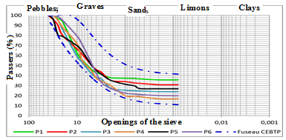
Figure 2: Granulometric curves of Banfeko samples relatively well inscribed in the standard zone recommended by CEBTP (1984) as a subbase.
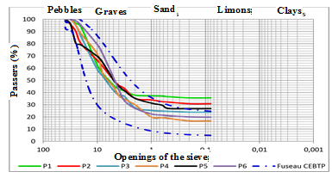
Figure 3: Particle size curves of Banfeko samples poorly inscribed in the standard spindle recommended by the CEBTP (1984) as a base layer.

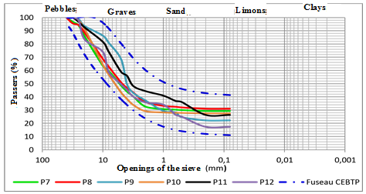
Figure 4: Particle size curves of the Bakoye samples very well inscribed in the standard spindle recommended by the CEBTP (1984) as a subbase.
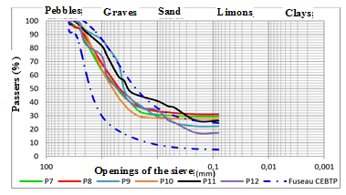
Figure 5: Particle size curves of Bakoye samples poorly inscribed in the standard spindle recommended by the CEBTP (1984) as a base layer.
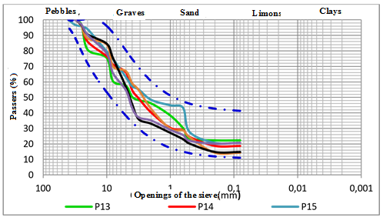
Figure 6: Particle size curves of the Ketcho samples very well inscribed in the typical spindle recommended by the CEBTP (1984) as a foundation layer
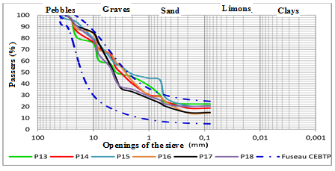
Figure 7: Particle size curves of Ketcho samples poorly inscribed in the standard spindle recommended by the CEBTP (1984) as a base layer.
Figures 2, 4 and 6, show the particle size curves, different superimposed samples, the reference particle size zone, recommended by the CEBTP (1984), for pavement sub-base materials. These curves are relatively well inscribed in this reference zone. On the basis of granulometric analysis, these materials can be directly used as a subbase. On the other hand, FIGS. 3, 5 and 7 represent the particle size curves of the different samples superimposed on the standard particle size spindle recommended by the CEBTP (1984) for the basecoats of pavements. It is noted that the branches of the upper part, of the different curves, overflow the upper branch of the type spindle, recommended by the CEBTP (1984), as a base layer. This would mean that the thresholds of coarse elements, and fine vis-à-vis the recommended values, in base layer, are either largely exceeded, or insufficient, both quantitatively and qualitatively. On the basis of granulometric analysis, these materials can not be used directly as a base coat. They thus require, a correction of their granulometry, by adding deficit granular classes.

3.4 Atterberg limits
The different results of the Atterberg limits are shown in Table 3. The values ​​of the liquidity limit vary between 53.30% and 65.35%, with an arithmetic mean of 58.99%, for the site. Banfeko. They vary widely, for the Bakoye site, ranging from 52.0% to 84.1%, with an average of 66.17%, and finally they range from 54.1% to 76.45%. , with an average of 65.27%, for the Ketcho site. The values ​​are in the same proportions as those obtained by (Djuickouo, 2012), (63%), and superior to those obtained (48.6%), by (Ananfouet, 2012), on indurated soils, on basalt in the locality of Dschang. On the other hand, these results do not agree with those obtained by (Remillon, 1967), according to which the limit of liquidity of lateritic soils does not exceed 35%.
The plasticity index of the materials studied varies between 13.15% and 25.10%, with an average of 17.89% for the Banfeko site. It is between 15.15% and 30.58%, with an average of 21.64% for the Bakoye site. It varies from 21.15% to 29.6%, with an average of 25.38% for the Ketcho site. The Guide to Road Groundwork (GTR, 1992) for tropical countries states that soils with plasticity indexes between 12% and 25% are moderately clayey soils. Given the values ​​of the consistency indices, which vary between 0.92 and 3.12, these soils are in a state of consistency, ranging from plastic to firm.

3.5 Modified Proctor Trial
Table 4 presents the different values of the modified Proctor optimum, (optimum water contents and maximum dry densities), as well as their arithmetic mean.

Table 4: Values of the Modified Proctor Optimum
Sites and averages | Number of wells | Depths (cm) | optimum proctor  w_{OPM} (%) | maximum density  Dmax  (g /cm³) | ICBR à  95% | Linear swelling (%)
Banfeko | P₁ | 133 | 13.4 | 1.957 | 60.04 | 0.323
Banfeko | P₂ | 128 | 11.3 | 2.001 | 36.38 | 0.611
Banfeko | P₃ | 131 | 12.2 | 1.955 | 48.73 | 0.218
Banfeko | P₄ | 129 | 13.3 | 2.014 | 25.07 | 0.454
Banfeko | P₅ | 130 | 14.0 | 2.038 | 49.90 | 0.197
Banfeko | P₆ | 129 | 14.2 | 1.902 | 35.70 | 0.213
Average |  | 130 | 13.6 | 1.978 | 42.64 | 0.337
Bakoye | P₇ | 122 | 10.7 | 1.962 | 60.04 | 0.514
Bakoye | P₈ | 120 | 12.8 | 1.900 | 36.38 | 0.043
Bakoye | P₉ | 118 | 13.3 | 2.025 | 48.73 | 0.615
Bakoye | P₁₀ | 123 | 9.6 | 1.920 | 25.07 | 0.623
Bakoye | P₁₁ | 121 | 13.3 | 2.045 | 49.90 | 0.536
Bakoye | P₁₂ | 118 | 11.9 | 1.988 | 35.70 | 0.454
Average |  | 120 | 11.9 | 1.973 | 31.51 | 0.464
Ketcho | P₁₃ | 131 | 9.7 | 2.071 | 55.18 | 0.346
Ketcho | P₁₄ | 130 | 14.8 | 1.845 | 62.07 | 0.142
Ketcho | P₁₅ | 127 | 14.3 | 2.100 | 49.65 | 0.187
Ketcho | P₁₆ | 133 | 10.8 | 1.889 | 47.81 | 0.340
Ketcho | P₁₇ | 130 | 13.2 | 2.204 | 50.01 | 0.298
 | P₁₈ | 129 | 13.8 | 2.134 | 46.77 | 0.119
Average |  | 130 | 12.7 | 2.041 | 51.92 | 0.239

Table 4 shows that optimal water contents vary from 11.3% to 14.2%. The value of 14.2%, observed in Banfeko, is in agreement with its high content in fines (35.6%). Optimum water contents range from 9.6% to 13.3%, with an average of 11.9% for the Bakoye site, and between 9.7% and 14.8%, with an average of 12 , 7% for the Ketcho site. These values are in the same proportions as those found by (Takala, 2017), for the Batoufam soils (13%), by (Ngo'o Zé, 2011) in the Akonolinga zone (11.5% and 16%). %), and by (Nanga, 2014) in Ebolowa (9.8% and 14.3%). The maximum dry densities ranged from 1.902 g / cm3 to 2.038 g / cm3, with an average of 1.978 g / cm3 for the Banfeko site. They range from 1.90 g / cm3 to 2.045 g/cm³, with an average of 1.973 g/cm³, for the Bakoye site and from 1.845 g/cm³to 2.204 g/cm³, with an average of 2.041 g/cm³ for the Ketcho site. These values ​​are higher than those found by (Eyenga, 2011) (1.67 g/cm³), and are lower than those found by (Takala, 2017) (2.23 g/cm³), respectively in Sa'a and Batoufam. . These values ​​are consistent with those recommended for basecoats, namely dmax> 1.90 (AUTRET, 1982), and do not appear to be in a baseline because the required value is dmax> 2. In the case of implementation of these materials, it will be necessary to let them dry, in order to obtain optimal compaction, this with respect to their natural water content, whose average is greater than 22% for all sites.

3.6 CBR test and measurement of linear swelling

The values in Table 4 show that the 95% CBR lift indices range from 25.07 to 60.04, with an arithmetic mean of 42.64 for the Banfeko site. They are little dispersed for the Bakoye site, and oscillate around the average value of 31.51. For the Ketcho site, they range from 46.77 to 62.07, with an average of 51.92. The results of the linear swelling, give the average values of 0.337%, 0.464% and 0.239%, respectively in the sites of Banfeko, Bakoye and Ketcho. The values of the indices of lift found, agree with those found by (Takala, 2017), in the nodular level of Melen's alteration profiles, between 47 and 49.4; but they are much lower than those found at Dschang by (Djuickouo, 2012). According to CEBTP specifications (1984), the lateritic soils of Banfeko, Bakoye and Ketcho belong to the S5 lift class (CBR> 30). The values of the CBR index, associated with those of the linear swelling that are less than 1%, and show that these materials, can be used, for the platforms of pavement, without preliminary treatment. From this point of view, they can also be used to improve the platform soils, that is to say as a form layer, for any type of traffic, ranging from T1 to T5. Sikali et al., 1986), working particularly on the soils of western Cameroon, point out that with a CBR between 30 and 60, a lateritic material can be used as a subbase, for T1 to T3 traffic. (Bagarre, 1990), also points out that gravel with CBR of at least 30, after immersion for 4 days, can be used as a subbase for traffic below 300 vehicles per day. For these authors, as for the guide (CEBTP, 1984), these materials are directly usable as a foundation layer. However, their use as a base layer requires an improvement of the carrying capacity because (CEBTP, 1984), specifies that in this case at 95% of the modified Proctor optimum, a CBR of at least 80.

3.7 GTR and HRB classification
The results of the granulometric analysis, and the Atterberg limits, shown in Table 3, made it possible to classify according to the GTR and the HRB.
According to (GTR, 1992), soils from all three sites are in subclass B6. It is sands and serious clay, with very clay. Their behavior is similar to that of a fine soil, having the same properties as fines, but with a greater sensitivity to water, due to the presence of the fine fraction, in large quantities.
According to the HRB, these are the soils of subclass A-2-7 (2), good to fair behavior in road construction for the Ketcho site. It is also the soil of the subclass A-2-7 (1), of excellent behavior to good in road construction, for the sites of Banfeko and Bakoye. These are all gravel and silty sands or clay.

4. Conclusion
At the end of this work, which concerns geotechnical identification, lateritic materials from the locality of Banka, for their use in road geotechnics. The laboratory results show that the soils studied are of subclass B6 according to the GTR, and subclass A-2-7 (2) for the Ketcho site, and subclass A -2-7 (1) for the Banfeko and Bakoye sites, all suitable for use in road construction, directly usable as a subbase. But their use as a base layer requires an improvement of the bearing capacity, because the value of the CBR remains less than 80 to 95% of the modified Proctor optimum. The lateritic soils of Banfeko, Bakoye and Ketcho belonging to the S5 lift class.
In the case of an implementation of these materials, it will be necessary to let them dry, in order to obtain an optimal compaction, this with regard to their natural water content, whose average is greater than 22%, for all sites, and optimal water contents ranging from 11.3% to 14.2%.

References

Ananfouet Djeufack C.Y., 2012. Mapping and geotechnical characterization of soils
developed on volcanic rocks of the city of Dschang, Master memory
II, Fac. sciences, univ.de Dschang, 89 p.
Autret P., 1982. Contribution to the study, gravelly lateritic. Withdrawal limits
. Liaison Newsletter of the Bridges and Roads Laboratories, n° 118, pp. 7-16.
Bohi, Z., 2008. Characterization of lateritic soils used in road construction: Case
of the Agnéby Region (Ivory Coast). Doctoral thesis National School of Bridges
and Roads, 121p.
Bagarre E., 1990. Use of lateritic gravels in road construction, document from the
Institute of Science and Technology of Equipment and the environment for
development, 143p.
Geological map of Cameroon, 1972.

CEBTP, 1984. Practical guide for pavement design for tropical countries.
ISBN 2-11-084-811-1, 154p.
Djuickouo C.N., 2012 Geotechnical characterization of lateritic gravel on basalts

of the Maka area (Dschang, west-Cameroon), presented memory
for a Secondary School Teacher's Diploma General Second Rank (D.I.P.E.S II)
,70p.
Eyenga P., 2011. Geotechnical characterization of alteration products on Sa'a Quartzites
, Master II, univ. from Yaoundé I, 81p.
Ghogue, 2009. Laboratory and in-situ tests and their interpretations for geotechnical t
studies and control, 15p.

GTR,1992. Guide to road earthworks, 12p.
Nanga Bineli M.T.,2014. Geological and Geotechnical Characterization of Gravel Lateritic on
Granites in the Ebolowa Region (Southern Cameroon), Master II Dissertation
, univ.de Yaoundé I, 73 p.
NF P 94-050 , 1995. Sols : Soils: recognition and testing - Determination of weight
Content of materials - Steaming method.
NF P 94-058 ,1993. Soils. Recognition and testing - Determination of the density
of solid particles by hydrostatic weighing.
NF P 94-056, 1996. Soils. Acknowledgments and tests. Particle size analysis Underwater.
sieving. AFNOR, 16p.

NF P 94-093, 1999 Normal Proctor Assays - Modified Proctor Assay. AFNOR, 19p.

NF P 94-078, 1997. Soils: Recognition and testing. CBR index after immersion Immediate
CBR index - Immediate index t. AFNOR, 12p.
Ngo’o Zé A., 2011 Effects of lime on some physico-mechanical properties of two
lateritic gravel from the Akonolinga area (central region). Master II memory..
fac. Sci. univ. Yaoundé I, 97 p.
Lohnes, R., & Demirel, T., 1973. Strength and structure of laterites and lateritic soils,
Eng. Geol., 13-33.
Remillon, A.,1967. Road research undertaken in French-speaking Africa.
An. Of the Inst. Tech. of Construction and Public Works No. 231, 366-388.
Sikali F.et al., 1986. Use of Laterites in Road Technology in Cameroon,
report LABOGENIE, pp 277-288.
Takala, 2017 Geotechnical characterization and evaluation in road construction of
the laterites of Batoufam, article, , 16p.

Téjani A., 2008. Physical and mechanical characterization of ferralitic soils of Bafoussam
and their correlations, PhD Thesis in Engineering Science, 121p.

