The synchronous occurrence of neuroendocrine tumor and gastrointestinal stromal tumor (GIST) at gastric site

Yassine Dkhissi ª ,Mohamed Alila^{b},Omar marghich ^{c},Loubna Hejjane^{d},Elbachir Benjelloun ^{e}
a: Department of general surgery A, CHU Hassan II FES , 30000 , MOROCCO
Email: yassine.fmpf@gmail.com
b : Department of general surgery A, CHU Hassan II FES , 30000 , MOROCCO
Email: mohammed.alila@gmail.com
c : Department of general surgery A, CHU Hassan II FES , 30000 , MOROCCO
Email : omar.marghich@gmail.com
d : Department of Oncology, CHU Hassan II FES , 30000 , MOROCCO
Email : dr.loubnahejjane90@gmail.com
e: Department of general surgery A, CHU Hassan II FES , 30000 , MOROCCO
Email : benjelloun19@gmail.com

Abstract
Gastrointestinal stromal tumors (GIST) are the most frequent sarcomas in the gastrointestinal tract. They affect all segments of the digestive tract. The incidental occurrence of GIST and other primary tumors has not been well described in literature.
We describe a case of a 73 year old patient who underwent surgery for gastric GIST with an incidental pathologic diagnosis of a gastric neuroendocrine tumor.

The occasional finding of this association underlines the importance of a carefully pathological diagnosis for its identification. In literature there is no evidence of concomitant neuroendocrine tumor and gastrointestinal stromal tumor (GIST) at gastric site.
Keywords: Gastrointestinal stromal tumor ; neuroendocrine tumor; synchronous Tumors; gastric
Introduction
- Gastrointestinal stromal tumors (GIST) are the most common mesenchymal neoplasms of the gastrointestinal tract accounting for 80% of gastrointestinal sarcomas [1],with a malignant potential 1 à 3 %.
- However, uncommonly they can be associated with synchronous tumors of different histogenesis, they are almost always discovered incidentally as during surgery or staging exams of the primary disease
Case presentation
- We describe a case of a 73 year old male patient, with history of many episodes of melena and anemia
- Upper gastrointestinal endoscopy revealed a nodular lesion sub mucosal in the antro-fundial junction measuring 25x15 mm another calcification was seen in the gastric fundus measuring 3cm
- Multiple tissue biopsies histological returning negative .Subsequently all the necessary staging exams, including a total body Computed Tomography (CT) were performed. The CT did show a lesion in the small gastric curvature measuring 14mm and another lesion in pyloro-duodenal level measuring 16mm (Figure 1)
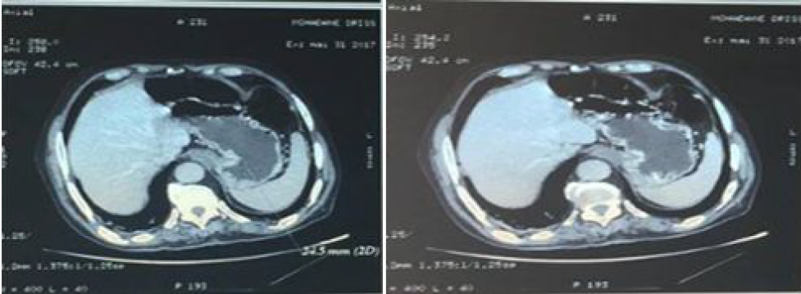
Figure 1: Contrast-enhanced computed tomography (CT) of upper abdomeshowed a lesion in small gastric curvature

Pathological examination
- Wedge resection of gastric tumor was performed (3 tumors founded)
- For the first nodule, histology revealed a neuroendocrine tumor, grade 1, the surgical margins were considered free of infiltration, and the final staging was pT1 pNx . Immmunohistochemistry showed strong staining for Synaptophysin , chromogranin confirming the neuroendocrine nature, The proliferate index Ki 67 was less than 5% .(Figure 2)
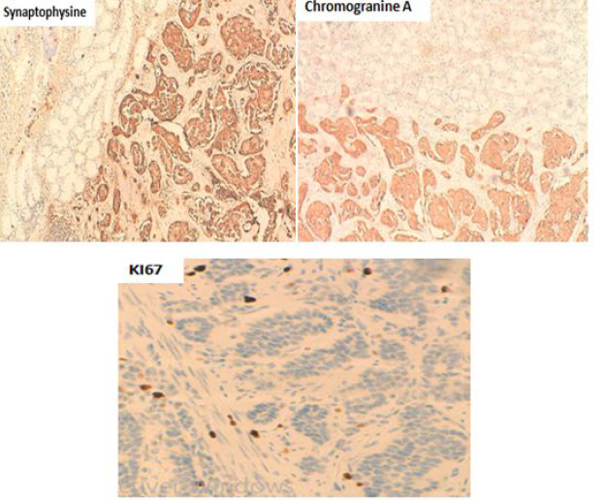

Figure 2: Histology of nodule showing nests of neuroendocrine tumor
- For the other nodules Stomach showed a firm sub mucosal tumor measuring 5.5 cm and 3.5cm, Immmunohistochemistry demonstrated positive staining for CD117 and Dog 1. Tumor cells were negative for AML and S100. Features were consistent with benign GIST. (Figure 3)

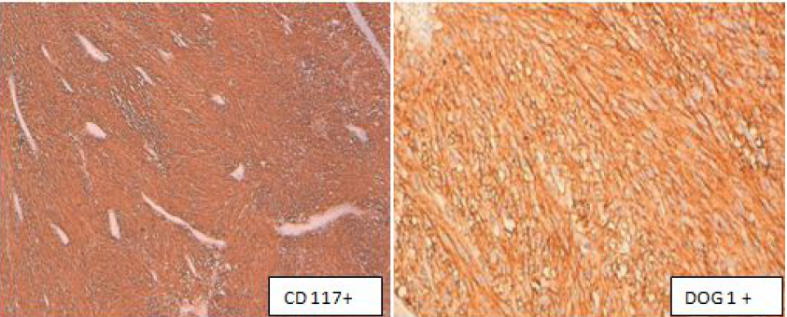

Figure 3: Histology of others nodules showing nests of GIST
Discussion
- Gastrointestinal stromal tumors (GIST) are the most frequent sarcomas in the gastrointestinal tract. They affect all segments of the digestive tract. They develop from the interstitial cells of Cajal , with a preferred gastric localization (about 60-70 % in the stomach and 20–30% in the intestine), with smaller percentages these lesions have been described in other regions such as the large intestine, rectum, and omentum [2].
- The median age of onset is 60–69 years and the symptoms are usually non-specific such as tiredness, abdominal discomfort and gastro-intestinal bleeding. [3].
- KIT and PDGFRA activating mutations are the oncogenic mechanisms in most sporadic and inherited GISTs [4].
- Positivity for the CD117 is the key feature of GIST, but CD34 and nestin are other commonly expressed but less GIST-specific antigens. Moreover, these tumors can be positive for smooth muscle markers and generally negative for desmine. S-100 protein expression is rare and glial fibrillary acidic protein is not present. Keratin 18 and Keratin 8 are occasionally expressed.
- GISTs are unique in 95% of cases. Multiple locations are very rare [5] with an average incidence of 10 to 35% described in the literature[6-11]
- The synchronous existence of two different tumors in the gastrointestinal tract is uncommon and an unusual event. with few published studies dealing with this phenomenon Most cases involve adenocarcinomas, lymphomas, carcinoids, or leiomyosarcomas of the stomach [12],coexistence of gastric GIST with neuroendocrine tumor is extremely rare
- Only 3 cases of concomitant gastric carcinoid and GIST have been reported in the literature [13,14]
- CRILLO reported , 4 of the 300 observed cases (1.3%) showed an unusual association with rare no epithelial neoplasms, 1 case of gastric carcinoid and gastrointestinal stromal tumor (GIST). [14].
- Ramneet Kaur et al ,report two cases of gastric GIST with synchronous tumors ,the first case is of a patient who was suspected with GIST of stomach and was incidentally found to have an associated duodenal neuroendocrine neoplasm [15].
- The etiology of synchronous occurrence of GISTs with histological unrelated tumors still remains unclear. Some authors have postulated that they may share common carcinogenic pathways or genetic mutations with proliferation of different cell lines [16].
- Awareness of occurrence and pattern of synchronous GIST and other neoplasms is important for both histopathologists and surgeons
Conclusion
The synchronous presence of GIST and other tumors is rare and unusual, generally revealed in perioperative and anatomo-pathology, whose etiologies remain obscure requiring molecular and genetic investigations to illustrate the mechanisms of carcinogenesis

References
- Blay JY, Landi B, Bonvalot S et al. Recommendations for the management of GIST patients. Bull Cancer 2005;92(10):907-18
.2. Miettinen M, Lasota J. Gastrointestinal stromal tumors: definition, clinical, histological, immunohistochemical, and molecular genetic features and differential diagnosis. Virchows Arch 2001; 438: 1-12.
3. Davis GB, Blanchard DK, Hatch GF 3rd, Wertheimer-Hatch L, Hatch KF, Foster RS Jr et al. Tumors of the stomach. World J Surg 2000; 24: 412-20.
4. Blay JY, Bonvalot S, Casali P, Choi H, Debiec-Richter M, Dei Tos AP, et al. Consensus meeting for the management of gastrointestinal stromal tumors. Report of the GIST Consensus Conference of 20—21 March 2004, under the auspices of ESMO. Ann Oncol 2005;16:566—78.
5 .Ouzzif A, Seddik H, Boulez J, Scoazec JY, Lapalus MG. Digestive protein loss from an ileal multifocal stromal tumor. Gastroenterol Clin Biol 2005;29:1066—8.
6. Maiorana A, Fante R, Maria CA, Adriana FR. Synchronous occurrence of epithelial and stromal tumors in the stomach: a report of 6 cases. Arch Patho Lab Med 2000;124:682e6.
7. Kawanowa K, Sakuma Y, Sakurai S, Hishima T, Iwasaki Y, Saito K, et al. High incidence of microscopic gastrointestinal stromal tumors in the stomach. Hum Pathol 2006;37:1527e35.
8. Igwilo OC, Byrne MP, Nguyen KD, Atkinson J. Malignant gastric stromal tumor: unusual metastatic patterns. South Med J 2003;96:512e5.
9. Agaimy A, Wunsch PH, Sobin LH, Lasota J, Miettinen M. Occurrence of other malignancies in patients with gastrointestinal stromal tumors. Semin Diagn Pathol 2006;23:120e9.
10. Invernizzi R, Martinelli B, Pinotti G. Association of GIST, breast cancer and schwannoma in a 60-year-old woman affected by type-1 von Recklinghausen’s neurofibromatosis. Tumori 2008;94:126e8.
11. Gottwald L, Gora E, Korczynski J, Piekarski JH, Morawiec Z, JesionekKupnicka D, et al. Primary uterine rhabdomyosarcoma in a patient with a history of breast cancer and gastrointestinal stromal tumor. J Obstet Gynaecol Res 2008;34:721e5.
12. Nakamura S, Aoyagi K, Iwanaga S, et al. Synchronous and metachronous primary gastric lymphoma and adenocarcinoma: a clinicopathological study of 12 patients. Cancer 1997;79:1077– 85
13. Lin YL, Wei CK, Chiang JK, Chou AL, Chen CW, Tseng CE. Concomitant gastric carcinoid and gastrointestinal, stromal tumours: a case report. World J Gastroenterol. 2008;14:6100–6103.
14. Cirillo F. Neuroendocrine tumours and their association with rare tumours: observation of 4 cases. Eur Rev Med Pharmacol Sci. 2010;14:577–588
15. Ramneet Kaur,a Sunita Bhalla,a Samiran Nundy,b and Sunila Jaina ;Synchronous gastric gastrointestinal stromal tumor (GIST) and other primary neoplasms of gastrointestinal tract: report of two cases, Ann Gastroenterol. 2013; 26(4): 356–359.
16. Shariq O, Odedra A, Alexopoulos A-S, Gould S, Soobrah R. Synchronous occurrence of gastrointestinal stromal tumour and ovarian neoplasm in a patient presenting with acute cholecystitis. J Gastrointest Cancer. 2012;43:113–116.

