Difficulties related to the implementation of ERPs in Morocco: Focus on Change Management

Younous EL MRINI^{(*)}, Mustapha BELAISSAOUI ^{(*)}, Issam TAQAFI^{(*)}
^{(* )} : Information System of Support Decision Laboratory (SIAD), National School of Commerce and Management (ENCG) of Settat, Hassan 1st University, Settat.
younous.elmrini@gmail.com
mbelaissaoui@gmail.com
issam.taqafi@gmail.com

ABSTRACT
The implementation of ERP (Enterprise Resource Planning) in the world represents today a critical vector for introducing major changes in the companies. The large Moroccan companies took great part in this trend with several implementations since 1995 using various products: Oracle Applications, SAP (Systems, Applications and Products for data processing), Odoo, etc. However, Enterprise Resource Planning projects implementation in Morocco don’t accord enough interest for the change management discipline throughout the life cycle of the project. This represents a major obstacle to the success of this kind of strategic projects in terms of Project Management discipline. In this paper, we focus on this phenomenon by studying two large Moroccan companies related to two distinct business sectors, using Action Research methodology. This study allowed us listing different missing parts in change management based on a literature review confronted with a reality experienced in a Moroccan context. Finally, we try to identify the main difficulties in change management by classifying them in different levels.

KEYWORDS: Enterprise Resource Planning (ERP), Change Management, Project Management, Morocco, Large companies.

- Introduction
Change management is a subject that requires more and more attention from companies wishing to migrate from a current state to an ambitious goal, usually through a business project. More specifically, ERP implementation projects within large organizations present an opportunity and/or an adequate means to lead a deep transformation in the company: change management is the key in this context in conjunction with project management.
The following is an attempt to highlight the key role of change management in the success of such ERP implementation projects. This paper describes the difficulties associated with this ERP projects implementation.
- Semantic problem

  - Change:
Van de Ven and Poole (1995) believe that "change is an observed event and a differentiation in the form, quality or state of an organizational entity over time". Bouchra and Chafik (2013) add that "change operates in many ways. It is a rich and varied concept depending on the depth, scope and pace with which it operates. The change can be incremental or global. It is also distinguished by the speed of progression and its continuity over time (Figure.1). It can be limited and brief, very large and heavy, long and deep, fast and violent, or consensual or imposed.

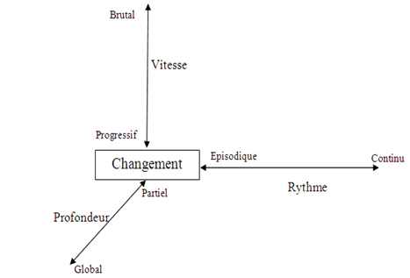

Figure.1: Change dimensions related to organizations

  - Change management
According to Iles and Sutherland (2001) the literature on change management is large and not easy to handle. It is enriched with numerous contributions from several disciplines : psychology, sociology, politics, engineering sciences and others. The managerial dimension of change requires the notion of performance, and is presented by studies of change in organizations, according to two main topics :
- It is involved in the definition of objectives related to the environmental data. In this case, the change is consistent with the strategy and becomes a strategic change
- It can also seek to change the organization and becomes an organizational change.
Being not dissociated, the two types of change mobilize the actors when it comes to change management. Change takes a strategic dimension when we are interested in its effects. A strategic change links organizational change with project purpose. The change significantly modifies the effectiveness of the organization (Carton, 2006) and challenges a dimension of performance, say Bouchra and Chafik (2013).
  - Confusion between change and change management:
A study on the confusion between change and change management was conducted in 2011 revealing that most of the population present this confusion (Prosci, 2011):

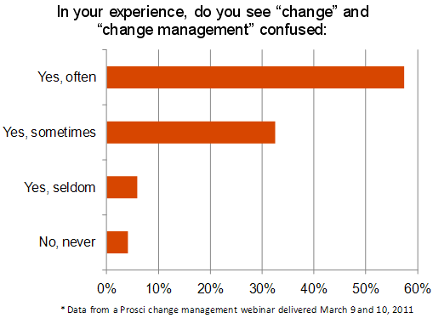

Figure.2 : Confusion between change and change management

To do without, (Prosci, 2011) has characterized the junction between change and change management as follows: Changes in an organization aim to create new future states in relation to the way we operate. To achieve them, employees must work differently. The achievement of the future states depends on the success of those who reach their own personal future states. Change Management is the structured approach (tool) that allows these individual employees to adopt the changes required by the projects.
  - Change management according to ITIL:
Another confusion (especially in English) exists between the change management defined above and the change management according to the Information Technology Infrastructure Library (ITIL), in which (Figure .3: last brick in the transition service), change management is a very important process among the processes of transition management. Indeed, it makes it possible to anticipate the negative impacts following any change in the information system through several phases: identification, impact study, approval, etc. This process is totally independent of managing changes in ERP implementation projects.

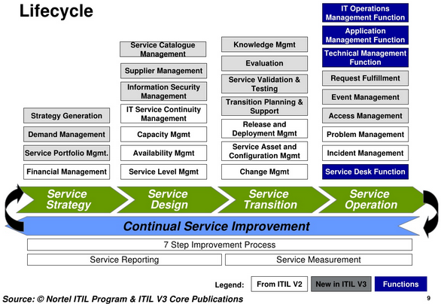
Figure.3 : ITIL Lifecycle
- Literary review
Kerzner (2013) discussed the significant impact of organizational change and culture on the project implementation process. Kloppenborg and Opfer (2002) and Leybourne (2007) evaluated the project management literature and concluded that while efforts to identify the importance of social / psychological approaches to project success are increasing, the implementation of a strategic change remains a company scale problem that cannot be solved by an exclusive focus on the project process. More recently, the PMI (Project Management Institute) seems to be formally recognizing the importance of organizational change management to the success of the project: the PMI has integrated change management into its program at its conference in 2014. This recommendation was issued by Hornstein (2015) who strongly emphasized that project management processes and the training of new project managers must consider the impact of organizational changes in the success or failure of the projects.
Even though change management is starting to have a relatively weak representation in the project management literature (communications, stakeholders, etc.), these referential don’t specifically address the management of organizational and behavioral changes as indicated for example in the process of change management. change in 8 steps of Kotter (1996).
Choi (2011) in an integrative literature review confirmed the importance of employees’ engagement and identified four behaviors required to accept organizational change: The will to change, the commitment to change, the opening to change and cynicism towards change. John Kotter (1996, 2008), a professor at Harvard Business School, made it clear that the focus on leadership change minimizes complacency and then reinforces the alignment and motivation of people affected by change, so they are ready to support and adopt it. Harvey Kolodny, recognized the need to integrate the practice of change management with project management (Kolodny, 2004). He said that it is necessary for the successful implementation of major managerial innovations (such as the implementation of an ERP). Kolodny (2004) argues that organizations should benefit from the synthesis of both approaches. Crawford and Hassner-Nahmias (2010), using data from change projects embedded in IT implementations in different organizations, confirm the recommendations og Kolodny (2004).
On the other hand, according to Aladwani (2001), the sources and types of users' resistance to a new technology, such as ERP, are numerous. Sheth (1981) has developed an interesting framework that classifies the types of user resistance to different facets of innovation such as the implementation of ERP by source of resistance. This framework shows that there are two fundamental sources of resistance to innovation (such as an ERP): perceived risk and habit. Perceived risk refers to a perception of the risk associated with the decision to adopt new things / behaviors; that is, the decision to accept an ERP system. Habit refers to the everyday practices of each individual daily. To reduce the resistance of employees to the implementation of an ERP. Therefore, the general management of companies must analyze these sources of resistance and must use all the appropriate strategies to counter them (Younous and al, 2018).
Improvement strategies, such as the implementation of an ERP generally involve structuring changes. Therefore, the right response is crucial in an organization to avoid the difficulties associated with this change (Al-Mashariet and Zairi 2000, Aladwani 1999, Aladwani 1998). Therefore, change management is one of the most important vectors to monitor during ERP projects. In the Moroccan context which is a country in the process of development and whose implementation of ERPs has become a strategic choice of multiple companies in different sectors of activity, we have not found any research work which deals with this kind of problematic.
- Interest of subject
Among the most important reasons for failing or at least delay in ERP implementation projects is that project managers do not give due attention to the risk management component of the project. this type of projects even though modern project management methods includes complete chapters for this aspect. For example, the Project Management Body of Knowledge (PMBOK) project management repository, 2013, which contains a process group for risk management.
The problem lies in the fact that many project managers perceive risk management as one more job with little added value and one more load. Even more so, even for the project managers who foresee that in their management, they treat it in a light way and think to suppress it under the guise of optimization when one feels a delay on the project.
Numerous studies have been conducted on this problem of risk management in ERP projects. In the table below (Figure .4), Aloini et al (2007) classified risk factors in an ERP context as follows:

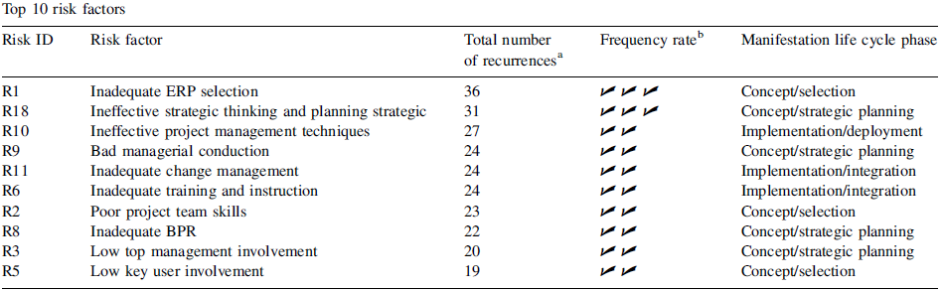

Figure.4 : Risk factors in ERP context

In this study, it is very clear that a bad adoption of change management (R11) represents a very important risk in the management of ERP projects: it is ranked fifth. Hence the interest of focusing this communication on the difficulties related to managing changes in ERP projects.
- Issue

According to Wong et al (2005), many reports around the world speak of unsuccessful implementations of ERPs. For example, Nike lost important orders for shoes. 70% of the ERP implementation projects have not achieved their expected benefits. Other studies have revealed that the percentage of failures of ERP implementation projects varies between 40% and 60% and has sometimes led to a global bankruptcy of the company. Practitioners tend to discuss the sources of failures of these implementations from different angles: proprietary closed system, the company uses only a small part of the ERP, and so on. Of course, these causes of failure vary according to the size of the company, the nature of the activity, the context of the project, the culture of the country, etc.
During the implementation of an ERP, the general management is often faced with a negative attitude on the part of the key users. This attitude plays a major role in the failure of this type of project or at least causes significant delays in planned implementation schedules.
Solutions must be made in advance to avoid this type of resistance. An effective strategy requires firstly a clear and precise identification of the difficulties encountered in this context.
What are the difficulties related to the implementation of ERPs, especially those related to change management in a Moroccan context?
- Methodology
According to Benbasat and al (1987), there is no standard definition for the case study. We will draw our definition from those presented by Benbasat (1984), Bonoma (1985), Kaplan (1985), Stone et al (1978) and Yin (1984). A case study examines a phenomenon in its natural setting, employing multiple techniques such as collecting data to gather information from one or a few entities (individuals, groups or organizations).
The "Action Research" or "Action Action" method used in this paper, and which is a type of case study, represents studies in which the author, usually a researcher, is a participant in the implementation of the system. This method makes it possible to record the results of a real experience throughout the different ERP implementation projects.
Participatory research or action research is based on the notion that the company must be experimentally understood through its major change processes in this case ERP implementations. Three important factors come into play: Context, relational quality and the quality of the research itself (Coghlan and Brannick, 2014).
- Results and discussions
The case study of this paper was conducted in two major Moroccan accounts: Company A and Company B.
Company A operates in the industrial sector. It markets raw materials as well as various derivatives with a workforce of thousands of staff spread over different geographical areas of Morocco.
Company B is a telecom leader marketing a range of products in various market segments. It is highly recognized by strong culture and its proximity to end customers. It is also present in the different Moroccan regions.
The results produced in this study are the result of several overlaps on two levels: common or different findings of the two companies; and conclusions drawn all along several ERP projects. Indeed, we participated, and we continue to participate in several projects: progressive scopes, different jobs, many users exceeding 3000 thousand sometimes, diversified technologies, etc.
During this study, we were faced with several difficulties of different types: slippage related to the uncontrolled change in the scope of the project, lack of engagement of the trades, arbitration between standard approach versus adoption of specific, tensions due to differences in systems values, etc. Among these difficulties, we were faced with a major problem related to change management materialized by a resistance of increased change on several levels.
  - Strategic level:

- Entities that did not see immediate benefit from the project were very difficult to co-operate with especially those who had the perception that the new ERP requires duplicate work (especially in the transition phase) when they will not get anything out of it.
- Other entities perceived the introduction of the ERP as a means of monitoring and monitoring the activity. This fear has increased over time during the KPI (Key Performance Indicators).
- Another difficulty has been that the progressive implementation approach prioritizes the integration of some business disciplines with others.

  - Operational level:

- A good part of the employees was totally against the change in the way of working especially those used to doing the same work for a considerable time.
- Another population was afraid of technological change by simple perception even if we can explain the simplicity of use and the contribution of integration.
- Others perceived the arrival of the ERP as a pretext for downsizing.

  - Functional level:

- Key user confirmed That the standard ERP process does not fully meet their business needs and therefore they preferred everything rejected despite the other benefits demonstrated.
- Others did not accept that the coverage scope was partial because they were forced to work in two different systems: they preferred all or nothing.

  - Transverse level:

- Project managers underestimated the important role of communication throughout the project: either the information is not disseminated to all relevant stakeholders or it is delayed.
- In terms of training, a difficulty has been linked to poor planning, especially since the number of the target population is very high: people trained in a hurry at the last minute while others were trained long before the start of production and have unfortunately forgotten.
- The impact of the use of ERP on the various infrastructures in terms of performance was another pretext for the non-appropriation of the ERP
Other resistance issues of change were also related to the difference in cultures between the panoply of project teams, the workload, and so on. All these difficulties coupled with other parameters were the source of significant delays compared to the calendars prepared previously.
- Conclusion
Through this communication, we first tried to remove semantic ambiguities among notions of change and change management. Then, we approached the theoretical part by positioning the subject in relation to a literary review while showing its interest. We also identified the difficulties related to the implementation of ERP project in major Moroccan companies. Finally, we presented the results of the case study (practical part) conducted by confirming various aspects of the literature in a Moroccan context, and more specifically in large companies, while concluding that greater attention should be given to change management component in such large-scale projects.
As prospects, this communication could be a basis for further research to reflect the Relationship between project management and change management and why not a model for the Moroccan context.
Bibliography :
A Guide to the Project Management Body of Knowledge (PMBOK® Guide)—Fifth Edition, 2013.
Aladwani, A. M. (2001). Change management strategies for successful ERP implementation. Business Process management journal, 7(3), 266-275.
Aladwani, A. (1998), « Coping with users resistance to new technology implementation: an interdisciplinary perspective » , Proceedings of the 9th IRMA Conference, Boston, MA, 17-20, May, pp. 54-9.
Aladwani, A. (1999), « Implications of some of the recent improvement philosophies for the management of the information systems organization », Industrial Management & Data Systems, Vol. 99 No. 1, pp. 33-9.
Al-Mashari, M. and Zairi, M. (2000), « Information and business process equality: the case of SAP R/3 implementation », Electronic Journal on Information Systems in Developing Countries, Vol. 2 (http://www.unimas.my/fit/roger/EJISDC/EJISDC.htm).
Aloini, D., Dulmin, R., & Mininno, V. (2007). Risk management in ERP project introduction: Review of the literature. Information & Management, 44(6), 547-567.
Benbasat, I. « An Analysis of Research Methodologies » in The Information Systems Research Challenge, F. Warren McFarlan (ed.), Harvard Business School Press, Boston, Massachusetts1, 1984, pp.47-85.
Benbasat, I., Goldstein, D. K., & Mead, M. (1987). The case research strategy in studies of information systems. MIS quarterly, 369-386.
Bonoma, T.V. « Case Research in Marketing:Opportunities, Problems, and a Process » Journal of Marketing Research, Volume 22, Number 2, May 1985, pp. 199-208.
Bouchra lotfi et Chafik Okar, « Conduite de changement et mesure de performance : vision convergente », 10ème Congrès International de Génie Industriel CIGI2013, Juin 2013.
Carton G-D., (2006), Éloge du changement. Méthodes et outils pour réussir un changement individuel et professionnel, 2ème édition de Village Mondiale.
Choi, M., 2011. Employees' attitudes toward organizational change: a literature review. Hum. Resour. Manag. 50 (4), 479–500.
Coghlan, D., & Brannick, T. (2014). Doing action research in your own organization. Sage.
Crawford, L., Hassner-Nahmias, A.H., 2010. Competencies for managing change. Int. J. Proj. Manag. 28 (4), 405–412.
Hornstein, H. A. (2015). The integration of project management and organizational change management is now a necessity. International Journal of Project Management, 33(2), 291-298.
Iles V. and K. Sutherland, (2001), « Managing change in NHS Organizational Change, A Review For Health Care Managers », Professionals and Researchers, NCCSDO, May 2001.
ITIL Lifecycle Publication Suiite. Ofice of Government Commerce (OGC). 2008
Kaplan, R.S. "The Role of Empirical Research in Management Accounting," Working Paper 9-785-001, Division of Research, Harvard Business School, Boston, Massachusetts, 1985.
Kerzner, H., 2013. Project management: a systems approach to planning, scheduling, and controlling, 11th edition. John Wiley & Sons, Hoboken, N. J.
Kloppenborg, T.J., Opfer, W.A., 2002. The current state of project management research: trends, interpretations, and predictions. Proj.Manag. J. 33 (2), 5–18.
Kolodny, H., 2004. Integrating Project and Change Management. Visiting Speaker SeriesJohn Molson School of Business, Concordia University, (Friday, April 9).
Kotter, J.P., 1996. Leading Change. Harvard Business School Press, Boston, MA.
Kotter, J.P., 2008. A Sense of Urgency. Harvard Business School Press, Boston, MA.
Leybourne, S.A., 2007. The changing bias of project management research: a consideration of the literatures and an application of extant theory. Proj.Manag. J. 38 (1), 61–73.
Prosci, 2011, http://www.change-management.com/tutorial-change-vs-change-management.htm.
Ronald Azuma. A survey of augmented reality. Presence : Teleoperators and Virtual Environments, 6(4) :355–385, 1997.
Sheth, J. (1981), ``Psychology of innovation resistance’’, Research inMarketing, Vol. 4, pp. 273-82.
Stone, E. Research Methods in Organizational Behavior, Scott, Foresman and Company, Glenview, Illinois, 1978.
Van de Ven A-H. and M-S. Poole, « Explaining development and change in organizations », Academy of Management Review, 1995, Vol. 20, No. 3, 510-540.
Wong, A., Scarbrough, H., Chau, P., & Davison, R. (2005). Critical failure factors in ERP implementation.
Younous.E, Mustapha.B and Issam.T (2018). Critical Success Factors to Implement Enterprise Resource Planning in Morocco Large Companies’ Case Study : American Scientific Research Journal for Engineering, Technology, and Sciences (ASRJETS) (2018) Volume 39, No 1, pp 159-168
Yin, R.K. Case Study Research, Design and Methods, Sage Publications, Beverly Hills, California, 1984.

