A Practical Method for Mapping of Pesticide Loss Risk in Cultivated Soils of Greece
Hatzigiannakis Evangelos^{a*}, George Arampatzis^{b}, Paschalis Dalambakis^{c}, Aikaterini Karyoti^{d}, Alexandros Tsitouras^{e}, Ioannis Vrouchakis^{f}, Andreas Panagopoulos^{g} and Theodore Karyotis^{h}

^{a,b,c,d,f,g}Hellenic Agricultural Organization "Demeter" - Soil and Water Resources Institute, 57400 Sindos GREECE,
^{e,h}Hellenic Agricultural Organization "Demeter" - Industrial and Forage Crops Institute, 41335, Larissa GREECE

ªEmail: hatzigiannakis@gmail.com;^{b}Email: arampgeo@gmail.com; ^{c}Email: dalabakis@gmail.com
^{d}Email: aikaterinikaryoti@gmail.com; ^{e}Email: tsitalex@otenet.gr; ^{f}Email: ivrouhakis@yahoo.gr;
^{g}Email:panagopoulosa@gmail.com;^{h}Email:theodorekaryotis@gmail.com

Abstract
In an attempt to map the soil factors controlling pesticide losses, surface soil samples were collected from 196 sites in the cultivated area of Trifyllia, SW Peloponnese, Greece. Up to now, the pesticide losses risk in the studied area is unknown. For this aim, the following key characteristics that affect movement or binding have been taken into consideration: soil texture, slope and soil organic matter content. A GIS map was compiled from discrete soil variables that affect pesticide losses (leaching and/or runoff). According to soil texture, 3 moderate leaching risk classes, 2 high and 1 low were defined, and the respective classes based on Soil Organic Matter (SOM) content were 3 low risk classes, 2 moderate and 1 class of high risk. The study area consists of two soil slope classes 0-2% and 2-6% which were used to calculate the leaching potential of pesticides. The compiled maps can be used by local authorities in order to minimize the potential negative environmental impacts of pesticide usage at farm level, and to suggest various mitigation strategies. Appropriate farming practices must be applied to decrease leaching or losses by runoff in order to mitigate the pollution of shallow aquifers and surface waters in SW Peloponnese. Rational irrigation management is of high importance as it increases the pesticide effectiveness and reduces off site movement. Moreover, runoff of pesticides can be reduced by using minimum tillage techniques to mitigate soil erosion. Finally, farming systems and practices that increase soil organic matter content (e.g. no tillage) can reduce substantially the risk of water pollution by pesticides.

Keywords: pesticide; organic matter; leaching; soil; pollution
*Corresponding author:
E-mail address: hatzigiannakis@gmail.com

- Introduction
The use of plant sanitary materials (pesticides, herbicides etc.) in the intensively cultivated areas often leads to groundwater pollution. It is well documented that interaction of the above substances with soil, plays a dominant role in determining the occurrence and the extend of pollution.
Soil texture and structure, organic matter and permeability [1,2,3,4] are among the main properties which affect loss risk or retention into soils. Soil organic matter influences the quantity of water which is retained in the soil and the absorption capacity of pesticide. Increasing the soil organic content, such as by application of manure, the ability of soils is enhanced to hold both water and dissolved pesticides in the root zone.
Sorption of pesticides to soil is another process and is influenced by the physicochemical properties of the pesticide itself, as well as the properties of the soil. Correlations with pesticide solubility and sorption have also been reported [5]. Organic carbon (OC) content, clay content, clay mineralogy, and pH are soil characteristics known to affect the immobilization and degradation of pesticides [5,6].The rate and timing of a pesticide's application are also critical factors in determining leaching potential, which also depends on the applied volume of pesticide and the rainfall/irrigation depth and intensity. It is well known that site conditions affect the potential for leaching of pesticides to the saturated zone and include: depth to groundwater, geologic conditions (including properties of the vadose zone and the saturated zone), topography, climate and irrigation practices.
In the context of the European and national legislation regarding the plant protection products registration (European Directive 91/414, 1991) and water resources protection, experience has been gained in Europe to assess groundwater vulnerability to pesticide at spatial scale (e.g. national, regional) by using geo-information integrated with pesticide leaching models.
An approach was developed by Gustafson [7] where the derived index is based on half-life of a pesticide in soil and the partition coefficient between soil organic carbon and water (Koc). When half-life is longer, the length of time the pesticide remains in the soil is greater, hence the period for leaching is longer.
Leaching of pesticides to the groundwater is a subject of high importance for EU Countries because groundwater is a vital source of drinking water and pressures from the application of pesticides in the intensively cultivated areas are very high. The leaching potential of pesticides can be calculated with dynamic, multilayer, mechanistic models at different scales, including field, regional and national scale [1,8,9]. The EuroPEARL model was developed and indicators of pesticide leaching are included at the European level [10]. This model ignores losses by field drainage due to the lack of the respective information at European scale. In general, available models can predict trend of pesticides’ leaching processes in soils and the level of accuracy can be attributed to variation of soil conditions.
A number of methods have been developed for assessing the leaching potential in soils with different characteristics. Among various studies, it is important to use a relatively simple approach that uses easily obtainable information to rank the pesticides losses risk based on selected soil properties. This paper deals with soil leaching potential (SLP) and soil runoff potential (SRP) in the Prefecture of Trifyllia, Southwestern Peloponnese, where pesticides are widely used by farmers. For this aim, representative surface soil samples were collected from sites in the cultivated area, in order to map the loss risk of pesticides.

- Material and Methods
Surface samples were selected from 0-30 cm depth at196 sites in the area of Trifyllia, SW Peloponnese, from soils cultivated mainly with olive trees. Soil samples were taken after removing the fresh plant debris and three replicates per soil sample were conducted. These were air–dried and the fine fraction (<2mm) was used for laboratory analyses. Particle size distribution was determined by the Bouyoucos hydrometer method [11]. A modified wet digestion Walkley and Black method [12] was used for the organic matter determination.
Soil texture, organic mater content and slope are the parameters used for the pesticides losses risk assessment. Their corresponding classes used in this rating system are presented inTable 1. The suggested soil textural classes include the following soil subclasses:
Class 1 (sandy): sandy, sandyloam, loamysand
Class 2 (loamy): silty, siltyloam, vfsandyloam, loam
Class 3 (clayloamy): sandyclayloam, clayloam, siltyclayloam,
Class 4 (clay): sandyclay, siltyclay, clay

Table 1: Soil texture, organic matter and slope classes for the assessment of leaching potential
Ranking | Class 1 | Class2 | Class3 | Class4
Soil texture | Sandy | Loamy | Clay Loamy | Clay
Leaching potential | Very high | High | Moderate | Low
Soil organic matter | <2% | 2-3% | >3%
Leaching potential | High | Moderate | Low
Slope | 0-2% | 2-6% | >6%
Runoff potential | Low | Moderate | High

The threshold value for soil organic matter (SOM) in agricultural soil is 2% by weight, beyond which soils cannot remain sustainable [13]. Taking into account this value, three soil organic matter classes were suggested (Table 1). In addition, textural and soil slope classes (Table 2) were used in this work, in order to calculate the losses potential. Slope classes of this system are in accordance to the Greek Soil Survey and these are used for the classification of soil units.
It should be stressed that the above soil properties can be easily determined under laboratory conditions without difficulties or restrictions, while cost is lowand the required infrastructure exists in all relevant soil laboratories. According to textural map (Figure2) and Table 3, the majority of soils belongs to clayloamy textural class and covers 72.9 % of the cultivated area, while the loamy and clay soils cover 14.0% and 13.1%, respectively.

Table 2: Suggested values of parameters for pesticide leaching potential (SLP) and Runoff Risk assessment
SOM % | SLP | Score
<2 | H | 10
2-3 | M | 7
>3 | L | 4
Texture | SLP | Score
Loamy | H | 10
Clay loam | M | 7
Clay | L | 4
Slope % | Runoff Risk | Score
0-2 | L | 4
2-6 | M | 7
Using SOM and soil texture, three indicative classes of soil leaching potential (SLP) are proposed: Low risk, value <10, Moderate 10-15 and High with values>15. The respective values of pesticide losses which affect both leaching and runoff are: L<15, M 15-20, and H>20.

- Results and Discussion
The total study area consists of 32,016.1 ha, located to the altitudinal zone between 0 and 500 meters above sea level and encompasses several municipalities. Field survey indicated that soils in the lowlands consist of alluvial and colluvial deposits, and the dominant parent material consists of conglomerates, limestone or marl; the cultivated soils occurring in this area are generally Fluvisols, Cambisols and Luvisols [14, 15], while the non cultivated are very shallow with steep slopes and belong to soil association of Leptosols (Figure 2).

Figure1: Soil associations map of Peloponnese, Greece (Yassoglou 2005)

Table 3: Distribution of soils after compilation of texture and SOM content
Soil classes |  | Texture | SOM % | Area (ha)
1 | SOMP_CL | Clay Loam | <2 | 886.4
2 | SOMM_CL | Clay Loam | 2-3 | 7,016.7
3 | SOMM_L | Loam | 2-3 | 3,926.6
4 | SOMH_C | Clay | >3 | 4,176.1
5 | SOMH_CL | Clay Loam | >3 | 15,439.7
6 | SOMH_L | Loam | >3 | 570.6
Total study area |  |  |  | 32,016.1 ha
where: CL* is clay loam, L** is loam and C***is clay texture
SOMP is SOM<2%, SOMM is SOM 2-3% and SOMH is SOM >3%

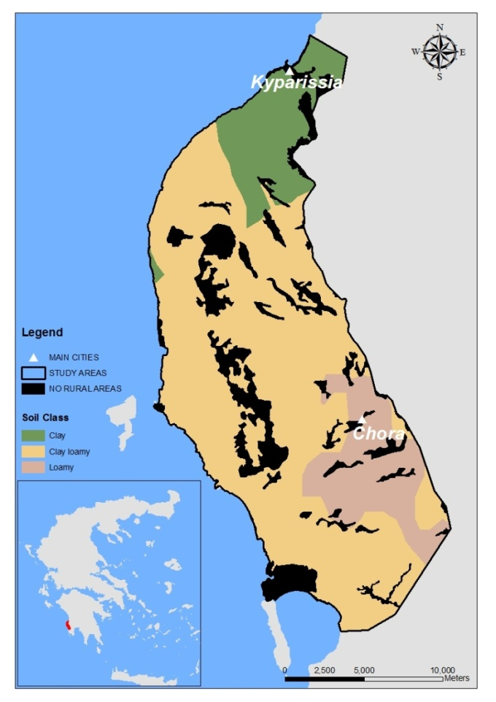
Figure 2: Soil textural classes of the study area

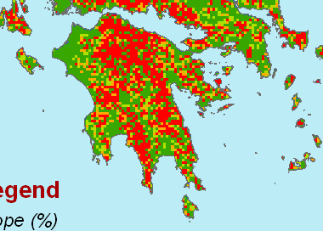
Figure3: Soil slope map of Peloponnese, Greece
Based on the slope map compiled for western Peloponnese (Figure 3), the cultivating area has a gradient less than 6%. To reduce the runoff risk, farming practices such as strip cropping and buffer strips are suggested. In sloping areas, dissolved pesticides adsorbed to soil particles can be moved across the agricultural soil by means of surface runoff. This is the most common pathway of pesticides from cultivated land as diffuse sources to surface water [16]. Pesticide losses in agricultural runoff have been quantified to assess the potential of contamination and was estimated that they are typically less than 1.5% of the applied pesticide [17] and in some cases <0.1% (3). The various soil types of Tryfillia and the main characteristics are presented in Figure 4 and Figure 5.These soils have different SOM content, depth, texture, degree of erosion and the surface horizons are acidic due to leaching of exchangeable bases.
Figure 4: Soils with SOM content > 2% in the surface horizons

:
Figure 5 Soil poor in organic matter (left) and soil derived from marly parent material (right)
By using the parameters in our rating system of SOM, texture and the suggested values for pesticide losses (Table 2), the leaching potential (SLP) for each soil class is presented in Table 4. High SLP were observed in clay loamy soils with SOM<2% and in loamy soils with SOM 2-3%. Moderate SLP were recorded in clay loamy soils with SOM 2-3% or >3% and in loamy soils which contain SOM >3%. Low values have soils with clay texture and high content in SOM. In this class, pesticides can be absorbed significantly by soil organic matter. Also, most pesticides can be adsorbed to clay particles, become immobile, and leaching risk is reduced. This process minimizes the downward movement of pesticides, and reduces the possibility of groundwater pollution. Results from previous studies conducted in Europe showed that the leaching risk generally increased with precipitation and irrigation and decreased with increasing organic matter content [18]. From Table 4, the areas with different degree of soil leaching potential were calculated and 71.9% of the cultivated land has moderate SLP, 15.0% has high and the rest 13.1% belongs to low SLP class.
Table 4: Categories of soil leaching potential
Soil classes | SOM % | Texture | Ranking | SLP | Area (ha)
SOMP_CL | 10 | 7 | 17 | H | 886.4
SOMM_CL | 7 | 7 | 14 | M | 7,016.7
SOMM_L | 7 | 10 | 17 | H | 3,926.6
SOMH_C | 4 | 4 | 8 | L | 4,176.1
SOMH_CL | 4 | 7 | 11 | M | 15,439.7
SOMH_L | 4 | 10 | 14 | M | 570.6
Total study area |  |  |  |  | 32,016.1

Another attempt was made to assess the overall pesticide leaching and runoff potential (SLRP), using SOM, texture and two slope classes. Results (Table 5) indicated that high SLRP was found in the following soil classes: clay loamy with SOM<2% and slope 0-6%, clay loamy with SOM 2-3% and slope 2-6%, loamy soils with SOM 2-3% or >3% and slope 0-6%.Apart from these soil characteristics, pesticide properties (solubility, adsorption), climate, farming practices (irrigation, cover crops, rotation schemes) quantity and frequency of pesticides application are among factors that also influence losses by leaching, runoff and adsorption.

Table 5: Compilation of soil leaching and runoff potential
SOM % | Risk | Score | Texture | Risk | Score | Slope % | Risk | Score | Total score | SLRP
<2%  <2% | H  H | 10  10 | CL  CL | M  M | 7  7 | 0-2 %  2-6 % | L  M | 4  7 | 21  24 | H  H
2-3%  2-3% | M  M | 7  7 | CL  CL | M  M | 7  7 | 0-2 %  2-6 % | L  M | 4  7 | 18  21 | M  H
2-3%  2-3% | M  M | 7  7 | L  L | H  H | 10  10 | 0-2 %  2-6 % | L  M | 4  7 | 21  24 | H  H
>3%  >3% | L  L | 4  4 | C  C | L  L | 4  4 | 0-2 %  2-6 % | L  M | 4  7 | 12  15 | L  L/M
>3%  >3% | L  L | 4  4 | CL  CL | M  M | 7  7 | 0-2 %  2-6 % | L  M | 4  7 | 15  18 | L/M  M
>3%  >3% | L  L | 4  4 | L  L | H  H | 10  10 | 0-2 %  2-6 % | L  M | 4  7 | 18  21 | M  H

Figure 6, illustrates the leaching potentialof pesticides for the wider area of Trifyllia in Southwestern Peloponnese.For the assessment of soilleaching classes, SOM andtexturewere taken into account (Table 5). SOM remains the most important soil constituent influencing pesticide sorption in soils (4) even thoughclaycontent hasan impact on pesticide sorption.

.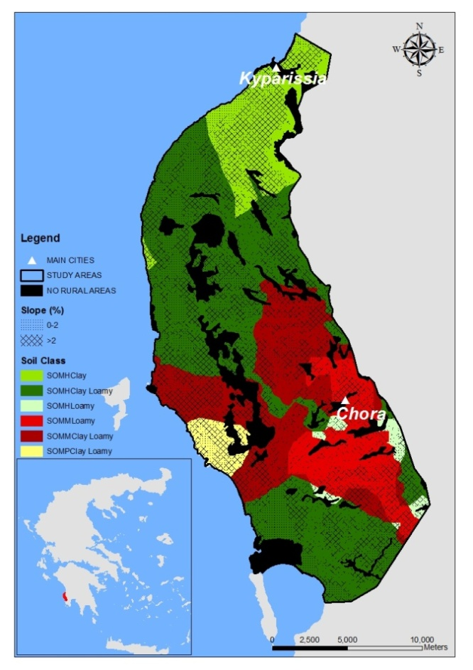
Figure 6: Soil leaching potential of pesticides for the wider area of Trifyllia, Greece

Organic matter and clay content together control the sorption potential of pesticides [19]. Soils with low sorption potentials are more sensitive to groundwater contamination than soils with high potentials. Interactions between leaching and sorption potential govern the overall sensitivity of the soil. A soil that has both a high leaching potential and a low sorption potential is the most sensitive, while soil with low leaching potential and high sorption is the least sensitive [18].
Fine textured soils rich in clay content have low sensitivities because they have low permeability and high sorption potential. According to our rating system, soil leaching potential (SLP) is high in clay loamy soils with increased SOM and in loamy soils with moderate SOM content. Low SLP was observed in clay soils with low SOM. Appropriate farming practices must be applied to decrease leaching risk aiming to minimize the pollution of shallow aquifers in W. Peloponnese. This map can be used by local authorities in order to minimize potential negative environmental impacts of pesticide usage at farm level, and to suggest various mitigation strategies. Another potential group of users are scientists working under the implementation of EU Water framework Directive in Greece.
Most results regarding the processes of leaching and runoff risk have been obtained under laboratory conditions. It is not well documented, under which conditions these laboratory results may be applied to the cultivated land. However, applied research is required regarding the impact of agricultural practices on the assessment of leaching risk in various soil types. It can be argued that mapping of soil units according to leaching risk is a challenging task and such practical investigation is possible to be achieved in the future. Provided that intrinsic risk maps have been compiled on the basis of the proposed assessment methodology, specific risk assessment maps may be further compiled incorporating the specific properties of each active substance, thus reaching a more precise and meaningful spatial distribution map of great use for a given region. Such maps may enhance the compilation of customized-region specific protection measures related to the safe for the environment use of agrochemicals.

- Conclusions
Soil factors controlling losses of pesticides, and among them texture and organic matter largely control pesticide movement in soil. Soil parameters were used and a practical and simple rating system was suggested for the soil leaching potential (SLP) for pesticides, in each soil class. Leaching potential (SLP) varied among soil classes and high risk is observed in clay loamy soils poor in SOM and in loamy soils of the area which have moderate SOM content. The lowest SLP was observed in clay soils with high SOM. This map illustrates low leaching potential in clay soils with high content in SOM. It has been calculated that 71.9% of the cultivated land has moderate SLPand15.0% has high SLP. Using SOM, texture and the two slope classes, results have indicated that high SLRP of pesticides (leaching and runoff) was found in soils with slope 2-6% and clay loamy or loamy texture. Losses in clay soils may be lower in comparison to the rest textural classes, and can be explained by the tendency of these soils to hold water and dissolved chemicals as they have more surface area on which pesticides can be adsorbed.
The frequent application of pesticides, and heavy irrigation in permeable soils with a shallow water table, create favorable leaching conditions which increase groundwater deterioration potential. Farmers have to apply rational irrigation methods and use the lowest required volumes for rational irrigation, taking into account soil properties to minimize the pesticides leaching risk. However, to manage effectively pesticide leaching, authorities, local agencies and land use planners have to deal with the identification of areas susceptible to pesticide leaching. Greece must prepare detailed SLP maps especially for the intensively cultivated areas by linking pesticide models with digital soil maps. Due to the fact that pesticide leaching risk is mainly dependent on specific soil properties and characteristics, it can be argued that soil specific sorption parameters are required for the assessment of the potential pesticide leaching risk.

Acknowledgements
This work was carried out with financial support from the European Union through the LIFE project “Establishment of Impact Assessment Procedure as a tool for the sustainability of agro-ecosystem: the case of Mediterranean olives (SAGE10)”.

References
[1] Vanclooster M., J. Boesten, M. Trevisan, C. Brown, E., Capri, O. Eklo, B. Gottesbüren, V. Gouy and A. van der Linden. 2000. A European test of pesticide-leaching models: Methodology and major recommendations. Agric. Water Management, 44:1-19
[2] Fogg P, Boxall AB, Walker A, Jukes A. 2004. Effect of different soil textures on leaching potential and degradation of pesticides in biobeds. J Agric Food Chem. 52(18):5643-52.
[3] Wu, Q., G. Riise, H., Mulder and L. Haugen. 2004. Influences of suspended particles on the runoff of pesticides from an agricultural field at Askim, SE-Norway. Environmental Geochemistry and Health, 26:295-302.
[4] Farenhorst, A. 2006. Importance of soil organic matter fraction in soil-landscape and regional assessment of pesticide sorption and leaching in soil. Soil Science Society of America Journal, Vol 70, pp. 1005-12.
[5] Hiller, E., Krascsenits, Z., Cernanský, S., 2008. Sorption of acetochlor, atrazine, 2, 4-D, chlorotoluron, MCPA, and trifluralin in six soils from Slovakia. B. Environ. Contam. Tox. 80, 412-416.
[6] Barriuso, E., Feller, C., Calvet, R., Cerri, C., 1992. Sorption of atrazine, terbutryn and 2, 4-D herbicides in two Brazilian oxisols. Geoderma 53, 155-167
[7] Gustafson D. 1989. Groundwater ubiquity score: a simple method for assessing pesticide leachability. Environmental Toxicology and Chemistry, Vol. 8, pp. 339-357.
[8] Capri E., L. Padovani, and M. Trevisan. 2000. La previsione della contaminazione della acquesotterranee da prodotti fitosanitari. Quaderni di techniche di protezione ambientale. Pitagora, Bologna, Italy.
[9] Tiktat, A., D. de Nie, A. van der Linden and R. Kruijne. 2002b. Modelling the leaching and drainage of pesticides in the Netherlands: The GeoPEARL model. Agronomie 22:373-387
[10] Tiktak A, Boesten JJ, van der Linden AM, Vanclooster M. 2006. Mapping ground water vulnerability to pesticide leaching with a process-based metamodel of EuroPEARL. J Environ Qual6;35(4):1213-26.
[11] Gee, G. and J. Bauder. 1986. Particle Size Analysis. In Methods of Soil Analyses, Part 2, 2nd Ed.; Klute, A., Eds.; Amer. Society of Agronomy and Soil Science Society of America: Madison, WI, 9: 383–411.
[12] Nelson, D. and L. Sommers, 1982. Total Carbon, Organic Carbon and Organic Matter. In Methods of Soil Analysis, Part 2; Book Series 9, Page, A.L., Eds.; American Society of Agronomy, Madison, WI, 539–579.
[13] Osman K.T. 2013. ForestSoils, Propertiesandmanagement: Organicmatter of forestsoils. Springer, pp. 63-76, ISBN 978-3-319-02541-4
[14] Yassoglou, N. 2005. Soil association map of Greece. Edited by Agricultural University of Athens (in Greek)
[15] FAO/Unesco.1990. Soil map of the World. Rome, ISBN 92-5-103022-7
[16] Bach M., M. Letzel, U. Kaul, S. Forstner, G. Metzner, J. Klasmeier, S. Reichenberger and H. Frede. 2010. Measurement and modeling of bentazone in the river Main (Germany) originating from point and non-point sources. Water Research 44:3725-3733.
[17] Schottler, S.P., Elsenreich, S.J. and Capel, P.D. 1994. Atrazine, Alachlor and Cyanazine in a large agricultural river system. Environ. Sci. Technol. 28: 1079-1089.
[18] Tiktak A., D.S de Nie, J.D PiñerosGarcet, A Jones, M Vanclooster .2004. Assessment of the pesticide leaching risk at the Pan-European level. The EuroPEARL approach. Journal of Hydrology, Vol. 289, Issues 1–4, 20, Pages 222-238
[19] Huddleston, J.H. 1996. How soil properties affect groundwater vulnerability to pesticide contamination.

