Analysis of Renewable Energy Sources, Aspects of Sustainability and Attempts of Climate Change
LAYTH HAZIM MAJIDª*, HAMID HAZIM MAJID ^{b}, HUSSEIN FAWZI HUSSEIN^{c}
ªPache Protopopescu 43, Bucharest 021406, Romania
^{b}Pache Protopopescu 43, Bucharest 021406, Romania
^{c}Calea Rahovei 293, Bucharest 050898, Romania
ªEmail:laith_aldolaemy@yahoo.com
^{b}Email: laithhazim02@gmail.com
^{c}Email: husseinalaubi@live.co.uk
Abstract
The world is rapidly becoming a global village due to the daily increase in energy demand by the entire population of the world, while the earth in its form cannot change.
The need for energy and related services to meet human social and economic development, well-being and health is growing. The return to renewable energies to help mitigate climate change is an excellent approach that must be sustainable to meet the energy demands of future generations.
The study looked at the opportunities associated with renewable energy sources, including: energy security, access to energy, social and economic development, mitigation of climate change and reducing the impact on the environment and health. Despite these opportunities, there are challenges that hamper the sustainability of renewable energy sources to mitigate climate change.
These challenges include market failures, lack of information, access to raw materials for the future use of renewable resources, and our daily carbon footprint. The study suggested several policy measures and recommendations that, when taken into account, would help achieve the renewable energy target, thus reducing emissions, mitigating climate change and ensuring a clean environment, as well as clean energy for future generations.
Keywords: renewable energy sources; climate change mitigation; sustainability issues; clean energy; carbon footprint; environmental sustainability engineering
- Introduction
The world is rapidly becoming a global village due to the daily increase in energy demand by the entire population of the world, while the earth in its form cannot change. The need for energy and related services to meet human social and economic development, well-being and health is growing. All companies require energy services to meet basic human needs such as health, lighting, cooking, space comfort, mobility and communication and serve as generative processes.[1]
Securing energy supply and reducing the contribution of energy to climate change are the challenges that energy sectors have to overcome on the path to a sustainable future.[2]
It is overwhelming to know in today's world that 1.4 billion people do not have access to electricity, while 85% of them live in rural areas. As a result, it is estimated that the number of rural communities based on the traditional use of biomass will increase from 2.7 billion today to 2.8 billion in 2030.[3]
From a historical point of view, the first commercial coal exploitation took place in 1750, near Richmond, Virginia. Coal is now the most preferred fuel for steam engines because of its higher capacity to transport energy than the corresponding amounts of biomass-based fuels (firewood and coal). It is worth noting that coal was comparatively cheaper and with a much cleaner fuel in the past centuries.[4]
The dominance of fossil fuel-based energy production (coal, oil and gas) and an exponential population growth in recent decades have led to a growing demand for energy, which has led to global challenges associated with a rapid increase in emissions carbon dioxide.[5]
Significant climate change has become one of the greatest challenges of the twenty-first century. Its serious impacts can, however, be avoided if efforts are made to transform the current energy systems. Renewable energy sources have the key potential to shift greenhouse gas emissions from fossil fuel-based energy production and thus mitigate climate change.
Research on alternative energy sources dates back to the 1990s, when the world began to get shock from oil production in terms of price tourism.[4]
The literature shows that replacing fossil energy sources with renewable energy sources, including bioenergy, direct solar energy, geothermal energy, hydropower, wind and ocean energy (tides and waves), would gradually help to achieve the idea of ​​sustainability.
Governments, intergovernmental agencies, stakeholders and individuals in the world today are looking forward to achieving a sustainable future, due to the opportunities created over the past decades to replace oil-derived materials from fossil fuel sources with alternatives to sources renewable energy. The recent launch of a set of Global SDHs contributes to tackling climate change for the 21st century and their impact, and a sustainable future is ensured and made a legacy for future generations.
In this context, the study attempts to examine the potential and trends of sustainable development with renewable energy sources and mitigation of climate change, the extent to which its potential challenges and the way the transition from fossil energy sources to renewable sources can contribute safe way of mitigating climate change.
------------------------------------------------------------------------
* Corresponding author.
E-mail address: laith_aldolaemy@yahoo.com.
- Renewable Energy Sources and Sustainability
Files Renewable energies fill naturally without being exhausted in the earth; they include bio energy, hydroelectric power, geothermal energy, solar energy, wind energy and ocean energy (tides and waves).
Tester (2005) Sustainable energy: Choosing between options defines sustainable energy as "a dynamic harmony between equitable availability of energy-intensive goods and services for all people and preservation of the earth for future generations."[6]
The increasing energy needs of the world, together with population growth, have led to the continued use of fossil fuel (coal, oil and gas) energy sources, which have become problematic by creating challenges such as the depletion of fossil fuels, greenhouse gas emissions, geopolitical and military conflicts, and ongoing fluctuations in fuel prices. These issues will create unsustainable situations that will ultimately result in a potentially irreversible threat to human societies.
However, renewable energy sources are the most remarkable alternative and the only solution to the growing challenges.[7]
In 2012, renewable energy sources provided 22% of global energy production at the level.
Renewable energy sources significantly reduce greenhouse gas emissions if they are replaced by fossil fuels. Since renewable energies are naturally obtained from the current energy flows in our surroundings, they should be sustainable. For renewable energy to be sustainable, it must be unlimited and provide a non-harmful delivery of environmental goods and services. For example, a sustainable biofuel should not increase net CO₂ emissions, should not adversely affect food security or threaten biodiversity.
- Renewable Energy Sources and Technology's
Renewable energy sources are sources of energy from the natural and persistent flow of energy that occurs in our immediate environment. These include: bio-energy, direct solar energy, geothermal energy, hydropower, wind and ocean energy.
  - Hydropower
Hydropower plants are a source of essential energy used by water moving from upper levels to lower levels, mainly to turn turbines and generate electricity. Hydro technical projects include the Dam reservoir project, run-of-river projects and in-stream projects and cover a range of project scale.
Hydro technical technologies are mature from a technical point of view, and their projects exploit a resource that varies temporarily. The operation of hydroelectric tanks often reflects their multiple uses such as flood control and drought.[8]
Primary energy is provided by gravity and the height of the water drop on the turbine. The potential energy of stored water is the water mass, the gravitational factor (g = 9.81 ms-2) and the head defined as the difference between the dam level and tail water level. The tank level changes somewhat down when the water is released and therefore influences the electricity production. The turbines are built for an optional flow of water.
Hydropower discharges practically no particulate pollution, can upgrade quickly, and it is capable of storing energy for many hours.[9].
3.1.1. Hydropower source potential
The annual technical potential generated by hydropower plants is 14 576 TWh, with a total estimated capacity of 3.721 GW; but nowadays the overall installed capacity of hydropower is much lower than its potential. According to the World Energy Council report, about 50% of the installed hydro power capacity is among the four countries, such as China, Brazil, Canada and the USA (World Energy Council, World Energy Council, 2013).
The resource potential of hydropower plants could be changed due to climate change. Globally, changes caused by climate change in the existing hydroelectric power system are estimated to be less than 0.1%, even if further research is needed to reduce the uncertainties of these projections.

3.1.2. Hydropower environmental and social impact
Hydroelectric generation does not produce greenhouse gases and is therefore mostly called a green energy source. However, it has its advantages and disadvantages. Improves a country's socio-economic development; but taking into account the social impact, it removes many of their homes to create, although they are compensated, but they are not enough.
The exploitation of hydropower sites, such as tanks that are often artificially created, leading to flooding in the former natural environment. In addition, water is drained from lakes and water courses and transported through channels over long distances and through pipelines, and eventually to turbines that are often visible but can also pass through the mountains through tunnels created inside them.[10]
Hydroelectric structures affect ecology of the river body, largely by inducing a change in its hydrological characteristics and by disrupting the ecological continuity of sediment transport and fish migration by building dams, dikes and ditches.
In countries where substantial plants or shaft caps are flooded during the construction of a dam, methane gas may be formed when plants begin to degrade in water, either released directly or when water is processed into turbines.
3.2. Bio-energy
Bio-energy is a source of renewable energy derived from biological sources. Bio-energy is an important source of energy that can be used for transports using biodiesel, power generation, cooking and heating.
Bio-energy electricity attracts a wide range of different sources, including forest by-products, such as wood residues; agricultural residues such as cane waste; and animal husbandry residues such as cow dung. An advantage of biomass-based electricity is that fuel is often a by-product, residue, or residual product from the above sources. Significantly, this does not create competition between the land for food and the land for fuel.[11]
3.2.1. Medial bioenergetics and social impact
The use of biological components (plant and animal source) to produce energy has always been accuse of worry especially to the general public and as to whether its food produce are to be used to provide fuel since there are cases of food aid needed around the world in deprived countries. About99.7% of human food is obtained from the terrestrial environment, while about 0.3% comes from the aquatic domain. Most of the suitable land for biomass production is already in use.[12]
Current studies have underlined both positive and negative environmental and socio-economic effects of bio-energy. Like orthodox agriculture and forestry systems, bio-energy can worsen soil and vegetation degradation related with the overexploitation of forest, too exhaustive crop and forest residue removal, and water overuse.[13]
Diversion of crops or land into bio-energy production can induce food commodity prices and food security.[14]
Proper operational management can bring about some positive effects which includes enhanced biodiversity.[15]
3.3. Wind energy
The emergence of wind as an important source of global energy has played an important role among renewable sources. Wind is found all over the world in some places with considerable energy density.[16]
Wind energy feeds the kinetic energy from the moving air. The primacy of the importance of mitigating climate change is to generate electricity from large (turbine) or offshore wind turbines (in freshwater or fresh water).
Onshore wind technologies are already being manufactured and deployed on a large scale. Wind turbines convert wind energy into electricity.
3.4. Tide and wave energy
Surface waves are created when wind passes over water (Ocean). The faster the wind speed, the longer the wind is sustained, the greater distance the wind travels, the greater the wave height, and the greater the wave energy produced.[17]
The ocean stores enough energy to meet the total worldwide demand for power many times over in the form of waves, tide, currents and heat. The year 2008 saw the beginning of the first generation of commercial Ocean energy devices, with the first units being installed in the UK-Sea Gen and Portugal-Pelamis. There are presently four ways of obtaining energy from sea areas, namely from Wind, Tides, Waves and Thermal differences between deep and shallow Sea water.[18]
- Renewable Energy and Sustainable Development
Renewable energy has a direct link to sustainable development through its impact on human development and economic productivity.[5]
Renewable energy sources offer opportunities in terms of energy security, social and economic development, access to energy, mitigation of climate change and reducing the impact on the environment and health.
In figure 1 we can see the opportunities of renewable energy sources towards sustainable development.
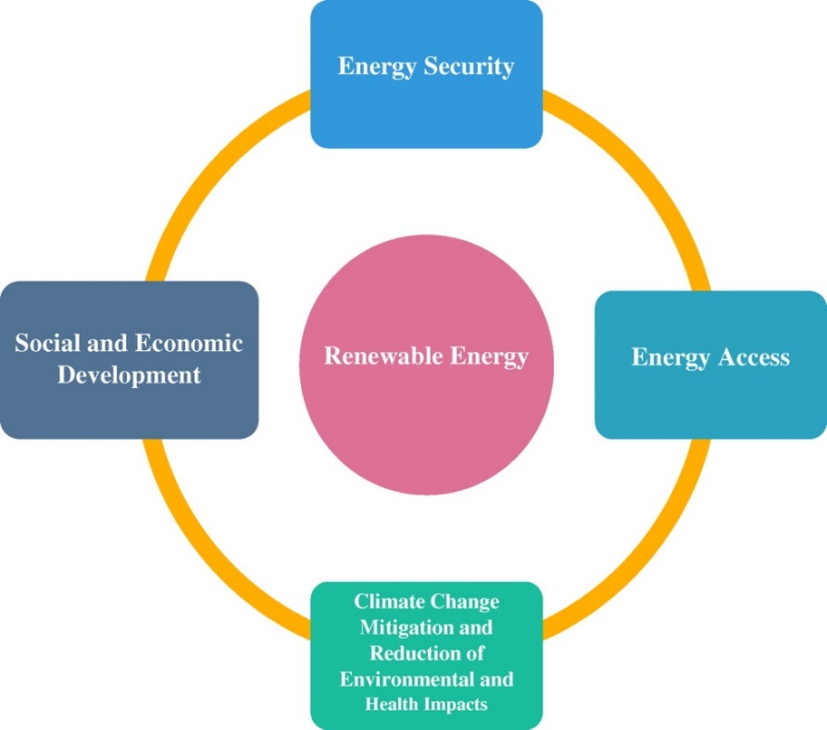

Figure 1: – Renewable energy [7]

  - Energy Security
The notion of energy security is generally used, but there is no consensus on its precise interpretation.
Nevertheless, the concern in the field of energy security is based on the idea that there is a continuous supply of energy that is essential to the functioning of an economy.[19]
Considering the interdependence between economic growth and energy consumption, access to a stable supply of energy is important to the political world and a technical and monetary challenge for both developed and developing countries, as prolonged interference would lead to serious economic and basic functioning difficulties for most societies.[20]
Renewable energy sources are distributed evenly across the globe compared to fossils and, in general, less traded on the market. Renewable energy reduces energy imports and contributes to diversifying the supply options portfolio and reducing the vulnerability of the economy to price volatility and represents opportunities to strengthen energy security across the globe.
The introduction of renewable energy can also help to increase the reliability of specific energy services in areas that often suffer from insufficient access to the grid. A diverse portfolio of energy sources along with good management and system design can help to increase security.[21]
  - Social and Economic Development
Generally, the energy sector has been perceived as a key to economic development with a strong correlation between economic growth and expansion of energy consumption. Globally, per captain comes are positively correlated with per capita energy use and economic growth can be identified as the most essential factor behind increasing energy consumption in the last decades.
It in turn creates employment; renewable energy study in 2008, proved that employment from renewable energy technologies was about 2.3 million jobs worldwide, which also has improved health, education, gender equality and environmental safety.[21]

  - Energy access
The Sustainable Development Objective 7 (clean and affordable energy) aims to ensure that energy is clean, accessible, available and accessible to all, and this can be done with renewable energy as they are generally distributed around the globe. Access to concerns must be understood in a local context, and in most countries there is an obvious difference between electrification in urban and rural areas, especially in Sub-Saharan Africa and in the South Asian region.[22]
Renewable grid-based grids are generally more competitive in rural areas with significant distances to the national grid and low levels of rural electrification, are substantial openings for renewable energy-based mines to ensure their access to electricity.[21]
  - Climate change mitigation and reduction of environmental and health impacts
Renewable energy sources used in energy production contribute to reducing greenhouse gas emissions that mitigate climate change, reduce environmental and health complications associated with pollutants from fossil energy sources. The change in total GHG emissions in the European environment The EEA (1990-1990) and GHG per capita emissions are shown in Figures 2 and 3. Figure 2 show that greenhouse gas emissions decreased by 14% between the 33 EEA countries 1990-2012.
However, there have been variations in individual countries, while there are
here was a decrease in GHG emissions in 22 EEA countries, there was an increase in 11 EEA countries. GHG emissions per capita decreased by 22% between 1990-2012 in the EEA countries, as described in Figure 3 (EEA, 2016).

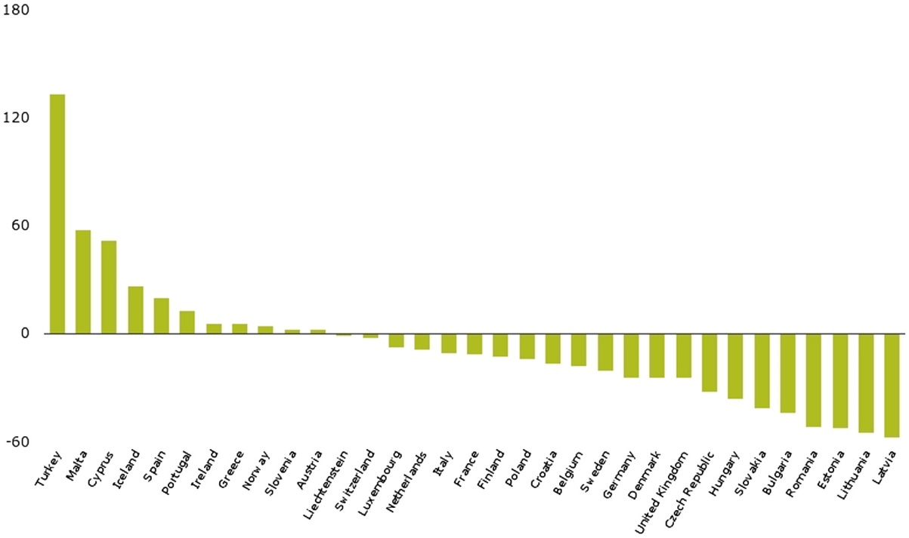
Figure 2: Change in total GHG emissions in EEA-33 countries – 1990-2012
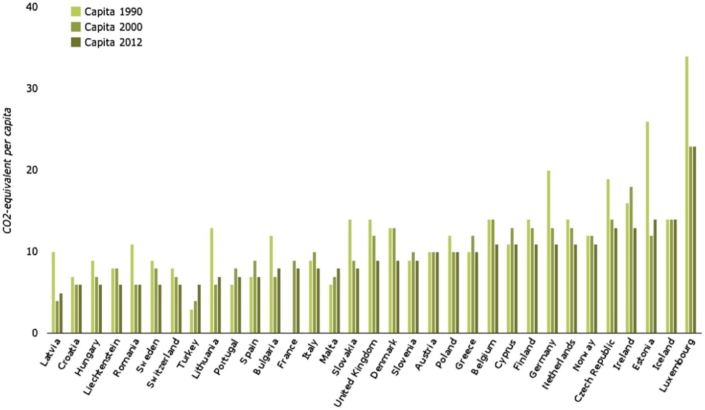
Figure 3: GHG emissions per capita in EEA-33 countries – 1990-2012
5. Challenges affecting renewable energy sources
Renewable energy sources could become the major energy option for low-carbon energy savings. Other changes to all energy systems are needed to make renewable sources of energy available on a large scale. Organizing the transition of energy from non-sustainable energy to renewable energy is often described as the major challenge of the first half of the 21st century.[23]
The following are policy recommendations from the study that can help mitigate climate change and its impact:
- All sectors and regions have the potential to contribute by investing in renewable energy technologies and policies to reduce them.
- Reducing our carbon footprint through lifestyle changes and behavioural patterns can greatly contribute to mitigating climate change.
- Research on innovations and technologies that can reduce land use and can also reduce accidents from renewable energy sources and the risk of resource competition, for example in the field of bio-energy where food for consumption competes with energy production.
- Increase international cooperation and support developing countries to expand infrastructure and modernize technology for modern supply and sustainable energy services as a means of mitigating climate change and its impact.

6. Conclusions
Energy is a compulsory asset in our everyday life as a way to improve human development that leads to growth and productivity.
Returning to renewable sources will help mitigate climate change but must be sustainable to ensure a sustainable future for generations to meet their energy needs. Knowledge of the relationship between sustainable development and, in particular, renewable energy is still limited. The aim of the paper was to determine whether it is possible to regenerate energy sources that are sustainable and how switching from fossil energy sources to renewable sources of energy would contribute to reducing climate change and its impact. Qualitative research has been used to review the articles in the scope of the study.
However, the full life cycle of renewable energy sources does not have net emissions to help limit the future global greenhouse gas emissions. However, cost, price, political environment and market conditions have become the barriers that prevent developing countries, the least developed and the developed ones from making full use of their potential.
In this way, creating a global opportunity through international cooperation to support LDCs and developing countries in terms of accessibility of renewable energies, energy efficiency, clean green technologies and research and investment in energy infrastructure will reduce the cost of renewable energy, remove barriers to energy efficiency (high upgrading rate) and promote new potential for mitigating climate change.
The study highlighted opportunities for renewable energy sources; energy security, access to energy, social and economic development and mitigation and reduction of climate change impacts on the environment and on health. There are challenges that tend to hamper the sustainability of renewable energy sources and its ability to mitigate climate change.
These challenges are: market failures, lack of information, access to raw materials for the future use of renewable resources, and, most importantly, our way of using energy inefficiently.
Based on the findings, the following suggestions can be made that can help improve renewable energy concerns as being sustainable and also reduce the ozone depletion rate due to greenhouse gas emissions, especially carbon dioxide (CO₂):
- To formulate policies and discussions in all sectors to improve technologies in the renewable energy sector to support them.
- Change in the use of our energy in a more efficient way as individuals, countries and the world as a whole. Efforts to increase the share of renewable energy and clean fossil fuel technologies in the global energy portfolio will help reduce climate change and its impact. Energy efficiency programs should be introduced globally, providing tax exemptions to firms that are proving to offer energy efficiency initiatives (energy efficient houses), product design (energy efficiency equipment) and services (heat and energy combined industry). Introducing the concept of use, adaptability and accessibility in the design of energy-dependent products is a way to promote energy-efficient behaviours.
- Increasing research in these areas, so that the fear of renewable sources poses risks in the future is limited.
- Improving education, awareness raising and human institutional capacity in climate change mitigation, adaptation, impact mitigation and early warning. Developed countries should include decarbonisation policies and strategies in industry, energy, agriculture, forests, health, transport, water resources, buildings and other sectors with potential for greenhouse gas emissions. Efforts in developing countries aim at improving institutional capacity building, strengthening institutions and improving research capacity in the field of climate change awareness, promoting adaptability and sustainable development. Least developed countries should develop and test tools and methods with global support leading to direct policy-making in climate change mitigation, adaptation and early warning.
If these suggestions are implemented, the sustainability of renewable energy sources would be as well as the seventh and thirteenth sustainable development objectives to ensure access to affordable, reliable, sustainable and modern energy for all, and to combat climate change and the impact of it.

References

[1] | R. P.-M. Y. S. K. S. P. M. S. K. C. v. S. O. Edenhofer, Renewable Energy Sources and Climate Change Mitigation, Cambridge: Cambridge University Press, 2011.
[2] | S. A. T. Abassi, Renewable energy sources: Their impact on global warming and pollution, Delhi: PHI Learning, 2010.
[3] | K. Kaygusuz, „Energy for sustainable development: A case of developing countries. Renewable and Sustainable Energy Reviews, 16.,” 2012. [Interactiv]. Available: http://dx.doi.org/10.1016/j.rser.2011.11.013. [Accesat 28 4 2018].
[4] | M. P. S. A. T. Abbasi, „The return to renewables: Will it help in global warming control? Renewable and Sustainable Energy Reviews, 15,” 2011. [Interactiv]. Available: http://dx.doi.org/10.1016/j.rser.2010.09.048. [Accesat 28 4 2018].
[5] | P. O. S. Asumadu-Sarkodie, Feasibility of biomass heating system in Middle East Techinical University, Northern Cyprus campus: Cogent Engineering, 2016.
[6] | J. Tester, Sustainable energy: Choosing among options, London: MIT Press, 2005.
[7] | R. M. G.N. Tiwari, Advanced renewable energy sources, London: Royal Society of Chemistry, 2011.
[8] | P. R. H. J. P. O. S. Asumadu-Sarkodie, „Situational analysis of flood and drought in Rwanda,” International Journal of Scientific and Engineering Research, nr. 6, pp. 960-970, 2015.
[9] | A. Hamann, Coordinated Predictive Control of a Hydropower Cascade, Pittsburgh, Pennsylvania: Carnegie Mellon University, 2015.
[10] | F. Forsund, Hydropower economics, vol. 217, New York: Springer, 2015.
[11] | T. M. F. Urban, Climate change, disasters and electricity generation, Brighton: Institute of Development Studies, 2011.
[12] | A. Ajanovic, „Biofuels versus food production: Does biofuels production increase food prices?,” 2011. [Interactiv]. Available: https://doi.org/10.1016/j.energy.2010.05.019.
[13] | J. G. L.P. Koh, „Biofuels, biodiversity and people> Understanding the conflicts and finding opportunities,” Biological Conservation, nr. 141, pp. 2450-2460, 2008.
[14] | S. F. D. Headey, „Anatomy of a crisis: The causes and consequences of surging food prices,” Agricultural Economics, nr. 39, pp. 375-391, 2008.
[15] | P. L. M. W. N. L. I. D. C. Baum, „Effects of short rotation coppice with willows and poplar on soil ecology,” Landbauforschung vTI Agriculture and Forestry Research, nr. 59, pp. 09-2009, 2009.
[16] | J. G. M. A. L. R. James F. Manwell, Wind Energy Explained: Theory, Design and Application, 2nd Edition, Massachussets: Wiley, 2009.
[17] | M. D. M.Z. Jacobson, „Providing all global energy with wind, water and solar power, Part I: Technologies, energy resources, quantities and areas of infrastructure and material,” Energy Policy, nr. 39, pp. 1154-1169, 2011.
[18] | D. L. M. Esteban, „Current developments and future prospects of offshore wind and ocean energy,” Applied Energy, nr. 90, pp. 128-136, 2012.
[19] | D. v. V. H. d. F. H. G. B. Kruyt, „Indicators for energy security,” Energy, nr. 37, pp. 2166-2181, 2009.
[20] | N. K. H.H. Larsen, „How do we convert the transport sector to renewable energy and improve the sector's interplay with the energy system?,” în Transport renewable energy in the transport sector and planning, Copenhagen, Technical University of Denmark, 2009, pp. 61-94.
[21] | R. P.-M. Y. S. K. S. O. Edenhofer, Reneable Energy.
[22] | A. Brew-Hammond, „Energy access in Africa: Challenges ahead,” Energy Policy, pp. 2291-2301, 2010.
[23] | A. Verbruggen, „Renewable energy costs, potentials, barriers: Conceptual issues,” Energy Policy, pp. 850-861, 2010.

