Tilling land up and down the slope increases chances of high erosion (Plate 4.1). Most farmers in Isiukhu river catchment till their farms up and down the slope encouraging high soil erosion risk. Poor land use increases C factor values.
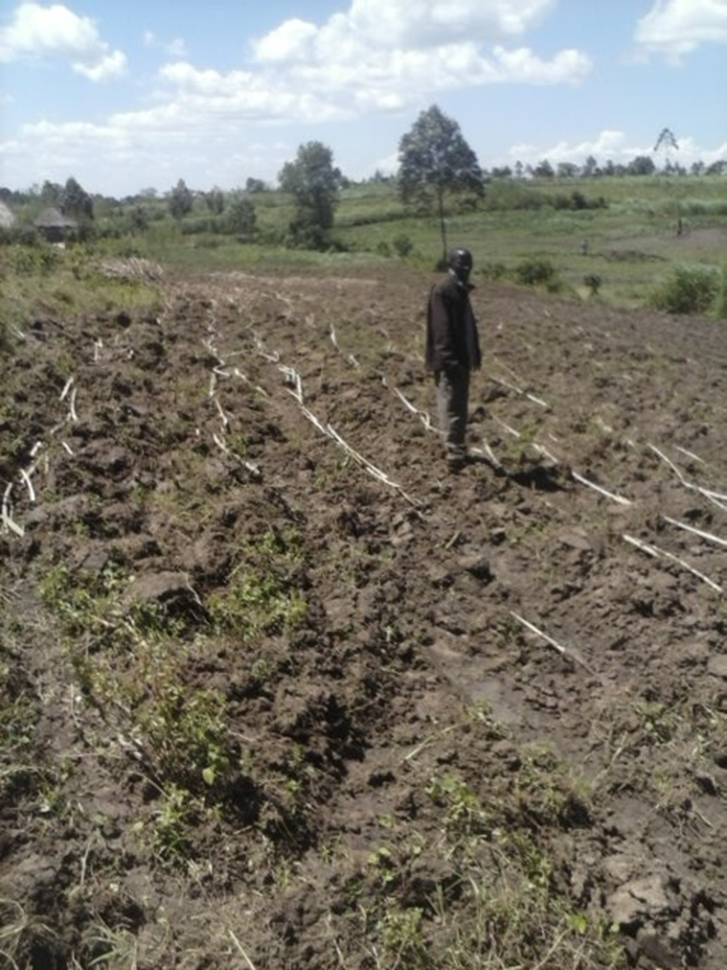
Plate 4. 1: Tilling land up and down the slope (improper land use) leads to high values C factor

Tilling land without soil erosion control support measures increases erosion rate (Plate 4.2). Most farms in Isiukhu river catchment have no soil erosion control support structures making P factor to have a maximum value of 1.
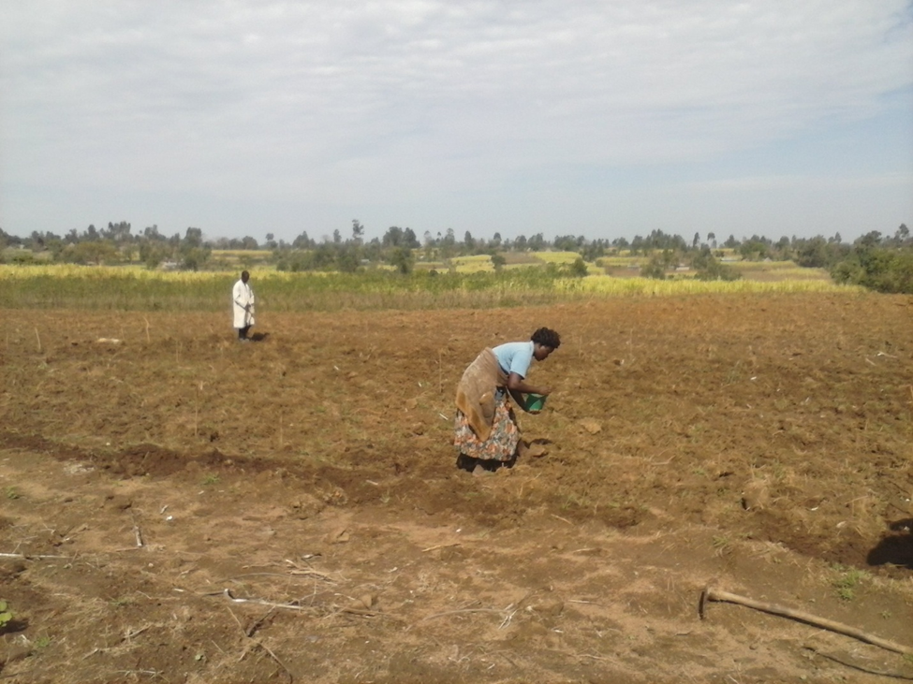
Plate 4. 2: A bare farm without soil erosion control structures in Isiukhu river catchment

Opening up land on steep slopes of Nandi escarpment which is the source of Isiukhu river is among the main factors contributing to soil erosion risk (Plate 4.3)
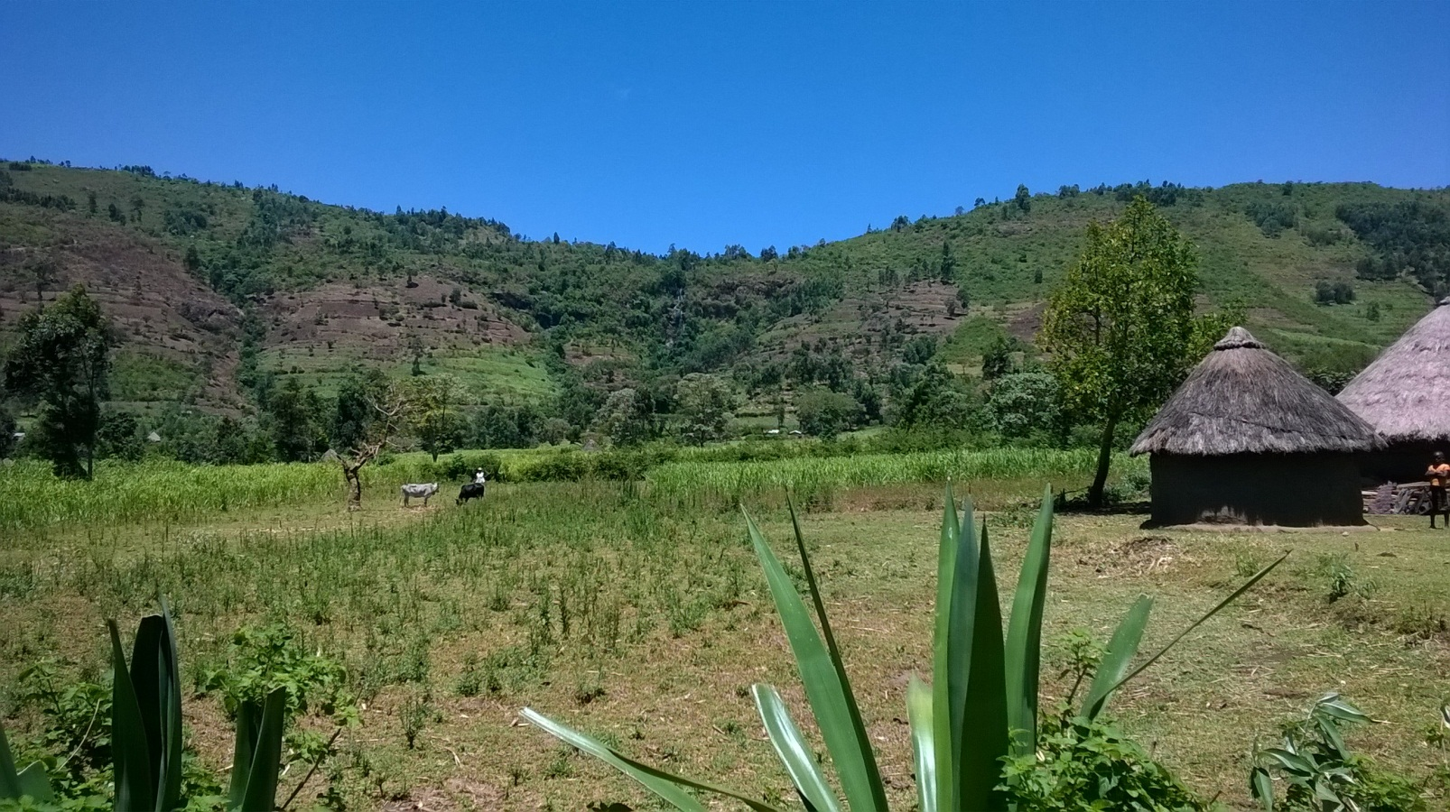
Plate 4. 3: Soil erosion on steep slopes of Isiukhu river source

Plate 4.3 shows evidence of encroachment on Isiukhu river catchment through intensive farming activities. Clearing forest land for crop activities and settlement has led to soil erosion risk within the catchment.

Plate 4.4 shows evidence of encroachment on Isiukhu river catchment through intensive farming activities. Clearing forest land for crop activities and settlement has led to soil erosion risk within the catchment.

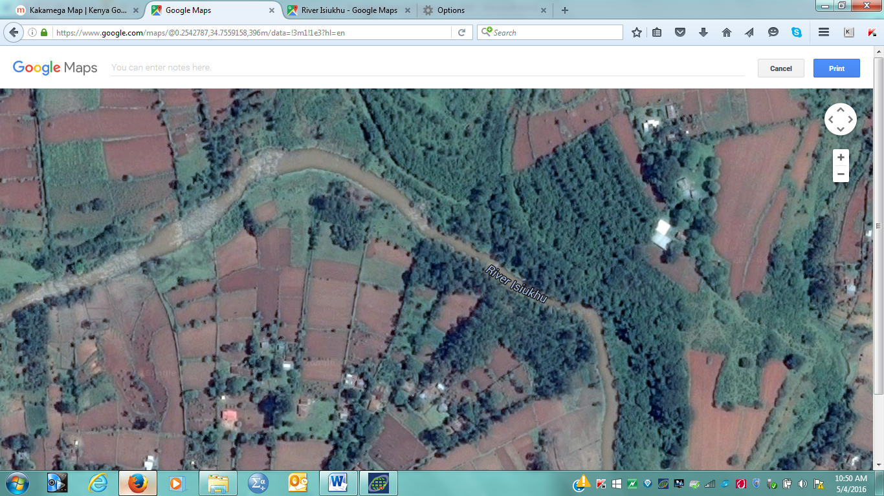
Plate 4. 4: Encroachment of Isiukhu river catchment
Source: Google map

Forest encroachment leads to high surface run-off. Encroachment on Isiukhu river catchment has increased with time (Plate 4.5).
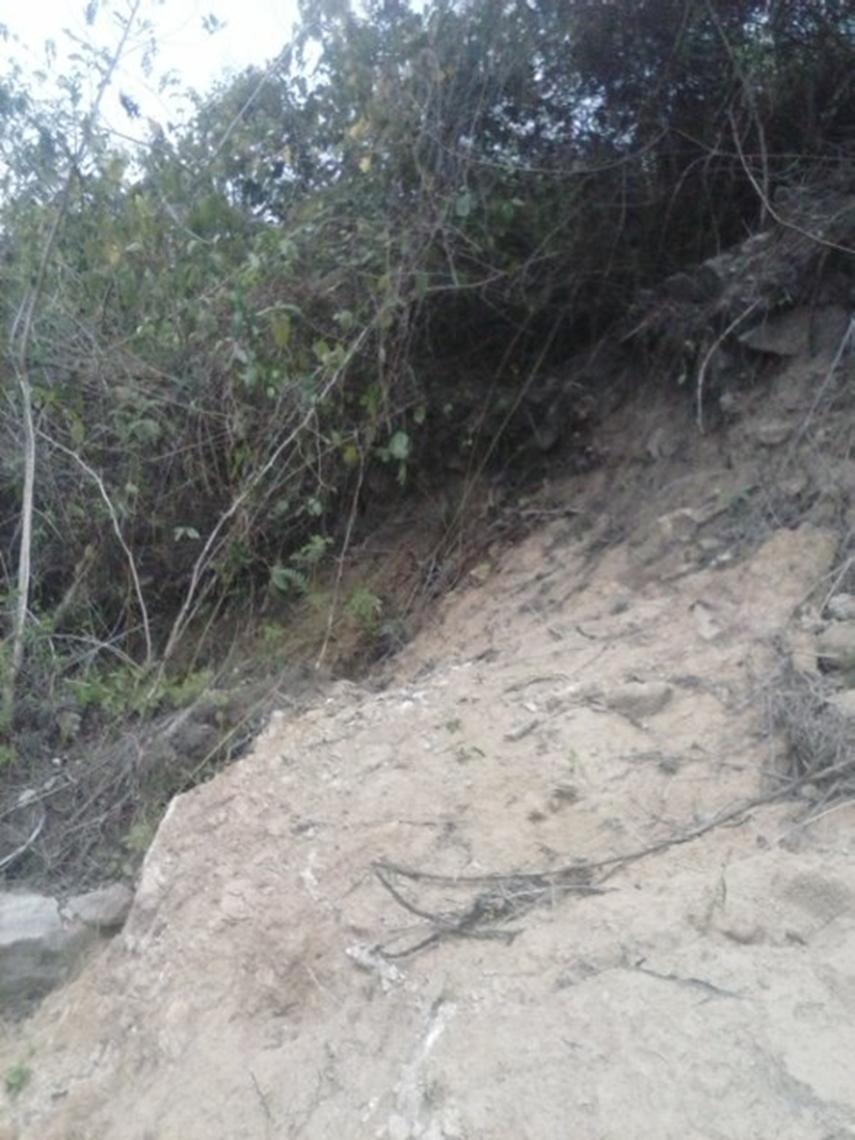
Plate 4. 5: Forest encroachment in Isiukhu river catchment

High rate of deforestation in Isiukhu river catchment has exposed ground surface to surface run-off (Plate 4.6).
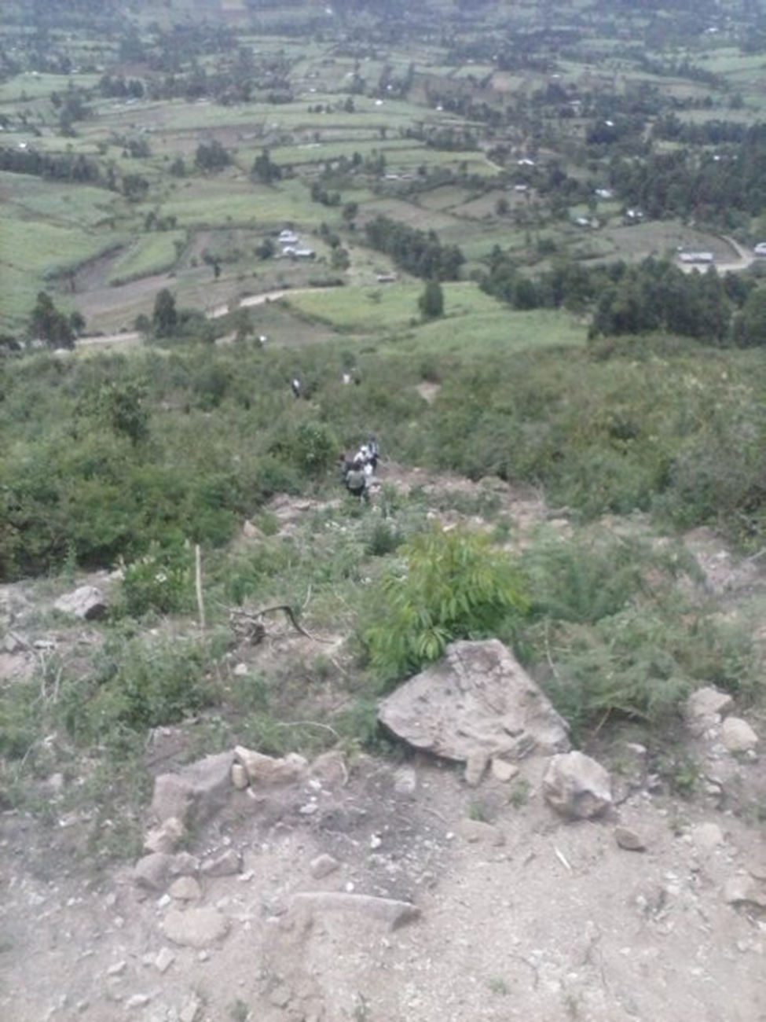
Plate 4. 6: Deforestation exposes ground surface

Plate 4.7 shows the landslide that occurred at Khuvasali area in Isiukhu river catchment in August 2007. The community within the catchment have not implemented erosion control measures to reduce land slide.

Plate 4. 7: Rescue team at KIhuvasali landslide in August 2007
Source: UN, 2007

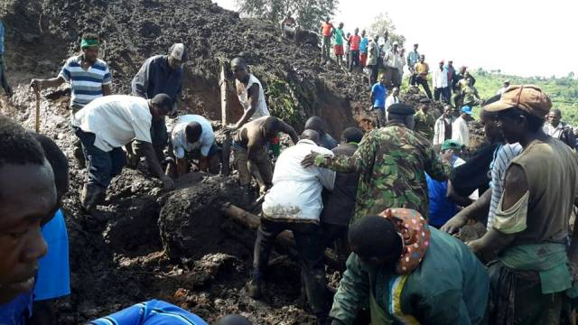
Plate 4. 8: Rescuers at Chepng’abai hills Landslide in May 2016
Source: UN, 2016

