**INEQUALITIES IN CHILD SURVIVAL IN NIGERIA: A MULTILEVEL MODELLING APPROACH**

Simeon. Olawuwo, Ntonghanwah. Forcheh and Keamogetse. Setlhare.

University of Botswana, Gaborone, Botswana**. (DE6C425 Simeon Olawuwo - sc)**

**Abstract-**

According to UNICEF estimates, Nigeria loses some 2,300 children aged five years or younger every year from mainly preventable causes. Many researchers have tried to shed light on the correlates of childhood mortality in Nigeria and targeted policies have led to declining rate of child mortality, but the rate of declining has been too slow for Nigeria to meet its MDG targets. Low coverage of interventions, a weak primary health care system, staffed by inadequate number of skilled health professionals, have been cited as some of the reasons behind the slow pace of reduction. Administratively, Nigeria is divided into regions, states within regions, and further sub-regional divisions that impact on how interventions can be rolled out to the population. Therefore, relevant research on identifying the background of children who are most at risk need to take this multi-level structure into account. The aim of this paper is to build multi-level models that can help explain the variation in child mortality in Nigeria and in particular to determine factors that are associated with childhood mortality in different regions in Nigeria. We use data from the 2013 Nigeria Demographic and Health Survey to build multi-level model that takes effects at regional level and individual child attributes into account. The study found that the risks of death were higher for children of mothers residing in the North-east and North-west regions compared with children in South-west region of the country.

**Key-words:**Childhood mortality, multilevel model, Contextual factors, NDHS, Individual-level factors.

.

**INTRODUCTION**

Nigeria is a large and very diverse country in terms of its geography, ecology, economic development, social and religious mix and cultural practices [3], health-seeking practices [9] and political milieu. The extent to which these factors contribute to the highly variable childhood mortality rates across the regions in the country need to be further examined.

Studies on childhood mortality in Nigeria have focused mainly on causes of child mortality. However, as echoed by UNICEF and others, the reasons for variations in childhood deaths are not well known. As a result of this, the ability to get targeted interventions to the right persons remains a major stumbling block. Indeed, it has been observed that improvement in healthcare programmes alone has not been adequate to bring down the level of childhood mortality to the MDG target because most illnesses are influenced by lifestyle of individuals [9], socio-economic factors [14], level of use of healthcare services [18] and cultural values [7]. In their studies [7, 19, 18] found the major causes of childhood mortality to include age of mother, feeding practices, type of household roofing materials and the geographical location of a child. These studies confirmed the views that the contextual characteristics of the community or neighbourhood where children are born or raised tend to affect their chances of survival.

The focus of this study is to determine the factors that contribute to regional variations in childhood mortality in Nigeria using a multilevel modelling approach that would help identify how different factors contribute to these variations. We focus on whether there are noticeable inequalities in child mortality among the regions and if there are, what major variables are responsible for such inequalities. The results of the study would help in removing obstacles that have been hindering interventions provided by both the Nigerian government and some international organizations from reaching the right persons in the right locations in the country. The study employs geo-additive Bayesian survival model to unravel the geographical variations in under-five mortality in the country. Inference is fully Bayesian and is based on Markov Chain Monte Carlo (MCMC) simulation technique. Used for the study is the 2013 Nigeria Demographic and Health Survey (NDHS) dataset. Discrete-time model allows for the analysis of time as a discrete phenomenon and is therefore considered appropriate in this study because survival times of children are given in months only.

To better examine the influence of the risk factors on the deaths of children across the regions in Nigeria, we put the variables into two categories. These are: demo-graphic variables that are related to the mother and child and those associated with facilities available to households where the child lives. It was assumed that infant mortality might be more associated with endogenous factors such as low birth weight and hereditary diseases [20] while deaths among older children would likely come from diseases and malnutrition, which are usually caused by socio-economic and cultural factors [24]. Therefore, we carried out the analysis only for all children under the age of five years, this was done to enable us study the current mortality rate from birth up to the first five years of life.

**DETERMINANTS OF CHILDHOOD MORTALITY**

There have been considerable numbers of studies on the effect of demographic, socio-economic and environmental factors on mortality in the developing world especially in Nigeria. For instance, [3] observed that there was regional inequalities in health-seeking attitude especially regarding immunizations in Nigeria, in the use of maternal and child health care services [3], communicable diseases [19], socio-economic and environmental factors [14]. Findings from these confirm perception of [18] that the place where a child is born determines his or her survival. We provide a brief review that we expect to guide us in the choice of variables to be included in the study based on these previous findings and other important factors. A malnourished child is not strong enough to fight infections, and malnutrition is a contributory cause of between one-third or half of all under-five deaths [2, 16]. Child under-nutrition in developing countries is usually caused by poverty, which usually comes from low family income, large family size, poor education, poor environment and housing, inadequate access to food, to safe water and to health care services [8]. Therefore, the following variables are included in the study: sex of the child, mother’s education, source of water, type of toilet facilities and the wealth index. These variables are considered important in examining the factors presumed to be responsible for inequalities in childhood mortality in Nigeria. The physical, socio-economic and political environment in some of the countries in sub-Saharan Africa account for geographical inequalities in childhood mortality [3]. Such environment primarily, is the regional environment. Environment characterized by pollution and poverty would expose children to disease-causing agents, influencing high rate of mortality in them. Therefore, other variables considered for inclusion in the study are type of place of residence (rural or urban) and the region of residence.

Mother’s education is considered important because of her responsibility for her own care during pregnancy and the care of her child through the most dangerous stages of its life. Mother’s educational level can affect child survival by influencing her choices and increasing her skills in health care practices related to contraception, nutrition, hygiene, preventive care and diseases treatment. In most developing countries, mother’s education has an inverse relationship to childhood mortality, this has been found to be stronger during childhood than infancy [4] and there has been”no stability across countries in absolute level of child survival according to mother’s level of education” [15]. Logically, it would be expected that women with secondary education, compared to less educated women, should have a better understanding of the modern world and be able to manipulate it to the survival advantage of their children. According to [5], higher income among educated parents should give them access to adequate nutrition, good housing and adequate medical services for their children. Consequently, their children would be expected to experience a lower rate of mortality. Therefore, one of the suggested ways for maternal education to influence child survival is in the utilization of health care facilities [17, 15]. According to [15], a mother’s education enables her to exploit the facilities of the city even if she is resident in a village. For example, she becomes less submissive to fate and more secular about illness, more capable of receiving attention from hospital workers and more informed about where the right facilities are and how best to exploit them to her child’s advantage. She is more persistent in the recommended treatment, more likely to report back if the situation does not improve and more likely to give rest to a sick child. Also, [6] found that more educated patients made more use of modern health services.

**MATERIAL AND METHOD**

**DATA**

The study uses the 2013 Nigeria Demographic and Health Survey (NDHS). Demographic and Health Survey (DHS) project is an ongoing collaboration between the United States Agency for International Development (USAID) and country-specific agencies to conduct nationally representative household sample surveys with cover-age of a range of population health indicators in low-and middle-income countries (LMICs) [10]. The DHS collects a wide range of objective and self-reported data with a strong focus on health, mortality, nutrition and self-reported health behaviours among adults such as alcohol consumption, tobacco use and detailed contraceptive use histories [11]. Data on household structure, urban and rural living, household wealth, maternal education, employment, fertility and health outcomes have been a major part of the DHS data collection effort. Child’s cause of death using a verbal autopsy in-strument to ascertain cause of death has been added to the DHS data [12]. The multi-stage sampling methodology of the DHS facilitates hierarchical data analysis, and level of interviews from households, mothers, fathers and children enables design of mother-child, or father-mother-child, and also facilitates intra-household analysis.

The 2013 NDHS was a nationally representative population and health survey con-ducted by the National Population Commission (NPC) in collaboration with the Ministry of Health, Nigeria and technical support was provided by the ORC Macro. The survey includes retrospective birth history data and death information on all children ever born to the respondents. Date of birth is reported in months and years, and age of mother at birth, survivor-ship status and current age or, if the child had died, age at death are generally reported in months for death at two years of age or younger, and in years for deaths above two years [13].

Nigeria is divided into 36 states and a Federal Capital Territory (FCT). These states are subdivided into 774 Local Government Areas (LGAs). The states are grouped by geographical location to form six regions. During the 2006 population census, each locality was subdivided into convenient areas called census enumeration areas (EAs). The EAs in Nigeria are small in size, with an average of 211 inhabitants (equivalent to 48 households) [13].

The 2013 NDHS program adopted the sampling frame designed for the 2006 population and housing census. The primary sampling unit (PSU) which was regarded as a cluster was defined on the basis of Enumeration Areas (EAs) from the 2006 EA census frames. Samples for the surveys were selected using stratified 3-stage cluster procedure [13]. Relevant data for this study (women age 15-49 years that had at least one live birth within the 5 years preceding the survey) were extracted from the datasets. This implies that the study population for this analysis included children born between exactly zero and five years preceding the survey; who were the outcomes of singleton deliveries and who either survived this period or not. The unit of analysis was the child born in 5 years before the survey. In the dataset, 40,320 households were selected, of which 38,522 were interviewed. In the interviewed households, 39,902 women in the childbearing age (15 49years) and 18,229 men were found eligible for the interview. This represents a response rate of 99 percent for households, 98 percent for women and 95 percent for men.

**STATISTICAL METHODS**

The discrete time-scale is usually partitioned into k intervals in the discrete-time survival analysis,  with. The intervals do not need to be equal in length and it is assumed that all censoring happen at the end of the intervals. Assume the discrete time T = t;  be the observed event in month after birth in the interval It. Also let  denotes a vector of covariates. Then, the discrete hazard function, which according to [18], is the conditional probability of failure (death) occurring in interval  given that the child survives to the beginning of the interval, is given by



The corresponding discrete survival function is given by



Information regarding the Survival of each child is recorded by , , where  is the child’s observed survival time in months and  represents the survival indicator with  if the child  is dead and  if the child is still alive at the time of the survey. Hence, for, ti is the age at which the child died while  is the child’s age at the time of the survey.

The event of death of the ith child could be regarded as a sequence of binary outcomes and can be cast into the framework of binary regression models [21] by defining a binary event indicator  with



|  |  |  |  |
| --- | --- | --- | --- |
|  |  |  |  |
|  |  |  |

The indicator  could be linked to the covariates Xit an appropriate link function for binary response model. The hazard function of (1) for the ith child can then be written as a binary response model



Where h is an appropriate link function. Here, we assumed the logit link which can be linked to the covariates as:

|  |  |
| --- | --- |
|  |  |

Where  is the baseline effect and  is a vector of fixed effects parameter. Equation (4) therefore becomes



where f(Xit) is a smooth function for the non-linear effects of continuous covariates, (e.g. mother’s age), the vector Vit are the categorical covariates while is a vector of the parameters.

To estimate model parameters and smooth functions, a fully Bayesian approach was adopted and priors assigned appropriately. We assumed Bayesian P-spline priors for the baseline and non-linear effects as in [22]. We assume diffuse priors for the fixed effects. Sensitivity analysis was done using different values for the hyperparameters. Standard choices for the hyperparameters are a = 1 and b = 0:005 or a = b = 0:001. The results we presented are those for a = b = 0:001. MCMC sampling from full conditional for all the effects is used for posterior analysis. We carried out a total of 15,000 iterations, with the first 2,000 discarded as burn-in and every 10th observation was thinned for parameter estimation.

**RESULTS**

Table 1 shows results of the fixed parameters for children under the age of five. Posterior means (i.e. mean of parameter estimates based on MCMC simulations) and 95 percent credible intervals (CI) are presented. Results of the fixed effects agree with previous research findings on child mortality in developing countries. Children in rural areas have higher risks of death compared with those living in urban areas. Results from the table also show lower risks for female children compared with their male counterpart.

From the table, children whose parents have primary, secondary or higher education experience lower risks of mortality compared with those whose parents are with-out education. Results for wealth index reveal that children from richest, richer and middle have lower risks of dying compared with those from the poorest index house-holds, while results for the poorer category is surprisingly higher. Children whose parents practice both Christianity and Islamic religions have higher risks of mortality compared with children of parents with traditional and other religion. Children from households with improved toilet facilities and those that source their water from pipes and wells have lower risks of dying compared with their other counterparts. Although, the table shows that the estimates for these variables are insignificant. For the six geopolitical zones, the table shows higher risks of mortality in the North-east and North-west compared with the North-central region, while there is a lower risk of dying from the southern regions except in the South-east where there is higher mortality.

The estimated posterior means and 95 percent CI for child’s age (baseline) for children under five are shown in Figure 1. The baseline for children under five reveals a quick decrease in risks of dying between age 0 and 1 month followed by a constant pattern till around 12 months where a slightly small bump is seen, which could be due to heaping effect. Thereafter, there is a gentle fall till around age 15 months before the curve rises gently again between age 20 and 24 months. It later followed by a sinusoidal pattern up to around age 54 months. Within this sinusoidal pattern there are two noticeable peaks around ages 36 and 48 months which might be the problem of heaped survival times. The risk of dying then remains very low from age 54 to 59

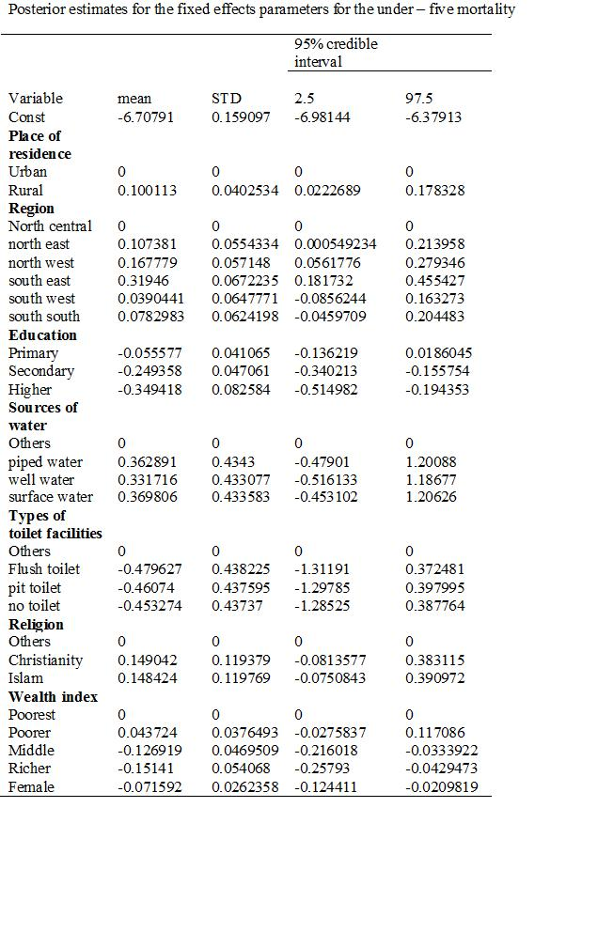



Table 1: Fixed Effects



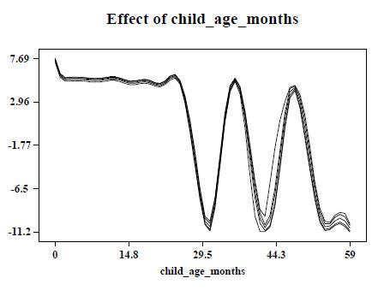

months. The baseline for the infant data shows that there is sharp drop in risks of dying at the neonate age. The estimated effects for the infants show an opposite pattern when compared with the curve for children under five.

**DISCUSSION OF RESULTS**

Findings from this study show patterns of under-five mortality that reflect significant inequalities among regions in Nigeria. For example, in respect to other regions, under-five deaths is considerably higher in North-east, North-west and South-east. However, significant lower mortality levels were obtained in the South-south and South-west of the country. The findings may be as a result of the fact that the health sector is characterized by wide regional disparities in status, service delivery, and resource availability. In Nigeria, there is more health services located in the Southern States than in the North. The North-east has also continued to face food insecurity because of the continual effects of the Boko Haram insurgency leading to severe acute malnutrition among children. Continual and persistent bombing in the oil-rich part of the southern Nigeria could also be responsible for high rate of child mortality in the South-east.

Importance of the provision of essential social amenities cannot be ignored as this may possibly be part of the reasons for high mortality in the north-east and part of the southern regions. Already, pervasive poverty, high level of illiteracy among women, limited access to safe drinking water and adequate sanitation, poor feeding and hygienic practices, overcrowded housing and limited access to quality health services have been suggested as the causes of huge childhood morbidity and mortality in these

regions [23]. Interventions that could lead to behavioural change (for instance, murderous mindset and the destructive tendencies of the Boko Haram and Niger Delta gangs) in addition to improving the available social amenities in these regions would go a long way to ameliorate the survival chance of the young children [18]

Mother’s educational status and household wealth index are important factors in explaining inequalities in child mortality. The strong relationship between mother’s education and child survival has led to the advocacy that enhancing mother’s education be adopted as a method for reducing child morbidity and mortality [14, 18]. Findings from this study show higher levels of child mortality for children whose parents attained primary education against those whose parents had no education. This there-fore, further establishes the need to raise mother’s education to at least the secondary level in Nigeria possibly by providing free and compulsory education for female children at these levels of education. Children born to parents from poor households are confronted with challenges such as food inadequacy and lack of access to basic health-care facilities. The results of the household wealth index are rather encouraging. We found significantly lower risks for children from the richest quantum in the model with-out amenity variables. This shows that, with the prevailing low level of social amenities in Nigeria, the impact of family wealth on child mortality becomes weak.

The importance of improved toilet facilities to child survival as shown in this study cannot be overemphasized. The use of pit latrine and other surfaces for passing excreta has been shown to have higher risk of morbidity and mortality among children because they could be easily contaminated [14]. The non-significance of water source might result from the fact that in Nigeria; pipes are often dry, leaving the people to obtain their water from other sources. The baseline effects show that risks of dying are highest in the first month of life and reduce thereafter. Interventions that are cost-effective, such as early post-natal home visits and case management of neonate infections need to be intensified in all regions in Nigeria.

**CONCLUSION**

The modelling approach clearly showed inequalities in child mortality from region to region in Nigeria. These inequalities might be attributed to common childhood disease prevalence, general healthcare practices, similar poverty level and acute malnutrition caused by food insecurity and problem emanating from the Boko Haram and Niger Delta disturbances in some part of the country. Cost-effective interventions would be needed to save the lives of these children. Findings from this study could help policy-makers and international donors in their various intervention programmes aimed at saving the lives of our children.

**REFERENCE:**

[1] UNICEF (2013). Level and Trend in Child Mortality Report 2013, United Nation Children’s Fund (2013).

[2] Black, RE, Morris, SS, Bryce, J. (2003).Where and why are 10 million children dying every year? Lancet 2003; 361: 2226-34.

[3] Antai et al. (2009). Ethnic disparities in child health in Nigeria: a multilevel analysis of individual and contextual factors. Ethnicity and Inequalities in Health and Social Care 2(4), 39-49.

[4] Palloni A. (1985). Health Condition in Latin America and policy’s mortality change. In Health Policy and Mortality Prospects (Edited by Valin J. and Lopez A.). Ordina, Liege, 1985.

[5] Colclough (1982). The impact of primary schooling on economic development: a review of the evidence. World Dev. 10, 167, 1982.

[6] Cleland JC (1989). Maternal education and child survival in developing countries: the search for pathways of influence in selected readings on the cultural, social, behavioural determinants of health. Australian National University. Canberra, 1989.

[7] Kandala NB, Ghilagaber G. (2006). A geo-additive Bayesian discrete time survival model and its application to spatial analysis of childhood mortality in Malawi. Quality and Quantity, 40,935-957.

[8] Gopalan, S. (2000). Malnutrition: Causes, Consequences, and Solutions. Nutrition 16, 556-558.

[9] Babalola, S. and Fatusi, A. (2009). Determinants of use of maternal health ser-vices in Nigeria- looking beyond individual and household factors. BMC pregnancy and childbirth. 9(1), 43.

[10] MEASURE DHS: Demography and Health Surveys. Calverton, MD: ICF Macro.2009. <http://www.measuredhs.com/who-we-are/upload/MEASURE-DHS-Brochure.pdf>

[11] Daniel, JC et al., (2011).Demographic and Health Surveys: a profile. International Journal of Epidemiology 2012: 1-12.

[12] Garrett DA, et al., 2011 Field-friendly technique for assessment of nutrition for development. Am J. Clin Nutr 2011; 94: 68-90.

[13] National Population Commission (NPC) [Nigeria] and ICF International. 2014: Nigeria Demographic and Health Survey 2013. Abuja, Nigeria, and Rockville, Maryland, USA: NPC and ICF International.

[14] Folasade, I.B. (2000). Environmental factors, situation of women and child mortality in South Western Nigeria. Socio Science and Medicine 51, 1473-1489.

[15] Caldwell, J.C. (1979). Education as a factor in mortality declines an examination of Nigeria data. Population Studies, 395-413.

[16] Caulfield L, Black R. (2002). Malnutrition and the global burden of disease: Underweight and cause-specific mortality. Geneva, Switzerland: World Health Organization; 2002.

[17] Orubuloye I.O. (1995). The Demographic Situation in Nigeria and Prospects for Fertility Transition. J. Int DEV 1995, 7:135-144.

[18] Gayawan, E., Adarabioyo, M.I., Okewole, D.M., Fashoto, S.G. and Ukaegbu, J.C. (2016).Geographical variations in infant and child mortality in West Africa: a geo-additive discrete-time survival modelling. Genus (2016) 72:5

[19] Kandala, N.B., Ji, C., Stallard, N., Stranges, S., and Cappuccio, F.P. (2007). Spatial analysis of risk factors for childhood morbidity in Nigeria. American Journal of Tropical Medicine and Hygiene,77(4),770-778

[20] Balk, D., Pullum, T., Storeygard, A., Greeenwell, F., and Neuman, M. (2004). A spatial analysis of childhood mortality in West Africa. Population, Space and Place, 10,175-216.

[21] Fahrmeir, L., and Tutz, G. (2001). Multivariate statistical modelling based on generalized linear models (3rd ed.). New York: Springer.

[22] Lang, S., and Brezger, A. (2004). Bayesian P-splines. Journal of Computational and Graphical Statistics, 13(1), 183-212.

[23] WHO. (2009). WHO country cooperation strategy 2008-2013. Sierra Leone: WHO regional office for Africa.

[24] Kembo, J., and Van Ginneken, J. K. (2009). Determinants of infant and child mortality in Zimbabwe: results of multivariate hazard analysis. Demographic Research, 2(13), 367-384.