Challenges to Industrial Water Pricing in Mandalay Region
Thwe Thwe Thana*, Aye Aye Thantb

ª Department of Civil Engineering, Mandalay Technological University, The Republic of the Union of Myanmar ^{b}Department of Civil Engineering, Mandalay Technological University, The Republic of the Union of Myanmar ªEmail: thwethwethan18@gmail.com
^{b}Email: yelinthant05@gmail.com

Abstract
This paper focuses on major aspects for challenges of industrial water pricing in Mandalay. The situational analysis on water supply system in Mandalay was conducted by questionnaire survey based on literature. In Mandalay, it is categorized by three zones of water resources according to the depth of tube wells which can get enough volume of groundwater. At present condition, there are 12 booster pumping stations, two treatment plants and 33 tube wells for public water supply. However, public water supply does not cover the whole city and industrial water supply is still being lack. Most industries extract vast amount of groundwater and discharge contaminated water into the surface water sources. Infrastructure in water supply, public appreciation for the water value, public-private-partnerships, going green, climate change patterns and impacts, groundwater abstraction, groundwater regulations and industrial water tariff system are studied in Mandalay area. Based on this study, the main challenges concerned with industrial water pricing are identified for Mandalay area.
Keywords: industrial water pricing; situational analysis; public water supply; main challenges; infrastructure in water supply
- Introduction
Myanmar is a country in a relatively favourable situation with respect to water resources. It has more fresh water per capita than all surrounding countries. With its abundance in natural resources, the country has great opportunities to achieve a balanced and sustainable development. All water resources of Myanmar are within the national borders and 3 out of 4 are national rivers [2].
------------------------------------------------------------------------
* Corresponding author.
E-mail address: thwethwethan18@gmail.com.
Mandalay is one of the most arid regions in Myanmar. Mandalay is situated on the eastern bank of Ayeyarwady river. The area of Mandalay is 121.75 squared miles. There are six townships in Mandalay. According to 2014 census, about 1.5 million of people live in Mandalay municipal area. It bears most of water problems: its climate is changing to warmer and less rainy; some of the places along the Ayeyarwady river are massively polluted; groundwater is overexploited. There is municipal water supply network being distributed from surface water sources such as Sedawgyi reservoir and Ayeyarwady river, and groundwater in semi-conscious area.
Average water supply from groundwater is 30 million gallons per day. Average distribution from moat water is two million gallons per day and that from Ayeyarwady river is one million gallons per day. Total water requirement for the whole area is about 37 million gallons per day. However, public water supply covers only 70 percent of urban population.
The municipal water supply system consists of 28 tube wells, reservoirs, pumping stations, and the associated distribution network. A feasibility study prepared by JICA in 2003 estimated that 400,000 people, or 50% of the urban population, were supplied through the system [4].
In Pyigyitagon Township, there is no municipal water supply network. There are three industrial zones in this township. Principally, industries cannot get water from municipal water supply networks. The industrial zones are very far from surface water source, from Ayeyarwady river. So, they cannot easily get surface water and, abstract groundwater indefinitely by digging tube wells. However, the groundwater is limited source for the environment. The volume of groundwater in storage become decreasing in many areas of Mandalay in response to pumping. Groundwater depletion is primarily caused by sustained groundwater pumping in Mandalay. Groundwater depletion and the lowering of the water table are very serious for several reasons in Mandalay.
Mandalay is divided into three zones of water resources in accordance with the depth of tube wells which can extract groundwater as shown in figure 1. In zone one, groundwater can be extracted from the depth between 300′ to 550′ and upto 1000′. For zone two, it can be extracted from the depth between 700′ and 1000′. As for zone three, groundwater cannot be extracted. Industrial zones are located in zone two. So, they possess good conditions of groundwater source. However, in even 1000′ depth of tube well, groundwater cannot be extracted significantly for production process of industries in the south of Mandalay where industrial zones are situated. Groundwater in Mandalay is used at a rate much higher than that of recharge rate. Therefore, groundwater withdrawal is needed to manage. There are seven districts in the Mandalay Region. Among them, Mandalay, Kyaukse, Meikhtila and Myingyan Districts have industrial zones and mostly they rely on local groundwater for their manufacturing.
A Water Regulatory Authority (WRA) is not established under Mandalay Regional Government. Therefore, the water tariff system and charges will not be fixed and regulated in general according to the principles stated in National Water Policy for autonomous manner [3]. The water charges are not preferably determined on volumetric basis in order to meet equity, efficiency and economic principles. At the moment, a sustainable framework of legislation, the setting of quality standards, enforcement and attention to water utilization saving is still lacking and therefore required. The main challenge of industrial wastewater management is, next to the lack of the right technologies, lack of appropriate monitoring facilities, proper and systematic keeping of records, regular monitoring and surveillance data for water quality control and proper industrial zone management strategy [9].
The lack of a unified water administration and management has been also acknowledged. The gap between planning and decision making is serious. The inadequacy of financial resources is an important constraint in addressing the water resources management. This paper aims to focus major aspects for challenges of industrial water pricing concerned with industrial water demand, use and lack of its tariff.
Map of the existing water supply system and condition of underground water resources in Mandalay City Area
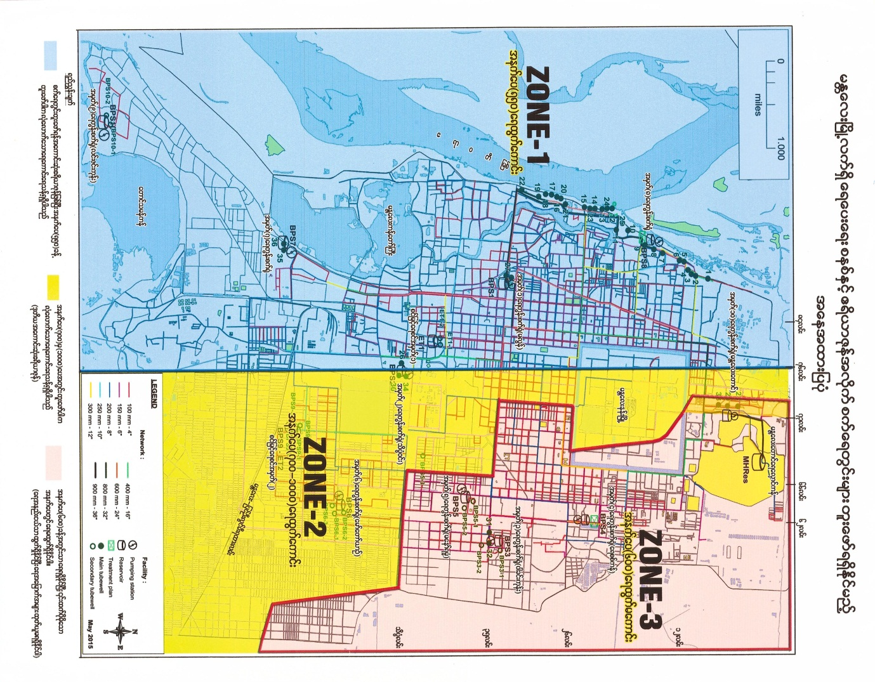
600′ depth (bad condition)

550′ depth (good condition)
700′-1000′ depth (good condition)

Figure 1: Three zones of water resources in Mandalay
Source: Mandalay City Development Committee
- Situational analysis of water supply
Mandalay has no improved source of water in all of its three industrial zones. There is no surface water supply from municipal source in Mandalay industrial zones and almost all industries tend to depend on groundwater and they consume unlimited groundwater. Industries in Mandalay are applying water from tube wells around the area of industrial zones. According to the questionnaire survey performed with the industries, the water pumped from these tube wells are not treated for industrial production process in most of the industries. In Mandalay, groundwater is the main source of water for industrial sector. To meet the water requirements of industries, groundwater has emerged as an important source in Mandalay City. However, the water tariff system has not been fixed and regulated for industrial water use in Mandalay Region. As a result of this situation, wasteful use of both surface and groundwater may encounter. Moreover, there is no accurate estimate of water consumption for industrial water. Therefore, questionnaire survey has been conducted to selected industries in Mandalay industrial zones in order to determine the industrial water demand. The questionnaire set based on the “Statistics Canada, Industrial Water Survey: Manufacturing Industries, 2011” has been launched to each industry for getting required information. Only thirteen numbers of industries have been surveyed as most industries refused to negotiate.
  - Water resource and its supply
Mandalay is surrounded by surface water as Ayeyarwady river and Dokhtawaddy river along its border line. The Ayeyarwady river is the longest river in Myanmar and the most useful river for Mandalay. Moreover, the Sedawgyi multipurpose reservoir distributes for domestic water in Mandalay.
At present condition, there are 12 booster pumping stations,two treatment plants and 33 tube wells for public water supply. At No. (8) booster pumping station, there is a treatment plant using slow sand filtration system to treat raw water from Ayeyarwaddy river. At No. (4) booster pumping station, there is also a treatment plant which treats raw water from Sedawgyi reservoir. At other booster pumping stations, raw water is distributed from groundwater sources. Some of the household in Mandalay currently use dug-wells where there is no public water supply. At those places, groundwater can be abstracted only from the depth of about 60 feet. Even the places where the public water supply has reached, people use shallow wells for domestic purposes [1].
  - Industrial water use and discharge
In many parts of the Mandalay industrial zones, especially where surface supplies are not available, industrial water needs can only be met by using the underground water. Manufacturers should ensure that water run through their systems is put through a proper water pretreatment process.
Few factories recycle and reuse wastewater in their production process such as paper factories. Most factories discharge wastewater to the Taungthaman lake without doing pretreatment process. There will be a plan for raw water treatment and distribution from Dokhtawaddy river for Pyigyitagon Township. From this plan, industries can be partly supplied by treated fresh water.
- Major challenges
3.1. Lack of infrastructure in water supply
The key factors which cause lack of water infrastructure in Mandalay are the fact that those are inadequate funds to build and operate infrastructure, less investment in water supply and sanitation, the increase amount of water demand over supply due to high population growth.
Municipal expenditures for water and wastewater infrastructure are one of the highest expenditure categories. Investment in water supply and sanitation has been far below the required levels to maintain and, to expand access and to improve service quality. The exceeding of water demand over supply capacity is caused by rapid urbanization as a result of high population growth.
Likewise, the root factors which cause the excessive amount of groundwater abstractions in industries for many processes are that there are no water supply system and proper water tariff structure for industrial water users due to the former factor. The cost of water itself is minimal, but there are a host of other expense drivers associated with planning, design, construction, operation and maintenance of supply network.
Inadequate finance for the upgrade of the aging pipes is another challenge in urban water supply. burst water pipe and water taps being decades old of existing water supply system are shown in figure 2 and 3. The cost and installation fees of pipes are other significant drivers. The electricity used to pump the water from its source and across terrain, is one of the largest recurring costs. And additional costs continuing to increase include that of building, replacing or improving treatment plants; protecting water from pollution or destroying; accessing new water sources, just to name a few.
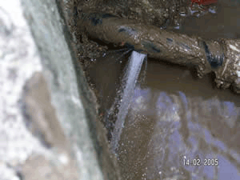
Figure 2: Burst water pipe

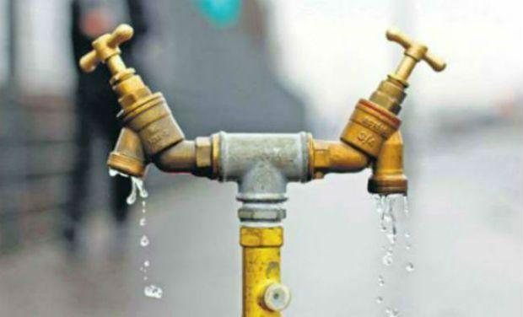
Figure 3: Water taps being decades old of existing water supply system

3.2. Lack of industrial water tariff
For industries in Mandalay Region, there is no appropriate industrial water tariff structure. In some large cities, the Mandalay City Development Committee is not in charge of the regulation to the industrial zones. And due to a lack of reliable city water supply, most factories use groundwater, hence creating subsidence risks. Due to lack of industrial water supply and wastewater tariff, many industries abstract excessive amount of groundwater and discharge very much polluted water into the fresh water courses.
3.3. Lack of public appreciation for the water-value
Due to lack of pricing of water for industries and lower pricing of water for domestic and commercial sectors, public appreciation for the value of water is gradually decreased. Water is necessary for life itself. Much as the human body relies on water to survive, virtually every aspect of society depends on water in order to function. Without it, there would be no fire protection, no agriculture, no manufacturing, and no power grid. At this moment, economic, cultural and socio-economic values of water should consider in Mandalay. Therefore, education programs are needed to do regularly for increasing public awareness of these values. Water use for cleaning without appreciation and water use without the need of purposes are shown in figure 4 and figure 5.
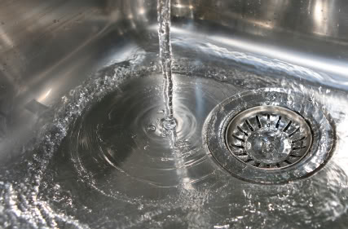
Figure 4: Water use for cleaning without appreciation
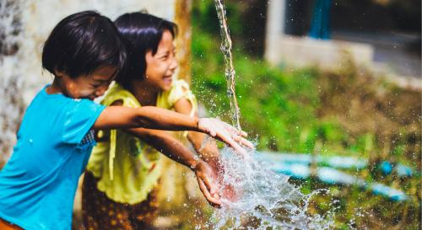
Figure 5: Water use without the need of purposes
One of the main factors for lack of public appreciation on the value of water in Mandalay is Non-Revenue Water (NRW) in terms of leakage, illegal connection and billing errors. NRW is defined as the difference between the amount of water put into the distribution system and the amount of water billed to consumers. It is usually used as an indicator for water utility performance. Another factor for lack of public appreciation on the value of water is that there is no pricing of water for industries in Mandalay.
Results of deteriorating infrastructure, fluctuating water temperatures, soil movement, vibrations and water pressure changes are just some factors in contributing to water leakage. And not only do leaks account for lost water, but they can also allow contaminants into the system that can endanger public health. Once a severe leak is discovered, the pipes are unearthed and then repaired or replaced. Digging up streets or highways is required to access the pipe. A community’s water system can temporarily be shut down and service can be disrupted by such a procedure. This process is accompanied by additional costs as well.
In some areas under metered water supply from municipal, most households unfix water meter and they achieve so much water using pumps or motors. The following are the current conditions of the problems facing with the public water supply in Mandalay [1].
- The percentage of Non-Revenue Water increases gradually up to 35 percent.
- Illegal connections are being used bypass pipe-line system.
- During dry season, public encounter water supply shortage due to electric shortage and water requirements.
- In some places of Mandalay, there are problems of pipe-line deteriorations.
- At the places far from booster pumping stations, people always meet the problems of low water pressure.
- The percentage of water shortage is three percent of the total water supply. Water supply shortage in Mandalay is shown in figure 6.

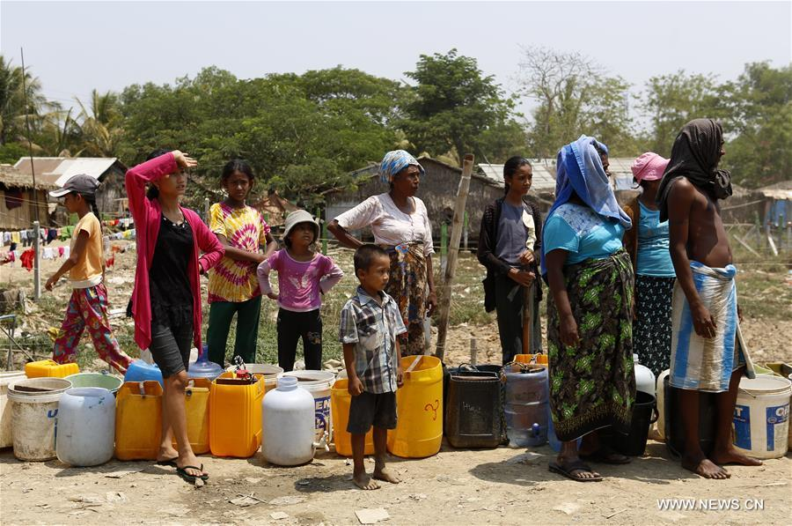
Figure 6: Water supply shortage in Mandalay
3.4. Lack of public-private-partnerships (PPPs)
Most anticipated water PPPs did not overcome contracting stage because of cost concerns, the limited financial resource and technical capacity of utilities. As a result, political and administrative support has remained tenuous for these projects.
Even with the willingness to spend the money and access to capital, many communities lack the in-depth experience, to design and/or implement such a plan on their own. The following are critical factors constraining public water supply.
Lack of stakeholder support for water PPP projects is a significant reason for PPPs in Mandalay. Stakeholder groups include authorities, local political parties, civil society groups and municipal employees of the public water utilities that did not support the projects. Several planned PPPs have been prevented financial risk perceptions from moving forward. Due to budget deficits, it is to delay or cancel infrastructure projects.
The lack of experience and limited understanding of water PPPs are not satisfactorily to address the risk concerns of private operators and the demands of project structuring. Many communities simply cannot afford to upgrade their systems, most of which are decades old. And frequently, communities with an aging system have a critical need for a stable water management system to meet incremental growth. Another challenge related to the increasing complexity of water management is to be addressed ill-equipped.
3.5. Lack of going green
The main constraint concerned with going green is lack of recycling wastewater from households and industries. According to industrial water survey, most industries do not recycle wastewater from industrial production processes.
Mostly, industries have no wastewater treatment plants except leather tanning factories have small pretreatment plants. Moreover, even pretreated wastewater cannot be reused for nonpotable purposes such as agriculture, land scape, public parks, and golf course irrigation.
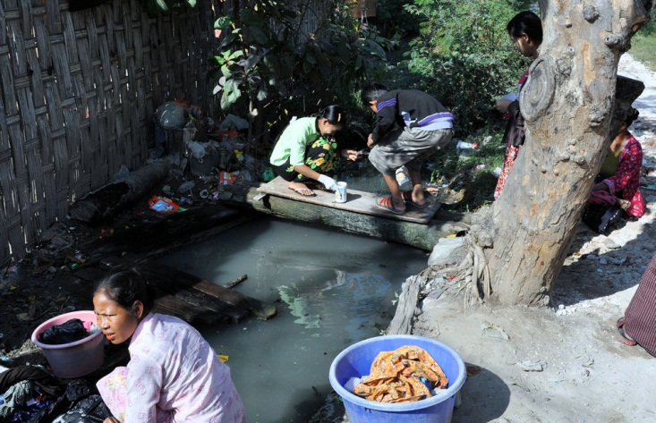
Figure 7: Water scarcity in informal settlement area
The effluent directly discharged by industries in rivers leads to much health problems and causes loss of agricultural production and mass motility of aquatic animals. Water scarcity in informal settlement area of Mandalay is shown in figure 7. Due to weakness of recycling wastewater and discharging without being pretreated to Taungthaman lake, aquatic animals died because of the effluent as presented in figure 8 and 9. For domestic purposes, much water is used for cleaning or flushing without recycling.
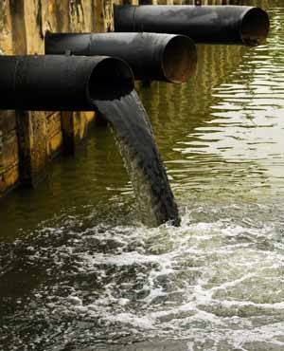
Figure 8: Wastewater discharge directly into water channel without pretreatment
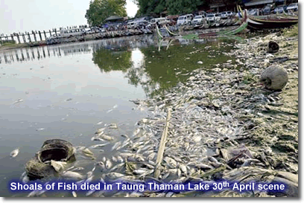
Figure 9: Fish died in Taungthaman lake due to wastewater discharge without treatment
3.6. Effects of climate change patterns
3.6.1. Changes in annual rainfall and temperature
Changes in rainfall and other forms of precipitation become one of the most critical factors determining the overall impacts of climate change. The frequency and intensity of precipitation changes as global temperatures rise. Although the frequency of rainfall is less, the intense rainfalls precipitate during less frequency. Some areas will get lower precipitation with an increased frequency of droughts while higher precipitation with an increased frequency of floods can be seen in other areas.
Variances in stream flow of Ayeyarwaddy river can also result from changes in the amount and rate of snow melting in mountain areas, for example, Kachin State. Higher temperatures cause more algal blooms, which may be toxins, poor taste, and odor compounds into water sources, leading to increased cost for the treatment plant.
3.6.2. El Niño and global warming
El Niño, a weather phenomenon occurred in Myanmar during summer in 2016. Likewise, Mandalay also suffered from El Niño. The negative impacts of El Niño may either be heavy rainfall or drought. Hailstorm due to El Niño in Mandalay can be seen in figure 10 and earth cracks due to drought in Mandalay can also be found in figure 11.
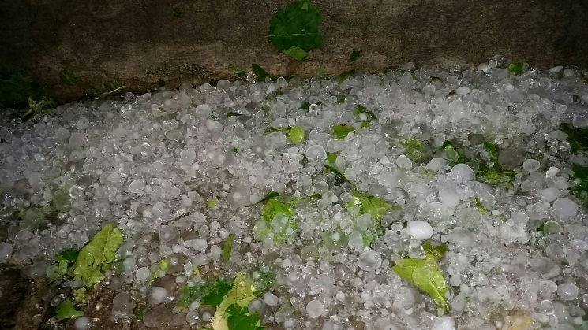
Figure 10: Hailstorm due to El Niño in Mandalay
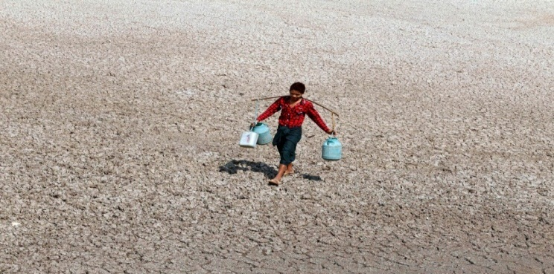
Figure 11: Earth cracks due to drought in Mandalay
As a result of global warming, the occurrence of El Niño has increased due to climate change. Heatstroke on cultivation due to El Niño is shown in figure 12.
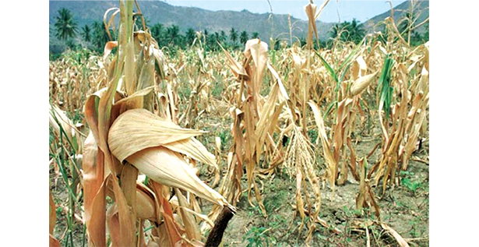
Figure 12: Heatstroke on cultivation due to El Niño
El Niño greatly impacts the water supply, power supply and agriculture sectors in most areas of Mandalay due to drought which causes aridity of the soil and losses of water resources or heavy rainfall which causes floods and water resources contamination.
3.7. Problems of groundwater abstraction
Groundwater depletion is a serious threat to the environment. Future water resources can be challenged by political and environmental limitations, continued growth, and the need to develop new water supplies. Due to the abstraction of vast amount of groundwater by industries, agriculture and households, some of the negative effects of groundwater depletion met in Mandalay are as follows:
- Lowering of the water table due to excessive pumping;
- Increased cost due to deep pumping;
- Reduced surface water potential because of the link between lakes, streams and rivers and groundwater.
There is no accuracy of groundwater consumption by the industrial sector. In Mandalay, groundwater level or pressure declination is concerned with groundwater extractions for stock or industries and dwellings and, recharge is decreased due to drought conditions. Groundwater extraction in Mandalay by various modes is illustrated in figures 13 to 15.
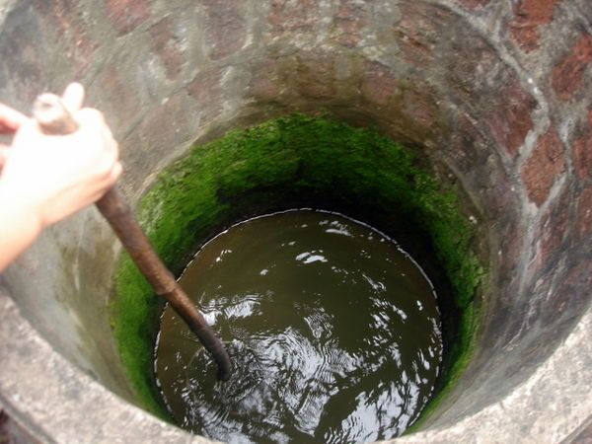
Figure 13: Open hang dug well where there is no municipal water supply network

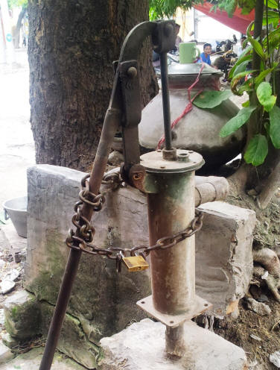
Figure 14: Standpipe
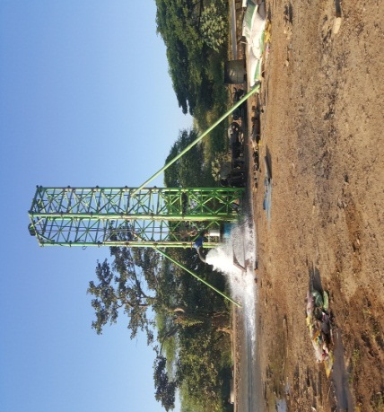
Figure 15: Tube well digging work in Mandalay area
Likewise, possible effects of falling groundwater level or pressure are loss of easy access to resource for existing domestic and industrial water users in Mandalay; reduction in baseflow of Ayeyarwaddy and Dokhtawaddy rivers; groundwater salinity increase, as a result, some areas of Mandalay industrial zones where pure groundwater for industrial production process cannot be pumped from even 1000 feet of depth. The annual baseflow for Ayeyarwady river and Dokhtawady river are shown in Table 1. From this table, it is evident that baseflow reduction occurs in Ayeyarwady and Dokhtawady river.
Table 1: Annual Baseflow for Ayeyarwady river and Dokhtawady river
Year | Discharge for Ayeyarwady river (m³/s) | Discharge for Dokhtawady river (m³/s)
2001  2002  2003  2004  2005  2006  2007  2008  2009  2010  2011  2012 | -  -  -  -  762  1330  1095  1370  1330  683  1620  1576 | 122  133  97  135  133  140  167  153  167  16  209  80
Table 1 (Continued): Annual Baseflow for Ayeyarwady river and Dokhtawady river
Year | Discharge for Ayeyarwady river (m³/s) | Discharge for Dokhtawady river (m³/s)
2013  2014  2015 | 762  1308  - | 67  85  96
Source: Department of Meteorology and Hydrology
3.8. Weakness of groundwater regulations
In the Union of Burma, “THE UNDERGROUND WATER ACT [Burma Act IV, 1930]” was enacted whereas it is expedient to conserve and protect underground sources of water supply since 21st June, 1930. Although the act is enacted for groundwater users, it is not so alive.
In Mandalay, as for now, there is no law concerning the exact amount of groundwater abstraction by the various industrial sectors. Laws related to groundwater extraction are also obsolete. As per act, first, no person shall sink a tube for the purpose of obtaining underground water except under and in accordance with the terms of a licence granted by the water officer. Second, every person owning a tube well which was in existence before the extension of this Act to the local area concerned shall apply to the water officer for a licence for this tube, and such licence shall be granted free of charge. Though this law has some relevance as far as the domestic groundwater use is concerned, it is illogical for industrial and commercial use. As a consequence of such laws, industries withdraw groundwater remaining unregulated and un-priced.
4. Conclusions
In summary, eight major challenges are identified related to industrial water pricing.
- Lack of infrastructure in water supply,
- Lack of industrial water tariff,
- Lack of public appreciation for the value of water,
- Lack of public-private-partnerships,
- Lack of going green,
- Effects of climate change pattern,
- Problems of groundwater abstraction,
- Weakness of Groundwater Regulations.
The level of water sector financing in Mandalay is widely criticized as being inadequate, but at the same time water supply budgets are often underutilized or ineffectively used. It is common for such tariffs to be set at levels that are below the real running costs. Water consumers without an improved water supply do not pay a financial tariff for water. Moreover, a low GDP is a major challenge facing efforts to improve water supply. Financial irregularities also often militate against continued payment of charges. Water pricing is difficult to set due to these facts in water sector. From the above mentioned factors, challenges to industrial water pricing should be looked for Sustainable Development Goal (SDG) for national water resources.
Acknowledgements
The author would like to acknowledge the support and encouragement of Dr. Myo Nyunt, Rector of the Mandalay Technological University.
The author would like to express her heartfelt thanks to her co-supervisor, Dr. Nilar Aye, Professor and Head of Civil Engineering Department, Mandalay Technological University, for her kind support, guidance and help. The author owes a debt of gratitude to her supervisor, Daw Aye Aye Thant, Lecturer of the Department of Civil Engineering, Mandalay Technological University, for her enthusiastic instruction, invaluable help, and indispensable guidance in the preparation of this paper.
The author would like to express her heartfelt gratitude to all teachers for their supports, valuable suggestions and discussions during the presentation of the paper.
Finally, the author wishes to express her heartfelt thanks to her family, especially her parents and all other persons for their supports and encouragements to attain her destination without any trouble.
References
- Mandalay City Development Committee, Lecture on Water and Sanitation, Advanced On-Job Training, January 2017.
- Embassy of the Kingdom of The Netherlands, Industrial & urban water in Myanmar, 2016.
- National Water Resources Committee, Myanmar National Water Policy, February, 2014.
- Asian Development Bank, Myanmar Urban Development and Water Sector Assessment, Strategy, and Road Map, August 2013.
- Kelvin Westerling, The 13 Biggest Challenges Facing The Water Industry, AWWA reports on the ‘State of the Water Industry’, 2013.
- Water and Sanitation Program, Trends in Private Sector Participation in the Indian Water Sector: A Critical Review, Field Note, September 2011.
- Suresh Chand Aggarwal and Surender Kumar, Industrial Water Demand in India: Challenges and Implications for Water Pricing, India Infrastructure Report, 2011.
- Statistics Canada, Industrial Water Use, Catalogue no. 16-401-X, 2009.
- Olli Varis, Pertti Vakkilainen, China’s 8 challenges to water resources management in the first quarter of the 21st Century, Article in Geomorphology, November 2001.
- Arjen Y. Hoekstra, Appreciation of water: four perspectives, Water Policy 1 (1998) 605-622, 21 September 1999.
- Burma Act IV, THE UNDERGROUND WATER ACT, 21st June 1930.

