The Impact of Coupling Signaling Protocols and Codecs Scheme in Achieving VoIP Quality

Abstract—VoIP is short for voice over Internet protocol and is also known as IP telephony, VoIP is a modern technology that enables us to make voice calls using IP networks. Therefore, VoIP can be achieved on any data network that uses IP, like the Internet, Intranets and Local Area Networks. In traditional network data is always fragmented into many data packets then transmitted independently. As the result packets arrived out of order at the destination ,in e-mail applications and downloading document this disorder is represent no problem since the packets will be reassembled in the correct order when they all has arrived at the destination. VoIP uses different signaling protocols and Coding schemes, choosing the inappropriate coding scheme for one of the signaling protocols leads to poor Quality of Service (QoS). This paper aims to specify the best combination of coding scheme and signaling protocols and Measure the QoS parameters (jitter, end to end delay, and throughput) of transmission protocol.
Key Words— VoIP, Quality of Service (QoS), Codec schemes, SIP.

Introduction
The VoIP protocols suite is broken into two Types, control plane protocol and data plane protocol. The control plane is the traffic required to connect and maintain the actual user traffic. It is also responsible for maintaining overall network operation (router to router communications). The data plane (voice) portion of the VoIP protocol is the actual traffic that needs to get from one end to another. VoIP also uses codecs schemes or voice coder-decoder (VOCODERs) to convert analog signal to digital signal and vice versa. Codecs are characterized with different sampling rates. Different codecs employ different compression methods, using different bandwidth and computational requirements. The common codec types used in VoIP networks are 64 kb/s G.711, 8 kb/s G.729 and 5.3/6.3 kb/s G.723.1 [11].
VoIP employs set of protocols like user datagram protocol (UDP) and transmission control protocol (TCP) to transport multimedia data. In addition VoIP also uses number of protocols in order to manage connection establishment. Signaling protocols are used to set up and tear down calls, carrying information required to locate users. There are several VoIP call signaling protocols. H.323 protocol suite, Session Initiation Protocol (SIP), Media Gateway Control Protocol (MGCP), and Megaco/H.248. H.323 and SIP is peer-to-peer Control-signaling protocols, while MGCP and Megaco are master–slave control signaling protocols [3]. SIP is the Internet Engineering Task Force's (IETF's) standard for multimedia conferencing over IP. SIP is an ASCII-based, application-layer control protocol that can be used to establish, maintain, and terminate calls between two clients. Like other VoIP protocols, SIP is designed to address the functions of signaling and session management within a packet telephony network. Signaling allows call information to be carried across network boundaries. SIP is neither a transport layer protocol nor quality of service (QoS) reservation protocol. In the other side, H.323 is a recommendation from the Telecommunication Standardization Sector (ITU-T), H.323 consists of a set of protocols that responsible for encoding, decoding, and packetizing audio and video signals, for call signaling and control, and capability exchange [12].
VoIP uses different signaling protocols and Coding schemes, choosing the inappropriate coding scheme for one of the signaling protocols leads to poor Quality of Service (QoS).
VoIP uses different signaling protocols and Coding schemes, choosing the inappropriate coding scheme for one of the signaling protocols leads to poor Quality of Service (QoS).
The aim of this paper is specify the best combination of coding scheme and signaling protocols, evaluate the suitable transport protocol (TCP, UDP) that has better performance for VoIP packets transmission the., and finally, to measure the QoS parameters (jitter, end to end delay, throughput) of transmission protocol.
Design H.323 and SIP architecture and implement E-model to calculate R factor and MOS is the methodology followed by this research to achieve the desired goals. OPNET Modeler 14.5 has been chosen to emulate the performance of the VoIP networks because it is one of leading environment for network modeling and simulation.

Voice over Internet Protocol (VoIP)
VoIP means that calls are transmitted over an IP network such as the Internet instead of Public Switched Telephone Networks (PSTN), in other world transferring voice over the traditional network as will as data. Since access to the Internet is available from any places in the word, it is possible to use VoIP in a higher degree [2].VoIP converts traditional telephone voice signals into compressed data packets that can be sent over IP. Before transmitted over packet switched networks, the speech signal has to be digitized at the sender; the reverse process is performed at the receiver.
Voice over IP networks in general is composed from:
- Gatekeeper: A gatekeeper or call manager node is optional for a VoIP network. In an H.323 IP telephony environment, a gatekeeper works as a routing manager and central manager that manage all the end nodes in a zone. A gatekeeper is useful for handling VoIP call connections includes managing terminals, gateways and multipoint control units (MCU). A VoIP gatekeeper also provides address translation, bandwidth control, access control [11]. Therefore, A VoIP gatekeeper can improve security and QoS.
- VoIP Gateway: A VoIP gateway is also required to handle external calls. A VoIP gateway functions as a converter that uses to convert VoIP calls to or from the traditional PSTN lines, it also provides connection between a traditional Private Branch Exchange (PBX) / Phone system and an IP network.
- VoIP Clients: Other required VoIP hardware includes a VoIP client terminal, a VoIP device could be an IP Phone, or a multimedia PC or a VoIP-enabled workstation runs VoIP software [22].
Most VoIP signaling protocols run over TCP/IP networks, which provide a full reliable transfer of data packets between clients or between clients and servers. The transfer of real-time packets (RTP protocol) is carried over UDP, which does not provide a loss less packets transfer between the two ends of the link, because resending lost packets is unnecessary since they usually arrive too late to be used in the voice stream. VoIP uses signaling protocols for establishing, modifying and tearing down unicast or multicast sessions consisting of one or several media streams [14].Different standards are presented to specify VoIP protocols. The following are the main standards used in this area: Session Initiation Protocol (SIP) and H.323.

VoIP Challenges
The use of VoIP is faced by number of challenges resulting from two main factors. First, the Internet was not designed to transfer real time data; it is a best effort network. Network equipment drop packets and may have queues that cause jitter in packets transfer delays. Also routing is more time consuming when compared to switching. Network delays and loss of packets affect the quality of service of VoIP. These factors are discussed in more detail later in this chapter. Multiple efforts are undergoing in various directions to eliminate those QoS variables, among which are Reservation Protocols (RSVP), design separate high priority queues for real time traffic and the use of a mix between routing and switching Multi-Protocol Label Switch (MPLS) to speed up packets through routing points. Second, PSTN has grown and added multiple features that are different to emulate. The main challenge that exists presently is the support of emergency services. Emergency workers responding to call can determine the exact location of the originator of the call, because of the relation between telephone number and geographic locations. Calls originating from a VoIP client are very difficult to cooperate to a geographic location because the lack of geographic structure in IP addresses. Several studies are undergoing to solve this problem but it still faces huge challenges [21]. In addition, there is a growing concern about the privacy and security of VoIP conversations. With the ability of capturing voice packets using a network sniffer, eavesdropping is easier in VoIP networks than it is in PSTN. Using wireless networks combined with VoIP further complicates these VoIP challenges [18].

Speech Codecs
Voice coding is process that uses transmitter to convert analog signal into digital signal based on sample rate of 8KHz ,after that the signal are quantized and encoded ,the final step is creating packet for sending over IP as shown in Figure (2.3). This process is inverse at the receiver. Different coding schemes used in telephony can cause different delay at the sources and at the destinations for audio compression and decompression, causing different end to end delay .Each one use his own different algorithm.
Codecs generally provide a compression capability to save network bandwidth. Currently, there are many different audio codecs available for voice applications. The simplest and most widely used codecs are G.711, G.723 and G.729. The simplest encoder scheme is G.711 [7]. G.711 is the sample based which uses Pulse Code Modulation (PCM) and does not use any compression; it has 8 kHz sampling rate, requires 64 Kbit/s of audio bandwidth and provides very good quality level. The acceptable packet loss factor of G.711 is up to 0.928%. G.723 and G.729 are frame based encoder scheme with higher compression and smaller data rates (8 kb/s for G.729, 5.3 and 6.4 kb/s for G.723.1). The G.723 encoder scheme uses algebraic-code-excited linear-prediction (ACELP) and Multiplus maximum likelihood quantization (MPMLQ) algorithm, and G.729 is a Conjugate-Structure Algebraic Code Excited Linear Prediction (CS-ACELP) speech compression algorithm approved by ITU-T. However, G.723 and G.729 also generate higher complexity and encoding delay with lower quality, it is necessary to select the appropriate codec to obtain best quality of voice with the lowest bandwidth requirements [26].The properties of widely voice codecs as shown in Table (1).

Table (1) Common Codecs:(modified from [9])

Codec | Algorithm | Bandwi-dth  /kbps | Comments
G.711 | PCM | 64 | Delivers precise speech transmission. Very low processor requirements.
G.723.1 | ACELP/MPMLQ | 5.3/6.3 | High compression with high quality audio. Can use with dial-up. Lot of processor power.
G.729A | CS-ACELP | 8 | Excellent bandwidth utilization. Error tolerant.

Quality of Service (QoS) parameters
The need to study Quality of Service (QoS) issues becomes very important special in the network which the data is multimedia. Unlike traditional IP network which the end user could not notice or be affected by latencies [3];in addition IP-based voice and video services within organizations usually do not have QoS support as the LANs provide enough bandwidth for real-time voice and video services. However, it is very hard to assure QoS for real time multimedia services across worldwide networks. There are many factors affect voice quality, which includes the choice of codec, delay, packet loss, and jitter. When these factors are properly controlled by QoS mechanisms, VoIP delivers better quality voice than they are accustomed to from dedicated voice networks, even over the lower speed connections. At the same time, data applications are also prioritized and assured of their share of network resources [10].

Packet Loss
Packet loss is losing of packets along the data path, which badly reduce the voice quality. There are number of reasons that cause packet loss, such as channel congestion, corrupted packets rejected in-transit, and bad networking equipment .Packet loss occurs frequently in data networks, but many applications are designed to provide reliable delivery using network protocols that request a retransmission of lost packets (e.g. TCP [7]). On the other hand, dropped voice packets are discarded, not retransmitted [13]. Packet loss calculated as follow:
$packet loss=\frac{ sending packets-receiving packets}{sending packets}*100$
Voice traffic can tolerate less than a 3% percent loss of packets before the caller parties feel perceivable gaps during conversation, and it will be considered as unacceptable if above this ratio [24].

End to End Delay
Delay is the time interval in which a packets travels from one node to another node. It is caused by the time for endpoint to create packets, by the time needed to fill data into packets, or the time to arrange digital data on a physical link .VoIP is very sensitive to delay; thus, it must be controlled and managed. As mentioned previously, it is inefficient to wait for all packets arriving in an organized order; therefore, some packets may be dropped if they don’t arrive in time and this can cause short periods of silence in the audio stream and causing bad VoIP quality. Ideally, End to end delay is calculated from equation (1) below:

$$De2e=Dn + De + Dd + Dc + Dde (1)$$
Where:
De2e = end-to-end delay.
Dn =network delay.
De = encoding delay.
Dd =decoding delay.
Dc = compression delay.
Dde =decompression delay.
Network delay is the time at which the sender node gave the packet to RTP to the time the receiver got it from RTP. From Table (2) ITU-T in terms of packet end-to-end delay are tabulated below in order to judge the quality of voice in the presented work. A good quality voice call should have a delay between 0 and 150 milliseconds. However, if call has delay greater than 400 milliseconds it is considered unacceptable [21].
Table (2) Accepted Delay Standard (Modified From ITU-T)
Description | Range in Millisecond
Acceptable for most user applications. | 0 – 150
Acceptable provided that administrators are aware of the transmission time and its impact on the transmission quality of user applications. | 150 – 400
Unacceptable for general network planning purposes. | Above 400

Jitter
Jitter is the variation of delay of each packet and it is one the most common VoIP problems. The quality of connections and traffic congestion is main reason for causing jitter .In addition packets take different equal cost-links is considering another reason. It is a very typical problem in packet switched network due to the fact that information is segmented into packets that travel to the receiver via different paths. In main time it is very difficult to deliver voice traffic at a constant rate. In order to minimize jitter, a jitter buffer (also known as playout buffers) is needed. A jitter buffer is used to trade off delay and the probability of packet interruption playout. If two consecutive packets leave the source node with time stamps t1 & t2 and are arrived at the destination node at time t3 & t4, then jitter can be found from equation below:
$$Jitter= (t4 - t3) - (t2 - t1) (2.3)$$
Negative jitter indicates that the time difference between the packets at the destination node was less than that at the source node .Jitter value is considered acceptable between 0 and 50 millisecond and above this value is considered as unacceptable [22][11].

Throughput
Throughput is the average amount of data that is successfully delivered over a communication link. The maximum throughput is less than or equal to the amount of digital bandwidth. It is measured by packet/bytes per seconds. Throughput for VoIP traffic varies based on the type of codec being used and the amount of compression applied. Data transmission from Node A to Node B, throughput refers to the total amount of data, received at Node B [22].

Mean Opinion Score (MOS)
MOS indicates the quality of a VoIP conversation; in other word MOS provide assessment of the quality of VoIP by represent the call quality as a number. The E-Model can be used to calculate the transmission rating factor R (R-factor) which is a simple measure of voice as indicated in Table (3). The R-factor as shown in equation (2) uniquely determines the Mean Opinion Score and lie in the range from 0 to 100, where R = 0 represents an extremely bad quality and R = 100 represents a very high quality. The E-model provides a statistical estimation of quality measures [24].
$MOS =1 + 0.035 * R + 7 * 10-6 * R*(R - 60)*(100 – R (2)$
Table (3) Relationship of MOS, R factor values to the Quality of Voice (modified from ITU-T G.107)

R-factor | Quality of Voice Rating | MOS
0< R < 100 | Best | 4.34 – 4.50
80< R < 90 | High | 4.03 – 4.34
70< R < 80 | Medium | 3.60 – 4.03
60< R < 70 | Low | 3.10 – 3.60
50< R < 60 | Poor | 2.58 – 3.00

Related Work
In2011, Di Wu , et al investigates the performance of VoIP traffic characteristics over Ethernet LAN. The study focus on the impact of increasing the number of VoIP clients and voice codec schemes. The results come out that VoIP service has different impact over wired and wireless network when the number of VoIP nodes is increasing the impact also comes from the choice of the voice encoder schemes. The simulation concludes that the VoIP services perform best under G.711 voice encoder scheme [10].
In 2011, Mohd Nazer Ismail, et al proposed an evaluation for VoIP performance over wireless LAN and WAN .The study shows that the performance of VoIP over LAN is better than WAN when using suitable codecs .GSM is perfect choice to improve and gives better VoIP quality over wireless LAN and WAN [5].
In 2011, Selvakumar et al, presented codec scheme G.711, G723, and G.729. Comparative is done Using OPNET Modeler .The result show that the best technique which gives good QOS parameters MOS, jitter, and packet delay variation is G.711 [8].
In 2013, Elechi Onyekachi et al, presented a simulation based network performance analysis to address how the QOS of VOIP effected by the various encoder schemes. Using OPNET Modeler ,this research provide a close look of VOIP over WIMAX using QOS parameters such as jitter ,packet –sent- packet –receive, and delay .The simulation result show that QOS of VOIP such as jitter ,packet –sent- packet –receive, delay, over WIMAX network impact by the right choice between codec schemes . The result also show that when the performance of VOIP traffic on WIMAX network effected by choosing the right codec scheme with a small number of voice frame size per packet [3].
In 2013, U.R.Alo et al, presented a simulation to examine the performance of VOIP over wireless LAN for an increased number of VoIP calls, the use of different coding scheme and increased number of workstations in video conferencing. The QOS in wireless LAN is result of coding scheme and number of VoIP calls that each wireless Access point can provide [4].

In 2013, Abdul-Bary Raouf et al, presented simulation for SIP-Based VoIP. The researchers study the case when added VoIP technology over the same exciting University IP network .The architecture of the university simulated using OPNET simulation. Three codecs are examined G.711, G.729, and G.723. The result shows G.711 give the best result in term of jitter, MOS and delay. In the other hand G.723 and G.729 codecs give better performance respect to bandwidth point of view [27].

In 2014, S.RATTAL et al, the study examine the Suppression or VAD (Voice Activity Detection) is a method that prevents sending packets in the case where one or all parties of a communication are not talking .Using OPNET Modeler with large number of user tasks under the signaling protocols SIP and H.323. The result show that more users are closer QoS is better [6].

In 2014, Ali M. Alshhlany, examine the performance of voice encoding schemes using in VoIP based integrated wireless LAN/WAN. Simulation is carried out with OPNET Modeler. Result show that G.729A the ultimate codecs that improve the QOS parameters such as MOS, jitter, end to end delay, traffic send and traffic received [7].

Methodology
Flow chart in Figure (1) indicates the research methodology, first step is choosing the signaling protocols SIP and H.323 each one has different set of elements and parameters.
The second step selects the codec type (G.711, G.729, and G.732.1), after that define the number of frame per packet and transmission protocols (TCP and UDP) as they have impact in QoS parameters. Then run the simulation to get result and measured the throughput, packet loss, end to end delay and jitter which are all QoS parameters. Afterward calculate MOS and R factor .Finally com out with best combination between signaling protocols and codec schemes that gives better VoIP quality.

Design
In this section OPNET simulation was used to simulate VoIP signaling protocols using different codec schemes. OPNET is a tool for modeling and simulation of networks is developed and marketed by OPNET Technologies Inc. It is now a standard reference in the field of network simulation. There are other simulation tools similar networks, such as NS-2 and OMNET. OPNET was chosen as simulation tool networks because that OPNET is developed in C+ + uses a graphical environment and runs under UNIX and Windows. These features allow to design, study, modify and simulate networks and communication protocols with flexibility. In addition, OPNET also allows simulating many kinds of hardware, such as routers, switches that are manufactured by Cisco, Nortel or Lucent. Because of this, existing networks wholes become easy to be modeled and simulated. OPNET provides effective ways to generate traffic related to most popular protocols and applications, such as HTTP, FTP, email, and database access.
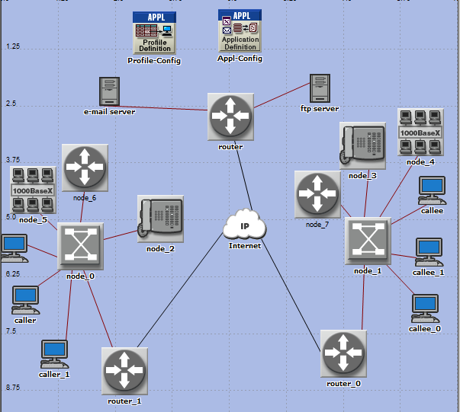
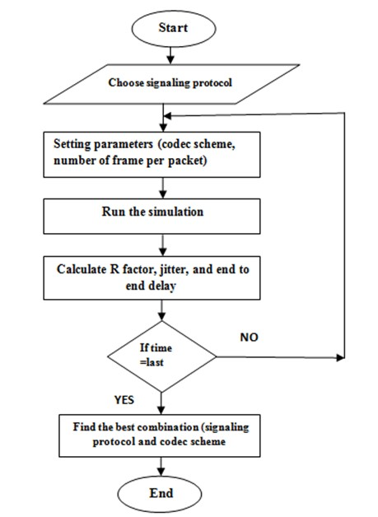
Figure 1. Methodology Flow Chart
Two kinds of topologies implemented in OPNET:
- SIP topology consists of user agent (client and server) and proxy server as shown in Figure (1).
- H.323 zone consists of terminal, gatekeeper and gateway as shown in Figure (2).
Each topology vary in terms of network connected devices, but they all have VoIP connected phone as illustrated in Figures (3.4)(3.5).A subnet containing ten nodes in each side of the backbone to create FTP and E-mail traffics to show their influence on quality of voice as they will consume an important amount of bandwidth. All network nodes are connected using 1000 Base-T links except routers and IP cloud they are connected using PPP DS1 duplex links. The PPP DS1 duplex links is common because it is a cost effective T-1 carrier solution with an acceptable bit rate of 1.544 Mbps. The IP cloud represents the Internet, which is a packet switch network that will allow for VoIP calling.
To generate maximum number of calls terminals are added in the network. A gatekeeper is implemented in each side of the network. In order to successfully simulate a VoIP call, application configuration, profile definition, and background traffic definition must be define.
The application definition was configured to support the predefined VoIP application, FTP, and E-mail. VoIP application is Customize by change attributes such as types of services and encoder scheme, the best effort service was implemented to simulate IP telephony. The length of talk and silence time used in a call was left with the default exponential distribution since it already replicated a typical conversational scenario. Once the application definition has been defined, the profile definition can be used to apply the service to the respective network device. The profile definition is built on top of the VoIP application where it specifies which workstation will support VoIP services. Since OPNET only supports P2P or Client to Server relationship for VoIP application, three profile definitions were created. Each profile represents a connection from one VoIP phone to another, and therefore each VoIP phone supported 2 profile services to simulate the call. The profile services of each VoIP phone will start simultaneously after 5 seconds into the simulation in order to establish the call.
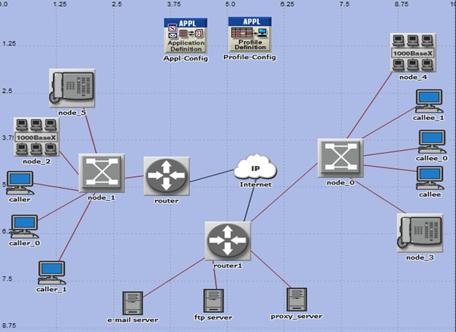
Figure 2. SIP Architecture Implemented in OPNET
Figure (3) H.323 Architecture Implemented in OPNET

There are thirty three scenarios implemented to compare the performance of VoIP signaling protocols , Table (4) describes the different parameters, in each time change the number of frame per packet (one and three) and the codec scheme as indicated in Figure (4).Also the transmission protocols TCP and UDP is change as shown in Figure (3.7).
Table (4) Network Design Parameters (frame per packet 1/ frame per packet 3)

Signaling protocol | Codec scheme | Transport layer
H.323 | G.711 | TCP
 | G.711 | UDP
 | G.729A | TCP
 | G.729A | UDP
 | G.723.1 | TCP
 | G.723.1 | UDP
SIP | G.711 | TCP
 | G.711 | UDP
 | G.729A | TCP
 | G.729A | UDP
 | G.723.1 | TCP
 | G.723.1 | UDP

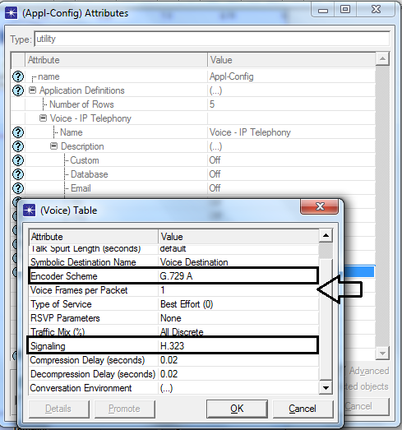

Figure (4) Changing the Used Encoder and Number of Frames per Packet

Mathematical Model
The E-model is based on the equipment impairment factor method, following previous transmission rating models. It was developed by an ETSI ad hoc group called "Voice Transmission Quality from Mouth to Ear" .E-model is used to predict the quality of the call in the data network. In other word the E-model is a transmission planning tool that provides a prediction of the expected voice quality, as perceived by a typical telephone user, for a complete end-to-end telephone connection under conversational conditions. The E-model takes into account a wide range of telephony band impairments, in particular the impairment due to low bit-rate coding devices and one-way delay, as well as the "classical" telephony impairments of loss, noise and echo. It can be applied to assess the voice quality of wireline and wireless scenarios [24].

Calculation of the transmission rating factor, R
R factor calculated by the E-model ranges from 100 down to 0, where 100 is excellent and 0 is poor. The equation (1) is used to calculate the R factor.

$R= Ro - Is- Id - Ie_eff +A$(1)
Where:

Ro = signal-to-noise ratio.
Is = combination of all impairments which occur more or less simultaneously with the voice signal .
Id = impairments caused by delay.
Ie-eff = impairments caused by low bit-rate codecs.
A = Advantage factor, allows for compensation of impairment factors when the user benefits from other types of access to the user.
The value of R0 and Is depends on the selected environment, the values are listed in Table (5).It is depend on the planer decision and set up in OPNET simulation.

Table (5) Voice Conversation Environment Values
Name | Communication system | R0 | Is
Land phone –Quite room | Conventional wirebound | 94.77 | 1.43
*Land phone –Noisy room | Conventional wirebound | 90.74 | 5.67
Call phone in building | Cellular mobility in a building | 85.91 | 2.32
Cell phone in SUV or sedan | Mobility across geographical area | 80.73 | 3.24
Cell phone in convertible | Mobility across geographical area | 70.32 | 4.87
*The environment that used in this study.

Effective Equipment impairment factor, Ie-eff
Equation (2) shows all factors involved in the calculation of Ie-eff values for codec operation under random packet-loss. Bpl conveys the packet loss robustness, the packet loss probability is represented by Ppl. BurstR is the packet loss burst ratio When packet loss is random (i.e., independent) BurstR= 1

$$Ie_{eff}=Ie+\left(95-Ie\right). \frac{ Ppl}{\frac{Ppl}{BurstR}+Bpl} (2)$$
Where:
Ppl = packet-loss probability.
Bpl = packet loss robustness factor.
The values for the equipment impairment factor Ie of elements using low bit-rate codecs are not related to other input parameters. Table (6) specific the Ie and Bpl value for each codec schemes G.711, G.729A, and G.732.1.

Table (6) Equipment Impairment Factor, Ie, Packet Loss Robustness Factor, Bpl for different codec scheme Modified from [24]
Codec scheme | Equipment impairment factor, Ie | packet loss robustness factor, Bpl
G.711 | 0 | 4.3
G.729 | 11 | 19
G.723.1 | 15 | 16

Advantage factor, A
The use of factor A and its selected value in a specific application is up to the planner's decision. In this study used A= 0. As the communication system is Conventional (wirebound).

Delay impairment factor, Id
The impairment factor representing all impairments due to delay of voice signals is further divided into three factors: Idte, Idle and Idd.
$$Id=Idte+Idle+ Idd (3)$$

Equation (3) represents the factors involved in the delay impairment, where The factor Idte gives an estimate for the impairments due to Talker Echo, The factor Idle represents impairments due to Listener Echo and The factor Idd represents the impairment caused by too-long absolute delay Ta, which occurs even with perfect echo cancelling and calculate as follow:
$$Idte = \left[\frac{\left(Roe-Re\right)}{2} + \sqrt{{\left(Roe-Re\right)}^{2}+100-1 }\right]\left(1-e^{-t}\right)$$

Where:
$$Roe=-1.5\left(No -RLR\right) (4)$$
No = power addition of different noise sources.
RLR = Receive Loudness Rating.
$$Re=80+2.5\left(TERV -14\right) (5)$$
$TERV=TELR–40\log{\frac{1+\frac{T}{10}}{1+\frac{T}{150}}}+6e^{-0.3T^{2 }} (6)$
Where:
T=Mean One-Way Delay
For values of T < 1millisecond, the talker echo should be considered as sidetone, i.e., Idte = 0. The computation algorithm furthermore combines the influence of STMR (Sidetone Masking Rating) to talker echo. Taking into account that low values of STMR may have some masking effects on the talker echo and, for very high values of STMR, the talker echo may become more noticeable, the terms TERV and Idte are adjusted for STMR < 9 dB as follows:
In Equation TERV is replaced by TERVs, where:
$$TERVs= TERV+\frac{Ist}{2} (7)$$
For 9 dB ≤ STMR ≤ 20 dB:
For STMR > 20 dB:
Idte is replaced by Idtes
Where:
$$Idtes= \sqrt{{Idte}^{2}+{Ist}^{2}} (8)$$

Factor Idle represents impairments due to listener echo. The equations are:
$$Idle = \left[\frac{\left(Roe-Re\right)}{2} + \sqrt{\frac{{\left(Roe-Re\right)}^{2}}{4}+169 }\right] (9)$$
Where:
$$Rle= 10.5(WEPL+7){(Tr+1)}^{-0.25}$$

WEPL = Weighted Echo Path Loss
Tr = Round-Trip Delay
Factor Idd represents the impairment caused by too-long absolute delay Ta, which occurs even with perfect echo cancelling.
For Ta ≤100 ms:
$$Idd=0$$

$$Idd=25\left\{{{(1+X}^{6})}^{ \frac{1}{6}}-3{\left[1+{\left[ \frac{X}{3}\right]}^{6}\right]}^{\frac{1}{6}}+2\right\} (10)$$
With:
$$X= \frac{log\left(\frac{Ta}{100}\right) }{log2} (3.12)$$
Where
Ta=Absolute Delay from (S) to (R)

Result and discussion
The topologies in chapter three was used to experiments different codec scheme and the two signaling protocols, H.323 and SIP, using OPNET simulation in order to get the best couple. The E-model was used to calculate the R factor and MOS. The results are presented in this section

End to End Delay
End to end delay, or mouth to ear delay, is combination of network delay, encoding delay, decoding delay, compression delay and decompression delay. Figure (6) shows the end to end delay for both SIP and H.323 operate different codecs G.711, G.729 and G.723.As Table (5) indicate, end to end delay in SIP is 0.16, 0.16 and 0.22 for G.711, G.729, and G.723.1 respectively. When compared these values with H.323 which is 0.18, 0.22ms and 0.25 for G.711, G.729, and G.723.1 respectively, it is clear that SIP and G.711, when number of frame per packet is one and transport layer protocol is UDP, gives better result in term of delay than other combination. Packet end to end delay for voice codec G.723.1 is highest in the two protocols 0.29 ad 0.34 in SIP, H.323 respectively. This is because, G.723.1 uses coding rate of 5.3Kbps or 6.3Kbps which results in the formation of packets of smaller size and larger count. As the number of packets increases in the network, the congestion in the network increases. Congestion directly affects the network packet delay and thus results in increasing packet end to end delay. Also the numbers of frame per packet impact on end to end delay, when the numbers of frame per packet increase the delay also increase. When the parameter voice frames per packet is set to one instead of three; the delay is all these codec schemes have good voice packet end to end delay values .
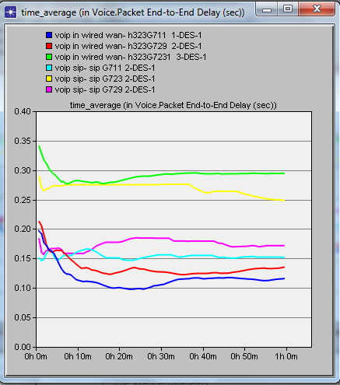
In SIP TCP is 0.24 and UDP is 0.16 this indicates TCP has highest delay in both two protocols (SIP and H.323) and in all codecs scheme than UDP.

Figure (6) End to End Delay UDP and TCP

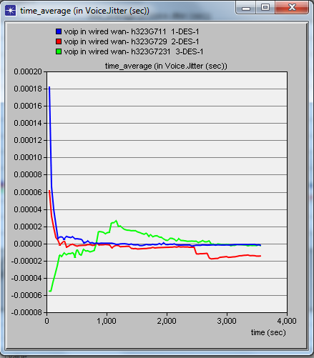
Table (7) Result Comparisons End to End Delay (H.323 protocol)
Codec Scheme | Transport layer protocol | One Frame  (sec) | Three Frames  (sec)
G.711 | TCP | 0.22 | 0.17
 | UDP | 0.18 | 0.20
G.729A | TCP | 0.24 | 0.21
 | UDP | 0.22 | 0.22
G.723.1 | TCP | 0.26 | 0.35
 | UDP | 0.25 | 0.34

Table (8) Result Comparisons End to End Delay (SIP protocol)
Codec scheme | Transport layer protocol | One Frame  (sec) | Three Frames  (sec)
G.711 | TCP | 0.24 | 0.24
 | UDP | 0.16 | 0.22
G.729A | TCP | 0.17 | 0.20
 | UDP | 0.16 | 0.18
G.723.1 | TCP | 0.25 | 0.35
 | UDP | 0.22 | 0.29

Jitter
Each packet of voice information takes a different amount of time to go from one end of the network to the other. This variation is called jitter. The jitter value should not exceed 20 to 50 milliseconds. Table (4.3) (4.4) show the jitter values, all the jitter values are in the acceptable area. G.729 gives better result when compared with G.711 and G.732.1. In H.323, codec G.729 is 0.00010 and 0.000035 sec in TCP and UDP respectively, and in SIP is 0.00044 and 0.00045 sec TCP and UDP respectively .which mean that jitter is less in case of TCP. As Figures (7) and (8) indicates all codecs gives better result in SIP than H.323.
Table (4.3) Result Comparisons Jitter Results (H.323 protocol)
Codec scheme | Transport Layer protocol | One Frame | Three Frames
G.711 | TCP | 0.000090 | 0.000002
 | UDP | 0.000061 | 0.00018
G.729A | TCP | 0.00010 | 0.000070
 | UDP | 0.000035 | 0.000061
G.723.1 | TCP | 0.00007 | 0.00007
 | UDP | 0.00008 | 0.00008
Table (4.4) Result Comparisons Jitter Results (SIP protocol)
Codec scheme | Transport layer protocol | One Frame  (sec) | Three Frames  (sec)
G.711 | TCP | 0.00015 | 0.00028
 | UDP | 0.000005 | 0.00020
G.729A | TCP | 0.000044 | 0.00013
 | UDP | 0.000045 | 0.00000
G.723.1 | TCP | 0.00036 | 0.00020
 | UDP | 0.00040 | 0.00012
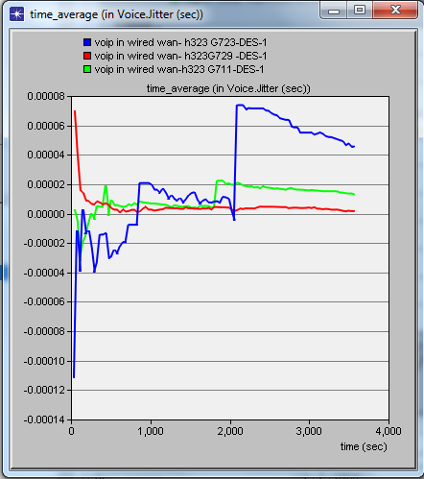
Figure(7) Jitter Result H.323 withUDP
Figure (8) Jitter Result H.323 with TCP
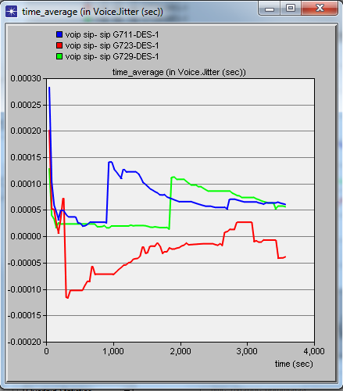
Figure (9) Jitter Result SIP with TCP
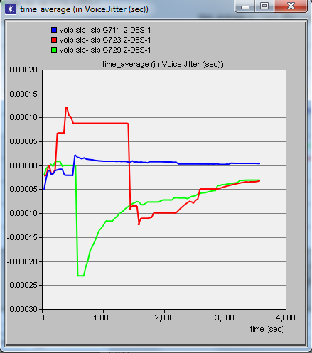
Figure (10) Jitter Result SIP with UDP

Throughput
Throughput is the average amount of data that is successfully delivered over a communication link. Figure (9) (10) shows the throughput delivered rate for TCP and UDP, TCP has larger throuput in all scenarios. TCP is 185 packets in H.32 and 79 in SIP which mean that H.323 has larger throuput than SIP. In both protocol SIP and H.323 there are seems to be loss in performance after period of time.

Mathematical Analysis
According to equations mentioned in chapter three ,the calculation of the R factor and MOS are implemented and listed in Table (4.5)(4.6) .the results shows that codec G.711 and SIP is 89.1 ,4.3 for R factor ,MOS respectively, and in case of H.323 is 87.8, 4.28 for R factor ,MOS respectively; whereas, codec G.723.1 has the lowest MOS value in H.32 is 3.24 and SIP is 3.52. It means that codec G.711 has higher quality, compared with the other two codecs. As the bit rate for G.723.1, G. 729 and G.711 is 5.3 Kbps, 8Kbps and 64 Kbps respectively .The delay for G .729 and G.711 is 30 milliseconds, 10 milliseconds, and 0.75 milliseconds. Based on the bit rate and delay for three codec, the MOS value rating from the simulation results makes sense because higher compression rate makes shorter delay which leads to higher voice quality. We observe that the faster the bit rate and shorter the delay of a codec, the better the quality, MOS, of VoIP.

Table (9) Result Comparisons R factor and MOS (H.323 protocol)
Transport layer protocol | Codec | R Factors 3 Frames | MOS 3 Frames | R Factors One Frame | MOS 1 Frame
TCP | G.711 | 88.6 | 4.3 | 83.3 | 4.14
 | G.729A | 73.6 | 3.76 | 69.4 | 3.58
 | G.723.1 | 52.0 | 2.68 | 62.8 | 3.24
UDP | G.711 | 89.5 | 4.33 | 87.8 | 4.28
 | G.729A | 74.8 | 3.81 | 72.3 | 3.7
 | G.723. 1 | 55.3 | 2.85 | 62.8 | 3.24

Conclusion
The research study the performance of the most popular signaling protocols used in VoIP, these protocols are , SIP and H.323 with codec schemes G.711, G.729A and G.723.1. OPNET is used to simulate the SIP and H.323 architectures to evaluate the QoS parameters (end to end delay and jitter), also investigate the impact of the number of frame per packet
The average voice jitter variation in case of codec G.723.1 is higher than the other two codecs. The jitter variation in case of G.711 lies between two other audio codecs and audio codec G.729A gives better results than audio codecs G.711 and G.723.1 respectively. So there is a high increase in jitter as audio codecs G.711 and G.723.1 are added to the network. This increase in voice jitter makes the voice difficult to understand as arriving packets at different time. All these codec schemes yield acceptable voice jitters .The use audio codec G.729A will make the jitter less and best performance of VoIP application in both signaling protocols.
The study also supports statistically the superiority of UDP over TCP in all the scenarios. The good performance of UDP in VoIP applications makes it a preferred transport layer protocol to carry voice packets from source to destination. TCP protocol was suitable for less delay sensitive data packets and not for delay sensitive packets. Furthermore, the study conclude that the end to end delay is increase as number of frames in one packet increase
The E-model is used to calculate the R factor and MOS; accordingly the most appropriate couple of codec and signaling protocols is G.711 and SIP as offers suitable jitter, best minimum delay and best call quality

References
- J. Rosenberg, H. Schulzrinne, G. Camarillo, A. Johnston “SIP: Session Initiation Protocol”, Internet Engineering Task Force (IETF), RFC 3261, June 2002.
- Ajay Kumar, "An Overview of Voice over Internet Protocol (VOIP)", Rivier College Online Academic Journal, Volume 2, Number 1, spring 2006.
- Elechi Onyekachi, Eze Elias,” Investigating the QoS of Voice over IP using WiMAX Access Networks in a Campus Network “, Computer Engineering and Intelligent Systems, Vol.4, No.5, 2013.
- U. R. Alo, Nweke Henry Friday,”Investigating the Performance of VoIP over WLAN in Campus Network”, Computer Engineering and Intelligent Systems, Vol.4, No.4, 2013.
- Mohd Nazer Ismail,”Best Codecs Selection for VoIP Conversation over Wireless Carriers Network” Department of Kuala Lumpur (UniKL), Malaysia, 2011.
- S.Rattal, A. Badri, M. Moughit,”A New Wireless VoIP Signaling Device Supporting SIP and H.323 Protocols Considering Silence Suppression” Faculty of science and techniques, 2014.
- Ali M. Alshhlany ”Performance Analysis of VoIP Traffic over Integrating Wireless LAN and WAN Using Different CODECS”, International Journal of Wireless &Mobile Network Vol. 6.NO. 3. June 2014.
- Selvakumar Vadivelu, ”Evaluation the Quality of Service in VoIP and comparing various encoding techniques”, Department of Computer Science University of Bedfordshire, MSc Thesis, 13rd January 2011.
- WaiC.Chu, John Wiley,”Speech Coding Algorithms Foundation And Evolution of Standardized Coders”,ISBN: 0-471-37312-5,2003.
- Di Wu, Kashif Nisar, Suhaidi B Hassan,”Performance Studies of VoIP over Ethernet LANs ”International Journal of the Computer, the Internet and Management Vol.19. No.3, September, 2011.
- Sun Lingfen, Jammeh Emmanuel, feachor Emmanuel, ”Guide To Voice and Video over IP ” ,Computer Communications and Networks, XII 272p, 2013.
- Ismail Dalgic, Hanlin Fang”Comparison of H.323 and SIP for IP Telephony Signaling”Technology Development Center, Cisco Systems.
- Md.Nazmul Hussain,”Performance Analysis of VoIP Network Using QoS Parameters”, Daffodil International University Dhaka, Bangladesh, February 2011.

- Saverio Niccolini,”IP Telephony: protocols, architectures and applications” Ph. D.Research Staff Member NEC Europe Ltd., Heidelberg, Germany.
- Bur Goode, ”Voice over Internet Protocol (VoIP) ”, Proceedings of the IEEE, VOL. 90, NO. 9, September 2002.
- ”Building a VoIP Network, SIP Architecture”, Chapter 8383_NTRL_VoIP_08.qxd 7/31/06 Page 345.
- Khaled Salah, ” On the Deployment of VoIP in Ethernet Networks: Methodology and Case Study” Department of Information and Computer Science ,King Fahd University of Petroleum and Mineral.
- Yuanchao LU, ”On Traffic Analysis Attacks To Encrypted VoIP” , Cleveland State University .November 2009
- Paul E. Jones,” H.323 Protocol Overview”, October 2007.
- Yue Pan,Jeffery Chung, ZiYue Zhang” Analysis of Performance of VoIP over various scenarios OPNET 14.0” ENSC 427 Communication Networks, Spring 2012 .
- Benson Lam, Winfield Zhao, Mincong Luo, ” Analysis on VoIP Using OPNET” ENSC 427, Communication Networks, April 05, 2009
- Karie Gonia,"Latency and QoS for Voice over IP" SANS Institute 2004
- International Telecommunication Union Telecommunication Standardization Sector (ITU-T) Study Group 12 – Delayed Contribution 106. The E-model: a computational model for use in transmission planning.
- Guoyou , ” H.323 protocol suite”, Helsinki University of Technology .
- Nishant H. Pancholi, Yogesh H. Zambare, ” Performance Comparison of Different Codecs over VoIP with Different Queuing Algorithms for IP Based Network” International Journal of Engineering Development and Research (IJEDR), Vol.2, Issue.
- Abdul-Bary Raouf Suleiman and Abdulhameed Hameed, ”Simulation of SIP-Based VoIP for Mosul University Communication Network”, Int. J. Com. Dig. Sys. 2, No. 2, 89-94, 2013.

