Antifungal Activity of Lactic Acid Bacteria Isolated from Soil Rhizosphere on Fusarium Species Infected Chilli Seeds
Akaram Husain^{a*}, Zaiton Hassan^{b}, Nur Huda-Faujan^{c} and Mohd Nizam Lani^{d}
^{abc}Faculty of Science and Technology, Universiti Sains Islam Malaysia (USIM), Bandar Baru Nilai, 71800 Nilai, Negeri Sembilan, Malaysia.
^{d}School of Food Science and Technology, Universiti Malaysia Terengganu (UMT), 21030 Kuala Terengganu, Terengganu, Malaysia.
ªEmail: akaramhusain@gmail.com
^{b}Email: drzaiton@usim.edu.my
^{c}Email: nurhuda@usim.edu.my
^{d}Email: nizamlani@umt.edu.my

Abstract

Lactic acid bacteria (LAB) are known to inhibit the growth of fungi and LAB cells or its can be used as biocontrol against plant pathogens. The aim of this study was to evaluate the efficacy of selected LAB strains isolated from rhizospheric soil against Fusarium spp. These fungi were isolated from infected different plant parts and identified as F. oxysporum strain KAML01, Fusarium sp. CID124, Fusarium sp. fus 124 and F. proliferatum with 99 % similarity using Internal Transcribed Spacer (ITS) analysis. Five LAB strains were showed strong antifungal activity against the Fusarium spp. were evaluated using dual overlay method. Isolates MSS1 and FCF11 were 100% similarity with Lactobacillus plantarum and isolate MSS5 99% was similarity with Pediococcus pentoceous using 16S rDNA sequence analysis. Inhibition of Fusarium sp. CID124 fungal biomass in the de Man, Rogosa and Sharpe Broth (MRSB) was significantly greater (P ≤ 0.05) by cells of P. pentosaceus (97.43%) compared to inhibition of Fusarium sp. CID124 fungal biomass by Cell Free Supernatant (CFS) of Lb. acidophilus ATCC314 (91.8%) using biomass dry method in Malt Extract Broth (MEB) medium. Fusarium spp. infected to seeds of three cultivars, Cili Kulai, Red spicy-0639 and GAAC-SEED-5005 and then, treated with CFS-LAB. All treated seeds with CFS-LAB showed good germination in the range of 82.6 to 93.3% compared to seed germination 53.3 to 70.0% of chili seeds infected with Fusarium spp. The percentage germination of chilli seeds was strongly suppressed when infected with Fusarium sp. CID124. This infection had significant (P≤0.05) reduction of seed germination to 53.3 % compared to other Fusarium spp. Finally, the pathogenicity effect of Fusarium sp. CID124-CS was highly virulent on seeds germination of chilli.

Keywords: Antifungal activity; chilli seeds germination; Fusarium spp.; Lactic Acid Bacteria; Rhizospheric soil

- Introduction
About 90% of the world food crops including chilli pepper are propagated by seeds [1]. Seeds are the passive carriers of some important seed borne diseases caused by microorganisms such as fungi, bacteria, viruses and nematodes that can be carried with, on or in seeds. Seeds infected with microorganisms would typically result in poor germination, poor plant vigor and considerable yield losses, because fungi of the genera Fusarium, Penicillium and Aspergillus are commonly known to produce toxic substances finally, suppressed seeds gemination [2] as well as that affect the plant growth. Toxic metabolites of F. equiseti retarded the root growth of wheat [3] while culture filtrates of F. oxysporum udum isolated from infected roots of Pigeonpea (Cajanus cajan) inhibited the seed germination of variety ICP-2376 by 10% [4]. Reduction in percentage seeds germination of chilli seeds was observed when seeds were soaked in different fungi; F. moniliforme, Colletotrichum capsici, Curvularia lunata, A. flavus and Rhizopus stolonifer [5]. Fusarium spp. are associated with fruit rot of chilli fruits in Malaysia and other countries. The pathogenic fungi Fusarium solani, F. ventrichosumm and F. oxysporum were isolated from pepper seeds [6]. Other fungi such as F. moniliformae, A. flavus, Rhizopus stolonifer, Colechotrichum capsici and A. niger were reported present in infected chilli seeds from India [7]. Recently, it was reported that chilli seeds infected with Aspergillus sp. showed reduction of percentage germination [8]. Use of chemical fungicides are the current practice of controlling fungal infection in plants, however, it is realized that such practices would created environmental pollution and thus, their use should be reduced or avoided using biological control would be an important alternative method to control fungal plant pathogens. In vitro studies indicated that lactic acid bacteria (LAB) have potential application as bio-control against phyto-pathogenic fungi [9; 10; 11] and [12]. It was reported that strains from the genus Lactobacillus spp. were frequently described as possessing antifungal activity [13]. For example, Lb. rhamnosus VT1 showed strong antifungal properties inhibiting the growth of many spoilage and toxigenic fungi including species in the genera Fusarium, Aspergillus and Penicillium [14] and [15]. Treating chilli seeds with cell free supernatant (CFS) of Lb. plantarum C5 allowed germination of chilli seeds infected with Colletotrichum capsici C5 [16]. Therefore, the approach of using LAB to control growth and proliferation of phyto-pathogenic fungi is promising. Strains LAB can be isolated from different sources including soil samples [17] (Gebreel et al. 2008), fish (threadfin salmon) and prawn (grass shrimp) [18]. Last few years LAB strains were isolated from soil and reported can be used to control soil borne phytopathogenic fungi species especially Pythium [19] and [20]. Therefore, the present study was conducted to determine the antifungal activity of LAB isolated from rhizospheric soil and fermented chilli against Fusarium species isolated from infected different plants parts. Selected LAB isolates were further evaluated for their efficacy in inhibiting the growth of the pathogen in the chilli seeds infected with various strains of Fusarium spp. were isolated different plants parts.
------------------------------------------------------------------------
* Corresponding author.
E-mail address: akaramhusain@gmail.com
- Materials and Methods
  - Isolation of Phyto-pathogenic Fungi
Phyto-pathogenic fungi were isolated from infected different plant samples including the chilli leaves (CL), the seeds (CS), the fruits (FC) and leaves of rose (LR) collected at around Bandar Baru Nilai, Negeri Sembilan, Malaysia. Isolation of fungi from different parts of plants was done according the method described by [21] with modification. Chilli samples were washed with distilled water and patted dry with tissue paper, followed by surface-sterilize in 1% sodium hypochlorite for 2 min, before placing aseptically on potato dextrose agar (PDA Oxoid, CM0139) using sterilized forceps. The plates were incubated at room temperature (28ºC) for 5 to 7 days. Then, the colonies of different shape and colors were sub-cultured on Potato Dextrose Agar (PDA, Oxoid) incubated at room temperature 28ºC for 5 to 7 days, and pure culture of each colony was maintained on PDA and stored at 4ºC. The fungi cultures were also maintained as conidial spore suspension in malt extract broth (MEB, Oxoid) with 25% glycerol and stored at -80ºC as described by [22] for long time preservation.
    - Genotypic Identification of Fungi Fusarium Species

2.1.2. Total Genomic DNA Extraction

Fungal isolates that showed the typical charasteristics of Fusarium spp. were further subcultured on PDA to get pure fungal isolates. Extraction of fungal DNA was carried out following the method described by [23] with modification. The fungi Fusarium isolates were inoculated into 20 ml malt extract broth (MEB, Oxoid) and incubated at room temperature 28ºC for 5 days. After incubation, the spores suspension were transferred to sterile Eppendorf tubes for DNA extraction. The fungal suspension 150 µl of each Fusarium species was added in to 1.5 ml tube with help of modified cut open of 1 ml pipette tip to enable suction of fungal suspension. The pellet of fungi was collected by centrifuging the broth at 14000 rpm for 2 min and supernatant was discarded. On the pellet of fungal samples, 100 µl of solution A was added which was provided by 1st Base Sdn. Bhd., Malaysia and vortexed gently and then, incubated 95ºC for 10 min in water bath. After heat treatment, 100 µl of sample B was added which was collected from 1st Base, Sdn. Bhd., Malaysia and vortexed gently to neutralize the reaction. Total genomic DNA of all fungi samples was extracted using Wizard ® Genomic DNA Purification Kit (Promega, USA) following the manufacturer’s instruction. Subsequently, the mixture was mixed gently before incubating for 5 min at 80°C. Three µL of RNase solution was added to the mixture and was incubated at 37°C for 15 to 60 min. 200 μL of protein precipitation solution was added to the mixture, vortexed continuously and were then incubated in ice for 5 min. The mixture was then followed by centrifugation at 13,000 rpm for 3 min. The supernatant obtained was transferred to a clean tube containing 600 μL of room temperature (25°C) isopropanol and mixed properly. The mixture was centrifuged for another 2 min at 13,000 rpm, and the supernatant was discarded. After that, 600 µL of 70% ethanol was added, mixed and centrifuged again for 2 min at 13,000 rpm. The ethanol was aspirated and the pellet was air-dried for 10 to 15 min. The DNA pellet was rehydrated in 100 μL of rehydration solution for 1 h at 65°C or overnight at 4°C.
    - PCR Amplification
Amplification of internal transcribed spacer (ITS) DNA for Fusarium samples were carried out by using PCR with primers based on the conserved region of ITS1 and ITS4 primers which the forward primer (ITS1) (5´ATGGGTAAGGA (A/G) GACAAGAC-3´) and Reverse primer (ITS 4) (5´GGA (G/A) GTACCAGT (G/C) ATCATGTT -3´) [24]. Polymerase Chain Reaction (PCR) was performed in 50 μL reaction volumes, containing 5μL Complete 10x PCR-Buffer, 1 μL dNTP mix (800 µM), 2.5 μL forward primer (0.5 µM), 2.5 μL reverse primer (0.5 µM), 0.5 μL DFS-Taq DNA polymerase, 36.5 µL of sterile distilled water (Bioron, Germany). The negative PCR non-template control (water only) and positive control (DNA extracted) from Flammulina velutipes is used as template. The amplification of PCR products was done by using T100 Thermal Cycler (Bio-Rad, Singapore). Five μL of 1 kb ladder (Norgen High Ranger, Canada) was loaded into the well of agarose gel and used as a standard. Aliquots of 7 μL of amplified product were then loaded into the well together with 3 μL of loading dye (Norgen, Canada). Amplification products were analysed by electrophoresis (100 V, 35 min) on a 1% agarose gel containing Gel Red dye (Biothium, USA) and visualised by computer based gel documentation system (Uvitec Cambridge, UK). Amplified PCR products were purified using high pure PCR product purification kit (Roche Diagnostic GmbH, Germany) by following the manufacturer’s instruction. 5 volumes of binding buffer and 1 volume of PCR product was briefly mixed well and transferred into high pure filter tube. The DNA was binded to the filter by centrifugation at 13,400 rpm (Eppendorf mini spin, USA) for 60 sec at 5°C. The flow-through was then discarded. An additional 500 μL of wash buffer was added and centrifuged at 13,400 rpm for 1 min. The flow-through was also discarded. Additional centrifugation at 13,400 rpm for 1 min was performed after 200 μL of wash buffer was added. Finally, DNA was eluted into a clean 1.5 ml micro-centrifuge tube by adding 50 μL of elution buffer (10 mM Tris-HCl) and centrifuged at 13,400 rpm for 1 min. Then, the DNA fragment of 5.8S-ITS was sent for sequencing to 1st Base laboratory in Shah Alam, Selangor after PCR amplification using the ITS1 and ITS4 primers. The assembled sequences were aligned and compared with the GenBank databases of the National Center for Biotechnology Information (NCBI). Searches in GenBank with Basic Local Alignment Search Tool (BLAST) program were performed to determine the closest known relative of DNA fragment of 5.8S-ITS [25]. The sequences obtained were assembled using the Chromas Lite software, version 2.1.1.
  - Isolation and Characterization of Lactic Acid Bacteria
Lactic acids bacteria were isolated from Malaysian soil, rhizosphere soil and fermented chilli fruits following the method described by [20] with some modification. Approximately, 300 soil samples were collected from different parts in Malaysia. One gram of sample was transferred to a 50 mL Falcon-tube containing 30 ml of previously sterilized de Man Rogosa and Sharpe Broth (MRSB Oxoid, CM0359) and incubated in an incubator shaker (SASTEC, Malaysia) for 2 days at 37ºC. Appropriate dilutions were prepared using sterile 0.1% (w/v) peptone water (Oxoid, CM0009), and 100 μL of dilution were spread plated on modified De Man Rogosa and Sharpe agar (MRSA Oxoid, CM0361) supplemented with 0.7% CaCO₃ and incubated under anaerobic conditions at 37°C for 24 h [26] and [27]. About 14 isolates from soil were showed clear zones and streaked on MRS agar plates to obtained pure colonies. Seven LAB isolates from fermented chilli fruits were collected from Faculty of Science and Technology Laboratory University Science Islam Malaysia (USIM). The colonies were tested for catalase activity with 4% H₂O₂. All isolates were checked for catalase negative and Gram positive bacteria. The 24 h pure culture of LAB isolates in MRS broth were stored at 4°C as working culture or kept at -20°C with 20% glycerol for long term storage.
2.2.1 Identification of LAB Isolates
Selected LAB isolates that showed antifungal activity against Fusarium species were identified phenotypically by using API CHL 50 kit (API system, Bio Merieux, France) following the methods described by the manufacturer. Strips were incubated at 37°C as recommended by the manufacturer. Changes in colors either to yellow or blue were recorded after 24 and 48 h and the results were analyzed using API WEB (Bio Merieux, France). Besides phenotypic identification, strains of LAB were identified genotypically using polymerase chain reaction following the protocol described by [28]. An overnight culture cells grown in 20 mL MRS broth incubated at 37ºC were used for total genomic DNA extraction using Master PureTM Gram positive DNA purification Kit (USA). One ml of the overnight culture was centrifuged at 11500 rpm for 10 min at 25ºC (Eppendorf centrifuge 5804 R) and supernatants were discarded and the pellets were collected before adding 150 μL of TE buffers and incubated at 37ºC overnight. One μl of proteinase K (50 μg/μL Sigma) was mixed to 150 μL of Gram positive lyses solution and were then added to TE buffere mixtures and mixed well. These mixture samples were incubated at 65ºC between 79ºC for 15 min and shaking every 5 min, used by placing in ice for 5 min. MPC protein precipitation reagent 175 μL were added to each sample then vortexed and centrifuged at 13000 rpm for 10 min at 4°C (Eppendorf centrifuge 5804 R). Then supernatants were transferred into new tubes and the pellets were discarded. One μL of RNase II (5 μg/μL) was added to each supernatant and mixed thoroughly then incubated at 37ºC for 30 min. Iso-propanol 500 μL was added to the supernatants and centrifuged at 13000 rpm (Eppendorf centrifuge 5804 R) at 4ºC for 10 min. Isopropanol was removed using an eppendorf pipette without disturbing the DNA pellet. The pellets were rinsed with 200 μL ethanol 70% and removed carefully and the DNA was resuspended with 35 μL of deionized water and was kept at -20ºC for further analysis.
2.2.2 Polymerase Chain Reaction of Lactic Acid Bacteria
Each sample of purified DNA was processed to the PCR using Fail Safe TMPre Mix Kit Epicentre® (An Illumina ® company), the oligo-nucleotide primer were used 16S forward (5’-AGAGTTTGATCCTGGCTC-3’) and 16S reverse: (5’-CGGGAACGTATTCACCG-3’) [29]. Primers were synthesized at 1st Base Sdn. Bhd. Malaysia. The setting of PCR was as follows: initial at 95ºC for 2 min, denaturation at 92ºC for 45 s, annealing at 54ºC for 1 min and extension at 72C for 1 min, with 35 cycles for each step. A 2 μL of each amplification mixtures were subjected to electrophoresis in 1.5% (w/v) agarose gels in 0.5 × TAE buffer for 45 min and 110 V. The DNA molecular mass marker (250 to 10000 bp) molecular ladders from 1st Base Sdn. Bhd. Malaysia was used as standard. Then, the gel was stained in ethidium bromide and was visualized to clear band and photographed with UV trans illuminator (BioRAD, USA). The partial 16S rDNA sequences were determined by 1st Base Sdn Bhd. Malaysia and sequences were compared with databases (Gen-Bank).
2.3.1 Quantitative Evaluation for Antifungal Activity by Dual Overlay Method
Antifungal activity of the LAB isolates against Fusarium species were determined using the dual overlay method as described by [30]. Initially, LAB strains were streaked on MRS agar plates and incubated at 37°C for 24 h, anaerobically. The plates were then overlaid with 10 mL of semi solid malt extract agar (0.07%) (Oxoid) containing 1 mL spores (10⁷/mL) suspension of targeted fungi, incubated at 28°C for 48 h, aerobically. Clear zone indicative of fungal inhibition was measured. The experiment was done in duplicate.
2.3.2 Quantitative Evaluation of Antifungal Activity of Lactic Acid Bacteria
The antifungal activity of LAB cells and supernatants were evaluated by determining the fungal biomass inoculated to MRS broth following the method described by [31] with modifications. Fungi was grown for seven days on PDA incubated at 30ºC. About 20 mL of sterilized distilled water was added and spores were collected by carefully scraping the surface of fungal growth. Spore suspension was subsequently diluted to 10⁵ spores/ml and 100 µl was inoculated into 20 ml of MRS broth (Oxoid, CM0359) followed by addition of 100 µl of 10⁵ cfu/mL cells of 24 h LAB previously grown in MRS broth incubated at 37ºC, anaerobically. The bottles were incubated in orbital shaker (Protech Orbital Shaker, Indonesia) at 150 rpm at room temperature for 7 days. The fungal culture was filtered by using preweighted Whatman filter paper and washed several times with distilled water then dried at 55°C in drying oven (BINDER, Gmblt, Germany) to a constant weight. The percentage inhibition of mycelia growth was calculated using the formula GI= [(TC-TT)/TC] x100; where GI refers to growth inhibitions (%), TC= total fungal mass (control) and TT=total fungal mass with LAB strains. Similar experiment was conducted using the cell free supernaant (CFS) of LAB following the method described by [31] with modifications. LAB strains were grown in MRS broth incubated at 37ºC for 24 h, anaerobically. The cultures were centrifuged 11500 × g rpm for 10 min at 4ºC (Centrifuge Combi-514R, Korea). The supernatant of each LAB isolate was filtrated using sterile filtered 0.45 μm-pore-sizes Millipore filter (Schleicher & Schuell, Dass el, Germany) before use. Fungal spores (1 mL, 10⁵ spores/ml) were inoculted to 40 mL Malt extract broth (MEB, Oxoid, CM0057) in 250 mL conical flask. Then, filter sterilized CFS of LAB (5 mL) was added and the flasks were incubated in orbital shaker (Protech Orbital Shaker, Malaysia) using speed of 150 rpm at room temperature for 7 days. The fungal culture was filtered by using preweighted Whatman filter paper and washed several times with distilled water then dried at 55°C in drying oven (BINDER, Gmblt, Germany) to a constant weight. The percentage inhibition of mycelia growth was calculated using the formula GI= [(TC-TT)/TC] x100; where GI refers to growth inhibitions (%), TC= total fungal mass (control) and TT= total fungal mass with LAB.
2.3.3.1. Preparation of Cells Free Supernatant from Lactic Acid Bacteria
The LAB isolates were inoculated into MRS broth (Oxoid, CM0359) and incubated for 24 h at 37°C in aerobic shaker incubator (SASTEC Laboratory Equipment, Malaysia) using method previously described by [32]. The LAB-CFS was prepared by centrifuging the broth at 11500 rpm for 10 min at 4ºC (Centrifuge Combi-514R, Korea). The supernatant of each LAB isolates was filtrated using sterile filter 0.45 μm-pore-size Millipore filter (Schleicher & Schuell, Dass El, Germany).
2.3.3.2. Determination Effect of LAB Treatment on Germination of Fungal Infected Chilli seeds
2.3.3.3. Preparation of Chilli Seeds
Three variety of chilli seeds namely Cili Kulai, Red spicy-0639 and chilli pepper (GAAC-SEED-5001) were purchased from Nilai Negeri Sembilan, Malaysia. The chilli seeds were prepared following the method described by [33] with modifications. The seeds were washed with running tap water and the seeds were disinfected with 1% sodium hypochlorite solution for 1 to 2 min., followed by washing with sterile distilled water for 2 to 3 times. Next, the chilli seeds were air-dried in laminar flow cabinet before they were used for further treatments.
2.3.3.4. Preparation of Fusarium Cultures
Fusarium spp. cultures were grown on acidified Potato Dextrose Agar (PDA, Oxoid, CM 0139) and incubated at room temperature 28°C for 5 days following the method mentioned by [31] with modification. Sterilized distilled water (10 to 20 ml) was poured onto the PDA plates. Then, the fungal surface was gently scraped to loosen the spores and the spores suspension was collected. The spores suspension (1 ml at 10⁵ spores/ml) were inoculated into 20 ml of malt extract broth (Oxoid, CM0057) and incubated for 5 day at 28ºC in orbital shaker (PROTECH MODEL 722). Then, fungal cultures were homogenized in a sterilized blender for few minutes and used for treatments on chilli seeds.
2.3.3.5. Effect of LAB cell free supernatant and Fusarium spp. treatment on germination of chilli seeds
The disinfected chilli seeds were soaked in the LAB-CFS for 1 h. Then, the seeds were air-dried in laminar flow cabinet until no observable moisture was detected. Aseptically, with the aid of sterilized forceps, ten the treated seeds were and placed on sterilized dried brown paper in a Petri dish. was aseptically placed inside the Petri dish. Another set of experiment was prepared in which the chili seeds were soaked in fungal spore suspension (10⁵ spore/ml) for 1 h. Then, the chilli seeds were air dried, and placed in the Petri dish as previously described. Chilli seeds soaked in sterilized distilled water was used as control. All the plates were incubated at room temperature (28 ± 2°C) in dark cabinet for two weeks to allow seed germination. Seeds that germinated were counted and the percentage germination was calculated using the equation GS= [(TNGS-TNTS)/ TNGS] x100; where, GS refers to Germination percentage of seeds (%), TNGS =Total numberof germinated seeds and TNTS= Total number of treated seeds. The experiments were done in triplicate.
  - Data Analyses
Mean ± standard deviation obtained from each analysis was analyzed using one-way analysis of variance (ANOVA) and the means separation was done by the Tukey’s test at (P≤0.05). The statistical analyses were performed using Minitab 16 software.
- Results
  - Isolation and Identification of Fusarium Species
Severely infected plants part were collected from Nilai, Negeri Sembilan, Malaysia. The pure colony of fungal isolates were obtained on PDA plate and focused mainly to fungi Fusarium spp. published information was used to identify the isolates as shown in Table 1.

Table 1: Morphological characteristic of Fusarium spp. isolated from infected plants
Fungi | Sources | References
Fusarium oxysporum f. sp. lycopersici | Chilli leaves (CL) | Nirmaladevi1 and Shrinivas (2012)
Fusarium solani | Chilli seeds (CS) | Dhoro (2010)
Fusarium acuminatum | Chilli fruits (FC) | Yu (2010)
Fusarium proliferatum | Rose leaves (LR) | Yu (2010)

Isolate from chilli leaves (CL) was similar to Fusarium oxysporum f. sp. lycopersici following the morphological characteristics described by [34] as shown in (Figure 1). Fungal isolate from chilli seeds (CS) was identified as Fusarium solani similar to as described by [35] as shown in (Figure 2). The morphological charcateristics of fungal isolate from chilli fruits (FC) was similar to Fusarium acuminatum (Figure 3) and fungal isolate from rose leaves LR was to similar as Fusarium proliferatum as described by [36] Yu (2010) as shown in (Figure 4). The fungi were further confirmed by using molecular method the internal transcribed spacer (ITS) method [25]. The isolates from chilli leaves (CL), chilli seeds (CS), chilli fruits (FC) and rose leaves (LR) were confirmed by genotypically as F. oxysporum KAML01, Fusarium specie CID124, Fusarium specie fus 124 and Fusarium proliferatum with 99% respectively. The detail similarity and accession code is shown in Table 2.
B
C
A
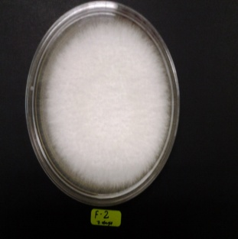
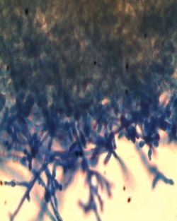
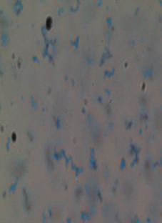
Note:- Morphology; A = culture on PDA, B = mycelia and C = spores
Figure 1: Fusarium oxysporum f. sp. lycopersici isolated from chilli leaves (CL)
B
C
A
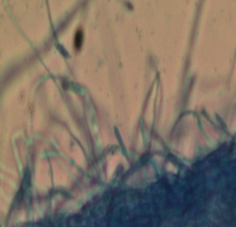
Notes:- Morphology; A = culture on PDA, B = mycelia and C = spore
Figure 2: Fusarium solani isolated from chilli seeds (CS
A
C
B
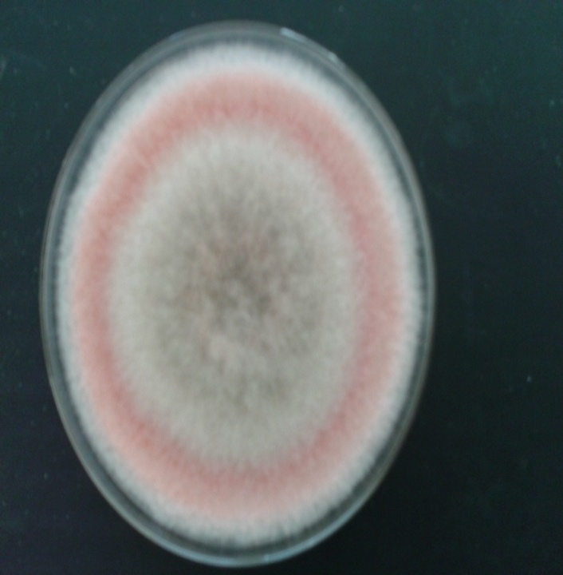
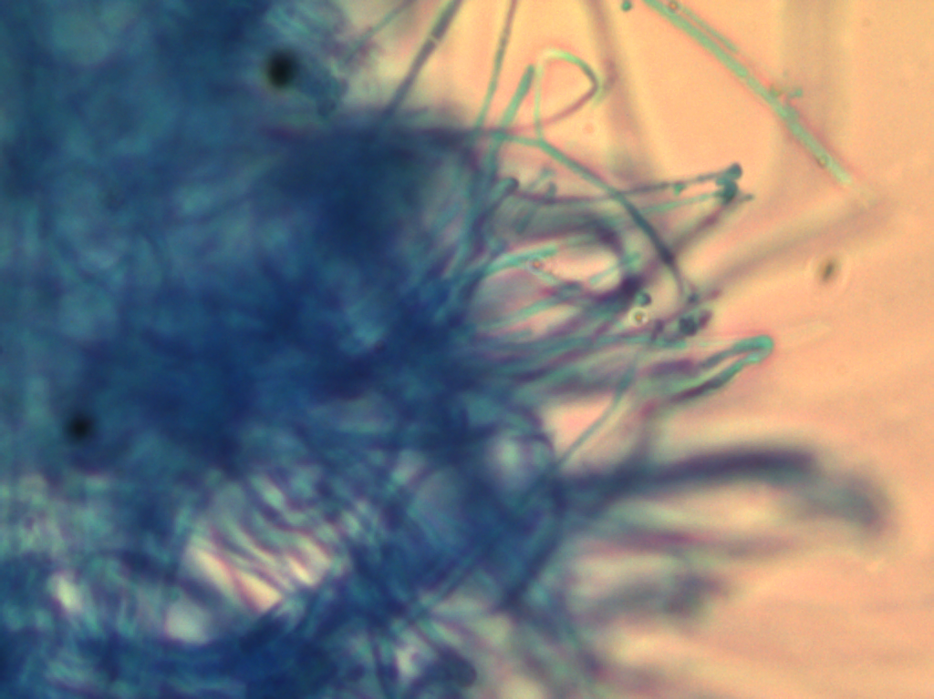
Notes:- Morphology; A = culture on PDA, B = mycelia and C = spores
Figure 3: Fusarium acuminatum isolated from chilli fruits (FC)
B
C
A
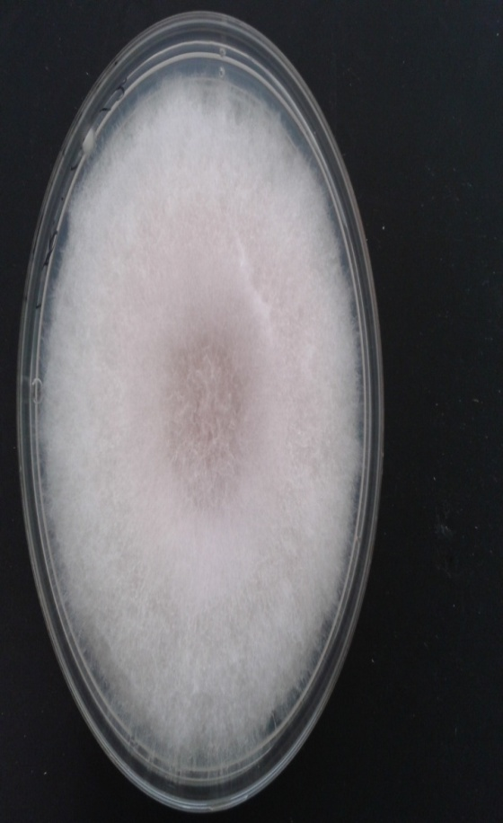
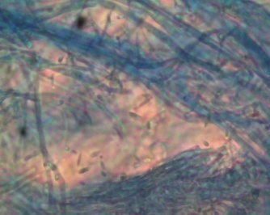
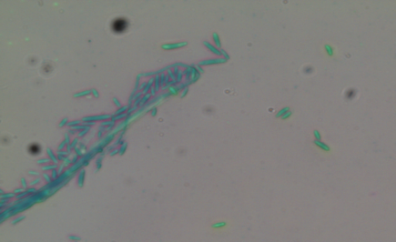
Note:- Morphology; A = culture on PDA, B = mycelia and C = spores
Figure 4: Fusarium proliferatum isolated from rose leaves (LR)
TABLE 2: Fusarium spp. identified by internal transcribed spacer
Morphological identification of fungi | Internal transcribed spacer (ITS) identification
 | Sources | Similarity | Identification | Accession
Fusarium oxysporum f. sp. Lycopersici-CL | Chilli leaves | 99% | F. oxysporum KAML01 | KC119203.1
Fusarium solani-CS | Chilli seeds | 99% | Fusarium sp. CID124 | EF589878.1
Fusarium acuminatum-FC | Chilli fruits | 99% | Fusarium sp. fus 124 | EF589878.1
Fusarium proliferatum-LR | Rose leaves | 99% | F. proliferatum | FJ040179.1

3.2.1. Isolation and Characteristics of Lactic Acid Bacteria
A total of 21 LAB isolates consiting of 14 from at soil samples and 7 from fermented chilli fruits. These isolates showed clear zone on the modified agar with 0.7% CaCO₃ and were catalase negative. Microscopic observation showed that the LAB isolates were cocci and rod shapes details description were mentioned in Table 3.

Table 3: Characteristics of lactic acid bacteria isolated from soil and fermented chilli fruits
Isolates | Sources | Places | Catalase tests | Gram’s stain test | Shapes
MSS1 | Soil | Nilai Land Scape Garden | Negative | Positive | Rod
MSS2 | Soil | Nilai Land Scape Garden | Negative | Positive | Rod
MSS3 | Soil | Subangjaya Nursery | Negative | Positive | Rod
MSS4 | Soil | Subangjaya Nursery | Negative | Positive | Cocci
MSS5 | Soil | Nilai Land Scape Garden | Negative | Positive | Cocci
MSS6 | Soil | Subangjaya Nursery | Negative | Positive | Rod
MSS7 | Soil | Subangjaya Nursery | Negative | Positive | Rod
MSS8 | Soil | Subangjaya Nursery | Negative | Positive | Rod
MSS9 | Soil | Subangjaya Nursery | Negative | Positive | Rod
MSS10 | Soil | Subangjaya Nursery | Negative | Positive | Rod
MSS12 | Soil | Puchong Selangor | Negative | Positive | Rod
MSS13 | Soil | Puchong Selangor | Negative | Positive | Cocci
MSS14 | Soil | Puchong Selangor | Negative | Positive | Cocci
MSS15 | Soil | Puchong Selangor | Negative | Positive | Cocci
FCF11 | FCF | Local Market | Negative | Positive | Rod
FCF16 | FCF | Local Market | Negative | Positive | Rod
FCF17 | FCF | Local Market | Negative | Positive | Rod
FCF18 | FCF | Local Market | Negative | Positive | Rod
FCF19 | FCF | Local Market | Negative | Positive | Rod
FCF20 | FCF | Local Market | Negative | Positive | Rod
FCF21 | FCF | Local Market | Negative | Positive | Rod
Note:- MSS= isolates from soil and FCF = isolates from fermented chilli fruits
3.2.2. Phenotypic and Genotypic Identification LAB Isolates
Phenotypic identification of the LAB isolates using API 50 CH kit showed that the isolates MSS1, FCF11 and MSS5 showed 99.9% similarity Lb. plantarum1 and P. pentosaceus1 in Table 4. Similarly, based on genotypic identification using 16s r-DNA showed that the isolates MSS1, FCF11 were 100% similarity with Lb. plantarum and MSS5 showed 99% were similarity with P. pentoceous in Table 5.

Table 4: Identification of LAB isolates using API 50CHL Kit
LAB Isolates | API 50CHL
 | Similarity | Identification
MSS1 | 99.9% | Lb. plantarum1
MSS5 | 99.9% | P. pentosaceus1
FCF11 | 99.9% | Lb. plantarum1
Note:- MSS1, MSS5= isolates from soil and FCF11= isolates fermented chilli fruits
Table 5: Identification of LAB isolates using 16S rDNA
LAB Isolates | 16S rDNA
 | Similarity | Identification | Accession
MSS1 | 100% | Lb. plantarum | KM207826.1
MSS5 | 99% | P. pentoceus | KP189228.1
FCF11 | 100% | Lb. plantarum | CP010528.1
Note:- MSS1, MSS5= isolates from soil and FCF11= isolates fermented chilli fruits
  - Qualititative Evaluation for Antifungal Activity of LAB Isolates by dual overlay method
The antifungal activity of LAB isolates against Fusarium species were influenced by species of LAB and fungi. Good antifungal activity was observed for 19 LAB isolates and three LAB strains of ATCC cultures by using the dual overlay method (Figure 5 & 6). Fungi F. Oxysporum KAML01-CL was readily inhibited by 20/24 of the LAB isolates with inhibitory zone 30 to 60 mm; the biggest inhibition was shown by LAB MSS5 within 48 h incubation. Antifungal activity of LAB against Fusarium sp. CID124-CS was variable where seven of the isolates showed inhibitory zone of 40 to 50 mm, nine LAB isoaltes inhibited the fungi with 30 to 40 mm and six LAB isolates showed no inhibitory activity. Fungi Fusarium sp. fus 124-FC was more difficult to be inhibited by LAB cells. It is interesting to note that F. proliferatum-LR isolated from severely infected rose leaves was easily inhibited by all the LABs isolates with inhibitory zone from 10 to 60 mm.

Figure 5: Distribution of inhibitory activity (in mm) od LAB isolates against Fusarium spp. by dual agar overlay method
Time of incubation influenced the antifungal activity. Longer exposure time 48 h at 28ºC was required for Fusarium sp. to be inhibited by LAB-MSS4 and LAB-MSS12. It was noticed that six LAB ioslates against Fusarium sp. CID124-CS and one LAB isoltes against F. oxysporum KAML01-CL did not to show antifungal activity. Similarly, two LAB isolates did not able to ihibit the Fusarium sp. fus 124-FC and F. Proliferatum-LR, therefore, growth of Fusarium spp. were seen to severely. Based on the results obtained from this screening test five LAB strains were selected for further study.

Growth of F. oxysporum f. sp. lycopersici-CL
LAB streak
Clear zone around cells
Note:- Antifungal activity of LAB-MSS5 against F. oxysporum f. sp. lycopersici-CL
Figure 6: Clear zone around the LAB streaks indicate antifungal activity
  - Quantitative Fungal Biomass Reduction
The quantitative funglal biomass reduction was observed in the de Man Rogosa and Sharpe Broth (MRSB) and Malt Extract Broth MEB broth medium using dry mass method the detail description in the following section.
    - Fungal Biomass in MRS Broth Inoculated with LAB Cells
Good growth of Fusarium species as determined by weight of fungal biomass was observed in MRS broth. However, growing the Fusarium spp. together with LAB cells in the MRS broth generally reduced the fungal growth from 76.93 to 97.43 % (Table 6), however, the antifungal effect was not significantly (P>0.05) different between the LAB isolates and fungi. Growth of Fusarium sp. CID124 was greatly reduced 97.43% but less for F. proliferatum 76.93% in MRS inoculated with P. pentosaceus1-MSS5). Similarly, Lb. plantarum 1-FCF11 effectively reduced growth of F. oxysporum KAML01-CL 96.09% and Fusarium sp. fus 124-FC 90.9%. As comparison, it was also observed that cells of L. plantarum ATCC8014 reduced the growth of F. oxysporum KAML01-CL by 96.6%, but lower for Fusarium sp. fus 124-FC (78.5%). Interestingly, cells of Lb. acidophilus ATCC 314 inhibited the growth of all Fusarium spp. evaluated by 87.43 to 91.96%.
Table 6: Percentage biomass reduction of Fusarium species by LAB cells in MRS broth after incubation for 7 days at room temperature
Name of LAB | Fungal mycelia mass reduction (%)
 | CL | CS | FC | LR
Lb. plantarum1 MSS1 | 93.33ª | 91.07ª | 90.37ª | 79.93ª
P. pentosaceus1MSS5 | 87.16ª | 97.43ª | 82.72ª | 76.93ª
Lb. plantarum1 FCF11 | 96.09ª | 94.32ª | 90.90ª | 87.59ª
Lb. acidophilus ATCC314 | 91.39ª | 91.96ª | 87.43ª | 92.32ª
Lb. plantarum ATCC8014 | 96.61ª | 85.72ª | 78.55ª | 82.92ª
Note:- Data was analyzed using one-way ANOVA (unstacked) with respect to single column. The alphabets (a,b,c & d) were being inferred the variables used in the study. Fungi Fusarium specie: CL= F. Oxysporum KAML01, CS= Fusarium sp. CID124, FC = Fusarium sp. fus 124 and LR= F. proliferatum
    - Fungal Biomass in MEB Broth Inoculated with LAB Cell Free Supernatants
MEB is the media normally used to grow fungi. Reduction in fungal biomass was observed in MEB with added LAB-CFS in the range between 29.9 to 91.8% (Table 7), but generally lower than that observed when the fungi were grown together with the LAB cells (Table 7). It was observed that CFS Lb. plantarum1-MSS1) and P. pentosaceus1-MSS5 was significantly not affective to reduce the biomass F. proliferatum; it was observed biomass was reduced by 34.0% and 29.9%, respectively. However, CFS of Lb. plantarum1-MSS1 reduced fungal biomass of Fusarium sp. fus 124-FC and F. oxysporum KAML01-CL to about 63.2%, and 68.7%, respectively. It is interesting to note the CFS Lb. acidophilus ATCC314 reduced fungal mass Fusarium sp. CID124-CS by 91.8% after incubation.
Table 7: Percentage biomass reduction of Fusarium spp. in MEB inoculated with LAB cell free supernatant after 7 days incubation at room temperature
Name of LAB | Fungal mycelia mass reduction (%)
 | CL | CS | FC | LR
Lb. plantarum1 MSS1 | 68.74ª | 71.41ª | 63.23ª | 34.08^{b}
P. pentosaceus1MSS5 | 78.72ª | 73.80ª | 57.38ª | 29.92^{b}
Lb. plantarum1 FCF11 | 80.00a | 80.03a | 69.72a | 56.36a
Lb. acidophilus ATCC314 | 75.62ª | 91.8ª | 59.53ª | 59.19ª
Lb. plantarum ATCC8014 | 75.62ª | 86.86ª | 57.47ª | 62.19ª
Note:- Data was analyzed using one-way ANOVA (unstacked) with respect to single column. The alphabets (a,b,c & d) were being inferred the variables used in the study. Fungi Fusarium specie: CL= F. Oxysporum KAML01, CS = Fusarium sp. CID124, FC = Fusarium sp. fus 124 and LR= F. proliferatum
  - Percentage Germination of Chilli Seeds Treated with LAB-CFS and Fusarium Species
The antifiungal activity of CFS of LAB isolates on fungal infected chilli seeds was evalauted on chilli seeds of cultivar Cili Kulai, Red spicy-0639 and GAAC-SEED-5005. Chilli seeds infected with fungi showed reduced
Table 8: Percentage germination of chilli seeds infected with Fusarium spp. and LAB-CFS
Treatments | Germination (%)
 | Cili Kulai | Red spicy-0639 | GAAC-SEED-5001
Control | 93.3ª | 83.3^{ab} | 82.6ª
Fungal infected seeds
F. oxysporum KAML01-CL | 63.3^{d} | 63.3^{c} | 70.0^{ab}
Fusarium specie CID124-CS | 53.3^{d} | 53.3^{c} | 60.0^{b}
Fusarium specie fus 124-FC | 70.0^{bcd} | 70.0^{bc} | 70.0^{ab}
F. proliferatum-LR | 66.6^{cd} | 60.0^{c} | 66.6^{ab}
LAB-CFS treated seeds
Lb. plantarum1 MSS1 | 90.0^{ab} | 93.3ª | 83.3ª
P. pentosaceus1MSS5 | 86.6^{abc} | 83.6^{ab} | 86.7ª
Lb. plantarum1 FCF11 | 93.3ª | 93.3ª | 90.0ª
Lb. acidophilus ATCC314 | 90.0^{ab} | 83.6^{ab} | 83.3ª
Lb. plantarum ATCC8014 | 86.6^{abc} | 83.6^{ab} | 83.3ª
Note:- Data was analyzed one-way ANOVA (unstacked) with respect to single column. The alphabets (a,b,c & d) are being inferred the variables used in the study
percentage germination between 53.3 to 70% after two week incubation at room temparature 28±2ºC (Table 10).
All seeds treated with the CFS showed good germination of 82.6 between to 93.3% comparable to seeds receiving no fungal treatment (contol). Interstingly chilli seeds were treated with LAB-CFS promoted earllier gemination within six days incubation compare to control and infected seed with fungi Fusarium sp. CID124-CS in Figure 7 displayed clearly.
A
Slow growth of shoot and no root growth appeared
Embryos
Shoot
C
No shoot and root growth
B
Secondary root
Primary root
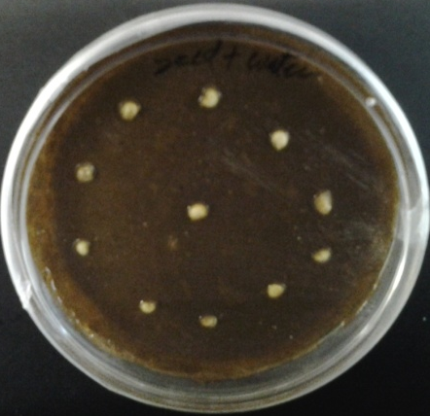
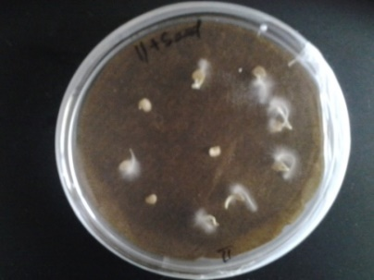
Note:- Seeds were placed on brown paper for seed germination study. (A) Seeds without LAB and Fungi (control) showing no shoot and root growth; (B) Seeds inoculated with fungi Fusarium sp. CID124-CS also showed slow growth; and (C) Seeds inoculated with LAB-FF11 after six days of incubation. Seeds in figure C showing good shoot and root clear
Figure 7: Seed germination experiment after six days of incubation
4. Discussions
Fusarium spp. are phytopathogenic fungi that have the ability to invade many plants and cause diseases of plants. In this study, Fusarium species were isolated from severely infected different plant parts of chilli plants and rose leaves and identified as F. oxysporum strain KAML01, Fusarium. sp. CID124, Fusarium sp. fus 124 and F. proliferatum using Internal Transcribed Spacer (ITS) analysis (Table 2). Similarly, F. oxysporum was isolated from different plant parts of tomato plants that caused plant wilt and fruit rot [23]; while F. avenaceum, F. pseudograminearum, F. semitectum, F. crookwellense, and F. compactum were isolated from naturally infected apple fruit [37]. Fusarium spp. such as F. oxysporum-1, F. solani-1, F. oxysporum-2, F. solani-2, F. rolfsii were noted as severely virulent strains of pathogenic fungi that often infect plants and seeds of tomatoes [31]. The search for microorganisms that showed antagonistic activity towards phytofungi would be an alternative to the use of chemical fungicides. Microorganisms such as LAB isolated from food, fruits and fermented foods were reported to have antifungal activity against food spoilage fungi [38; 39; 13] and phytopathogenic fungi [40]. Additionally, isolated LAB from soil and other sources and reported their antifungal activity against phytopathogenic species Pythium [20]. It is interesting to note that 14 LAB strains isolated from soil and rhizospheric soil samples and seven isolates from fermented chilli fruits showed antifungal activity against the four species of Fusarium isolated from infected plants parts, especially Lb. plantarum 1 and P. pentosaceus 1 isolated from soil and Lb. plantarum 1 isolated from fermented chilli fruits. This indicates that soil samples can be a source of LAB with antifungal activities. Similarly, it was reported that the presence of P. pentosaceus 1 in rhizospheric soil [41], however, the antagonistic activity against phytofungi was not reported. Interestingly, P. pentosaceus with antifungal activity against A. oryzae was isolated from tempeh, a fermented soybean commercially available in Malaysia [32]. Similarly, cells of LAB isolates from the soil rhizosphere and fermented chilli have antagonistic activity in liquid form medium in MRSB and MEB against the four Fusarium spp. MRSB is the culture media for LAB and this study showed that it also supports good growth of the fungi. Isolate Lb. plantarum IS10 grown in the MRS broth were reported able to produce antifungal compounds such as peptides and rutrin by the work of [42]. Similarly, Leuconostoc mesenteroides DU15 was produced antifungal peptides that have ability to inhibit growth of A. niger [43]. Even though the antifungal compounds were not determined in this study, it is expected that the presence of antifungal compounds in the MRSB have resulted in suppression of fungal spore germination and growth of the fungi biomass in the media especially by P. pentosaceus1-MSS5 isolated from soil. Similar finding was reported by other researchers that indicated LABs such as Lactobacillus sp. 1, Lactobacillus acidophilus sp. 2, Lactobacillus sp.4 and Lactobacillus sp.5 were effective against phytopathogenic fungi F. oxysporum-1, F. oxysporum-2, R. solani-2, R. solani-1 and S. rolfsii that infected tomato seeds [31]. In addition, CFS of Lb. plantarum LAB-C5 and LAB-G7 isolated from Malaysian fruits strongly inhibited the growth of phytofungi C. gloeosporioides and C. capsici [44], in another experiment CFSs of LAB were inoculated to MEB that is normally used to culture fungi. Fungal biomass was reduced to 86.86% especially by CFS of Lb. plantarum ATCC8014. This further supports that LAB supernatant contains antifungal compounds that were effective against Fusarium spp. especially Fusarium sp. CID124 isolated from severely infected chilli seeds. The differences in the efficacy of antifungal activity of LAB-CFS cultured in MRSB or MEB may be related to the amount of the antifungal metabolites produced by the LAB strains in the media. The variability in biomass reduction could be related to specificity of metabolites produced by LAB that may have caused failure of conidia germination and mycelium proliferation. Similar observation was noted by [32] who reported that cell mass of A. oryzae, a food spoilage fungi was inhibited by LAB-CFS of P. pentosaceus Te010 and Lb. brevis G004 in MRSB and further identified novel peptides produced by Lb. plantarum IS10 isolated from fruits and fermented foods that inhibited spore germination of A. flavus MD3, P, roqueforti MD4 and E. rubrum MD5 [42]. This study observed that soaking the chilli seeds with the LAB-CFS enhanced and improved the seeds germination percentages compared with chilli seeds infected with Fusarium spp. Seed germination of all the three cultivars was enhanced to range between 83.6% to 93.3% in seeds treated with CFS of Lb. plantarum 1-MSS1 isolated from soil rhizosphere and Lb. plantarum1-FCF11 isolated from fermented chilli fruits. Additionally, it was reported that Lb. plantarum-C5 isolated from fermented durian inhibited growth of C. capsici and C. gloeosporioides as well as promoted good germination of chilli Bangi [45]. Delaying in seed germination infected with phytofungi was reported in study [46] reported delayed seed germination and poor seedling growth of pigeon pea treated with culture filtrates of F. oxysporum udum. Similarly, it was found that Lb. plantarum was effective in reducing many plant pathogens including Fusarium spp. on the germination of seeds of cereals crops and pigeon pea [47]. In this study the percentage germination of all chilli seeds was delayed by Fusarium spp. especially seeds infected with Fusarium sp. CID124-CS one of the Fusarium spp. isolate from infected chilli plants. In another study [48] reported that knapweed seedlings inoculated with Fusarium CID124, Fusarium CID107 and Alternaria isolates CID62, Alternaria CID123, Epicoccum CID66 produced fewer flowering heads later compared to control knapweed seedlings.
5. Conclusions
In conclusion, soaking chilli seeds in CFS of Lb. plantarum 1 and P. pentosaceus 1 isolated from soil and Lb. plantarum1 isolated from fermented chilli fruits before infection occurs with fungi would be the best bio-control strategy in reducing the fungi contamination in chilli seeds. This application is economical and practical to be implemented by farmers and would have greater impact in reducing lost in agricultural commodity as a result of phytofungi infection.
6. Acknowledgements
Authors thank to the Ministry of Higher Education, Malaysia for supporting this research through Exploratory Research Grant Scheme (ERGS), Vot. No. 55087 and other funding support provided by the Faculty of Science and Technology, Universiti Sains Islam Malaysia (USIM).
7. References
[1] R.B. Maude, “Seed borne diseases and their Control”, CAB International Cambridge, pp. 280, 1996.
[2] K. Singh, J. C. Frisvad, U, Thrane and S. B. Mathur, “An iltustroted Manual on identification of Some Seed- Borne Aspergilli, Fusario, Pencillia ond their Mycotoxins”, Aio rryk as odense, Denmark, pp. 133, 1991.
[3] A.B. Anasol, P.D. & A.M. Emechebe, “Preliminary studies on toxic metabolites produced by Drechslero rostroto and Fusarium equiseti and their effect on root growth in wheat”, Nigerian Journal plant protection Vol. 5, pp. 102-105, 1981.
[4] V. Jalonder & B. D. Gachonde, “Effect of culture filtrates of Fusarium oxysporum on seed germination and seedling growth of pigeon pea (cnanus cnani varieties)”, Bioscience Discovery, Vol. 2, No. 2, pp.185-188, 2011.
[5] M. Z. Alam, I. Hamim, M. A. Ali, and M. Ashrafuzzaman, “Effect of seed treatment on seedling health of chili”, Journal of Environmental Scienc & Natural Resources, Vol. 7, No. 1, pp. 177 – 181, 2014.
[6] E. Chigoziri and E. J. Ekefan, “Seed borne fungi of chilli pepper (Capsicum frutescens) from pepper producing areas of Benue State”, Nigeria Agriculture and Biology Journal of North America ISSN Print: 2151-7517, ISSN Online: 2151-7525, 2013.
[7] M. N. Asalmol, V.P. Kale & S.T. Ingle, “Seed borne fungi of chilli, incidence and effect on seed germination”, Seed Resources, Vol. 29, pp. 76-79, 2001.
[8] R. Tharsika and G. Mikunthan, “Impact of Aspergillus fungi on germination of chilli seeds and its control”, International Journal of Scientific & Technology Research, Vol. 4, No. 05, MAY, 2015.
[9] C. Stephane, D. Brion, N. Jerzy, C. Christophe and A. Essaid, “Use of plant growth-promoting bacteria for bio-control of plant diseases: principles, mechanism of action, and future prospects”, Applied Environmental Microbiology,Vol.71,pp.4951-4959,2005.
[10] Rosalia,TLluis, B. Emilio and M. B. Esther, “Lactic acid bacteria from fresh fruit and vegetables as bio-control agents of phytopathogenic bacteria and fungi”,International Microbiology,Vol.11,pp.231-236,2008.
[11] H. Ashgar, & Mohammad, “A review on biological control of fungal plant pathogens using microbial antagonists”, Journal of Biological Science, Vol. 10, pp. 273-290, 2010.
[12] H. K. Wang, H. Yan, J. Shin, L. Huang, H. P. Zhang and W. Qi, “Activity against plant pathogenic fungi of Lactobacillus Plantarum IMAU10014 isolation from xinjiang koumiss in China”. Annals of Microbiology”, Vol.61,pp.879-885,2011.
[13] B. J. A Muhialdin, Z. Hassan & S. Sadon Kh, “Antifungal Activity of Lactobacillus fermentum Te007, Pediococcus pentosaceus Te010, Lactobacillus pentosus G004, and L. paracasi D5 on Selected Foods”, Journal of Food Science, Vol. 76, pp. 493–499, 2011.
[14] M. Plockova, J. Stiles & J. Chumchalova, “Control of mould growth by Lactobacillus rhamnosus VT1 and Lactobacillus reuteri CCM 3625 on milk agar plates”, Czech Journal of Food Science, Vol. 19, pp. 46-50, 2001.
[15] I. H. Yousef, and B. B. Lloyd, “Antifungal activity of Lactobacillus paracasei ssp. Tolerans isolated from a sourdough bread culture”, International Journal of Food Microbiology,Vol. 121. pp. 112-115,2008.
[16] El-Mabrouk, H. Zaiton, M. M. Ahmed & M. A. H. Khaled, “Screening of Lactic Acid Bacteria as Biocontrol Against (Collectotrichum capsici) on Chilli Bangi”, Research Journal of Applied Sciences, Vol.7, No. 9 & 12, pp. 446- 473, 2012.
[17] H.M. Gebreel, A.A. El-Mehalawy, I .M El-Kholy, H.M Rifaat,. and A.A. Humid, “Antimicrobial activities of certain bacteria isolated from Egyptian soil against pathogenic Fungi”, Research Journal of Agriculture and Biological Sciences, Vol. 4, No. 4, pp. 331-339, 2008.
[18] N. Noordiana, A. B. Fatimah & A. S. Mun, “Antibacterial agents produced by lactic acid bacteria isolated from Threadfin Salmon and Grass Shrimp”, International Food Research Journal Vol. 20, No. 1, pp. 117-124, 2013.
[19] J. Kohl, J. Postma, P. Nicot, M. Ruocco & B. Blum, “Stepwise screening of microorganisms for commercial use in biological control of plant-pathogenic fungi and bacteria”, Biological Control, Vol. 57, pp.1‒12, 2011.
[20] P. L. Matthias, V. M. C. M.., C, C, “Lactic acid bacteria as bio-control agents of soil-borne pathogens, Biological Control of Fungal and Bacterial Plant Pathogens”, IOBC-WPRS Bulletin, Vol. 78, pp. 285-288, 2012.
[21] D. K. Jha, “Laboratory Manual on Seed Pathology”, Vikas Publishing House Private Limited, pp. 13-30, 1995.
[22] L. J. Judith, G. Anderson, R. D. Thomasd & K. S. Oliver, “Inoculation and growth with soil borne pathogenic fungi Medicago truncatula handbook version”. Australian Centre of Necrotrophic Fungal Pathogens, SABC, Department of Health Sciences, Murdoch University, South State, Murdoch 6150, Western Australia, 2006.
[23] M. Ignjatov, D. Milosevic, Z. Nikolic, J. Gvozdanovic-Varga, D. Jovicic and G. Zdjelar, “Fusarium oxysporum as Causal Agent of Tomato Wilt and Fruit Rot”, Pestic Phytomed Belgrade, Vol. 27, pp. 25–31, 2012.
[24] D.M. Geiser, M.D. Jimenez-Gasco, S.C. Kang, I. Makalowska, N. Veeraraghavan, T.J. Ward, N. Zhang, G.A. Kuldau, and K. O’Donnell, “Fusarium-ID V. 1.0: A DNA sequence database for identifying Fusarium”, European Journal of Plant Pathology, Vol. 110, pp. 473-479, 2004.
[25] F.S. Altschul, T. L. Madden, A. A. Schaffer, J. Zhang, Z. Zhang, W. Miller & J. L. David, “Gapped BLAST and PSLBLAST: a new generation of protein database search programs”, .Nucleic Acids Research, Vol. 25, pp. 3389-3402, 1997.
[26] De Man, J.D., M. Rogosa & M.E. Sharpe,“A medium for the cultivation of lactobacilli”, Journal of Applied Bacteriology, Vol. 23, pp. 130-135. DOI: 10.1111/j.1365-2672.tb00188, 1960.
[27] P. Wanchai, S. Pramuan and W. Nisakorn, “Identification and evaluation of lactic acid bacteria for Pla-som (fermented fish) starter”, Proceedings of the 2nd International Conference on Fermentation Technology for Value Added Agriculture Products, May, 2007, pp. 23-25, Kosa Hotel, Khon Kean, Thailand. pp.1-6, 2007.
[28] B. W. Jarvis & L. M. Hoffman, “Epi-centre forum”, Vol. 11, pp. 0-5, 2004.
[29] J. Magnusson, “Antifungal activity of lactic acid bacteria”, Ph.D. Thesis, Agraria 397, Swedish University of Agricultural Sciences, Uppsala, Sweden, 2003.
[30] J. Magnusson & J. Schnurer, “Lactobacillus coryniformis subsp. coryniformis strain Si3 produces a broad-spectrum proteinaceous antifungal compound”, Applied Environmental Microbiology. Vol. 67, pp. 1-5. DOI: 10.1128/AEM.67.1.1-5, 2001.
[31] H. Hamed, A. M. Yomna and M. A. A. Shadia, “In vivo Efficacy of Lactic Acid Bacteria in Biological Control against Fusarium oxysporum for Protection of Tomato Plant”, Life Science Journal, Vol. 8, No. 4, pp. 462-468, 2011.
[32] B. J. A. Muhialdin, Z. Hassan, “Screening of Lactic Acid Bacteria for Antifungal Activity against Aspergillus oryzae”, American Journal of Applied Sciences, Vol. 8, No. 5, pp. 447-451, ISSN 1546-9239, 2011.
[33] M. N. Khare, “Methods to test seeds for associated fungi”, Indian Phyto-pathology, Vol. 49, pp. 319-328, 1996.
[34] D. Nirmaladevi1, M. Venkataramana, R. K. Srivastava, S. R. Uppalapati, V. K. Gupta, T. Yli-Mattila, K. M. Clement T., C. Srinivas1, S. R. Niranjana & N. S. Chandra, “Molecular phylogeny, pathogenicity and toxigenicity of Fusarium oxysporum f. sp. Lycopersici”, Scientific Report Vol. 6, 21367, 2012.
[35] Dhoro, M. 2010. “Identificaation and differentiation of Fusarium species using selected molecular methods”. Thesis. p. 1-74.
[36] H. Yu, Z. Lei, L. Lin, Z. Chengjian, G. Lei, L. S. Wenchao, Peixin, Q. Luping, “Recent developments and future prospects of antimicrobial metabolites produced by endophytes”, Microbiological Research. Vol. 165, pp.437-449, 2010.
[37] Sever z., d. ivic, T. kos, and T. milicevic, “Identification of Fusarium species isolated from stored apple fruit in Croatia”,Arh Hig Rada Toksikol, Vol.63, pp. 463-47, 2012.
[38] A. Ponce, M. Moreira, C. A. Del Valle & S. Roura, “Preliminary characterization of bacteriocin-like substances from lactic acid bacteria isolated from organic leafy vegetables”, LWT - Food Science and Technology, Vol. 41, No. 3, pp. 432-441, 2008.
[39] C. Ibarguren, M. Audisio, T. Farfaan, and M. Apella, “Silicates characterization as potential bacteriocins carriers”, Innovative Food Science and Emerging Technologies, Vol. 11, No.1. pp.197-202, 2010.
[40] El- W. Mabrouk Asma Saleh, Z. Hassan, A. Mahir Mokhtar Khaled. M. A. Hussin, “Antifungal Activity of Lactobacillus plantarum LAB-C5 and LAB-G7 Isolated from Malaysian Fruits”, Acta Biologica Malaysiana, Vol. 2, No. 1, pp. 22-30, 2013.
[41] Y.S. Chen, F. Yanagida & T. Shinohara, “Isolation and identification of lactic acid bacteria from soil using
an enrichment procedure”, Letters in Applied Microbiology, Vol.40, pp.195–200, 2005.
[42] B. J. A. Muhialdin, Z. Hassan, F. A. Bakar, L. H. Algboory, N. Saari, “Identification of antifungal peptides
produced by Lactobacillus plantarum IS10 grown in the MRS broth”, Food Control, Vol. 59, pp. 27, 2016.
[43] B. J. A. Muhialdin, Z. Hassan, F. A. Bakar, L. H. Algboory, N. Saari, “Novel antifungal Peptides produced
by Leuconostoc mesenteroides DU15 effectively inhibit growth of A. niger”,
Journal of Food Science, Vol. 5, pp. 26-30, 2015.
[44] El- W. Mabrouk,“Lactic acid bacteria as biological control against Colletotrichumgloes porioides and
Colletotrichum capsici on chilli plants”, Thesis. Unsersity Sains Islam Malaysia, 2014.
[45] W. El-Mobrouk, H. Zaiton, Ahmed M. M., K. M.A. H. & K. Sh. B. A.K. Fredy, “Screening of lactic acid
bacteria as bio-control against (Colletotrichum capsici) on chilli bangi”, Research Journal of
Biological Science, Vol. 7, No. 4, pp. 159-164., 2012.
[46] V. Jalonder and B. D. Gachonde, “Effect of cutture filtrates of Fusarium oxysporum on seed germination
and seedling growth of pigeon pea (cnanus cnani varieties)”, Bioscience Discovery, Vol. 2, pp. 185-188,
2011.
[47] A. Laitila, H. L. Alakomi, L. Raaska, T. Mattila- Sandholm & A. Haikara, “Antifungal activity of two
lactobacillus plantarum strains against Fusarium mould in vitro and in malting of
barley”. Journal of Applied Microbiology, Vol 93, pp. 566-576, 2002.
[48] G. Newcombe, A. Shipunov, S. D. Eigenbrode, K. H. Anil Raghavendra, H. Ding, Cort L. Anderson,
“Endophytes influence protection and growth of an invasive plant”, Communicative & Integrative Biology,
Vol. 2, No. 1, pp. 29-31, 2009.

