**Integrated assessment of nitrogen resource management**

**in Songyuan, China**

Bin Jina, Zhihong Shen b[1]*, and Yoshiro Higano c

*aUniversity of TSUKUBA, 1-1-1 Tennodai, Tsukuba, Ibaraki, 305-8577, Japan*

*bJapan International Research Center for Agricultural Sciences, 3-1-3 Kannondai, Tsukuba, Ibaraki, 305-8604, Japan*

*cUniversity of TSUKUBA, 1-1-1 Tennodai, Tsukuba, Ibaraki, 305-8577, Japan*

*aEmail: korea_friend2005@yahoo.co.jp*

*bEmail: hirosi98@affrc.go.jp*

*cEmail: higano@jsrsai.envr.tsukuba.ac.jp*

**Abstract**

Due to the extensive use of nitrogen fertilizer in China, excess nitrogen has been discharged into groundwater, rivers, and the air, contributing to environmental problems such as eutrophication and the generation of greenhouse gases. In this research, an inter-industry analysis method and linear programming were used to design and assess integrated nitrogen resource management policies for Songyuan city, China. An inter-industry model was constructed using nitrogen mass balance. Based on our simulation results, we suggest optimal policies of integrated nitrogen resource management to support sustainable economic development in Songyuan city. We propose to increase organic fertilizer use instead of chemical fertilizer application within 4% along with installing a maximum of 16 units of biomass methane fermentation/power generation technologies in the city. These comprehensive policies would reduce nitrogen discharges by 513 thousand tons and create a net social benefit of 1,453 million yuan, accounting for about 1.5% of the region’s gross regional product for 2010. The Chinese government should focus on efficient use of nitrogen resources in its agriculture and livestock industries by reducing chemical fertilizer application and increasing organic fertilizer.

***Keywords:***integrated assessment, nitrogen cycle, biomass resources, simulation analysis, sustainable development<0}

1. **Introduction**

To ensure safe food production and protect the environment in China, it is important to understand the nature of the nitrogen cycle and biomass utilization efficiency associated with food production and consumption. As China has experienced enormous economic growth and urbanization, household food consumption patterns have changed drastically, with increased consumption of meats such as pork, beef, and chicken. As a result, nitrogen emissions from the livestock industry now exceed those from the manufacturing industry and pose a major emission problem [1]. To obtain the animal feed necessary for the livestock industry, it is also necessary to expand the production of grain. Efficient nitrogen resource management is an urgent concern from both environmental and economic perspectives. Its benefits include the reduced emission of greenhouse gases (GHGs), improved energy supply to self-sufficiency ratio, improved water quality, improved soil quality, reduced costs associated with the procurement of chemical fertilizer and fossil fuels, job creation, regional revitalization, and secure access to energy during emergency.

Considerable research has been conducted in the field of environmental policy simulations of the nitrogen cycle using linear programming. Isermann and Isermann developed a nitrogen balance model for Germany using statistical data from 1995 to 1998; their model considered grain, livestock, and waste to analyze the national nitrogen discharges [2]. The INITIATOR [3] and STONE [4,5] models focused on regional environmental evaluation, calculating the input, output, and net loss of nitrogen caused by agriculture and livestock of production, and household of food consumption using the proportional distribution principle. Liu built a national model to analyze the input and output of nitrogen in China during 2001, encompassing agriculture, livestock, and environmental factors [6]. Ma created a nutrient flow cycle model based on the earlier models developed by Isermann and Isermann and by Liu [7]. Shen et al. focused on analyzing medium- and long-term projections of the supply–demand balance of nitrogen nutrients in China. To achieve this purpose, they proposed an integrated projection methodology to manage the livestock industry in China sustainably and generate useful data [1].

There has been limited research in China using simulations to link the nitrogen material balance with socioeconomic activities. The present research is intended to characterize the inputs and outputs of nitrogen and total nitrogen (TN) discharges including both industrial and household activities. The objectives of this study are as follows:

* To establish a static, comprehensive optimization simulation model that considers water pollution emissions, GHG emissions, and gross regional product (GRP) in the study area;
* To evaluate the impact of environmental policies for reducing water pollution emission and GHG emission on GRP and environmental efficiency, with restrictions on fertilizer application and installation of advanced technologies (referred to here as bioenergy technologies A and B in section 3); and
* To observe whether optimal policy can satisfy the requirements of sustainable economic development.

1. **Methodology and Data**
   1. ***Method***

In conjunction with the scenario analysis method, we constructed a static simulation model based on input–output theory. The input-output theory developed by Wassily Leontief in 1966 [8] describes the interdependencies between different branches of multiple scale economies. Input–output models are widely used in comprehensive policy evaluations [9, 10, 11, 12]. Our simulation was completed using LINGO, an optimization modeling software for linear, nonlinear, and integer programming developed by LINDO Systems.

* 1. ***Data***

The study area for this research was Songyuan city, located in the middle western part of China’s Jilin province. The city, which encompasses 22,000 square kilometers, is well known for agriculture and livestock farming and plays a major role in food production and exports in China. However, due to overuse of nitrogen fertilizer in this region, excess nitrogen is discharged into groundwater, rivers, and the air, causing environmental problem such as eutrophication and GHG emissions. Rapid economic growth in the area is contributing to further environmental deterioration. Datasets related to population, the industrial economy, energy use, product supply and demand, water resources, land use, and production costs based on local statistics [13], regional statistics [14, 15], and government reports [16, 17] were used for the computer simulation analysis. Many of the coefficients used in the environmental load calculations came from published survey data [1,6].

1. **Integrated Assessment Model Structure**
   1. ***Model Structure***

In this study, a local nitrogen resource management model expressing nitrogen concentrations such as nitrogen oxide (NOx), TN, and others and a model describing local socioeconomic activities were constructed, taking into account the nitrogen environmental load problems caused by production and consumption in the study area (Figure 1). Then, the models were linked together in a form that describes the interactions between dynamic environmental data and socioeconomic activities in the target area. Furthermore, environmental restoration technologies and various policy options were incorporated in the interaction phase in the form of load reduction or recycling.

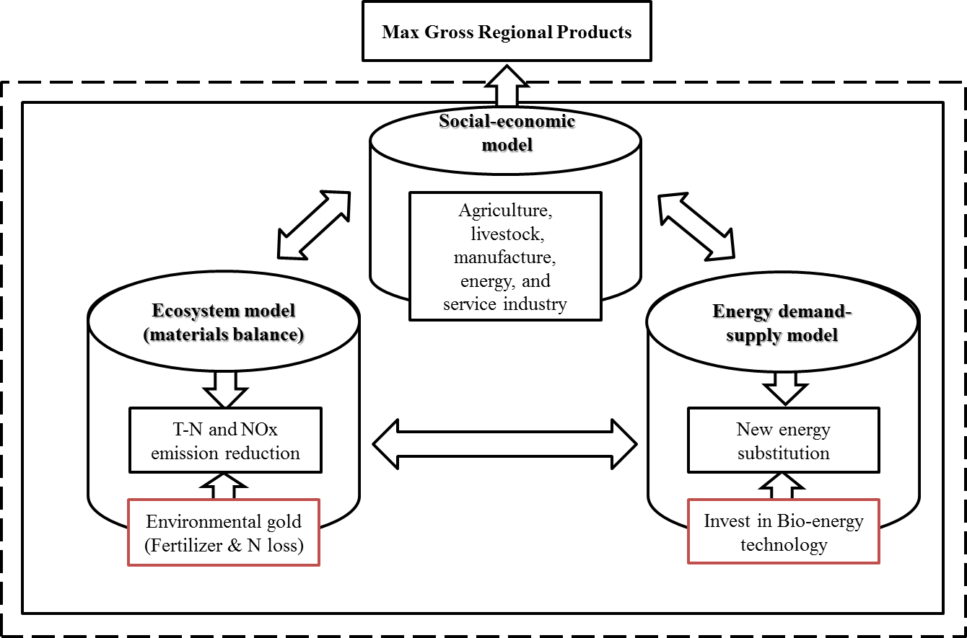

Figure 1. Simulation model schematic diagram<0}

The flow diagram shown in Figure 2 reflects nitrogen loads relevant to agriculture, the livestock industry, households, and the manufacturing sector. The manufacturing sector’s involvement is mainly associated with the manufacturing of fertilizer, which directly relates to the nitrogen load.

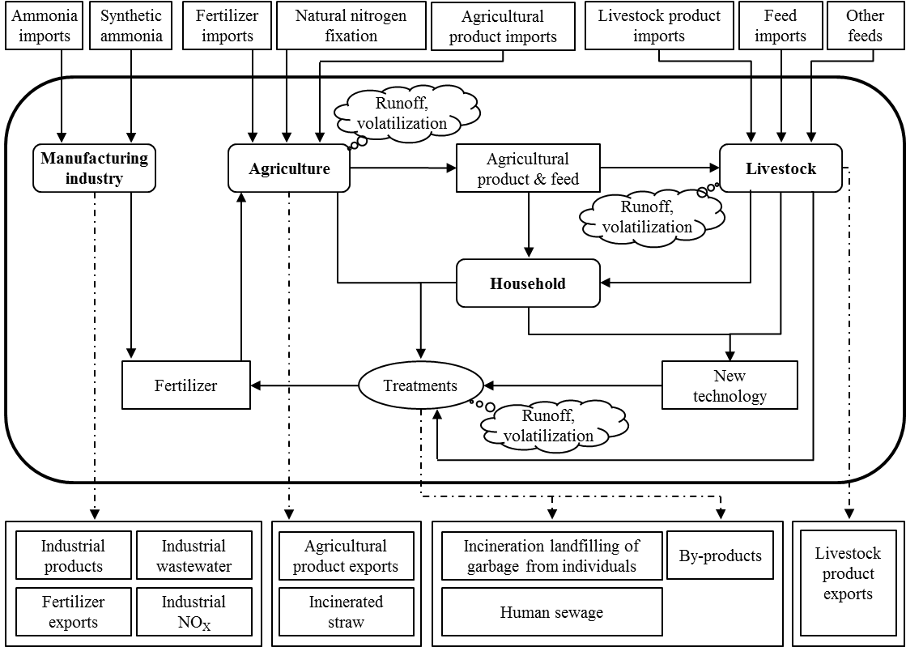

Figure 2. Summary of nitrogen flow in Songyuan

***3.2 Simulation Model Formulation***

The model consists of two types of variables: endogenous (En) and exogenous (Ex). The exogenous variables are based on annual data, and the simulation stipulates the endogenous variables. The most important formulas are presented below.

**Materials flow model of nitrogen input.** The actual amount of nitrogen input is determined by the amount of nitrogen deposited in the whole city, the amount of nitrogen in agricultural irrigation water, the amount of nitrogen fixation in farm products, the amount of nitrogen used in the manufacturing industry, and the imported amount of nitrogen.

 　　　　　　　 　(1)

where,

|  |  |
| --- | --- |
|  | = actual amount of nitrogen accumulated (Ex) |
|  | = nitrogen deposited (Ex) |
|  | = nitrogen in agricultural irrigation water (En) |
|  | = nitrogen fixation in farm products (En) |
|  | = nitrogen charged in the manufacturing industry (En) |
|  | = nitrogen imports (En) |

**Nitrogen output**. The actual amount of nitrogen discharged is determined by the loss of nitrogen in production and consumption including agriculture, livestock industry, manufacturing industry, and households.

　 　　　　　　 (2)

where,

|  |  |
| --- | --- |
|  | = nitrogen production in agriculture (En) |
|  | = nitrogen production in the livestock industry (En) |
|  | = nitrogen production in the manufacturing industry (En) |
|  | = nitrogen production by households (En) |

**Nitrogen load in the study area**. All nitrogen loads that impact the aquatic and atmospheric environment are described. The nitrogen load for the entire city is obtained by subtracting the livestock products, agricultural products, and industrial products shipped out and nitrogen reduction due to the introduction of biomass conversion technology from the nitrogen emissions in the whole city:

 　　　　　 (3)

where，

|  |  |
| --- | --- |
|  | = nitrogen load (En) |

**Reduction due to new technology installation.** The nitrogen reduction due to the introduction of biomass conversion technology is represented as follows:

 　　　　　　 (4)

 　　　　　　　 (5)

where

|  |  |
| --- | --- |
|  | = reduced amount of nitrogen discharge by increasing bioenergy utilization (En) |
|  | = reduction of nitrogen discharges by installing technologies A and B, respectively (En) |
|  | = coefficient of nitrogen discharge reduction per unit investment for technologies A and B, respectively (Ex) |

**Economic evaluation of biomass technology.** The number of installed apparatuses, installation costs, profits, and energy yield are formulated as follows:

　　　　 　 　　　　　　　 　 (6)

　 　　 　 　　　　　　　 (7)

　 　 　　　　　　　 　　 (8)

 　　　　　　　 (9)

 　　　　　　　　　 (10)

where,

|  |  |
| --- | --- |
|  | = the number of bioenergy conversion apparatuses (En) |
|  | = installation investment cost per bioenergy conversion apparatus (Ex) |
|  | = investment in bioenergy conversion apparatus (En) |
|  | = investment limit in bioenergy conversion apparatus (En) |
|  | = equipment maintenance management cost per bioenergy conversion apparatus (En) |
|  | = profits from the production of biomass energy (En) |
|  | = net profits from the production of biomass energy (En) |
|  | = energy market price (Ex) |
|  | = production cost per kilowatt-hour (kWh) of energy (Ex) |
|  | = energy production efficiency (Ex) |
|  | = bioenergy production amount (En) |

**Energy balance based on biomass technologies.** The energy production amount is determined by the energy production coefficient and the number of installed apparatuses. The energy supply amount is the value obtained by subtracting the energy consumption amount from the energy production amount. The energy consumption amount is determined by the energy consumption coefficient and the energy production amount.

　　　 　　　　　　　(11)

where,

|  |  |
| --- | --- |
|  | = net energy regeneration amount (En) |
|  | = energy consumption rate of biomass energy conversion technologies A and B, respectively (Ex) |

**Socioeconomic model: conditional expression of flow for normal goods.** The production amount of each industry in Songyuan city is stated using the following conditional expression of flow for the product market. The production amount is obtained by subtracting the import amount from the sum of the intermediate demand, biomass technology investment, private consumption, government consumption, investment, and exports:

 　　　　　　　 (12)

where,

|  |  |
| --- | --- |
|  | = the production amount of the normal goods industries (En) |
|  | = input coefficient and matrix of normal goods to normal industries (Ex) |
|  | = private consumption of normal goods (En) |
|  | = government consumption of normal goods (En) |
|  | = gross investment of normal industries (En) |
|  | = export of normal goods (En) |
|  | = import of normal goods (En) |
|  | = each of the industries involved: agriculture, livestock, manufacturing, energy, and service industry |

**Socioeconomic model: value balance equation for the normal goods industry.** The left-hand side of equation (14) shows the income and the right-hand shows the cost. The price rates of  of all industries are set to 1 at the benchmark year 2010.

 　 　　　　　　　　 　　(13)

where,

|  |  |
| --- | --- |
|  | = normal goods price index (En) |
|  | = matrix obtained bydiagonalizing  (En) |
|  | = depreciation rate (Ex) |
|  | = discount rate of employee disposable income for the normal goods industry (Ex) |
|  | = discount rate of operating profit(s) for the normal goods industry (Ex) |
|  | = generalized tax rate and row vector for the normal goods industry (Ex) |

**Restrictions for each simulation case.** In this study, we performed our analysis by restricting the reduction rate in the loss of nitrogen environmental load in the process of production, consumption, and treatment within Songyuan city:

 　 　　　　　　 　 (14)

where,

|  |  |
| --- | --- |
|  | = the reduction rate of the nitrogen environmental load (Ex) |
|  | = the base-year emission amount of the nitrogen environmental load (Ex) |

**Objective function.** The Gross Regional Product (GRP), a regional economic indicator, is calculated from the gross value added for the usual industries. The simulation is conducted using maximization of GRP in the whole city as the objective function, as shown in the following equation, for the purpose of evaluating the impact of new technologies [10]. The model used in this study is a macro aggregation model. On the assumption that the socioeconomic sphere consists of representative actors, we obtain the same result as the aggregate results of individual behavior by maximization of a certain potential function. We formulate utility maximization per head instead, and we formulate the equation in the following way by taking the other significant factors mentioned above into consideration:

 　　　　　　　 　 (15)

 　 　　　　　　　 (16)

where,

|  |  |
| --- | --- |
|  | = Gross Regional Product (En) |

**Simulation scenarios.** The simulation is run up to the solution limit to verify the effect of each case on the nitrogen cycle and to determine the related economic and environmental effects (Table 1). Case 0 is set using data from baseline year 2010, and the other three cases are based on feasible environmental improvements and resource utilization. Case 1 sets a limit on the amount of reduction of chemical fertilizer application; in Case 2, compost is made from animal and kitchen waste, maximizing the nitrogen reduction impact by substituting for chemical fertilizer; Case 3 implements biomass methane fermentation/power generation technologies. In general, the possible installation amount, maximized pollutant effect, and economic effect are calculated based on potential available waste in the whole area.

**Table 1:** Setting of simulation cases

|  |  |  |  |  |
| --- | --- | --- | --- | --- |
| Items | Case 0 | Case 1 | Case 2 | Case 3 |
| Objective function | Base year  (Fixed value) [13] | GRP maximization | | |
| Operation variable | Chemical fertilization restriction (Sensitivity 1%) | Restriction on amount of nitrogen load substances released (Sensitivity 1%) | |
| Policy function  (Operation function) | Reducing chemical fertilizer application | Chemical fertilizer alternatives  from composting | Biomass methane fermentation and power generation technologies introduced; budget limit: 100 million yuan |

**Summary of biomass technologies.** In this research, Japanese biomass technologies A and B [18] are introduced as a countermeasure, using animal and household waste from Songyuan city. When this technology is applied, animal and kitchen waste can be disposed of together in a distributed system and used to produce energy. The technologies are composed of a two-part methane fermentation system, an electrochemistry waste water treatment system, a co-generation system, and a carbonization system. Mixing treatment of animal manure and household waste enables a stable, efficient reaction that improves methane fermentation. The technological parameters of these biomass technologies are shown in Table 2.

**Table 2:** Detailed condition set for biomass technologies

|  |  |  |  |  |
| --- | --- | --- | --- | --- |
| Items | Evaluation factors | Technology A | Technology B | Unit |
| Construction costs | Government investment | 8.1 | 8.1 | million yuan |
| Maintenance | 0.6 | 0.81 | million yuan |
| Inputs | Manure and urine | 11.7 | 14.2530 | t-N/year |
| Kitchen waste | 18.3 | 4.38 | t-N/year |
| Outputs | Compost | 18.0 | 18.6 | t-N/year |
| HNOX | 12.0 | 12.0 | t-N/year |
| TN | 0.0305 | 0.0330 | t-N/year |
| N2O | 0.0003 | - | t-N/year |
| Requirements | Power consumption | 27,907 | 411,813 | kWh |
| Supply | Generated electrical energy | 227,907 | 3,363,140 | kWh |

**4．Results and discussion**

***4.1 Model validation***

Model validation was determined by calculating GRP and by separately assessing production and consumption for 2010, the study’s base year. A simulation using 2010 data was conducted to examine the model’s consistency. The results showed a GRP of 100,400 million yuan, only slightly different from the actual 2010 figure of 99,910 million yuan [13]. Comparing the actual production statistics for each industry (agriculture, livestock, manufacturing, energy, and service) with the simulation results we found differences of less than 1% in all five cases. The slight difference can be explained because of how the model seeks an optimal solution by optimizing production conditions to maximize GRP. This difference commonly occurs in simulation analysis. Therefore, the model calculates the base-year values with a high degree of precision, proving its consistency.

***4.2 Objective function***

The simulation results indicate that the limit on the reduction rate in Case 1 is 1.32%, which is equivalent to 10% of all chemical fertilizer application within the total nitrogen load in the study area (Figure 3). The reduction rate limits in Cases 2 and 3 are 10% and 13%, respectively. No solution provides a greater reduction rate than these. Our results show that the emission reduction rate of the nitrogen load substances is 0.66% in Case 1 (equivalent to 5% of chemical fertilizer application in 2010), 4% in Case 2, and 6% in Case 3. Additionally, the respective economic index values (GRP) are higher than the fixed value for the base year.

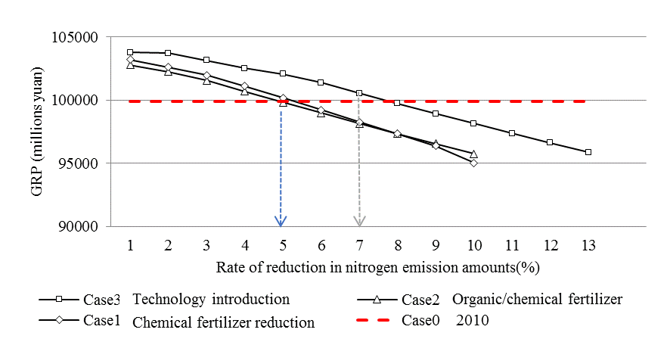

Figure 3. Tradeoff between nitrogen load reduction policies and GRP

***4.3 Comparison of Economic Effects***

Based on the appropriate reduction rates as presented in Figure 3, the economic effects relevant to each case are shown in Figure 4. In Case 1, it is possible to create economic benefits of 255 million yuan with a reduction rate of 0.66% in nitrogen emissions (reducing fertilizer application by 5% relative to 2010); in Case 2, the economic benefit is 780 million yuan with a reduction rate of 4% in nitrogen emissions. However, Case 3, with the best nitrogen discharge reduction rate of 6%, shows the best performance economically as well, with economic benefits of approximately 1,453 million yuan when compared with Case 0 (1,198 million yuan greater than Case 1 and 673 million Yuan more than Case 2). This is equal to approximately 1.5% Therefore, Case 3, with a reduction rate of 6%, is selected as the best fit between economic activities and environmental protection.

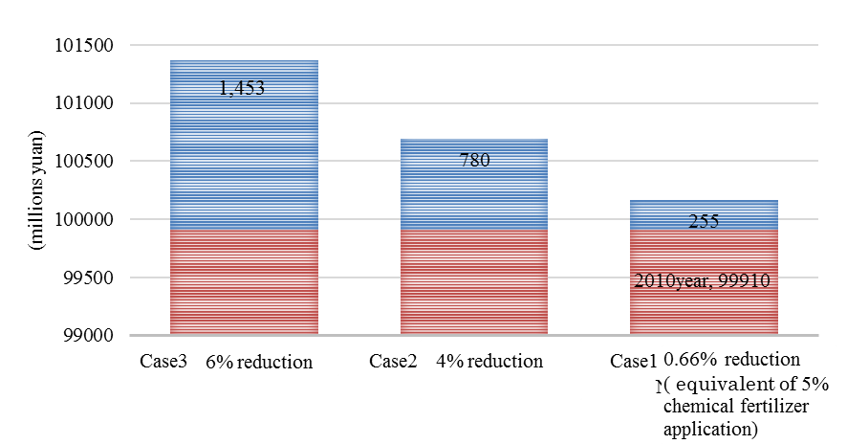

Figure 4. Economic effects of each policy case

***4.4 Analysis of new technologies***

Our results in Case 3 show that the appropriate number of biomass methane fermentation and power generation installations is 6 to 11 units of technology B and 0 to 5 units of technology A, based on the policy function for nitrogen reduction. The energy production amount is determined by the potential biomass input and the biomass methane fermentation and power generation technology applied, based on the nitrogen load reduction policy function. Supply of biomass energy is about 15 to 32 gigawatt hours per year (GWh/year) and 0.2 to 1 GWh/year for technologies B and A, respectively. The total income is calculated by multiplying the amount of electricity sold using each technology times the electricity price. Technology B achieved a higher profit, with total income of 4 to 14 million yuan, whereas the profit gained by technology A was 300,000 to 700,000 yuan. Marginal profits of nitrogen reduction tended to increase as the nitrogen load reduction policy became tighter. The optimal solution in Case 3 shows that indirect reduction of nitrogen load discharges reaches approximately 7,000 and 200 tons of nitrogen with technologies B and A, respectively. Due to the high productivity of technology B, the substitutional effect of replacing fossil fuel use was the most outstanding feature. The installation of technologies A and B can reduce the total regional nitrogen load by 513,000 tons when compared with the situation of no policy change. In general, technology B tends to be increasingly substituted for technology A in the model as the nitrogen load is reduced. These results imply that technology B offers greater potential for reducing nitrogen load discharges than technology A and contributes strongly to the nitrogen reduction policy function.

**Conclusion**

In the present study, we investigated the current circumstances relevant to the nitrogen cycle in the Chinese city of Songyuan, based on information obtained from the public statistics yearbook, academic papers, reports, and other sources. The current balance of nitrogen substances in Songyuan indicates extreme nitrogen levels, attributable to the adverse effects of anthropogenic nitrogen fixation and the excessive application of nitrogen fertilizers. Concerns include disproportionate nitrogen oxide emissions from the industrial sector and a prodigious amount of nitrogen runoff into the environment from the livestock industry, agriculture, and biological waste. In our analysis, the results of Case 1 indicate a margin for increasing the effective utilization rate of nitrogen fertilizers in Songyuan; however, reducing the use of nitrogen fertilizers by 5% or more would have negative effects on the economy. The results of Case 2 indicate the effects of replacing fertilizers with compost, i.e., using livestock manure and other waste as a substitute for nitrogen fertilizer. Case 3 is found to be economically viable, although more stringent constraints were applied in this case than in the other cases. Thus, the research indicates that Case 3 appears to be the most appropriate choice for Songyuan, and accordingly this scenario is recommended for the study area. The economic and environmental benefits demonstrated by this study suggest that the Chinese government should encourage more efficient, environmentally sensitive use of nitrogen resources in its agriculture and livestock industries.

**References**

[1] Shen Z, Kusano E., Chien H., Koyama O. (2014). “Predictive Analysis of Nitrogen Balances Resulting from the Production and Consumption of Livestock Products in the Huang-Huai-Hai Region, China.” *Japan Agricultural Research Quarterly*, Vol.48(3), pp.331-342.

[2] Isermann K.，Isermann R. (1998). “Food production and　consumption in Germany: N flows and N Emissions.” *Nutr.Cycl. Agroecosys*, Vol.52, pp.289-301.

[3] de Vries, W., Kros, J., Oenema, O. and de Klein, J. (1998). “Uncertainties in the fate of nitrogen II：A quantitative assessment uncertainties in major nitrogen fluxes in the Netherlands.“ *Nutr cycle Agroecosys*, Vol.66, pp.71-102．

[4] Wolf, J., Beusen, A.H.W., Groenendijk, P., Kroon, T., Rötter, R.P. and Zeijts, H. (2003). “The Integrated Modeling System STONE for Calculating Nutrient Emission from Agriculture in the Netherlands.” *Environment Model Software*, Vol.18, pp.597-617．

[5] Wolf, J. Rotter, R. and Oenema, O. (2005). “Nutrient emission models in environmental policy evaluation at different scales experience from the Netherlands.” *Agriculture Ecosystem Environment*, Vol.105, pp.291-306.

[6] Liu, X. “Nitrogen cycling and balance in Agriculture Livestock Nutrition Environment System of China.” Agricultural University of Hebei, College of Resources and Environment Science, Master degree thesis, 2005. (in Chinese).

[7] Ma, L. “Research on Nutrient Flow and Cycle Model in China Nutrition System”, Agricultural University of Hebei, College of Resources and Environment Science, Master degree theses, 2005.

[8] Leontife, W. (1966). “Input-Output Economics.” New York: Oxford University Press.

[9] Higano, Y. (1996). “Distribution of the Value Added to the Input of the Environmental Goods based on the Materials Balance Principle.” *Studies in Regional Sciences*, Vol.26, pp.181-187.

[10] Shen, Z. and Higano, Y. (2007). “Bas in management policy of water quality improvement in Taihu valley.” *Japan Association for Human and Environmental Symbiosis*, Vol.14, pp.25-34. (in Japanese).

[11] Shen Z., An, L. and Higano Y. (2012). “Application Feasibility of Environmental Purification Technology and Financial Policies in Rural Areas Taihu Economic Circle China.” *Japan Association for Human and Environmental Symbiosis*, Vol.20, pp.34-43.

[12] Shen, Z., Mizunoya, T. and Higano Y. (2012). “Agriculture and Sustainable Development: Policies Analysis of the Taihu Economic Circle in China”, *Int. J. of Foresight and Innovation Policy*, Vol.8, No.2/3, pp.210-235.

[13] Songyuan Statistical Bureau. (2011). “Songyuan Statistical Yearbook.” Beijing: China Statistics Press. (in Chinese).

[14] Jilin Statistical Bureau. (2011). “*Jilin Statistical Yearbook*.” Beijing: China Statistics Press. (in Chinese).

[15] “*Input-output table of Jilin Province*.” (2007). Beijing: China Statistics Press. (in Chinese).

[16] Water Department of Jilin. (2010). “*Jilin Water Resources Bulletin*.” (in Chinese).

[17] Environmental Protection Department Jilin Province. (2010-2011). “*Jilin Environment Bullet*”. (in Chinese).

[18] Ibaraki Prefecture Science and Technology Promotion Foundation. (2005). “*Kasumugaura biomass recycle collection development project results*.” pp.49-53. (in Japanese).

1. * Corresponding author.