A New Record: Cyclamen persicum Mill. var. autumnale Grey-Wilson was Added to the Native Lebanese Flora.

Khodr Addama ^{a*}, Mohammad S. Al-Zein ^{b}, Mounir Bou-Hamdan ^{c}, Hala Naous ^{d}.
^{a,d} Faculty of Business Administration, Research department, Arts, Sciences and Technology University in Lebanon, AUL.
^{b} Faculty of Science, American University of Beirut, AUB.
^{c} Clinker Production Unit at Lebanese Cement Factory,LCF

ªEmail: draddam@hotmail.com
^{b}Email:msalzein@gmail.com
^{c}Email:mounirbouhamdan@yahoo.com
^{d}Email:halanaous@hotmail.com

Abstract
Cyclamen persicum var. autumnale Grey-Wilson was observed to thrive in abundance in the village of Bchamoun, Lebanon. The plant was re-described and illustrated. Morphologically, this variety closely resembles Cyclamen persicum Mill. But it differs in some taxonomic and other details, such as smaller flowers and leaves, growth of flowers before leaves, and very early flowering (in Autumn) for a short period.
Key Words: Primulaceae; Cyclamen persicum Mill. var. autumnale Grey-Wilson; taxonomy; biodiversity; flora; Lebanon; Mediterranean.
1. Introduction
Although the land area of the Mediterranean basin is only 1.5% of the earth’s land surface, its flora includes more than 25,000 species of flowering plant [1], which is approximately 10% of all known flowering plant species on earth[2].
Lebanon is one of the richest Mediterranean countries in its flora. In the sixties Lebanon was labelled worldwide as ‘Green Lebanon’. This is due to the forests that cover this small country (total area of 10,452 km2).
Relative to its small size, Lebanon has one of the highest densities of floral diversity in the Mediterranean basin (more than 80% of plant species in Lebanon are terrestrial).
--------------------------
* Corresponding author.
E-mail address: draddam@hotmail.com
Lebanon also is highly mountainous with a natural environment, mosaic of biotopes and typical Mediterranean climate. [5,6,7]
There is no exact calculated new number of the Lebanese floral varieties, but certainly there are already more than 3150 plant species. This large number of wild plants is due to its geomorphology (five geomorphological regions} and microclimates that boast their biological wealth and survival. Moreover, Lebanon hosts a lot of rare endemic Mediterranean species, which makes it one of the world's most phenomenal spots for conservation. [8]
Mount Lebanon area (where Cyclamen persicum Mill. var. autumnale was found) is noted as a “regional hotspot”. It is remarkable that endemism in this region increases with altitude, which explains the very high levels of endemism among plant species in the Mount Lebanon chain. [4,9,10,11]
The family Primulaceae includes twenty-three species of the genus Cyclamen. Their distribution in the wild is most concentrated in the Mediterranean, Western Asia, parts of North Africa and Europe.
The name Cyclamen comes from the Greek kyklaminos, meaning circle. It may be a reference to the spiraling habit of the seed stem or the round corms.
It is thought that some species in the wild around Palestine and Syria brought to west Europe in the 17th century, were distributed in France, Belgium, England, Holand (Netherlands) and Germany. Cyclamen persicum is the only one species distributed these days as a garden caltivar, although many species exist in the wild like Cyclamen repandum, Cyclamen coum, Cyclamen cilicium and Cyclamen persicum .[12]
The presence of Cyclamen coum Mill. Figure (1,a), Cyclamen persicum Mill. Figure (1,b) and Cyclamen libanoticum Hildebr. in Lebanon was mentioned by Dr. Paul Mouterde, Dr. George Edward Post, Georges and Henriette Tohme. [13,14,15]
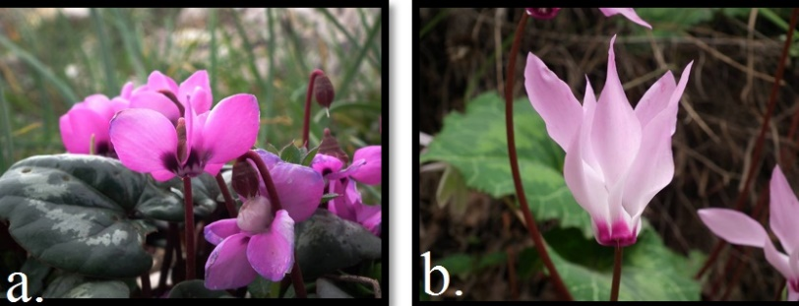
Figure 1: Cyclamen coum Mill. and Cyclamen persicum Mill.
In addition to the kinds of Cyclamen mentioned above, Mouterde highlighted the presence of Cyclamen persicum Mill. var. autumnale Wilson Grey Figure 2. in 1966 without knowing that it was a new species and considered it Cyclamen persicum Mill. He said that the flowering of Cyclamen persicum was observed from the second half of October and lasted until May, with apparently two maxima, one in autumn in late November and another in February and March. In the one that blooms in October-November, sometimes the flowers precede the leaves. [13] It is now clear that he was talking about Cyclamen persicum Mill. var. autumnale Wilson Grey. This was about thirty years before it was published by Christopher Grey-Wilson for the first time. [16]

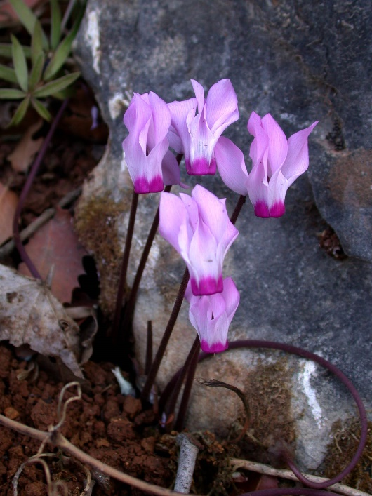
Figure 2: Cyclamen persicum Mill. var. autumnale Grey-Wilson.
The classification of Grey-Wilson (1997) for various taxa is based on the flowering period and petal color:
Cyclamen persicum
Cyclamen persicum var. autumnale (flowering in autumn. Figure (2, 7).
Cyclamen persicum var. persicum (flowering in winter and spring, all of range) Figure (3,4).
Cyclamen persicum var. persicum f. persicum (white to almost pale pink) Figure (3).
Cyclamen persicum var. persicum f. albidum (pure white) Figure (4,a).
Cyclamen persicum var. persicum f. roseum (rose to pink) Figure (4,b,c,d).
Cyclamen persicum var. persicum f. puniceum (red to carmine) [17]

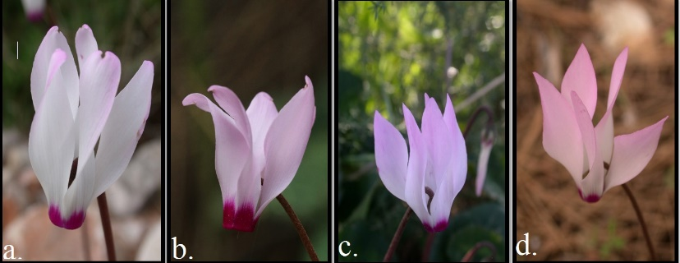
Figure 3: C. persicum var. persicum f. persicum
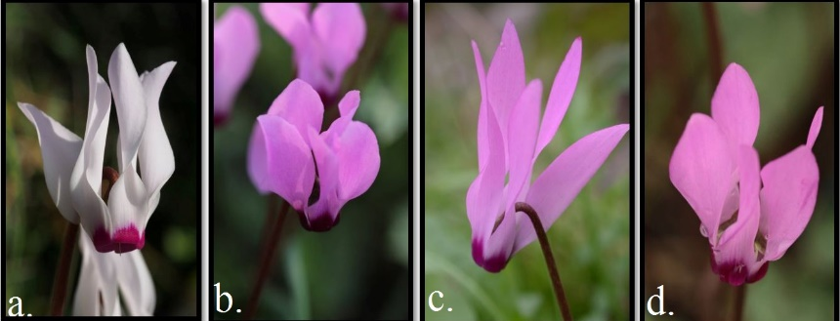
Figure 4: C. persicum var. persicum f. albidum (a), C. persicum var. persicum f. roseum (b,c,d).

2- Materials and Methods
Around 100 Cyclamen persicum var. autumnale varieties were found by Dr.Addam at 9/XI/2003 in Bchamoun (western slopes of Mount Lebanon), but they were not identified as Cyclamen persicum var. autumnale Two years later the research team observed that the flowering time of this cyclamen was about one month before the blooming of C.persicum. Another interesting and significant observation was the absence of the leaves during the bloom (the flowers bloom before the leaves). The serious taxonomic and chorological study started after eight years (2011) and the plant was closely monitored. At the beginning, the team thought it was a new species due to lack of information about it; even the description they found about it later was very limited.

1.2. Taxonomy and observation
Detailed taxonomic description of the plant was developed by Mr. Al-zein and Dr. Addam and for the first time this variety had a full description for every tiny detail. Mr. Bou-Hamdan followed the process of identification from the beginning to the final confirmation. Cyclamen persicum Mill. var. autumnale Grey-Wilson. is still growing safely in the place it was found in and the team found more of it in nearby places in 2016. The team think that the number may soon increase because the search for this rare Cyclamen will continue.

2.2. Voucher specimen
A voucher specimen (dried material) of the flower was deposited in the Post Herbarium (BEI) American University of Beirut and collected by Dr.Addam at 31/X/2015, collection number (Addam 5).
The existing herbarium material was examined and identified and its distribution recorded. Figure (5).
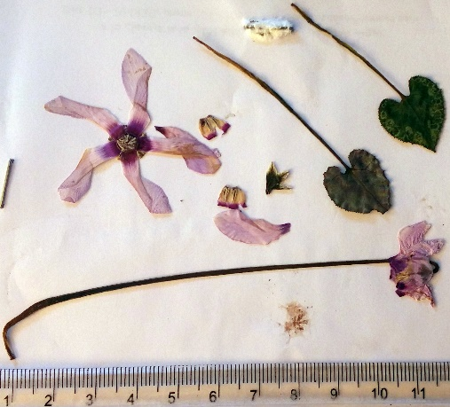
Figure 5: The dried herbarium material.

3.2. Pictures
All pictures were taken by Dr. Addam and Mr. Bou-Hamdan.

3. Results and Discussion
Cyclamen persicum Mill. var. autumnale Grey-Wilson was added for the first time to the flora of Lebanon in this study.

C. persicum var. autumnale can be identified by the following key:

• Flowering time is one month before the blooming of C. persicum var. persicum. ----- 1.3 -- 2
• The flowers bloom before the leaves. --------------- 1.3 -- 2
• The flowers are smaller and Pedicels are shorter. -----------1.3 -- 2
• Grows in tight places between the rocks. 1.3 -- 2

1.3. Species description
1- Morphologic description of Cyclamen persicum Mill.
Numerous flowers, individual stalks 10-23 cm long or more with five almost erect petals on top. The flowers vary from pure white to deep red, pink, mauve and purple with a deep pink or crimson-magenta zone at the base of each petal. The flowers’ stalk rises among leaves (5-10 cm) that are marked in silver. The long leaf-stalks rise directly from a corky, flattened tuber of the plants. Figure 3. [17]
2- Morphologic description of Cyclamen persicum Mill. var. autumnale Grey-Wilson.
Plant, perennial, 11.00-14.00 cm in height. Tuber globose, its shape mostly determined by the shape of the rocks surrounding it, dark brown to greyish brown, ca. 5.50-6.00 cm in diameter Figure (6,d), rooting from the lower surface. Roots unbranched, often covered with mucilage, growing into very shallow, uncompact soil and sometimes penetrating cracks in rocks. Figure (6,d). Leaves thick, forming a sparse rosette; cordate, sometimes elongated; margin serrate, the teeth round, yellowish-orange and very close to each other; lamina 2.20-3.40 cm long, 2.00-2.40 cm wide. Figure (6,b). Pedicels erect to ascending; dark cream at the base, becoming greenish at the surface of the soil and dark brown towards the middle, the upper half reddish brown darkening towards the flower; curving at a right angle in flower and fruit, the curved part more fuzzy; 3.75-5.60 cm long, greenish grey at the base, lighter towards the top. Figure (6,b). Flowers appearing in autumn (Oct - Nov), less crowded than in C. persicum var. persicum; calyx campanulate with reflexed lobes, greenish brown at the base, grey green with greenish brown to brown longitudinal veins; the lobes triangular, greenish grey towards the base and lighter towards the tip, greyish (yellowish) white to pure white at the margin; ca. 0.40 x 0.30 cm; corolla 5-merous, white, light pink or deep pink, darker (sometimes magenta) towards the mouth and fading into the petal lobes; veins greenish-purple, brownish and prominent inside the mouth, and blurred, sometimes barely visible in petal lobes; petal lobes elliptical, sometimes elongated but not arrow-like, twisted, 2.3-3.6 long , ca. 0.22-0.35 cm wide at the mouth, 0.66-1.10 cm at maximum width; mouth (opening of the corolla) 0.65-0.70 cm wide; stamens 5, purple, with a yellowish orange margin, adnate to corolla, the anthers 0.40-0.50 cm x 0.12-0.14 cm; ovary superior, 5-carpellate; style purple, the uppermost part white, 0.40-0.60 cm long. Figure 7,6 – a,c.
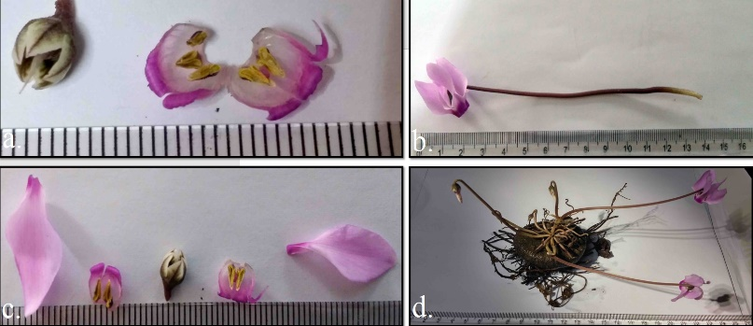
Figure 6: Cyclamen persicum var. autumnale flower parts variations.
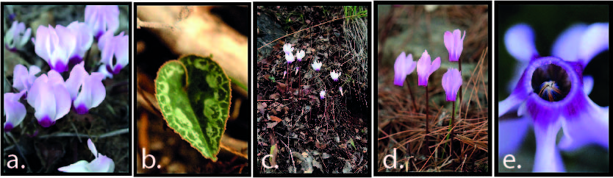
Figure 7: Cyclamen persicum var. autumnale flower viewed from all around.
2.3. Phenology
From the beginning of October (depends on the rain fall) to the end of November.
3.3. Habitat
Perennial flowering herbaceous plant growing from a tuber, native to shrub land rocky hillsides, and under pine trees. Figure. (7,c).
4.3. Distribution and Location
Western slopes of Mount Lebanon Range, Bchamoun (N 33, 46, 385 EO 35, 31, 129, 434 m alt., N 33, 46, 383 EO 35, 31, 132, 440 m alt., N 33, 46, 414 EO 35, 31, 107, 445 m alt.), located in the Qadaa of Aaley , an administrative division of the Mohafaza of Mount Lebanon, 18 km from Beirut. Figure (8). [18]
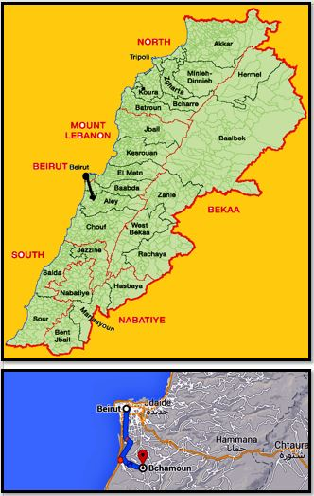
Figure 8: Distribution of C. persicum var autumnal in Lebanon.
4. Conservation Status
This Cyclamen variety is very rare worldwide, but even though it was found in fair abundance (more than 100 varieties) it is in big danger in Lebanon. The process of fast urbanization in the region it was found in might soon lead to the extinction of this flower, but so far Cyclamen persicum Mill. var. autumnale Grey-Wilson. is still growing safely it was discovered and we found more of it in other places nearby in 2016. We think that the number may increase more soon because the search for this rare Cyclamen will continue.
This variety is viewed by the team as endangered and very rare, and should be classified as Critically Endangered (CR B1ac (ii, iv). [19]

5. Acknowledgement
The team wish to thank Dr. Mustafa Hamzah, Chairman of the Board of Trustees at the Arts, Sciences and Technology University in Lebanon (AUL)), and Dr.Adnan Hamzah, AUL President for their committed support of this research for 15 years; Dr. Nada Sinno Saoud (American University of Beirut), and Katia Saade (Lebanon University), besides special thanks for Mr. Khaled Jamal Aldine (AUL IT Department).

References

[1] P. Queze, Definition of the Mediterranean region and origin of its flora. In plant conservation in the Mediterranean area (ed. C. Gomez- campo), pp. 9-24.
[2] E. Baletto, A. Casale, (1991). Mediterranean insect conservation. In the conservation of insects and their habitats (ed. N.M. Collins and J.A. Thompson) pp. 121-142.
[3] http://biodiversity.moe.gov.lb/Resources/Pages/Links.aspx
[4] J. Blondel, J. Aronson). Biology and Wildlife of the Mediterranean Region, Oxford University Press, 1999.
[5] F. Medail, P. Quezel. Hot-spots analysis for conservation of plant biodiversity in the Mediterranean Basin, Annals of the Missouri Botanical Garden, 1997, pp. 112-127.
[6] N. Myers (1990). “The biodiversity challenge: expanded hotspot analysis”. The Environmentalist, 10, pp. 243-256.
[7] Ministry of Lebanese Environment (2011). State and Trends of the Lebanese Environment, MOE/UNDP/ECODIT.
[8] Mc. Gowen, A. Sabeh. Historical Setting. In Collelo, Thomas. Area Handbook Series (3rd ed.). Washington, D.C.: TheDivision. OCLC 18907889,1989.
[9] E. J. Sattout, 2009 "Terrestrial Flora in Jabal Moussa: Preliminary Site Diagnisis" (PDF), Jabal Moussa. Lebnon, pp. 4.
[10] Université Saint-Joseph de Beyrouth, Faculty of Sciences."Species by scientific name". Flora of Lebanon. Retrieved 29 August 2013.
[11] D. Carey and T. Avent. Cyclamen- Great Hardy Perennials for the Garden 2012, Plant Delights Nursery, Inc. By www.plantdelights.com , 9241 Sauls Road Raleigh, NC 27603 919.772.4794.
[12] Association of Ena floriculture studying, “Cyclamen in Ena - history of 80 years”, 2003. http://www.izumi-nouen.co.jp/english/files/history.html.
[13] P. Mouterde. Nouvelle flore du Liban et de la Syrie, 3rd tom (text), Dar-el-Machreq, Beyrouth, 1966,1970,1983, pp. 7.

[14] G.E. Post and J.E. Dinsmore. Flora of Syria, Palestine and Sinai, 2nd tom, Beirut, Lebanon, Librairie du Liban, Publishers American University of Beirut, 2007, pp. 179.
[15] G. Tohmé, H. Tohmé. Illustrated Flora of Lebanon. CNRS Publication Beirut, 2014, pp. 508.
[16] C. Grey Wilson. Genus. Cyclamen, 2nd ed., Timber Press 1997, pp. 174. The Genus Cyclamen. A Kew Magazine Monograph. London: Christopher Helm. Portland: Timber Press.
[17] C. Grey-Wilson. Grey-Wilson, Christopher. 2003. Cyclamen: A guide for gardeners, horticulturists and botanists. 2nd ed. Portland: Timber Press; London Cyclamen, Timber Press, 2003, pp. 169-171.
[18] http://www.localiban.org/rubrique394.html
[19] IUCN Species Survival Commission (2016). IUCN Red List Categories and Criteria: Version 2, IUCN, Gland, Switzerland and Cambridge, UK.

