Study on the Treatment of Liquid Waste from Rare Earth Processing by Chemical Precipitation
Tin Moe Hlaingª*, Aye Thi Tar^{b}, Thant Zin Myo^{c}
^{a,b,c}Material Science Research Division, Department of Research and Innovation, Ministry of Education,
The Republic of the Union of Myanmar
ªtmh001@gmail.com
^{b}dr.ayethitar@gmail.com
^{c}dr.thantzinmyo@gmail.com
Abstract
This paper describes treatment of liquid waste from rare earth processing by chemical precipitation. Monazite ore from Moemeik Myitsone area was used as raw material for rare earth processing. Large amount of solid and liquid wastes were generated after rare earth oxide processing. Solid waste was stored in the storage tanks and liquid waste needed further treatment before discharges to the environment. Research process serves the purpose of reducing the volume of the waste as much as possible to protect men and the environment from any undesirable effects for the present and future generation. Treatment methods are selected based on the composition, quantity and form of the waste materials. The used method is chemical precipitation method. For liquid waste treatment, the most coagulation treatment used is the Fe ⁺⁺⁺ co-precipitation followed by settling, decantation and filtration of the supernatant liquid. The efficiency of the process can be improved by careful control of the pH and the settling the decantation procedure. The sludge was filtered, dried in oven and collected in plastic bags and temporary stored in 100 liters plastic drums. Finally all of the decontaminated effluents are safety discharged to the environment. All of the experiments were analyzed by the X- ray Fluorescence Spectrometer (XRF). Before treatment thorium contained (<2000 ppm) and uranium contained (< 300 ppm) range and this is in the low level waste. After treatment result in decant water gives uranium (< 1 ppm) and thorium (< 10 ppm). According to the threshold limits for the UK radioactive classification system, liquid waste from rare earth processing was less than (0.4 Bq/g) and this range is in exempt waste and can be discharge to drain and to the environment safety. The safety regime was in place and improved simultaneously by survey monitoring by using Alert Monitor 4 meter Scale in USV/H.
Keywords : rare earth processing; chemical precipitation; coagulation; co-precipitation; settling; decantation; filtration; decontaminate; effluents; sludge; discharge; x-ray fluorescence spectrometer; alert monitor
……………………………………..
*Corresponding author.
1. Introduction

The aim of the research work is to protect men and its environment from any undesirable effects of radiation, for the present and future generation. Solid and liquid wastes were generated from rare earth processing. Treatment of liquid waste from rare earth processing was carried out at waste management laboratory, Material Science Research Division. Treatment mean manipulation by some chemical or physical process whereby the original waste is separated into a concentrated and a much larger volume of dilute effluent which often could be liberated to the environment without hazard to the population [2] .Waste treatment techniques are used to change the physical, chemical or biological character of the waste to reduce its volume and or toxicity and to make safer for disposal. Treatment methods are selected based on the composition, quality and form of the waste material. In Myanmar, monazite and xenotime occur associated with placer cassiterite and wolframite deposits. Columbite and tantalite also occur in these deposits, which are found in the Dawei and Myeik areas of southern Myanmar. Rare earth oxide can be extracted from monazite and is discovered locally as heavy sands in Myitsone area, Moemeik Township, Homalin area, Sagaing Division, Thabeikyin Township and Heinze and Kanbauk area, Tanintharyi Division [1]. Monazite ore from Moemeik Myitsone area was used as raw material for rare earth processing because Moemiek Myitsone area contains (11.82 %) of Monazite and others regions contain less than 4% of Monazite, it can be seen in Figure 1. Monazite, a major source of rare earths, contains characteristically high concentration of thorium series radionuclides.

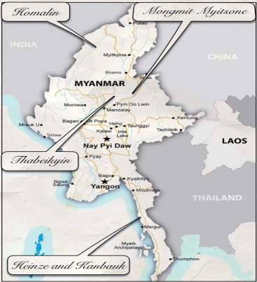

Figure 1: location of regional monazite ores

Monazite is widely distributed in many countries such as Australia, Brazil, China, Egypt, India, Malaysia, South Africa, Sri Lanka, Taiwan (China) and the United States of America are engaged in its production. Large deposits of this mineral at Mountain Pass, California and the Bayan Obo deposit in China contribute the most important sources of rare earths in the world. Wastes from the processing of radioactive ores are potential sources of radiological impact; both for those working in the industry and for members of the public who may be exposed if waste are dispersed in the environment. These wastes are characterized by large volumes and low activity concentrations of radionuclides with very long half-lives. Acidic and alkaline effluents from the processing plants and water and chemicals used for decontamination constitute the liquid effluents in monazite processing [3].Removal of radioactive isotopes by chemical precipitation can be effected by co-precipitation, adsorption and ion exchange. Chemical precipitation processes are generally applied to high volume waste streams with relatively low radioactivity concentrations. Chemical precipitation has been applied for many years to large volumes of low level liquid wastes from research establishments and also to low and intermediate level liquids from processing plants [5].The most obvious method for removal of unwanted materials from solution is to precipitate it by addition of chemicals. Reagents are added to the liquid waste to form flocculants precipitation which carries down colored organic contaminants, suspended matter, certain undesirable metals and other impurities, without addition of many dissolved ions to the waste water. The sludge produced by chemical treatment processes are first thickened by settlement. The decontaminated effluents were passed through in activated carbon column first and then reduced on sand bed then discharged to the water body or can often be disposed into ground.
Safety in waste management demands strict control at the place of origin as well as at the place of disposal. Proper collection and packing of waste is essential. The treatment of radioactive wastes, as of other wastes, is to achieve one or both of these aims:
- Concentration or conversion to a form permitting more economical and more easily controlled storage and
- Dilution or conversion in part to a more dilute form which may be discharged to the environment.
When the aim of treatment is to permit dispersal to the environment, monitoring of the environment around disposal facility was carried out to protect men and its environment from any undesirable of radiation, for the present and future generation [6].

2. Experimental Procedure

This research work was carried out at waste management laboratory. Large amount of solid and liquid wastes were generated from rare earth processing laboratory. Solid waste was stored in the storage tanks and rest of the liquid waste needed further treatment before discharge to the environment. Waste management laboratory collected all of the waste to tanks and then started treatment to discharge all. The reference used for classified waste was shown in Table 1.

Table 1: United Kingdom radioactive waste classification system

exempt waste | very low level waste | low level waste | intermediate level waste | high level waste
0.4 Bq/g (limit) | 4 Bq/g (limit) | 4 ~ 400 Bq/g | 12000Bq/g  (alpha limit 4000 Bq/g) | >12000 Bq/g  Significant heat generated

1 becquerel (Bq) = 1 disintegration per second
The United Kingdom and a number of other European countries use similar concentration ranges of radioactivity to classify hazardous waste [4]. Treatment of liquid waste from rare earth processing was carried out at waste management laboratory. Sodium hydroxide (NaOH) was used in the treatment of effluent for the heavy metals and of acidity. Potassium permanganate (KMnO₄) was used as an oxidizing agent. Ferric ion (FeCl₃) was used for co-precipitation. Activated carbon was used for removes contaminants from water, absorption and catalytic reduction. Nitric acid was preferred used for its oxidizing ability. Sand bed was used for volume reduce of effluents. Treatment methods are selected on the composition, quantity and form of waste materials. The treatment of liquid waste from rare earth processing serves the purpose of reducing the volume of the waste as much as possible: solidifying and finally dispose of the waste. Chemical precipitation method was used for treatment of liquid waste from rare earth processing. The most reliable coagulation treatment is the -
Fe ⁺⁺⁺ co-precipitation [7]. Flow chat for liquid waste treatment was shown in Figure 2.

For liquid waste one liter (1000 ml) – pH is adjusted to 2.5 (If acid addition is necessary, used Nitric Acid (HNO₃). Ferric Chloride, FeCl₃ (Fe ⁺⁺⁺ ) is added at least 6.2 ml (0.1 M) and Potassium permanganate (KMnO₄) is added until a pink coloration persists for 20 minutes. pH is adjusted to 7 to 9 by adding 2 M caustic soda (NaOH) and Stirring discontinued and allowed to age for 6 to 12 hours. Liquid treatment process for one liter of waste was shown in Figure 3. After precipitation, decant water was passed into the activated carbon column to filter and absorb contaminants from liquid waste. Finally the decontaminated water was reduced on sand bed and then discharged to the water body or can often be disposed into ground. Sludge obtained from the filtration of filtrate was dried in an oven and finally placed in the plastic bags and temporary stored in 100 liters plastic drums. Sludge, which is generated in small volumes but which may have activity concentrations, usually has to be held in storage pending the establishment of suitable disposal facilities. The wastes can be suitable disposed of either in earthen trenches or in engineered cells, depending on the activity concentration.

Figure 2: flow chat for liquid waste treatment

Figure 3: liquid treatment process
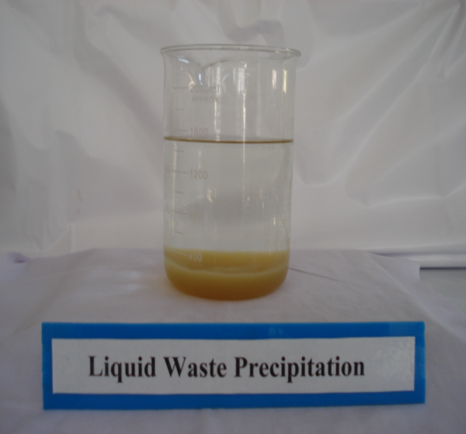
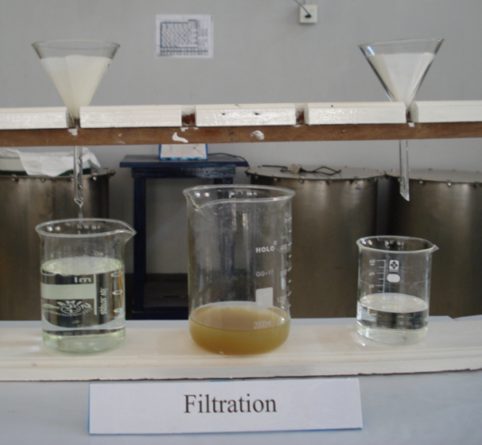
Figure 4: liquid waste precipitation Figure 5: filtered the precipitant

Figure 6: sludge dried in an oven

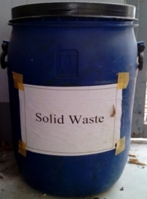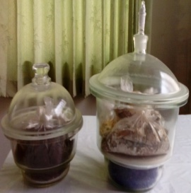

Figure 7: sludge stored in container
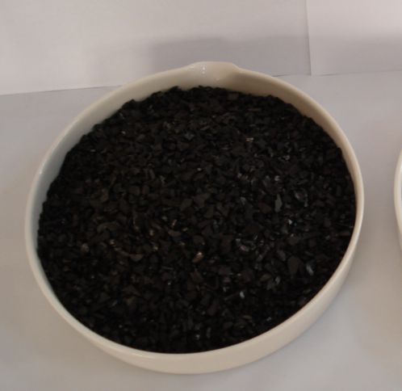

Figure 8: activated carbon and activated carbon column

3. Results and discussion

Wastes from the processing of radioactive ores are potential sources of radiological impact, if wastes are dispersed in the environment. Therefore liquid waste from rare earth processing was collected and managed to become decontaminated water and disposed to the environment if it is in safer to public. Treatment of liquid waste from rare earth processing was carried out at waste management laboratory. Waste treatment techniques are used to change the physical, chemical or biological character of the waste to reduce its volume and or toxicity and to make safer for disposal. Analytical result of sludge from the precipitation was analyzed by X- ray Fluorescence Spectrometer (XRF). After many experiments have been done, the following composition of elements in sludge (waste) result obtained, analyzed by X- ray Fluorescence Spectrometer (XRF). Analytical result of sludge contained radioactive materials such as thorium, uranium and other rare earth elements, shown in Table 2. According to the result, the sludge needed to store in the storage tank for safety and can be recycled for other purposes. Analytical results of liquid waste before treatment and after treatment was shown in Table 3.

Table 2: Analytical results of sludge from liquid waste treatment

Rare earth oxide processing | Thorium  (%) | Uranium  (%) | Sodium  (%) | Rare earths and other elements  (%)
sludge of liquid waste from digestion process | < 1 % | < 0.5% | < 50% | < 48.5%
Sludge of liquid waste from rare earth hydroxide process | < 1 % | < 0.5 % | < 55% | < 43.5 %
Sludge of liquid waste from rare earth oxalate process | < 0.5% | < 0.5% | < 55% | < 44%

Table 3: Analytical results of liquid waste before treatment and after treatment
Liquid wastes from rare earth oxide processing | Before treatment  (low level liquid waste) |  | After treatment  ( exempt waste)
 | Thorium | Uranium | Thorium | Uranium
liquid waste from digestion process | < 2000 ppm | < 300 ppm | < 10 ppm | < 1 ppm
liquid waste from rare earth hydroxide process | < 2000 ppm | < 300 ppm | < 10 ppm | < 1 ppm
liquid waste from rare earth oxalate process | < 2000 ppm | < 300 ppm | < 10 ppm | < 1 ppm

Effective processes for the treatment of most types of radioactive wastes have been developed. Therefore co precipitation method was used for treatment of liquid waste. Before treatment, all of liquid waste pH was adjusted to 2.5 and chemical precipitation method was used to precipitate. Analytical result of liquid waste before treatment was given by X- ray Fluorescence Spectrometer (XRF). Radioactive elements, uranium and thorium also contain in that liquid waste. Experiments have been done by using the liquid waste 1, 2, 3, 4, 5, 6, 7, 8, 9, 10, 15, 20, 25 and 30 liters of waste before treatment and after treatment. Before treatment thorium contained (< 2000 ppm) and uranium contained (< 300 ppm) range. The concentrate that is used for the refining process contains if uranium (30 ppm) and thorium (1700 ppm) that generates between 3.5 to 8 Bq/g of specific activity. According to the threshold limits for the UK radioactive classification system, liquid waste from rare earth processing was in (4 ~ 400 Bq/g) and it is in the range of low level waste [4].
After treatment of liquid waste by chemical precipitation, result in decant water gives uranium (< 1 ppm) and thorium (< 10 ppm). According to the threshold limits for the UK radioactive classification system, liquid waste from rare earth processing was less than (0.4 Bq/g) and this range is in exempt waste and can be discharge to drain and to the environment safety. Decant water passed through to the activated carbon column step gives to remove contaminants from water; absorption and catalytic reduction, activated carbon also can make more attractive to chemical and impurities. This step gives safer to discharge to the environment. The safety regime was in place and improved simultaneously by survey monitoring by using Alert Monitor 4 meter Scale in USV/H.

4. Conclusions

Wastes from the mining and processing of radioactive ores are potential sources of radiological impact, both for those working in the industry and for members of the public who may be exposed if wastes are dispersed in the environment. Liquid waste treatment from rare earth processing laboratory is classified as low level waste. Before dispersed to the environment, liquid waste required to remove contaminants in waste stream. Treatment methods are selected on the composition, quantity and form of waste materials. Effective processes for the treatment of most types of radioactive wastes have been developed. Chemical precipitation method was used for treatment of liquid waste from rare earth processing. After treatment, decontaminated effluents were in an acceptable level and can be safely discharge to the environment. According to the X- ray Fluorescence Spectrometer (XRF) result, the sludge from liquid waste treatment contains uranium and thorium. All of the sludge was stored in containers and placed in storage and therefore additional measures may be needed to provide for the protection of future generation.

Acknowledgements

The authors deeply grateful to our Director General, Department of Research and Innovation and thanks to Deputy Director General, Material Science Research Division, Ministry of Education to allow us to do this research work. Deeply thank to all of our team members who for co-operation and implementation for this paper.

References

[1] Gupta CK., Krishnamurty. N. Extractive Metallurgy of Rare Earths, CRC Press, 2005

[2] C. A. Mawson, Management of Radioactive Wastes, 1965

[3] P.M.B. Pillai, Naturally Occurring Radioactive Material (NORM) in the Extraction and Processing of Rare Earths, Proceedings of an International Symposium Seville, IAEA, Spain, 19-22 March 2007

[4] Lee Bell BA MA (ESD), Rare Earth and Radioactive Waste, A Preliminary Waste Stream Assessment of the Lynas Advanced Materials Plant, Gebeng, Malaysia, 2011

[5] International Atomic Energy, Treatment of Alpha Bearing Wastes, Technical Reports Series No.287, IAEA Vienna, 1988

[6] R. H. Burns, J.H. Clarke, T.D. Wright and J. H. Myatt United Kingdom, Present Practices in the treatment of Liquid Wastes at the Atomic Research Establishment, Harwell, Proceedings of a Symposium, IAEA Vienna, 1965
[7] D. J.KVAM, University of California, USA, Waste Management Practices at Lawrence Radiation Laboratory, Proceedings of a Symposium, IAEA Vienna, 1965

