Re-Thinking "Emotionally": Central of Business District (CBD) of Alexandria City as a Retailing Center
Haidy Shehata, B. Sc., Department of Architecture, Faculty of Engineering, Alexandria University, post-haidy.shehata@alexu.edu.eg
Ali F. Bakr, Professor of Urban and Regional Planning, Department of Architecture, Faculty of Engineering, Alexandria University, alibakr@alexu.edu.eg
Zeyad M. El Sayad, Assistant Professor, Department of Architecture, Faculty of Engineering, Alexandria University, zelsayad1@alexu.edu.eg

Abstract
The decisions of the Alexandria Local Authorities would be a key motive power of the flourishing process in Alexandria City Center as a retailing center. The objective of this study is to pay more attention toward re-thinking "Emotionally" to identify any planning policies at various levels. This new tendency would be helpful for having a prosperous city center, after losing its significance as a retailing center. This degradation due to the presence of "Malls and Plazas" like 'City Center Mall," "Green Plaza," and "Down Town Plaza" lying on the peripheral of the city as well as many other reasons. Studying the Saad Zaghloul Street is part of this paper to prove that re-thinking "Emotionally" is the answer to the enhancement Alexandria City Center as a retailing center.

Keywords
Central of Business District (CBD), Alexandria City, Retailing Center, Re-Thinking "Emotionally", emotions, attitude, behavior, Saad Zaghloul Street.

1. Introduction:
Cities are a complex mixture of physical and human creations which interrelate with each other by diverse social, economic, environmental and cultural factors. This interaction does not operate in a vacuum; rather it is subject to institutional frameworks, laws, resources and social influences. At present, one of the major obstacles facing the public sector in many developing countries is its ability to improve quality of life, provide effective urban services, and raise living standards under severe challenges of rapid urban growth (Alnsour, 2016; Hu, 2015; Zhao, Lü, & Woltjer, 2009).
Since the start of this decade, more than 100 million people have migrated to cities globally. By 2050, the World Health Organization estimates that at least 70% of the world’s population will live in cities, which will add more burdens on the capacity of cities and their performance (He and Lin, 2015; Rao et al., 2015).
Mediterranean cities have undergone huge transformations in the last thirty years, mainly from traditional compact models to discontinuous and dispersed morphologies (Kasanko, Barredo, & Lavalle, 2006; Longhi & Musolesi, 2007; Schneider & Woodcock, 2008). This change was accompanied by the rapid—and sometimes disordered—development of rural land on the fringes of large cities (Salvati, Gargiulo Morelli, & Rontos, 2013). At the same time, the decline of the urban core—a latent change in the economic functions of the consolidated city—and the emergence of new satellite cities (‘sub-centres’) was explained by the birth of a polycentric spatial asset (DeRosa and Salvati, 2016).
Qin (2016) and Zhen, Wang, and Wei (2015) refer to the extensive use of information and communication technology (ICT), particularly the Internet by retailers, shoppers, enterprises, and residents. This extreme use of ICT has changed our daily activities, which in turn reform our city flourishing areas as well as the face of our city urban fabrics.
Add to that CBDs have different impacts on human emotions, attitude and behavior. Physical aspects and emotions leads to attitude, which is translated into behavior from citizens at the end. These emotions, attitudes and behaviors are affected directly and indirectly through the urban settings, physical aspects, transportations, street vendors, land uses, weather, and many other reasons (Raslan, Al-Hagla & Bakr, 2014).
For now, CBD of Alexandria city is suffering from shrinking and worsening conditions due to several reasons on the top of them the decline in retail and shopping activities. In meanwhile, the CBD has an immense competition from new retail and shopping "Malls and Plazas" like 'City Center Mall," "Green Plaza," and "Down Town Plaza" lying on the peripheral of the city. This influential competition because of the availability of easy parking spaces, safe and secured indoor spaces, air-conditioned environment as well as more positive characteristics, which are not provided in the CBD of Alexandria City now.
CBD of Alexandria city has a misuse of its activities, due to interrelated change in transportations, land use and street vendors, these CBDs have gradually lost much of their attractiveness to investors, To redirect the process of decline and work, revival CBDs are required to make these spaces attractive again through create vitality based on principles about human behavior and their activities. This is the main aim of this research. This revival could be undertaken through inform decision makers to establish new strategic plans.
To clearly understand the impacts of early mentioned causes, we proposed the following two hypotheses:
H1: the city of Alexandria CBD retrograde is due to negative emotions during being there from different shoppers; and
H2: physical declination in Alexandria CBD is because of several physical problems.
The research adopts deduction analytical approach to set up its aim. This approach needs to divide the research into four parts. In the first part emotion, attitude, and behavior are reviewed and their relation to each other. The information technology impacts are also reviewed in this part. In the second part the physical definitions of CBDs and their relation with urban spaces are discussed. The third part shows the Saad Zaghlool Street as explanatory case study for our research. Finally, the conclusion of this work is displayed.

2. Urban Retail Dynamics
Urban retail has two main pillars, namely supply and demand. Regarding consumers, who are constantly renewing their rations, requests and wishes, always change their shopping activities due to conversion in their behaviors and lifestyles. Hence in a highly competitive environment, shopkeepers should renovate their vision, and approaches toward their strategies, retail concepts, and shopping environments (Borchert, 1998).

2.1. Spaces for Shopping to Places of Consuming
Creating serious imbalances in the structure and spatial organization of the urban retail systems in recent decades. The decline of small businesses at the expense of large corporations, the weakened role of the CBD over the suburbs, the disappearance of neighborhood stores in contrast to the growth of out-of-town mega-projects, and the devaluation of utilitarian premises in favor of the ‘‘spectacular’’ shopping spaces are now common features shared by cities with different positions in the urban hierarchy (Urban-Net, 2010).
Since retailing and consumption are key elements of the urban fabric and essential to the experience of the contemporary city, urban sustainability has been related with the preservation of balanced and cohesive retail systems set up in a great diversity of facilities, shopping environments and places. Similarly, urban retail resilience has been defined as the ability of stores and shopping districts to tolerate and adapt to changing environments that challenge the retail system’s equilibrium, without failing to perform its functions in a sustainable way (Wrigley & Dolega, 2011). In this sense, urban retail systems can be considered resilient if, in a changing environment, thus responding efficiently to the needs of different consumer groups, including the most disadvantaged, which are constrained to use the local and neighborhood retail/service facilities. he preservation of urban sustainability and the resilience of retail systems are closely linked with the mechanisms of supply and demand mediated by socio-spatial contexts (Arnould, 2005; Cachinho, 2014).
In essence, shopping has been found to improve one's mood. It is important to understand some of the emotional and/or psychological reasons consumers shop for apparel as this may help retailers better understand the motivations of fashion leaders (Shephard, Kinley, Josiam, 2014).
The aim of local authorities is to compete for mobile shoppers and spending power. Opportunistic projects are designed in order to attract inter-urban flows of shoppers and their consumption capital. As a response to the increasing uniform retail offer resulting from the rise of global retail chains, functional and physical differences between city centers are created, stressed and marketed in order to compete for consumption capital (Spierings, 2009; Spierings, 2013; Warnaby, 2009).

2.2. Trading

Shopping is a defining act of modern urban life. Retailers satisfy basic material needs of their customers and attempt to justify their desires (Novak and Gilliland, 2011). Shopping districts are vital places in the public realm where people congregate and interact. Economically, retailers provide employment and serve as an essential link in the commodity chain, Furthermore, Stores are significant components of the built environment, acting as a liaison between producer and consumer (Novak and Gilliland, 2011). Typically lining and defining the character of a city's busiest arteries.

2.3. Shopping Online

Indeed, technology-mediated person-to-person communication in organizational environments has been a subject of academic research for several decades. For example, studies have investigated how people work collaboratively with the support of groupware technologies, such as e-mail, bulletin boards, group schedules, group support systems, workflow systems, and collaborative authoring tools (Zhu et al., 2010).

Additionally, a large number of empirical studies have compared computer-mediated communications to face-to-face interactions. However, to date there has been little research attention paid to the phenomenon of collaboration in online shopping with new IT-enabled features, such as synchronized navigation and instant communication. Because of the lack of knowledge of these emerging collaborative technologies, as well as the social nature of online shopping, it may be presumptuous to apply the previous findings on the use and impact of collaborative technologies in working environments to an online shopping context. Therefore, additional research effort is needed to analyze and evaluate collaborative online shopping technologies theoretically and empirically to advance the IS knowledge concerning this important and expanding buying channel (Zhen, Wang, Wei, 2015).

3. Mobility in the Information Era
Currently, information and communication technology (ICT), particularly the Internet, is extensively used by retailers, shoppers, enterprises, and residents. This extreme usage of ICT can change urban activities and effect our daily life activities to speed up population, goods, knowledge, technology, and capital mobility between different areas within a city (Maeng and Nedovic-Budic, 2010; Qin et al., 2016; Zhen & Wei, 2008; Zhen, Wang, and Wei, 2015). The extensive usage of ICT has sparked renewed debates between numerous urban researchers regarding whether ICT usage leads to the centralization or decentralization of urban form. Some scholars have believed that although the need for physical proximity to the Central of Business District (CBD) of the city has been challenged by the advances in ICT, face-to-face contacts in daily life are becoming more dynamic than ever (Boden and Molotch, 2004; Qin et al., 2016) and that highly specialized services. Generally, in the information era, centralization and decentralization phenomena can be encountered in the process of urban spatial development, and ICT usage may exert dissimilar effects on different urban activities. Residential mobility, which is one of the most vital urban activities, is typically related to changes of urban space because of its effects on the decisions of housing location and daily commutes of residents (Maeng and Nedovic-Budic, 2010); therefore, it has received considerable interests from numerous scholars. Previous studies have reported that several factors, such as transport, household structures or lifecycle, and employment opportunities, drive householders to consider relocating (Qin et al., 2016).
The transformation of natural, open or agricultural land into built-up land is one of the major features of land use changes in most urbanized countries and regions (Angel, Parent, Civco, Blei, & Potere, 2011), but particularly in developing countries (La Rosa, Barbarossa, Privitera, & Martinico, 2014; Wang, He, Liu, Zhuang, & Hong, 2012). The inefficient land use patterns that are commonly associated with increases in population growth that accompany suburban and exurban development, or urban sprawl, have been identified as a significant cause of the rapid loss of arable land in many areas (Salvati, 2014). The expansion of built-up land and the associated land use have numerous effects on ecological and social systems, such as a concentration of the population, traffic jams, housing shortages, resource shortages, biodiversity reductions, “heat island” effects, noise, and pollution (Yi Chen, 2016).

4. Public Urban Spaces
Urban space, as a formal space, contains predominant characteristics such as the quality of enclosure and the activity that occurs in it. These qualities establish the sense of urban space. Urban space as an inseparable part of the spatial structure of the city comprises two basic forms of the square and the street. The functions of the street and the square define these spaces. Amin (2008) discussed the functions of these forms and their relation with public culture. ‘‘Every public space has its own rhythms of use and regulation, frequently changing on a daily or seasonal basis (Hajrasouliha, and Yin, 2015; Mahmoudi et al., 2015).
Urban spaces affect emotions, attitude, and behavior of their users because of their physical arrangement, surrounding land uses, as well as applicable activities in them.
Places located in major spaces used to many purposes: shopping, meeting, Residence, Transportation, Recreation and Work. Zoning is intended to provide land for both active and passive recreational
Places located in major spaces used to many purposes: shopping, meeting, Residence, Transportation, Recreation and Work. Zoning is intended to provide land for both active and passive recreational
Activities Major existing open spaces in the Area include the Squares, Gardens, streets and Parks which are well patronized. (Rasouli 2013)
Any Central, being the heart of city since its earliest phases of history and development, provide a finest example to this fact. Its strategic location within the central district territories and the placing of seaport has made Central to be conglomeration (Rasouli 2013).
Nuclear places which occupy much of central business district can provide opportunities for social interaction, social mixing and social inclusion, and can facilitate the development of community ties. It is in the public spaces that people can physically become a part of the larger community (Li 2003 )

4.1. The Keys to Successful Public Life in CBDs:
A good indicator of successful public life is people’s use of the public realm for a variety of activities during the course of a typical day. Two factors that can be observed and recorded readily are (Architects 2009): 1) Number of people in a CBDs, 2) The amount of time people spend in the public realm.
Spaces where a large number of people linger for a long period of time tend to be more successful. Spaces with few people walking slowly or lingering for long periods of time are perceived to be less successful.

5. Emotions, Attitude and Behavior Dimensions in CBDs
Stets, and Turner (2006) and Mayer et al. (2004) modeled emotional intelligence into four-branch ability model as follows: 1) perceive emotions, 2) use emotions to facilitate thought, 3) understand emotions, and 4) manage emotions.
The most important massage sent by any emotion expression, it link between human attitude then to his behavior in the built environment. Emotions and behaviors have become the integral part in urban spaces and fundamental to human life (Raslan, Al-Hagla & Bakr, 2014). So they are different way to think that our mind and connects triggers to deal with different situation we face in our lives (Cambria et al., 2012) and it joins emotional relation and the degree of emotional reaction.
Emotions would be classed into two main categories: Positive and Negative emotions (Stets, and Turner, 2006).
Positive emotions are connected with: needs, effective emotional management (person's ability to be in contact with their own needs self-knowledge). Positive emotions are related with increased creativity, spontaneity and responsiveness to stimuli, influences how easy involvement in professional and constructive approach and creative tasks by exploring new ways to meet the requirements of professional activity (Alina, 2011; Raslan, Al-Hagla & Bakr, 2014).
In the contrary, Negative emotions correlated with: unmet needs, barriers to achieving the objectives (frustration), inefficient emotional management (low capacity of the person to be in contact with their own needs and emotions, deficient knowledge of self), dysfunctional cognitions (negative thinking) and / or prone to keeping the information processing unpleasant situations perceived as threatening (real or imagined danger), losses, traumatic events, penalties and constraints. In the class of negative emotions enter sadness, discouragement, disappointment, anger, unhappiness, depression, regret, frustration, feelings of hopelessness, desolation, grief, loneliness, despair, self-closing, feelings of guilt, pain, suffering, anger, unhappiness, shame , disgust, bitterness, envy activity (Alina, 2011; Raslan, Al-Hagla & Bakr, 2014).
Raslan, Al-Hagla & Bakr (2014) concluded that Jaines-Lange and Cannon-Bard agreed that stimulation happen because of certain situation, which stimulate feelings, or responses according to their visions.
Speaking of Stets and Turner (2006) as editors of Handbook of the Sociology of Emotions and their effort to explain all the theoretical bases of emotions (types, models, classifications, et.) one and all can consult their book for that because there is no room here to explicate these bases.
Referring to Kugler et al. (2008) as editors and their book Decision Modeling and Behavior in Complex and Uncertain Environments and how they discuss perceptual and cognitive challenges in acquiring and processing behavior in different levels.

6. Saad Zaghloul Street, Retailing Center, Alexandria City
In the following part of the research Saad Zaghloul Street is studied as a retailing center for city of Alexandria in its CBD. This case study is summarized here to give the glimpse of the Saad Zaghloul Street, and how emotions effect the retailing activities in a certain place.

6.1. Methodology of the case study
This research uses an exploratory case study of Saad Zaghloul Street to prove hypotheses H1, and H2 concerning retailing process within emotional context. The method included in this case is delivered to collect data through a field survey, which is conducted for the street from October 10th 2015 till January 20th 2016. This field survey as a source of collected data contains four types as follows: 1) land use data, 2) physical details of the shops, 3) researchers observations, and 4) Questionnaire for Users Viewpoint.
6.1.1. Land Use Plan
A land use survey is carried out to define the activities in the city center, specially, Saad Zaghloul Street as a retailing magnet.
6.1.2. Physical Details of Shops
A number of physical details, which have impact of users' emotions, are verified for the shops of surveyed area. These physically details are seen to be valuable for the influence on the users' emotions.
6.1.3. Researchers Observations
Notes that are taken by the researchers regarding different aspects of the street is one the sources of data in that case study during the field survey. These notes such as sidewalks conditions and pedestrian movement. Transparency, which maintain a good connection between indoor of shops and street sidewalks, is one of the notes taken by researches.
6.1.4. Questionnaire for Users Viewpoint
This questionnaire is conducted to review users' emotions, when they are in the street, regarding several major points such as comfort, enjoyment, protection, safety, etc.
Questionnaire is undertaken, using Like ret Scale Module to indicate the degree of agreement or disagreement with each statement as shown in figure 1, for fifty users of the street with different activities (shoppers, retailers, café seekers, etc.).
Figure 1: Example of Likert Scale Module
6.1.5. Data Analysis
We analyzed the collected survey data to confirm our hypotheses; the analysis process was divided into two parts. The first part involved analyzing H1 by using a total of 50 samples, with moving distance considered a dependent variable. The second part entailed analyzing H2 by using a total of 50 samples

6.2. Physical Definition
Saad Zaghloul Street, which is the famous retailing street in Alexandria located in Central Business District (CBD) as shown in figure (2). The street has a considerable value as a historical and retailing street. It is visited by most inhabitants of Alexandria every day for both shopping and leisure. Physically, the street is 344 meter long and 12 meter wide. It is considered as a public space within city center as shown in figure (3). Saad Zaghloul Street is connected with three popular streets Safia Zaghloul Street, El –Naby Danial Street and EL-Hodary Street (Figure 2). Comparing street activities from the turn of the previous century with present-day street scenes, an obvious change in the volume and character of public life stands out as shown in figure (4).
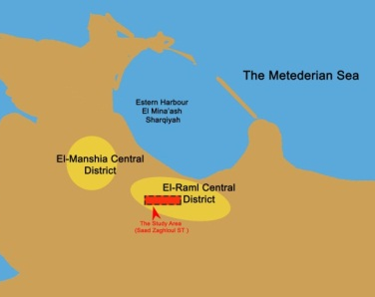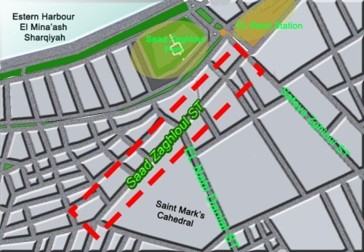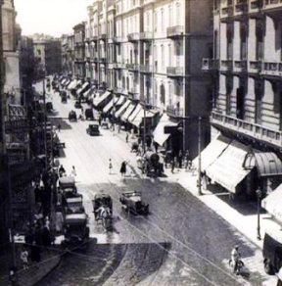
Figure 2 (Left): Location of Saad Zaghloul Street within El-Raml District (Researches, 2016).
Figure 3(Middle): popular streets connecting with Saad zaghloul Street (Researches, 2016).
Figure 4 (Right): Saad Zaghloul Street through History (AlAhram, 1875).

6.3. Land use Plan:
Saad Zaghloul Street is the heart of the city, which contain the concentration of commercial land use. There is a variety in the land use activities in this street as retailing use at the ground level, and mix of the built form of the buildings in line with street boundaries uses for business activities. Saad Zaghloul Street land use patterns divided into categories. In correspondence to the figure-ground map (5), the land use map shows intense commercial activity along the Saad Zaghloul Street and mix of the buildings surrounding the street uses for business work like clinics, offices, in between these activity we see famous cafes such as Brazilian Coffee and Delice Cafe besides a pure hotels use like.
It has activities used to many purposes: shopping, gathering, transportation, and business. The street, as shown in figure 6, and 7, shopping areas covers large section approximately 65 %, cafes approximately 15%, business 10% and 5% recreational.
As seen on the map, shows other facilities along street such pharmacies, tourism companies and mini markets, also there are other financial use such ATM bank services (Barclays Bank) completely.
The overall impression of the maps 5, 6, and 7 confirms the analysis Saad Zaghloul Street is full of a dense and busy retailing activities on the ground level, which is accessible directly from the street as shown in figures 8, 9, and 10.
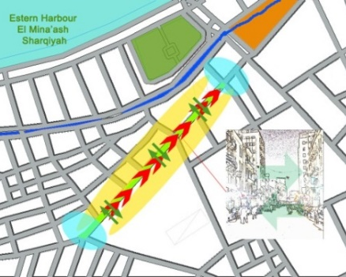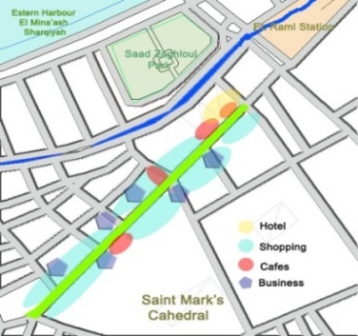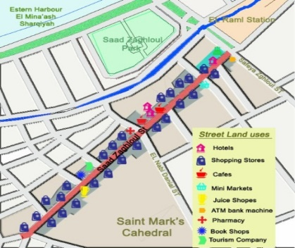
Figue 5 (Left): Map of Saad Zaghloul Street provide social mixing and social inclusion by activities and shoppers needs (Researchers, 2016).
Figure 6 (Middle): Map of Saad Zaghloul Street activities along the Street (Researchers, 2016).
Figure 7 (Right ): Map of Saad Zaghloul Street shows commercial activities (Researchers, 2016).

6.4. Analyzing of Saad Zaghloul as a Pedesterian Street :
According to Gehl (2010) defines a criteria to evaluate public spaces: 1) protection, 2) enjoyment and 3) comfort.
6.4.1. Protection:
Protection focuses on safe from accident, traffic, crime, climate problems. When moving through the city center protection from uncomfortable sensory experiences.
6.4.1.1. Results
a. Researchers Observations:
From the field survey and researchers observations it was noted that there are lack in traffic safety because of the increase in traffic volumes and congestion and negative impact on street activities. Bad-behaved of street vendors seriously affect the attractiveness of walking along street to shop. There are no cross walk area and loading zones add more negative feelings as shown in figures 11, and 12.
b. Questionnaire for Users Viewpoint:
Concerning protection 20% of users strongly disagree, while, 30% of users disagree. However, 6% of users strongly agree, and 6% agree, while, 38% feel neutral.
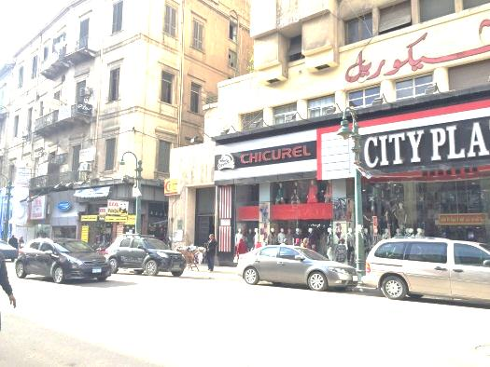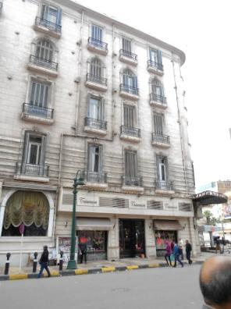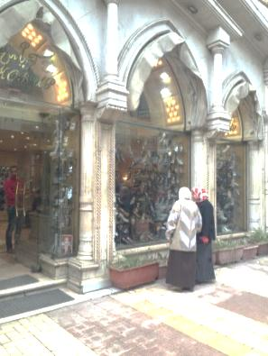
Figure 8 (Left):Shows the façade of Chicoril Department store (Researchers, 2016).
Figure 9 (Middle): Shows the façade of Metropolis Hotel , (Researchers, 2016).
Figure 10 (Right): Shows the façade of Shoes Store Koppas (Researchers, 2016).
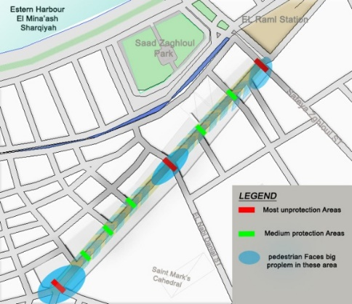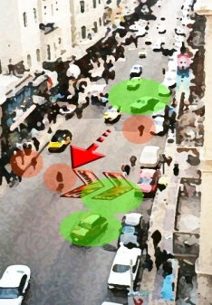
Figure 11 (Left): Map shows areas Faces unprotection along the street (Researchers, 2015).
Figure 12 (Right): Real photo shows protection problem (Researcher, 2015).
6.4.2. Comfort:
This parameter actually relates to one’s assessment through environmental experience and could be evaluated by social analysis (Martins, 2016).
6.4.2.1. Result
a. Researchers Observations
There are items, which pedestrian can feel uncomfortable in this street and it is directly related to environmental and physical comfort along street. Lack of sitting elements, bad quality of pavement, accessibility and others need signage, lack of greenery as negative points of this street. But there are lighting elements along the sidewalk as a positive point figure 13, and 14.
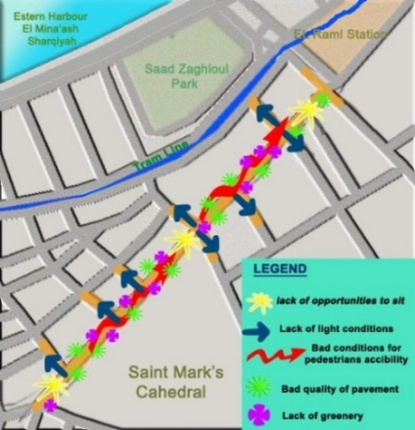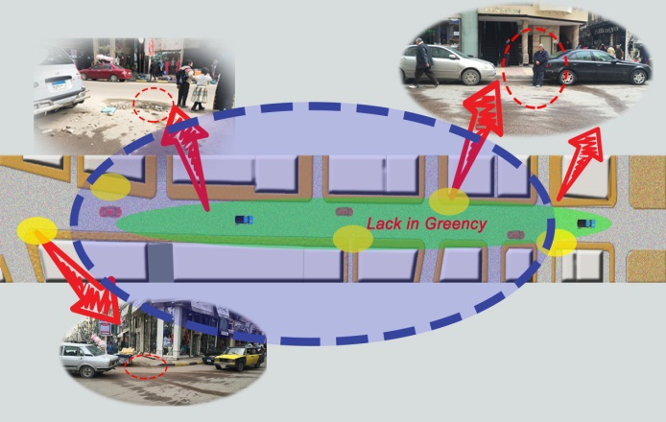
Figure 13 (Left): Map shows environmental and physical comfort along street.
Figure 14 (Right): Diagram shows areas uncomfort along the street (Researchers, 2016).
b. Questionnaire for Users Viewpoint:
Based on these results, 32% of users strongly disagree, while 18% disagree. In the meanwhile, 30% of users strongly agree, whereas, 10% agree. Feeling neutral is the viewpoint of the 10%.
6.4.3. Enjoyment
Shopping enjoyment has become an important concept in retailing. Shopping enjoyment refers to the customer experience regarding amusement, entertainment, leisure, excitement, fun, and other sensory stimulation which can be experienced while shopping (Shephard, Kinley, Josiam, 2014).
6.4.3.1. Results
a. Researchers Observations
Along street there are lack in quality material and bad conditions of pavement and roadway, which affect richness in visual qualities and enjoyment including cleanliness and aesthetic aspects in Saad Zaghloul Street.as shown figures 15, 16, and 17.
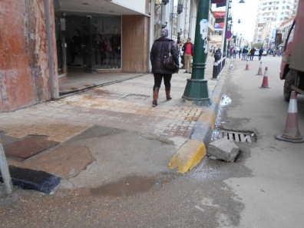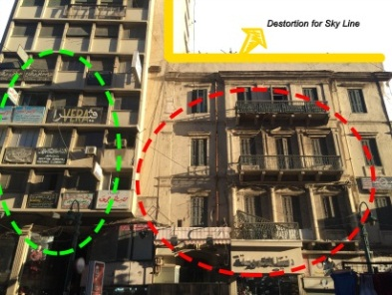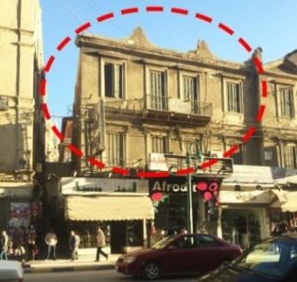
Figure 15 (Right): Shows poor finishing material and condition for sidewalks (Researchers2016).
Figure 16 (Middle): Shows visual clutter and bad conditions of buildings (Researchers2016).
Figure 17 (Left): Shows lack in maintenance of buildings façade (Researchers2016).
b. Questionnaire for Users Viewpoint
Based on questionnaire, 20% of users strongly disagree, while, 20% disagree with enjoyment. In the meanwhile, 30% strongly agree, although, 10% of users agree with enjoyment. Feeling neutral is the viewpoint of the 20% of users.

6.5. Saad Zaghloul Street Façade and Sidewalk Analysis:
Analyzing the shape of sidewalks and façades aim to provide tools to assist policy makers, designers, and citizens in advocating for the pedestrian experience through knowledge sharing and collaboration. It is within field survey for Saad Zaghloul Street to serve as a guide or reference for a variety of users. This analysis should help policy makers to become aware of the specific regulations they create or adjust that might ensure, encourage, or restrict certain kinds of pedestrian experiences and opportunities for people to be physically active. It warns of the unintended consequences of over-regulating, or of providing no guidance at all for the elements that shape a sidewalks and façades. This is the reasons behind that researchers adopt this analysis technique from Bloomberg (2013) (2010) as they see them proper for our case study.
There are two types of factors affecting façade design. They are as follo ws: 1) Tangible Factors, and 2) Less Tangible Factors. Each factor includes several sub-categories.
For example, less tangible factors consist of: 1) Accessibility and Connectivity, 2) Safety, 3) Human Scale and Complexity, 5) Continues Variety, Sustainability & landscape plantings
6.5.1. Accessibility and connectivity:
First, accessibility to Saad Zaghloul Street is easy because it is considered as a mid-point for several streets. There are different modes of transportation stop near the street's entrances.
A good pedestrian network invites people to walk along appealing, comfortable, and uninterrupted links that bring people from one end of the city to the other.
A streetscape can be classified as uncomfortable and create low interest to walk along, although, there are transparency and activity on the ground floor, paving and other street elements that should create a cohesive design do not. In the street there is no continuous high quality pedestrian network.
6.5.1.1. Results:
a. Researchers Observations
There are some stretches of streets with unpleasing walking environment because there are many street vendors grouping in different points. Sidewalks and their pavement material are exposed to a high rate of wear and tear due to high flow of pedestrian (figures 18, 19, and 20).
b. Questionnaire for Users Viewpoint
Those who are strongly disagree comprising 46%, while, 14% disagree. Whereas, 20% strongly agree, but, 20% agree. No users are neutral in that questionnaire.
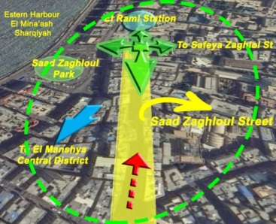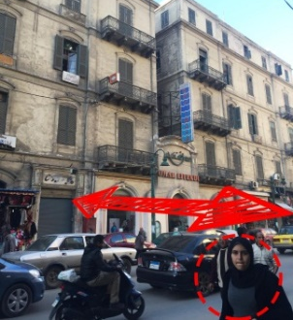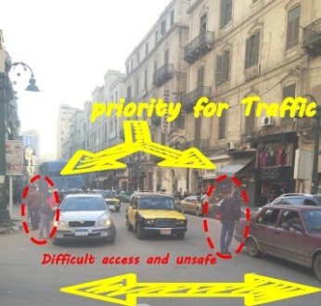
Figure 18 (Left): Shows the accesibility of Saad Zaghloul Street (Researchers, 2016).
Figure 19 (Right): Shows the difficulty in the connectivity (Researchers, 2016)..
Figure 20 (Middle): Picture shows prioritized for cars and traffic (Researchers, 2016).
6.5.2. Safety and Security:
Safety and security are two sides of the same coin. A weakness in security creates increased risk, which in turn creates a decrease in safety. Hence, safety and security are directly proportional, but are both inversely proportional to risk.
6.5.2.1. Results
a. Researchers Observations
Traffic congestion and lack of pedestrian crossing signals or markings reduce the level of safety for people, specially, with disabilities as shown in figure 21, and 22. .
This unsafe situation make it dangerous for shoppers. Also, street sidewalk condition, which considered unsafe for pedestrian. There are a lot of street vendors occur tripping along the street is another reason for unsafely along the street.
b. Questionnaire for Users Viewpoint
Along the street, 40% strongly disagree, while, 20% disagree. Even though 10% strongly agree, while, 10% agree. Although, 20% neutral in that questionnaire.
6.5.3. Human Scale
Human scale could be felt, when Spooner (2007) accepted that “enclosure” is the ratio between horizontal and vertical dimensions of a space. These ratios ranging from 1:1, 2:1, 3:1, and greater. It is understood that ratios that are 4:1 and greater begin to lose their enclosing properties and the sensation of space is diminished. In the meanwhile, ratios less than 1:1 convey claustrophobic feeling and are considered uncomfortable. This claustrophobic feeling because the human scale vanishes.
6.5.3.1. Results
a. Researchers Observations
As shown in figure 23, sketch shows that enclosure in Saad Zaghloul Street from the two sides almost 1:1, which is the regulations approve them.
b. Questionnaire for Users Viewpoint
Regarding humans scale and complexity, 10% strongly disagree, while, 6% disagree. With the same concern, 60% of users strongly agree, while only 14% agree. The remaining 10% are neutral in that questionnaire.
6.5.4. Continuity, Variety, and Plantings
The studied part from Saad Zaghloul Street could be divided into three sections (Figure 24). Section A, section B, and section C according to continuity, variety, and plantings.
6.5.4.1. Results
a. Researchers Observations
Section A has low activity as a result of inactive façades that relate poorly to the street, where pedestrian want to go quickly, allows people just to move. While, section B offers the opportunity to stop for a while for rest and refreshment because there are many shops and cafes, which give pedestrian a chance to stop when pass by. Also in section C allows pedestrian for slower speed. Along the street, there are no trees or green spaces as shown in figures 25, and 26. The absence of green spaces with presence of polluting transport modes add air pollution to it.
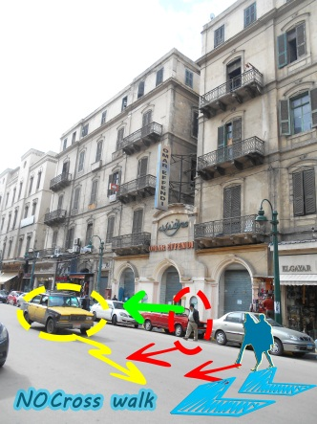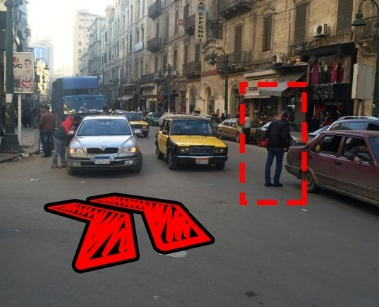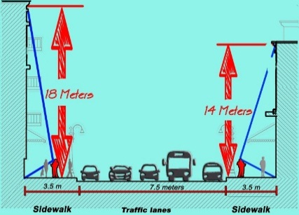
Figure 21 (Left): Lack in the level of safety for pedestrian (Researchers, 2016).
Figure 22 (Middle) : Lack of pedestrian crossing signals and cross walk (Researchers, 2016).
Figure 23 (Right): Shows human scale with buildings along Saad Zaghloul street (Researchers, 2016).
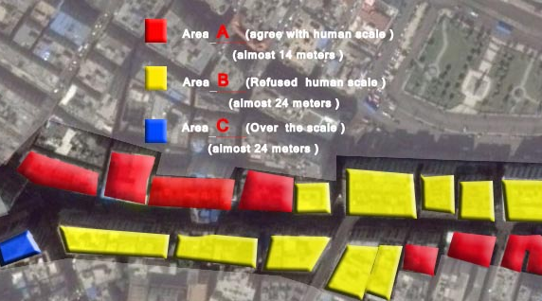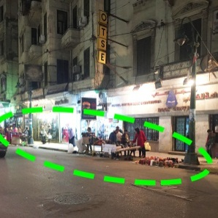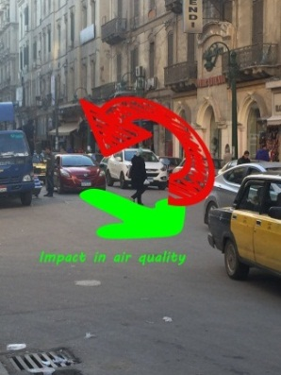
Figure 24 (Left): Saad Zghloul map shows variety of speed areas for A,B and C (Researchers, 2016).
Figure 25 (Middle): Shows no trees or green spaces along sidewalk (Researcher, 2016).
Figure 26 (Right) : Lack in green and trees impact on air pollution and protection (Researcher, 2016).

6.6. Tangible Factors:
Saad Zaghloul Street contains two zones as figure (27): Sidewalk, and one-way road way, which is divided into four lanes without any green island and one lane for off-street parking. Analysis is adopting Bloomberg (2013, and 2010). He dissects the cross section of the street into four planes, which are grappled with the complex interaction of physical elements shaping the pedestrian experience of the sidewalk. While separating the planes is helpful for exploring the details (Figure 27). In the following section a brief researchers observations would be considered to remark users emotions for them.
6.6.1. Plane 1: Ground Plane (Sidewalks):
This plane is the sidewalk plane, which plays a significant role in users' movement as well as activities linking. It attracts users or repels them.
6.6.1.1. Results
a. Researchers Observations
Pavement material condition is very bad. It is badly maintained, which affect safety negatively. There are many street vendors on ground plane, which affect pedestrian movement, and pavement clearance for them. There is an absence of street furniture like wastebaskets, and benches. There are bases of lighting and signage poles with bad arrangement as in figure 28. Bad sidewalk conditions affect users' emotions negatively as shown in figure 29.
6.6.2. Plane 2: Roadside Plane
This plane is defined primarily by the rhythm of vertical physical elements like light poles.
6.6.2.1. Results
a. Researchers Observations
Actually, in Saad Zaghloul roadside plane some street vendors occupy the road itself as well as illegal off-street parking.
6.6.3. Plane 3: Building Façade Plane
In this part, it is noticed that this plane in Saad Zaghloul Street could be divided into two different levels: 1) Street Level, and 2) Upper Level. Whatsoever the level, pedestrian emotions are affected by: 1) Architectural style, 2) Color, size and materials of signage panel, 3) Lighting of entrances and displays, and 4) Color, and size of awning.
6.6.3.1. Results
a. Researchers Observations
These lastly mentioned points influence users' emotions on either street or upper levels, which are reflected on their behavior: negatively, or positively as actions or reactions. In most cases the influences on users' emotions are negative.
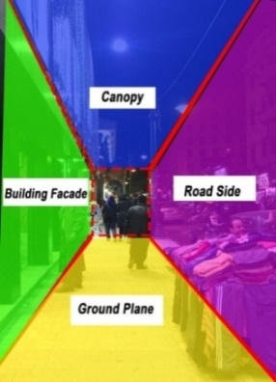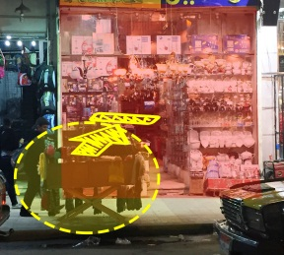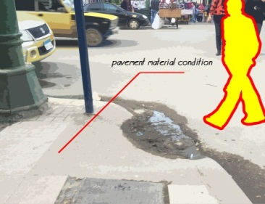
Figure 27 (Left): Judging from the pedestrian perspective, Saad Zaghloul sidewalk is conceptualized as a room with four planes ( Researcher after Bloomberg, 2013; Bloomberg, 2010).
Figure 28 (Middle): Shows some street vendors' stands located on sidewalk (Researchers, 2016).
Figure 29 (Right): Show parts of the pavements and its poor conditions (Researcher, 2016).
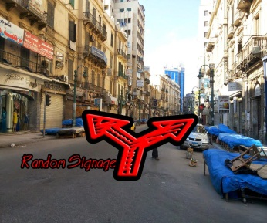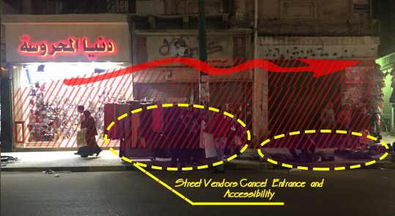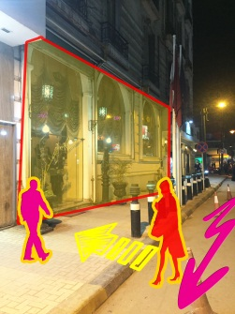
Figure 30 (Left): Shows the haphazardness of signage along the street (Researchers, 2016).
Figure 31 (Middle|): Shows storefront when street vendors stand in front of it (Researchers, 2016).
Figure 32 (Right): Shows clear attractive entrance of Metroplois Hotel (Researchers, 2016).
b. Questionnaire for Users Viewpoint
Regarding the façade plane, 8% strongly disagree, while, 10% disagree. In contrast, 48% strongly agree with buildings' façades, while, 32% agree. Whereas, 2% only do not care.
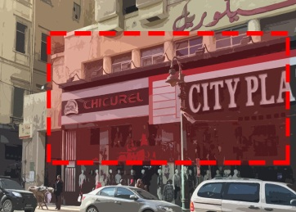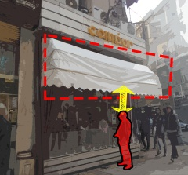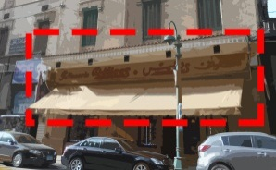
Figure 33 (Left): did not found any awning above shops (Researchers, 2016).
Figure 34(Middle): Large façade without any awning (Researchers, 2016).
Figure 35 (Right): Intersting the style more than awinging (Researchers, 2016).

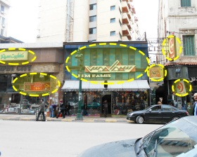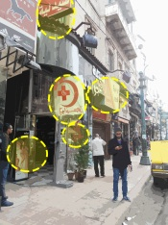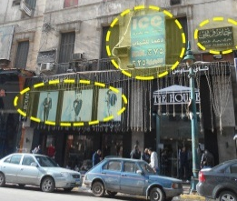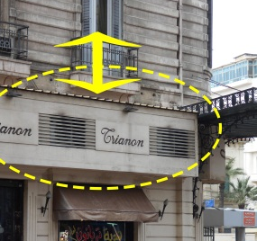
Figure 36 (Right): Signage race, uncomfortable size (Researcher, 2016).
Figure 37 (Middle right): random and crowded signages (Researcher, 2016).
Figure 38 (Middle left):different colors and non compatible material with area style (Researcher, 2016).
Figure 39 (Left): signage compatible with buildings architectural styles (Researcher, 2016).
6.6.4. Plane 4: The Canopy Plane
The ending of the surrounding buildings represent the canopy plane. These endings are related to the architectural style of the building.
6.6.4.1. Results
a. Researchers Observations
Along Saad Zaghloul Street a variety of architectural styles are seen for storefront, which do not respect buildings' architectural styles. Each store has different design and style for its façade. The storefront designers do not respect canopy plane in their designs, or even its style.
6.7. Roadway Physical Aspects
Saad Zaghloul Street have a number of physical aspects such as off-street parking, crosswalk points, and distinct loading zones. Parking for shoppers as drivers or employees of the shops.
6.7.1. Results
a. Researchers Observations
Saad Zaghloul Street is suffering from shortage in off-street parking spaces in relation to land use activities and their density, which enforce drivers to park illegally (figures 40, 41, and 42).
These problems impact negatively the emotions of users whether they are pedestrian, car or cab drivers, or goods suppliers. First, problem is the crosswalk points, which impact pedestrian movement negatively. Second, shortage in parking places and the impact of that on retailing process. Finally, suppliers and in turn shops owners distinct loading zones.
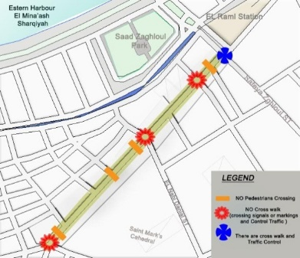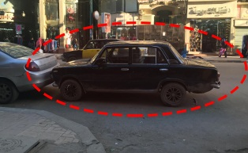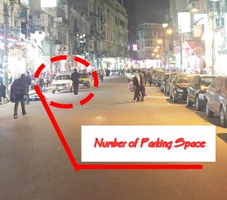
Figure 40 (Left): Map shows crosswalk points along Saad Zaghloul Street (Researchers, 2016).
Figure 41 (Middle): Illegal off street parking (Researchers, 2016).
Figure 42 (Right): Lack of parking space reflects negatively on retailing (Researchers, 2016) .

7. Discussion
Analyzing Saad Zaghloul Street, it is noticed that results always give negative emotions. For example, concerning protection, it is obvious that a weighable amount (50%) of users either strongly disagree or disagree versus a few amount (12%) agree.
This high percentage of disagreement is due to bad-behaved street vendors and absence of cross-walk marks.
As regards comfort, it is clear that 50% of users either strongly disagree or disagree because of lack of sitting elements, bad quality of pavement, signage, and lack of greenery.
Along street there are lack in quality material for pavement and condition of roadway, which reduce enjoyment of users because of the lack of richness in visual qualities, cleanliness and aesthetic. That is why two fifth of the users strongly disagree (20%) or disagree (20%).
The unpleasing walking environment because of the existence of many street vendors grouping in different points. In addition to the sidewalks and their pavement material, which are exposed to a high rate of wear and tear due to high flow of pedestrian, affect accessibility and connectivity negatively, which is obvious in the relatively high (60%) disagreement or strongly disagreement between users.
Traffic congestion and lack of pedestrian crossing signals or markings reduce the level of safety and security of shoppers, particularly, those with disabilities, and street vendors occur tripping along the street. This unsafe status quo explains why 60% of users are strongly disagree or disagree regarding safety and security.
Regarding humans scale, almost three quarters of the users are either agree or strongly agree. This is due to the 1:1 enclosure, which convey positive emotions.
Visual pollution is a natural outcome of bad storefront designs, which are not respecting architectural style of existing buildings.
The lack in parking areas enforce drivers to park illegally, which in turn bother pedestrian shoppers.
These findings have negative impacts on the emotions of users whether they are pedestrian, car or cab drivers, or goods suppliers.

8. Conclusion
This study shows that the emotions of shoppers in Saad Zaghloul Street is mostly negative. This undesirably impact the retailing process in that street as a part from Alexandria City Center.
Decision makers in Alexandria Local Authorities are always trying to solve the city center problems using physical solutions. They do not take into consideration the emotions of the shoppers. These emotions affect shoppers' interest negatively in retailing from the street.
To enhance the shopping process in Saad Zaghloul Street the following recommendations could be carried out:
To improve the street safety and security conditions, the local authorities should remove the street vendors and find another place for them;
To increase the attractiveness of city center the sidewalks and roadways finishing material should be more impressive and in excellent conditions;
- To attract more shoppers, whether using private cars or cabs, off-street parking fare system with some restriction should be applied. The land use plan should be reviewed to be sure that parking places would fulfill the needs;
- To maintain the architectural style of the street, a building regulation term of reference for the city center should be established, and designers for storefront should follow this;
- To improve the safety and security level bollards on the sidewalks should be installed, and the crosswalk paths should be set up;
- To stop the visual intrusion, all signage should be alike (size, font, location, etc.), and lighting fittings should follow certain regulation;

- To boost the shopping process in the CBD of Alexandria City the public transport system in the city should be more reliable for upper middle class, and low upper class emotions to add more liveliness and vigor;
- To enrich the shopping process, direction sings should be located everywhere;
- To develop the street shopping environment, an eye-catching, and smart street furniture should be added;
- To create an attractive storefront, awning should be standardized (color, size, height, etc.);
- To generate healthy environment during shopping process, green areas, flowers, trees, and bushes should be placed; and
- To facilitate disabilities and senior movement, pavement borders heights, and ramps should be established and precisely designed.

9. References:
Arnould, E. (2005). Animating the big middle. Journal of Retailing, 81(2), 89–96.
Mayer, D. J. el al. Emotional Intelligence: Theory Findings, and Implications, Psychological Inquiry 2004 Vol. 15, no. 3: 197-215.
Angel, S., Blei, M. A. The spatial structure of American cities: The great majority of workplaces are no longer in CBDs, employment sub-centers, or live-work communities, Cities 51 (2016) 21–35
Heimlich, E. J. & Ardoin, M. N. Understanding behavior to understand behavior change: a literature review, Environmental Education Research, Vol. 14, No. 3, June 2008, 215–237
Boden, D., & Molotch, H. (2004). Cyberspace meets the compulsion of proximity. In S. Graham (Ed.), The cybercities reader. New York: Routledge.
Maeng, D. M., & Nedovic-Budic, Z. (2010). Relationship between ICT and urban form in knowledge-based development: empirical analysis of Washington, DC metro region. International Journal of Knowledge-Based Development, 1(1), 97-117.
Cachinho, H. Consumerscapes and the resilience assessment of urban retail systems, Cities 36 (2014) 131–144
Miron, R. The Vocabulary of Reality, Hum Stud (2015) 38:331–347
Qin, X., Zhen, F., Zhu, S.-J. Centralisation or decentralisation? Impacts of information channels on residential mobility in the information era, Habitat International 53 (2016) 360-368
Chen,Y., Chen Z., Xu, G.& Tian ,Z. Built-up land efficiency in urban China: Insights from the General Land Use Plan (2006-2020), Habitat International 51 (2016) 31-38.
Steg,L., Vlek, C. Encouraging pro-environmental behaviour: An integrative review and research agenda, Journal of Environmental Psychology 29 (2009) 309–317.
Chaiklin, H. Attitude, Behavior and Social Practice, journal of Sociology and Social Welfare, March 2011, Vol. XXXVIII, Number 1: 31-54.
Khademian , M. A. Organizing in the Future: Pursuing Purposefulness for Flexible Accountability, Public Administration Review, Vol. 70, Supplement to Volume 70: The Future of Public Administration in 2020 (December 2010), pp. S167-S169
Novak, M. J. and Gilliland, A. J. Trading Places: A Historical Geography of Retailing in London, Canada, Social Science History 35:4 (Winter 2011): 543-570
Sabates, A. L., Capdevila, J. M. contribution from attitude change theory on the conceptual between attitudes and competencies, Electronic Journal of Research in Educational Phycology, 8 (3) 2010: 1283-1302
Zhu, L., Benbasat, I. & Jiang, Z., Let's Shop Online Together: An Empirical Investigation of Collaborative Online Shopping Support, Information Systems Research Vol. 21, No. 4, December 2010, pp. 872-891
Savini. F., Boterman, R., W., van Gent,W., P.C.& Majoor, S. Amsterdam in the 21st century: Geography, housing, spatial development and politics, Cities 52 (2016) 103–113
Spierings, B. Fixing missing links in shopping routes: Reflections on intra-urban borders and city centre redevelopment in Nijmegen, The Netherlands, Cities 34 (2013) 44–51.
Zhen, F., & Wei, Z. (2008). Inﬂuence of information technology on social spatial behaviors of urban residents. Chinese Geographical Science, 18(4), 316-322.
Rao ,C., Goh M., Zhao, Y.& Zheng J. Location selection of city logistics centers under sustainability, Transportation Research Part D 36 (2015) 29–44

Zinck, A. & Newen, A. Classifying emotion: a developmental account, Synthese (2008) 161:1–25.
Longhi, C., & Musolesi, A. (2007). European cities in the process of economic integration: Towards structural convergence. Annals of Regional Science, 41(2), 333–351.
Schneider, A., & Woodcock, C.E. (2008). Compact, dispersed, fragmented, extensive? A comparison of urban growth in twenty-five global cities using remotely sensed data, pattern metrics, and census information. Urban Studies, 45, 659–692.
Warnaby, G. (2009). Look up! Retailing, historic architecture and city centre distinctiveness. Cities, 26(5), 287–292.
Kasanko, M., Barredo, J.I., & Lavalle, C. (2006). Are European cities becoming dispersed? A comparative analysis of fifteen European urban areas. Landscape and Urban Planning, 77(1–2), 111–130.
De Rosa , S. & Salvati, L. Beyond a ‘side street story’? Naples from spontaneous centrality to entropic polycentricism, towards a ‘crisis city’, Cities 51 (2016) 74–83.
Alnsour, A. J. Managing urban growth in the city of Amman, Jordan, Cities 50 (2016) 93–99.
Salvati, L., Gargiulo Morelli, V., & Rontos, K. (2013). Latent exurban development: City expansion along the rural to urban gradient in growing and declining regions of southern Europe. Urban Geography, 34(1), 376–394.
Zhao, P., Lü, B., & Woltjer, J. (2009). Consequences of governance restructuring for quality of urban living in the transformation era in Beijing: A view of job accessibility. Habitat International, 33(4), 436–444.
Amin, A. (2008). Collective culture and urban public space. City, 12(1), 5–24.
Mohadeseh Mahmoudi, Faizah Ahmad, and Bushra Abbasi, Livable streets: The effects of physical problems on the quality and livability of Kuala Lumpur streets, Cities 43 (2015) 104–114.
Borchert, J. G. (1998). Spatial dynamics of retail structure and the venerable retail hierarchy. GeoJournal, 45, 327–336.
Wrigley, N., & Dolega, L. (2011). Resilience, fragility, and adaptation: New evidence on the performance of UK high streets during global economic crisis and its policy implications. Environment and Planning A, 43(10), 2337–2363.
He , S. and Lin, C. G. Producing and consuming China’s new urban space: State, market and society, Urban Studies 2015, Vol. 52(15) 2757–2773.
Hu, Z. F. Industrial capitalization and spatial transformation in Chinese cities: Strategic repositionin g, state-owned enterprise capitalization, and the reproduction of urban space in Beijing, Urban Studies 2015, Vol. 52(15) 2799–2821.
Yeh, A., Yang, F. and Wang, J. Economic transition and urban transformation of China: The interplay of the state and the market, Urban Studies 2015, Vol. 52(15) 2822–2848.
Qian, J. No right to the street: Motorcycle taxis, discourse production and the regulation of unruly mobility, Urban Studies 2015, Vol. 52(15) 2922–2947.
Schuetz, J. Do rail transit stations encourage neighborhood retail activity?, Urban Studies 2015, Vol. 52(14) 2699–2723.
Zhen, F., Wang, B. and Wei, Z. The rise of the internet city in China: Production and Consumption of Internet Information, Urban Studies 2015, Vol. 52(13) 2313–2329.
Hajrasouliha, A. and Yin, L. The Impact of Street Network Connectivity on Pedestrian Volume, Urban Studies 2015, Vol. 52(13) 2483–2497.

Raslan, R., Al-Hagla, K., & Bakr, A. Integration of Emotional Behavioral Layer "EmoBeL" in City Planning. In: Schrenk, M. et al. (eds.) Real CORP, 2014 Vienna, Austria, 309-317.
Pham, M. T., Emotion and Rationality: A Critical Review and Interpretation of Empirical Evidence, Review of General Psychology, 2007, Vol. 11, No. 2, 155–178
Jan S. E. and Jonathan H. Turner (ed.) Handbook of the Sociology of Emotion. United State of America, 2006, Springer.
Kugler, T., Smith, J., Connlly, T., Son, Y. (ed.) Decision Modeling and Behavior in Complex and Uncertain Environment. Springer (2008).
Shanahan, J., Qu, Y., Wiebe, J. (ed.) Computing Attitude and Affect in Text: Theory and Applications. Springer (2006).
Rooij,V. R. Attitude and Changing Contexts. Springer (2006).
Gehl, J. Cities for People. Island Press: Washington (2010).
Martins, T., Adolphe, L., Bonhomme, M., Bonneaud, F., Faraut, S., Ginestet, S., Michel, C., Guyard, W. Impact of Urban Cool Island measures on outdoor climate and pedestrian comfort: simulations for a new district of Toulouse, France. Sustainable Cities and Society, In Press, Accepted Manuscript, Available online 12 May 2016.
Shephard, A., Kinley, T., Josiam, B. Fashion leadership, shopping enjoyment, and gender: Hispanic versus, Caucasian consumers' shopping preferences. Journal of Retailing and Consumer Services 21 (2014) 277–283.
Bloomberg, R. M. Active Design: Shaping the Sidewalk Experience. City of New York. Report from City Council 2013.
Bloomberg, R. M. Active Design Guidelines: Promoting Physical Activity and Health in Design. City of New York. Report from City Council 2010.
Spooner, Enclosure and Walkability: An Italian Street Study. Proceeding of The Environmental Design Research Association (EDRA) 38, 2007: 85-89.
Architects, Gehl. Public sSpaces & Public Life. Seattle : City of Seattle, 2009.
Him, C. Sze , Matthew. City as Landscape,Urban Edge In Central Distric. The Untversity of Hong Kong: The Untversity of Hong Kong, 1998.
Li, M. "Urban Regeneration Through Public Space: A Case Study in Squares in Dalian, China." Waterloo, Ontario, Canada, 2003 .
Rasouli, Mojgan. Analysis of Activity Patterns and Design Features Relationships in Urban Public Spaces Using Direct Field Observations, Activity Maps Mel Lastman Square in Toronto as a Case Study. Waterloo, Ontario, Canada: the University of Waterloo in fulfillment, 2013.
Stevens, Q. "The shape of urban experience: a reevaluation of Lynch's." Environment and Planning B: Planning and Design,, 2006 : volume 33, pages 803 - 823.

