Three New Records of Orobanche (Orobanchaceae)
to the Flora of Iraq
Widad M. Al-Asadiª and Abdulridha A. Al-Mayah^{b}
Department of Ecology, College of Science, University of Basrah
ªWidad220@yahoo.com
^{b}Abdulalwan@yahoo.com
Abstract
Three species of Orobanche L., O. alba Stephan ex Willd., O. caryophyllacea Sm. in Trans, and O. reticulata Wallr. were recorded for the first time to the flora of Iraq. O. alba is collected from Chah-Maka village, after Sheomersy from Zalan junction in Sulaimanyia District (MSU), it is parasitized on Vicia monantha. O. caryophyllacea is collected from Pira-Magron mountain (MSU), it is parasitized on Galium sp. (Rubiaceae) and O. reticulata is collected from Pera-Magron and parasitized on Vicia monantha. Key to the species, description, habitat, distribution map and photographs were provided.
Keywords: Orobanchaceae, Orobanche, Broomrape, Iraq, Parasitic plant.
1. Introduction
The family Orobanchaceae which is supposed to be accounted by Kew in volume 7 of Flora of Iraq has not yet been published. Several authors such as [1, 2, 3, 4, 5, 6, 7] treated the genus Orobanche in its broad sence to include Phelipanche and Phelypaea.
[5] in his checklist of wild plant of Iraq mentioned 10 species of Orobanche s.l. including Phyelypaea coccinia, while [7] in his MSc thesis reported 11 species of Orobanche and Phyelypaea coccinia. The taxonomy status of Orobanchaceae among other flowering plants is often subject of debate [8].
During the last two decades several molecular markers were used for reevaluate systematic and evolutionary relationship within Orobanchaceae. Recent studies supported by molecular systematic analyses have resulted in dividing Orobanche L. into to distinct genera, Phelipanche Pomel and Orobanche L..
All species of the section Trionychon of Orobanche s.l. which are distinguished by having 2 bracteoles were transferred to the genus Phelipanche Pomel, while all the other species of Orobanche which lack the 2 bracteoles remained under Orobanche L. [9, 10, 11].
In this paper, which is a part of our PhD project on the taxonomy of Orobanchaceae of Iraq, We agree with the concept of the 2 distinct genera Phelipanche and Orobanche, therefore We gathered all species without bracteoles under Orobanche. Here we introduce some new records of Orobanche species recorded for the first time for Flora of Iraq.

2.Materials and Methods
Detailed taxonomic and chorological study of the Orobanchaceae in Iraq have been carrying out since 2014. A floristic survey of almost all regions of Iraq was accomplished. Fresh materials for the parasites plant with their host were collected and photographed simultaneously in the field for easier and more accurate identification of species. Voucher specimens were prepared and deposited in the Herbarium of Basrah university (BSRA). The existing herbarium materials in the National Herbarium of Iraq (BAG) and other main regional herbaria BUH, BAH, BUNH, BSRA, ASUH were examined, identified and their distribution recorded. [1, 3, 12, 13, 14,15, 16] were consulted for species identification.

3. Results and Discussion
Orobanche alba, O. caryophyllacea and O. reticulata were recorded for the first time to the flora of Iraq in this study.
The 3 species can be identified by the following key:
1- Calyx half usually entire, Parasitized on Vicia ……………………………………………………….……. 2
1- Calyx half clearly bifid, Parasitize on Galium……………………………………....……… O. caryophyllacea
2- Corolla dark purple throughout, filament glabrous at base, stigma purple…………………….. O. rticulata
2- Corolla tube whitish-cream at the base, pinkish above, filament hairy at base, stigma red-orang..… O. alba
1.3. Species description
1- Orobanche alba Staf. ex Willd. Sp. Pl. 3: 350 (1800).
Flowering stem simple, usually (19-30)cm, brownish or dark orange-red, thick 4.5-9mm diameter, glandular-pubescent. Scales (12-25)mm, ovate-lanceolate. Inflorescence short cylindrical, few flowered (8-12), shorter than stem. Bracts (15-19)mm, lanceolate, glandular, equaling or slightly longer than flower. Calyx (14-16)mm, usually entire, rarely bidentate, often equaling corolla tube, glandular pilose. Corolla (15-22)mm, pale-cream at the base of tube, pinkish or orange-brown above, glandular-pubescent, campanulate-cylindrical, lower lip glandular ciliate. Stamens inserted (0.5-2.5)mm above corolla base, hariy at base, glandular above. Stigma red-orange, the lobes joined. Flowering period May.
2- Orobanche caryophyllacea Sm. in Trans Linn. Soc. Lond. 4: 169(1797).
Flowering stem simple, (17-30)cm, dirty pink or pale purple in colour, stout, (5-10)mm diameter, glandular-hairy. Scales (12-25)mm, lanceolate, glandular hairy. Inflorescence long cylindrical, (10-22)cm, with numerous flowers in a rather lax spike, denser at the top, often longer than stem. Bracts (17-24)mm, lanceolate-acuminate, glandular-pubescent, almost shorter than flower. Calyx (11.5-20)mm, bidentate or ± entire, glandular pilose, teeth acuminate often shorter than corolla tube. Corolla (20-24)mm, glandular-pubescent, same colour as stem, often pale-cream at base, darker at lip, brownish-purple, dark brown when dried, campanulate, broadest just behind mouth, upper lip curved downward with an erect tip. Stamens inserted (2.5-3)mm above base of corolla tube, filaments hairy below, glabrous above but glandular pubescent below anther. Anther glabrous. Style sparsely glandular hairy. Stigma dark purple, brown or orange. On Gallium. Flowering period May.
English name Clove Broomrape.
3- Orobanche reticulata Wallr., Orob. Gen. 42(1825).
Flowering stem (20-42)cm, simple, dirty purple, lighter above, thick, (7-12)mm diameter, glandular-hairy. Scales (12-20)mm, acuminate. Inflorescence long cylindrical, rather dense, laxer below, much longer, than stem. Bracts (15-23)mm, narrowly triangular, equal to or slightly exceeding flower. Calyx (11-14)mm, bifid, glandular pubescent; teeth shorter than corolla tube. Corolla (18-22)mm, glandular-pubescent, purple outside, yellowish or white inside, cylindrical-campanulate, with dark glands on the back of lips, upper lip with spreading or downwardly curved lobes. Stamens inserted (1-3)mm above the base of the corolla tube; filaments glabrous or subglabrous below, sparsely glandular above. Stigma purple, with 2 lobes touching at base. On Rubiaceae. Flowering period May.
English name Thistle Broomrape.
The main taxonomical characters of the 3 species are given in table 1, their map of distribution is shown in fig. 1. Habitat and floral characters are elustrated in fig. 2, 3.
2.3. The Taxonomically Important Characters
Orobanche is the most important genus of the family Orobanchaceae. It is known as a taxonomically very difficult genus, this is mainly due to that many of the useful characters many lost on drying, and the lack of adequate field notes.
Orobanche species are almost enormously variable in characters such as colour, size and pubescence, yet these details are rarely recorded on labels of specimens. Because of this variation and their use in the taxonomy of the genus, care should be taken not to rely on a single character in species determination (Rumsey and Jury, 1991) . It is very important to identify and mention the plant host. However, an incorrect host plant in many cases are given and this has rowngly influenced later identification.
The three newly recorded Orobanche to the flora of Iraq are very closely related species. Although the 3 species are recorded in the same physiographic district (MSU) in Iraq, but O. alba collected from the eastern part of the district near the Iraq. Iran border, while the other two O. caryophyllacea and O. reticulata collected from the western part of the district on Pera-Magron mountain (Fig. 1). Non of the 3 species can be accurately identified on a single character, however, O. caryophyllacea can be easily separated by its almost bidentate calyx, long inflorescence and pale corolla base with brownish or reddish corolla lips. O. alba differs from O. reticulata by having corolla with lighter colour at the base, filament insertion near the base of corolla tube and hairy filament at the base. Phytogeographically, O. alba and O. caryophyllacea were reported by Rechinger, 1964b and Davis, 1982 to occur in Iran and Turkey but they did not mentioned O. reticulata, but Beck, 1930 mentioned that O. reticulata occurs in Kurdistan in Persia, and Rumsey and Jury, 1991 reported its presence in S.W. Asia. O. reticulata is very similar to O. caryophyllacea, and when they occur in same habitat it is very difficult to separate them on any distinct character. The presence of the 3 species in Iraq is just an expanding to the their natural distribution to the adjacent habitat.
3.3. Pollen and seed morphology
Pollen grains and seeds micromorpholoical characters examined under Scanning Electron Microscope (SEM) have not shown any taxonomical importance for species isolation. Pollen surface ornamentation were scabrate and similar in the 3 species. Similarly the seeds surface sculpturing were nearly similar in the 3 species except for a little variation anther pericliual cell walls fig. 4.

Table 1: Characters of the recorded Orobanche species.

Characters | O. alba | O. caryophyllacea | O. reticulata
Height of plant (cm) | 19-30 | 27-52 | 20-42
Stem length (cm) | 14-24.5 | 17-30 | 9.5-17
Inflorescence length (cm) | 5-5.5 | 10-22 | 10.5-25
Scale length (mm) | 12-25 | 12-25 | 12-20
Bract length (mm) | 15-22 | 17-24 | 15-23
Calyx length (mm) | 14-16 | 11.5-20 | 11-14
Calyx teeth(mm) | 10-11 | 7.5-15 | 8-10
Calyx half shape | Entire | Bifid | Entire
Corolla length (mm) | 15-22 | 20-24 | 18-22
Filament base | Hairy | Hairy | Glabrous
Filament insertion on corolla | 0.5-2.5 | 2.5-3 | 1-3
Stigma colour | Orange | Brown or Purple | Purple
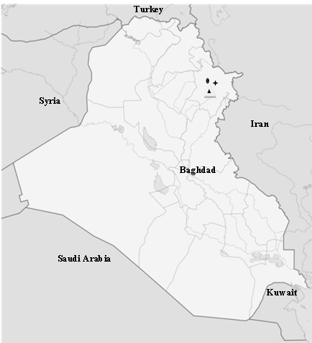

Fig. 1: Distribution in Iraq of O. alba; ( ) O. caryophyllacea ( ) O. retciulata ( )

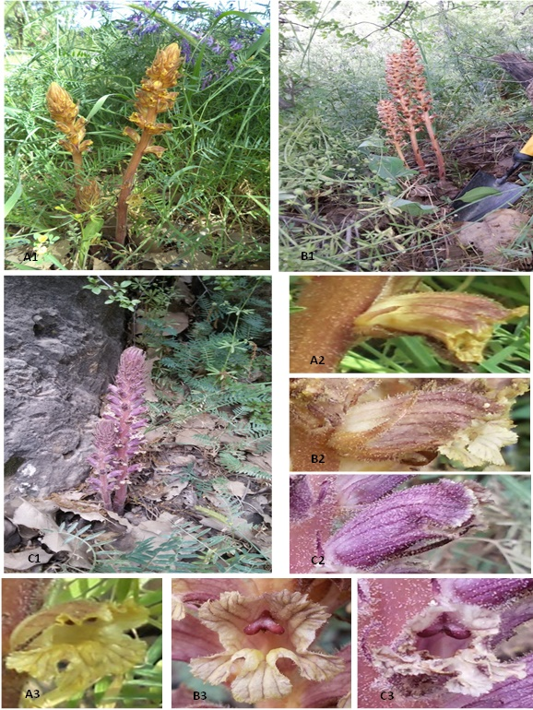

Fig. 2: Habitat and floral characters of the 3 newly recorded Orobanche species, A1-3: O. alba; B1-3: O. caryophyllacea; C1-3: O. reticulata

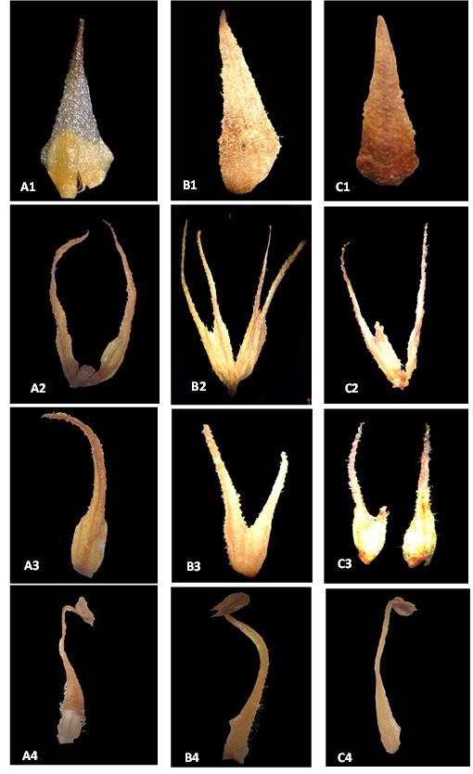

Fig.3: Floral characters of the 3 newly recorded Orobanche species. A: O. alba; B: O. caryophyllacea; C: O. reticulata, from top to bottom: bract, calyx, calyx half, filament.

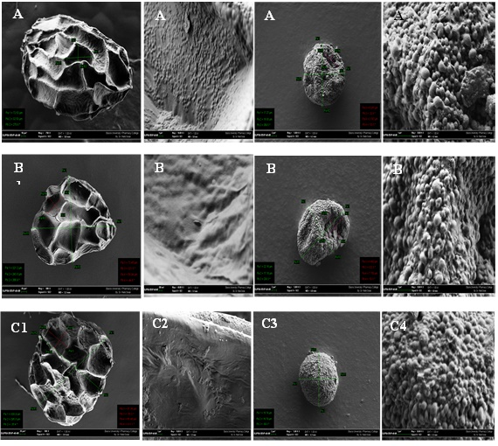

Fig. 4: SEM micrographs of the pollen and seeds of A1-4: O. alba;
B1-4: O. caryophyllacea; C1-4: O. reticulata.

4. References
[1] Davis, P.H.; J.R. Edmondson and R.R. Mill. Flora of Turkey. The university Press. Edinburgh. Vol. 7, 1-23(1982)
[2] Rechinger, K.H. Flora of Low lands Iraq. Velage van. Grover, Wein, P.663 – 664(1964a).
[3] Rechinger, K.H. Flora of Iranica. Orobanchaceae. No.5, P.1-20(1964b).
[4] Daoud, H.S. Flora of Kuwait. KPI, in association with Kuwait Unversity, vol. 1. 190-194(1985).
[5] Al-Rawi, A. Wild plants of Iraq. Ministry of Agriculture & Irrigation . Abu Ghiraib- Iraq(1964).
[6] Migahid, A. M. Flora of Saudi Arabia. 2nd ed., Vol.1. Riyadh Univ. publication, PP.647(1978).
[7] Salih, S. H. A systematic study of the family Orobanchaceae Vent. In Duhok, Arbil and Sulaimanyia Governorates Kurdistan Region-Iraq. Sulaimaney University. MSc. thesis, 136pp(2002).
[8] Gevezova, M.; Dekalska, T.; Stoyanov, K.; Hristeva, T.; Kostov, K.; Batchvarova, R. and Denev Iliya Recent advances in Broomrapes research. J. BioSci. Biotech. 2012, 1(2): 91-105(2012).
[9]Holub, J. Some taxonomic and nomenclatural changes within Orobanche s. l. (Orobanchaceae . Preslia, 62: 193-198(1990).
[10] Joel D. Taxonomic and evolutionary justifications for considering Phelipanche as a separate genus. P.15 in: Rubiales D., Westwood J. & Uludag A. (ed.). Proceedings of the International Parasitic Plant Society (IPPS), 10th World Congress of Parasitic Plants, 8–12 June 2009, Kuşadasi, Turkey(2009).
[11] Banfi, E.; Galasso, G. and Soldano, A. Notes on systematics and taxonomy for the Italian vascular flora 2. Atti Soc. Ital. Sci. Nat. Mus. Civico Storia Nat. Milano 152: 85-106(2011).
[12] Beck, G. Orobanchaceae. In Engler, A. (ed.). Das Pflanzenreich. Regni Vegetabili Conspectus. Wilhelm Engelmann. Leipzig., 1-348(1930).
[13] Tutin, T.G.; V.H. Hewwood; N.A. Burges; D.M. Moor; D.H. Valentine; S.M. Walter and D.A. Webb Flora Europeaea Cambridge, at the University Press. Vol. 3., 285-294(1972).
[14] Clapham, A.R.; Tutin, T.G.; Warburg, E.F. Flora of the British Isles. Cambridge: Cambridge University Press (1962).
[15] Stace, C. New Flora of the British Isles. Cambridge, UK: Cambridge University Press . (1991)
[16] Rumsey, F.J. and S.L. Jury. An account of Orobanche L. in Britain and Ireland. Watsonia, 18: 257-295(1991).

