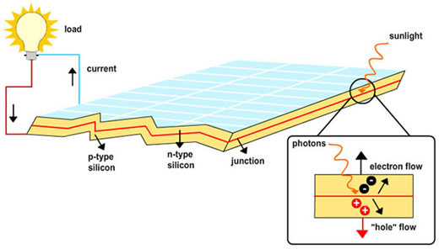
Figure 1: Schematic typical Solar cell

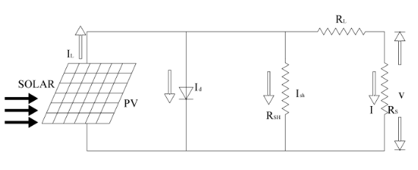
Figure 2: Equivalent circuit of PV cell

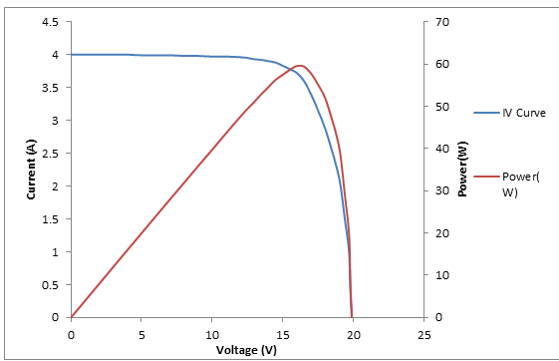
Figure 3: IV and PV curves of a silicon module

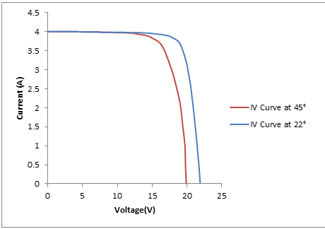
Figure 4: IV characteristic curve of PV module at different Temperatures

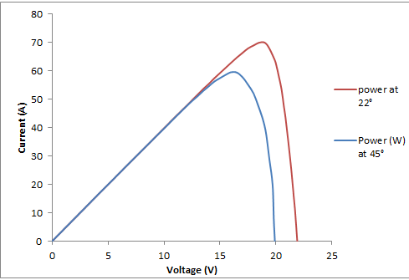
Figure 5: PV curve of solar cell at different temperature
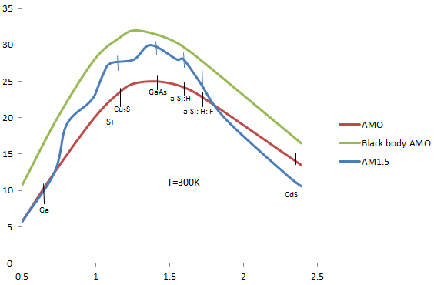
Figure 6: Relation between conversion efficiency and semiconductor band gap

