Production of compost and its economic importance

Dr.Sc.Isuf Lushi, Prof.Assis.¹
^{1,}University “Ukshin Hoti”, 20000, Prizren, Kosova

Abstract
Composting has a great importance in economic terms, because it affects a lot and directly into increased productivity culture for which it is used.
Compost is organic matter that has been decomposed and recycled as a fertilizer and soil amendment. Compost is a key ingredient in organic farming. At the simplest level, the process of composting simply requires making a heap of wetted organic matter known as green waste (leaves, food waste) and waiting for the materials to break down into humus after a period of weeks or months. Modern, methodical composting is a multi-step, closely monitored process with measured inputs of water, air, and carbon- and nitrogen-rich materials. The decomposition process is aided by shredding the plant matter, adding water and ensuring proper aeration by regularly turning the mixture. Worms and fungi further break up the material. Bacteria requiring oxygen to function (aerobic bacteria) and fungi manage the chemical process by converting the inputs into heat, carbon dioxide and ammonium. The ammonium (NH₄) is the form of nitrogen used by plants. When available ammonium is not used by plants it is further converted by bacteria into nitrates (NO₃) through the process of nitrification.
Compost is rich in nutrients. It is used in gardens, landscaping, horticulture, and agriculture. The compost itself is beneficial for the land in many ways, including as a soil conditioner, a fertilizer, addition of vital humus or humic acids, and as a natural pesticide for soil. In ecosystems, compost is useful for erosion control, land and stream reclamation, wetland construction, and as landfill cover (sees compost uses). Organic ingredients intended for composting can alternatively be used to generate biogas through anaerobic digestion.
Kosova market have not compost production, we fertilizer imported from Serbia, and on the basis of this research conclude that Kosova about 70% of arable land will be needed for this product.
While in terms of horticulture (for flowers) 100% this production is imported from the Netherlands.
The paper deals with the construction of the collection point with all the advanced technological tools for the production of manure or compost in the space of 0, 5 ha. Where will invest 450,000.00 € and will be produced compost from 15.000 to 30.000 t compost/year and earned about 3,000,000.00 € and will fertlized 1000 ha of agricultural land.

Keywords: Soil, leaves, grass, dung, urine, water, nitrogen fertilizers.

- Introduction
Composting as a recognized practice dates to at least the early Roman Empire since Pliny the Elder (AD 23-79). Traditionally, composting involved piling organic materials until the next planting season, at which time the materials would have decayed enough to be ready for use in the soil. The advantage of this method is that little working time or effort is required from the composter and it fits in naturally with agricultural practices in temperate climates. Disadvantages (from the modern perspective) are that space is used for a whole year, some nutrients might be leached due to exposure to rainfall, and disease-producing organisms and insects may not be adequately controlled. [1]
Composting was somewhat modernized beginning in the 1920s in Europe as a tool for organic farming. The first industrial station for the transformation of urban organic materials into compost was set up in Wels, Austria in the year 1921. Early frequent citations for propounding composting within farming are for the German-speaking world Rudolf Steiner, founder of a farming method called biodynamics, and Annie Francé-Harrar, who was appointed on behalf of the government in Mexico and supported the country 1950–1958 to set up a large humus organization in the fight against erosion and soil degradation.
In the English-speaking world it was Sir Albert Howard who worked extensively in India on sustainable practices and Lady Eve Balfour who was a huge proponent of composting. Composting was imported to America by various followers of these early European movements by the likes of J.I. Rodale (founder of Rodale Organic Gardening), E.E. Pfeiffer (who developed scientific practices in biodynamic farming), Paul Keene (founder of Walnut Acres in Pennsylvania), and Scott and Helen Nearing (who inspired the back-to-the-land movement of the 1960s). Coincidentally, some of the above met briefly in India - all were quite influential in the U.S. from the 1960s into the 1980s. [2]
There are many modern proponents of rapid composting that attempt to correct some of the perceived problems associated with traditional, slow composting. Many advocate that compost can be made in 2 to 3 weeks. Many such short processes involve a few changes to traditional methods, including smaller, more homogenized pieces in the compost, controlling carbon-to-nitrogen ratio (C:N) at 30 to 1 or less, and monitoring the moisture level more carefully. However, none of these parameters differ significantly from the early writings of Howard and Balfour, suggesting that in fact modern composting has not made significant advances over the traditional methods that take a few months to work. For this reason and others, many modern scientists who deal with carbon transformations are sceptical that there is a "super-charged" way to get nature to make compost rapidly. [1]
In fact, both sides are right to some extent. The bacterial activity in rapid high heat methods breaks down the material to the extent that pathogens and seeds are destroyed, and the original feedstock is unrecognizable. At this stage, the compost can be used to prepare fields or other planting areas. However, most professionals recommend that the compost be given time to cure before using in a nursery for starting seeds or growing young plants. The curing time allows fungi to continue the decomposition process and eliminating phytotoxic substances.
Many countries such as Wales and some individual cities such as Seattle and San Francisco require food and yard waste to be sorted for composting.
Kew Gardens in London has one of the biggest non-commercial compost heaps in Europe. [3]
Kosova market have not compost production, we fertilizer imported from Serbia, and on the basis of this research conclude that Kosova about 70% of arable land will be needed for this product.
While in terms of horticulture (for flowers) 100% this production is imported from the Netherlands.

2. Materials, Tools and Methods
2.1. Materials
For this research they are used sources of information, such as:
The data from relevant institutions
Data from other studies
Data from the scientific literature
Other data’
Bacteria kompostuese 4 Raw require to work effectively:
Carbon - materials with high carbon content usually brown and are dried.
Azotin- this is material of microbial protein builder kompostuese and need for expansion of these. Materials with high nitrogen content usually are colored green (or colored, eg. Fruit and vegetables) and wet.
Ooxygen.
Water - in the right amount, so as not to cause lack of oxygen.
Urine - (can be used as as fertilizer or compost can be added. Adding compost urine usually raises the temperature of the compost, so the compost increases the ability to kill pathogens and bad seeds)
Dung and straw
Fruits and vegetables
Egg shells, nut shells
Leaves
Coffee, tea
Hairs, feathers
Comics, white sheets (no more than 10% of the total weight of the heap).

2.2. Tools
Construction of the collection point / location
Car march on the recycling culture
Half cop wet material
Mixer
Disk granulator
Machine drying
Cooling machine
Rotating coils Machines
Conveyor belt
Car Package
Hiring 20 workers.

2.3. Work methods
Methods in the sciences are essential research tools, which enable us to achieve results and new knowledge, or correcting existing ones. In this design the business plan are implemented modern scientific methods with the aim of achieving the goal through targets using the methods outlined below:
2.3.1 Empirical Method
After the visits we have made in farms throughout the Republic of Kosovo, we found that despite depositing manure by the farmers, as they express its need to buy manure produced bio. From this we conclude that the production of compost will be sold and welcomed by these farmers.
2.3.2. Descriptive methods
This method we have used to address more clearly the terms of the importance of compost, that the importance of functioning manufacturer with a positive or negative balance of a company that produces compost. Then, the use of authentic knowledge, previous studies and the implementation of best practice in this production.
3. How is composting
1. First place stack (space surrounded collection products recycling)
2. Disintegrating organic waste used. Grinding, shredding and crushing speeds decomposition of organic materials. For the formation of a pile of compost is used at least 1 m³ shredded material.
3. Huddle compost should be placed in a warm place, protected from excessive exposure to wind and sun. Heat and air facilitate composting, but overexposure dries materials. [5]

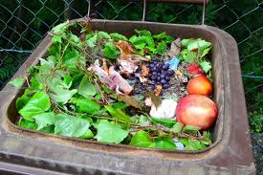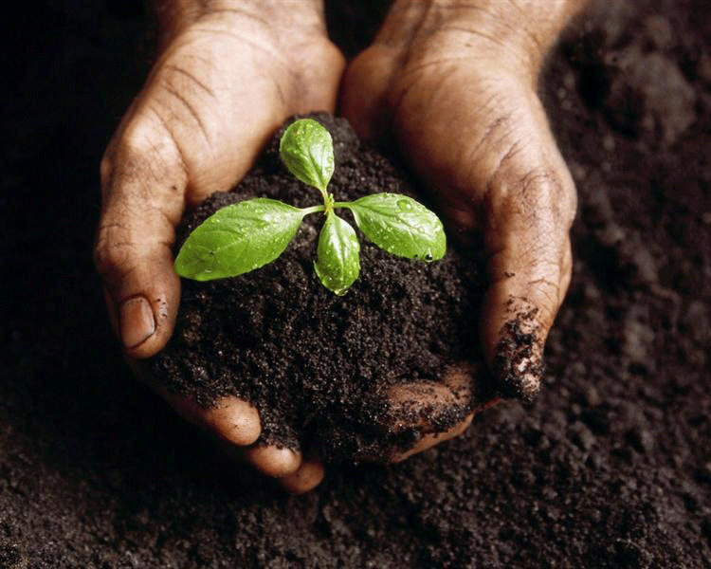
Of course the picture is a little basket, and what will we produce includes very large area.

4. Nitrogen composting speeds. Good sources include grass, excrement, blood and nitrogen fertilizers. Ashes should be used sparingly, preferably not used. Grace hastens decomposition, but if too much can cause loss of nitrogen, and usually not necessary unless the pile is large quantities of pine and fir leaves or fruit.
5. Huddle of good compost should be ventilated. Some decomposition occurs in the absence of air, but then it happens slowly and bad odors.
Materials to be kept moistened stack as a squeezed sponge. Too little or too much water delaying decomposition. Excessive moisture causes bad smell and loss of nutrients.[6]

3.1. Ingredients compost

Compost is organic matter that has been decomposed and recycled as a fertilizer and soil amendment. Compost is a key ingredient in organic farming. At the simplest level, the process of composting simply requires making a heap of wetted organic matter known as green waste (leaves, food waste) and waiting for the materials to break down into humus after a period of weeks or months. Modern, methodical composting is a multi-step, closely monitored process with measured inputs of water, air, and carbon- and nitrogen-rich materials. The decomposition process is aided by shredding the plant matter, adding water and ensuring proper aeration by regularly turning the mixture. Worms and fungi further break up the material. Bacteria requiring oxygen to function (aerobic bacteria) and fungi manage the chemical process by converting the inputs into heat, carbon dioxide and ammonium. The ammonium (NH₄) is the form of nitrogen used by plants. When available ammonium is not used by plants it is further converted by bacteria into nitrates (NO₃) through the process of nitrification.
Compost is rich in nutrients. It is used in gardens, landscaping, horticulture, and agriculture. The compost itself is beneficial for the land in many ways, including as a soil conditioner, a fertilizer, addition of vital humus or humic acids, and as a natural pesticide for soil. In ecosystems, compost is useful for erosion control, land and stream reclamation, wetland construction, and as landfill cover (sees compost uses). Organic ingredients intended for composting can alternatively be used to generate biogas through anaerobic digestion. [5]
Bacteria kompostuese 4 Raw require to work effectively:
Carbon - materials with high carbon content usually brown and are dried.
Azotin- this is material of microbial protein builder kompostuese and need for expansion of these. Materials with high nitrogen content usually are colored green (or colored, eg. Fruit and vegetables) and wet.
Oxygen.
Water - in the right amount, so as not to cause lack of oxygen.
Urine - (can be used as as fertilizer or compost can be added. Adding compost urine usually raises the temperature of the compost, so the compost increases the ability to kill pathogens and bad seeds)
Dung and straw
Fruits and vegetables
Egg shells, nut shells
Leaves
Coffee, tea
Hairs, feathers
Comics, white sheets (no more than 10% of the total weight of the heap). [6]

3.2. Planning and production of compost
First we need land to build collection point, about 0.5H. For the production of compost we need sophisticated tools that speed up the production process, from the collection of up to packaging.
An important part of the trucks are transporting raw materials to the collection point and then to the potential customers. [1]

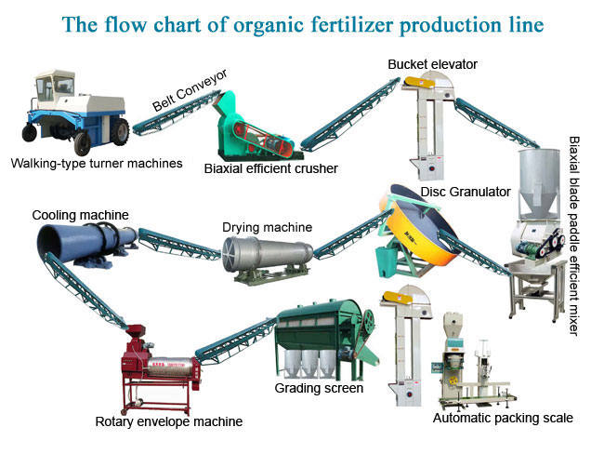
Packing: as you can see in the picture Packaging had done directly from the production process. The packaging will write the contents of the product and the logo of firm.

4. Financial statements
The paper deals with the construction of the collection point with all the advanced technological tools for the production of manure or compost in the space of 0, 5 ha. Where will invest 450,000.00 € and will be produced compost from 15.000 to 30.000 t compostc/year and earned about 3,000,000.00 € and will fertlized 1000 ha of agricultural land.

5. Maintenance

Return and blending of the heap with a pitchfork or shovel provides the oxygen needed to decompose and remove excess moisture. Stacks that can interfere not require 34 times more time to decompose. Recommendations for agitating the heap change every 3 days every 6 weeks. The most common cause’s confusion faster composting. If there are winds it means that the pile is too wet or there is a lack of oxygen and that need more shpesh.Herë turbulent time may need irrigation of the heap to keep damp, especially in times of thatë.Një stack that decompose quickly creates temperatures around 60-70°C in the center of it. Heat kills many bad seeds, insect eggs and pathogenic bacteria. Huddle should return when the center begins to cool. Return of the heap retains the heat and ensures that all the material is exposed to heat center. When cool pile composting ends. [2]

6. The finished compost

The finished compost is dark brown, crumbly and earthy smell. Depending on ambient temperatures created a stack of good compost and composted maintained for 2 weeks to 4 months. A shabby stacked with non-shredded material may require more than one year to decompose. [4]

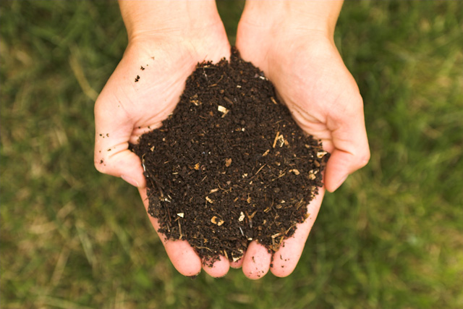
+ ITS COMPOST TIME !!!

7. Market Analysis
Kosova market have not compost production, we fertilizer imported from Serbia, and on the basis of this research conclude that Kosova Afeer 70% of arable land will be needed for this product.
While in terms of horticulture (for flowers) 100% this production is imported from the Netherlands.

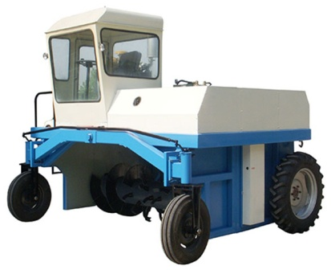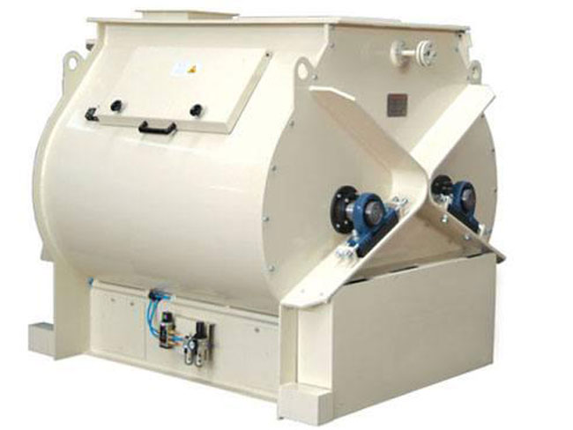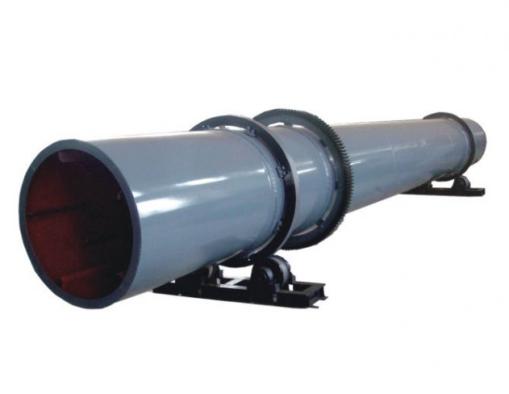
Photo tools needed to open the factory.

With the purchase of these machines will have a production capacity of 150.000 to 200.000 t / year.

8. Conclusions

• Production of compost has a significant economic importance for each country's agricultural production.
• People and staff demonstrated in relevant fields.
• There should be an adequate framework for its implementation.
• Do not zavendson use of fertilizer, which during its production comes to environmental pollution.
• Bio compost will produce no pollution.
• Will increase the yield of agricultural crops with its use.
• Increase the number of employment of workers.
• It will stop importation of fertilizer.
• Especially important and has a greater opportunity to use the vegetable culture and Horticulture.

References

[1] Haug, Roger. "The Practical Handbook of Compost Engineering". CRC Press,. Retrieved 26 October 2015.
[2] Martin & Gershuny eds. (1992). The Rodale Book of Composting: Easy Methods for Every Gardener. Rodale Press. Retrieved 26 October 2015.
[3] "Composting - Compost Microorganisms". Cornell University. Retrieved 6 October2010.
[4] Jenkins, J.C. (2005). The Humanure Handbook: A Guide to Composting Human Manure. Grove City, PA: Joseph Jenkins, Inc.; 3rd edition. p. 255. ISBN 978-0-9644258-3-5. Retrieved April 2011.
[5] “From ideal to success” Gregg Fairbrothers, Backyard composting 1992. Harmonious technologies, harmonious press, Ojai, CA.
[6] Tävaara et al. Compost maturity - problems associated with testing. in Proceedings of Composting. Innsbruck Austria 18-21.10.2000.

http://www.gubaswaziland.org/files/documents/resource9.pdf http://en.wikipedia.org/wiki/Composting http://www.dep.state.pa.us/dep/deputate/airwaste/wm/recycle/facts/compost.htm

