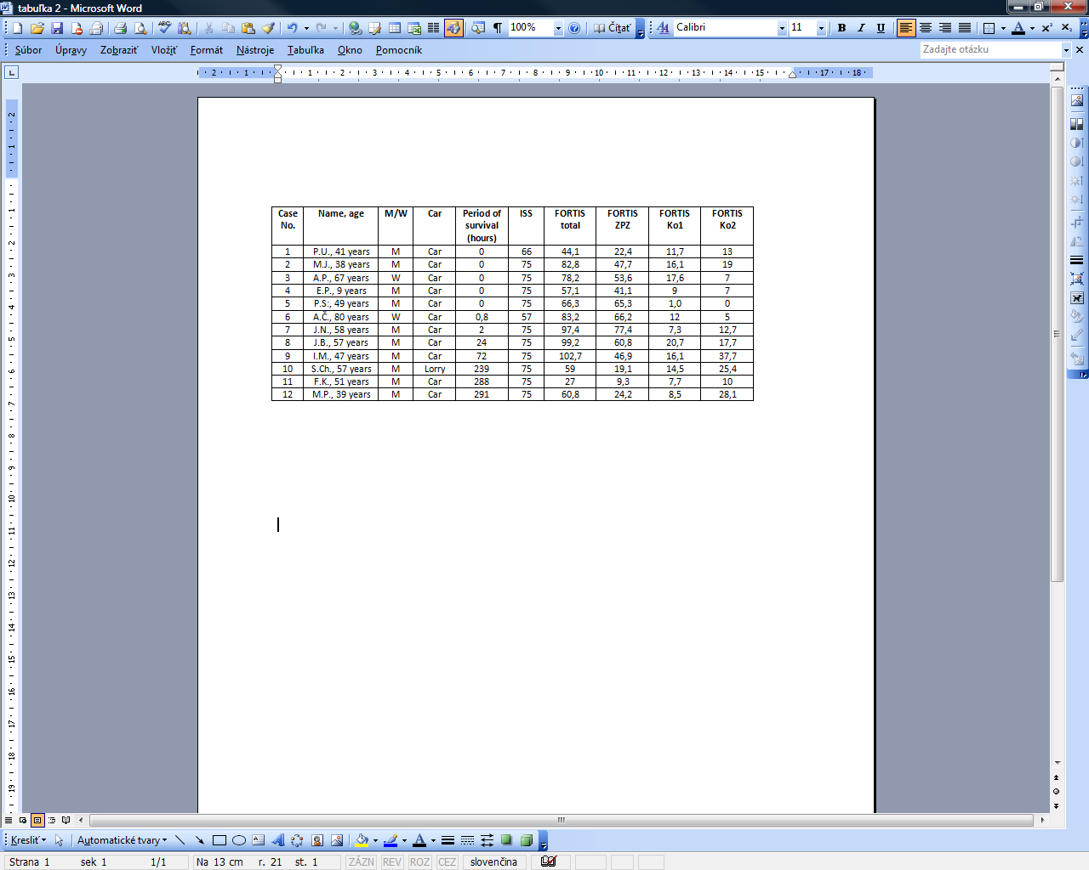
Table 1 Scoring of traffic accidents of pedestrians, using classical methodology AIS/ISS and respective modified FORTIS system

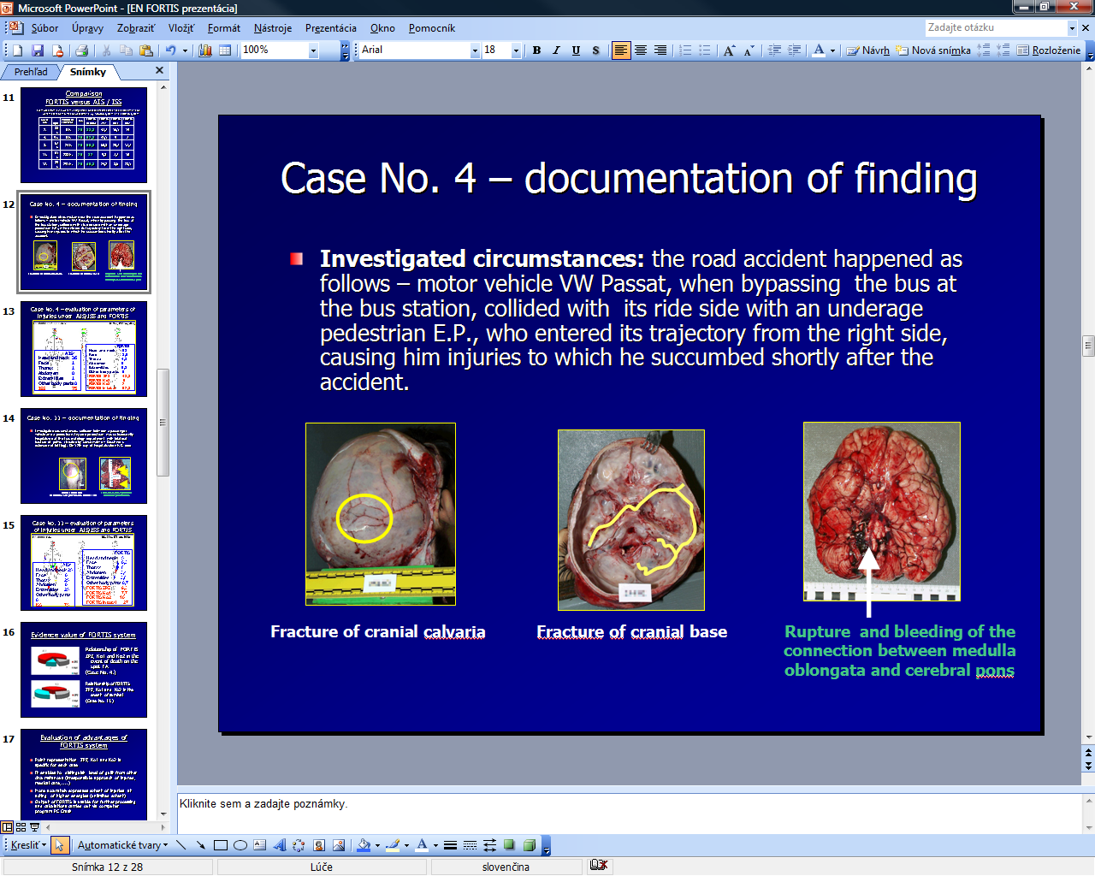

Fig. 1 Documentation of finding - illustration to case no. 4

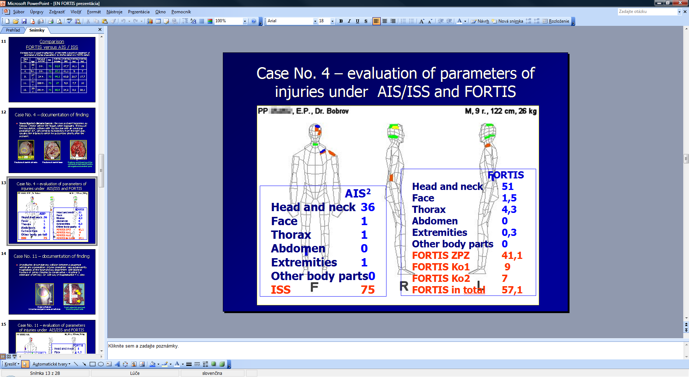
Fig. 2 Evaluation of parameters of injuries in the case no. 4 via custom modified FORTIS system and comparison of FORTIS values with AIS/ISS values

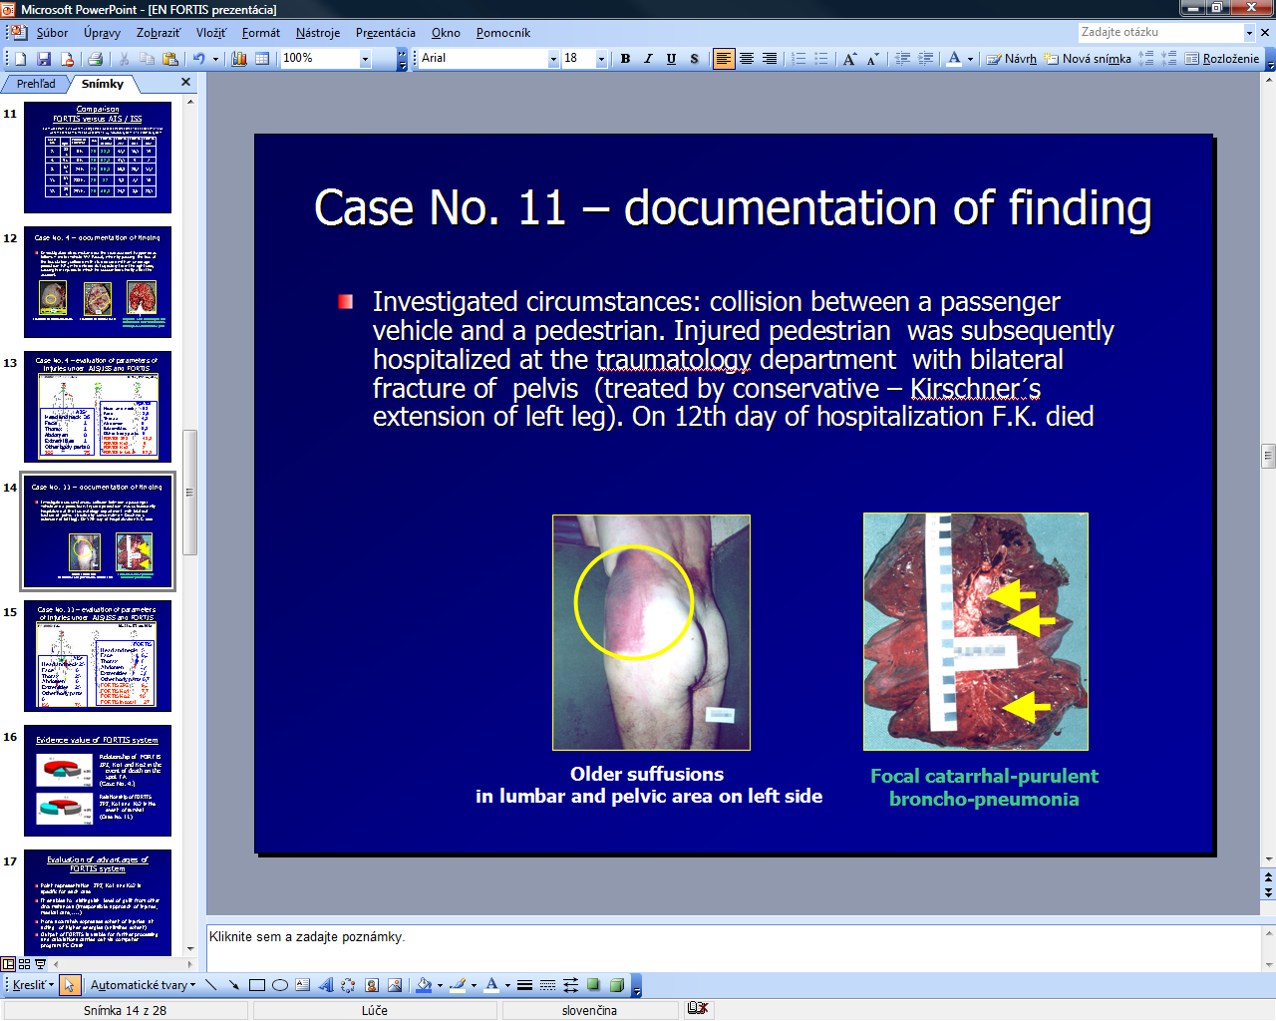

Fig. 3 Documentation of the finding - illustration to case no. 11

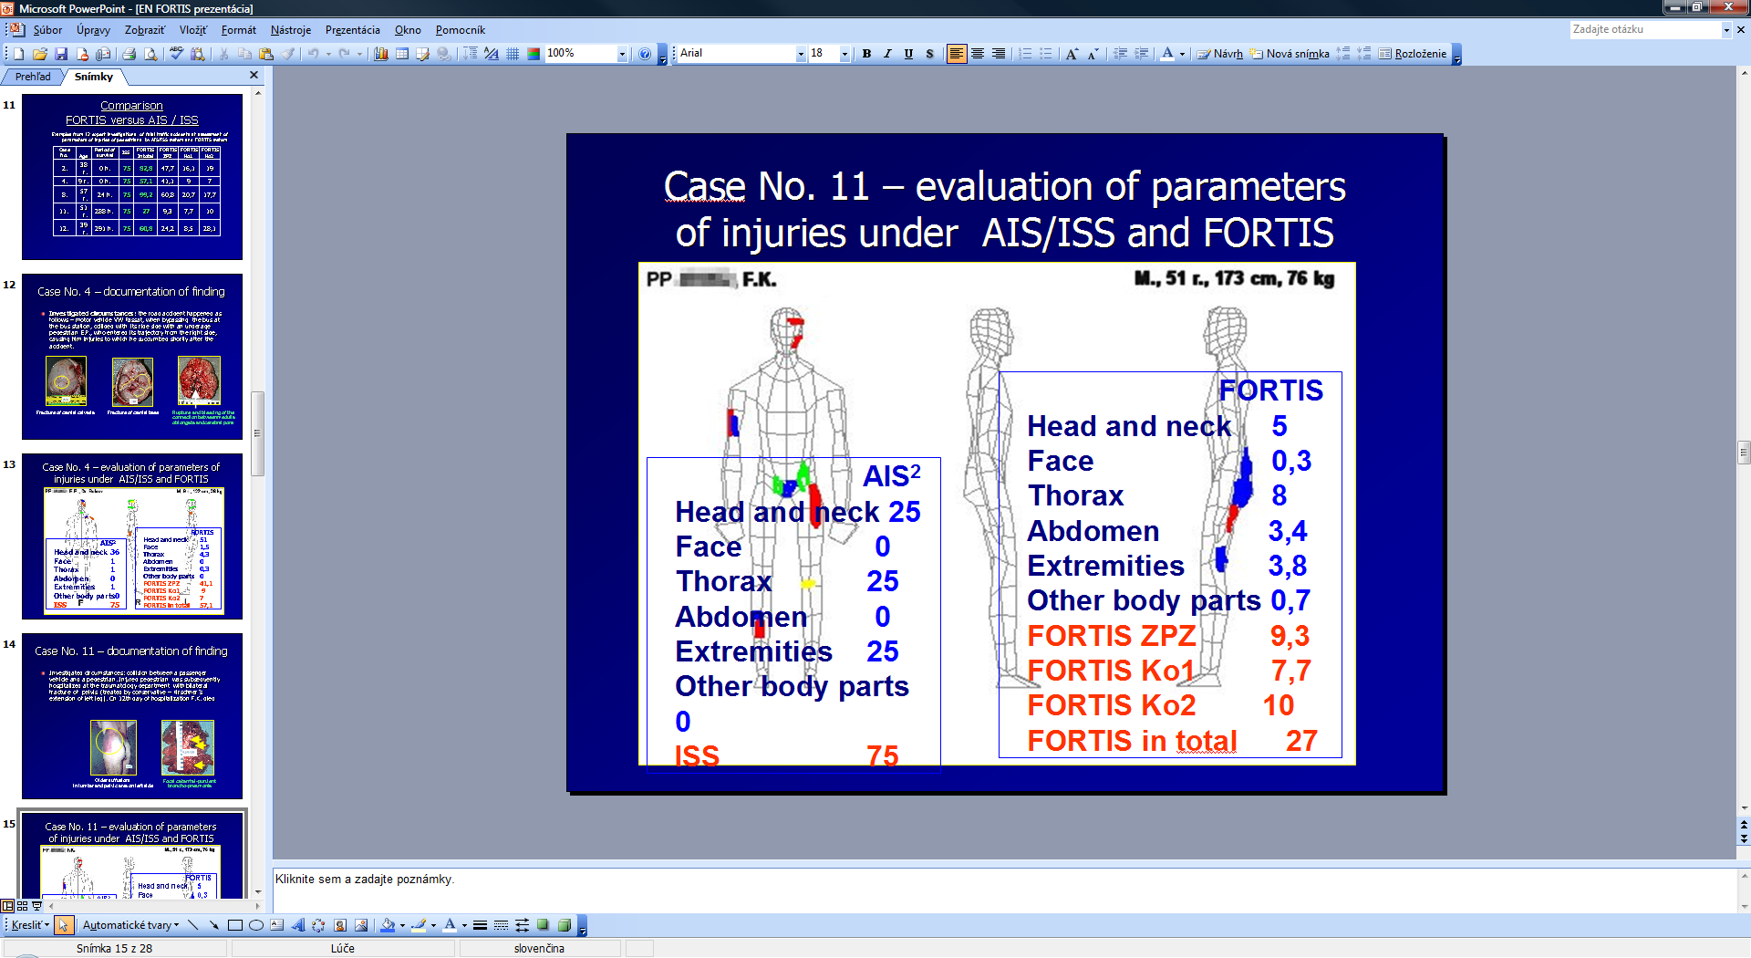
Fig. 4 Evaluation of parameters of injuries in case no. 11 via custom modified FORTIS system and comparison of FORTIS values with AIS/ISS values

Fig. 5 Relationship of FORTIS ZPZ, Ko1 and Ko2 in the event of death on the spot DN- case no. 4

Fig. 6 Relationship of FORTIS ZPZ, Ko1 and Ko2 in the event of survival - case no. 11

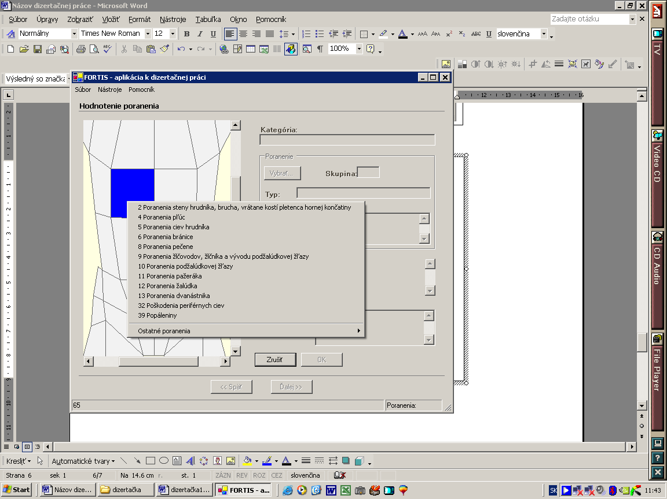
Fig. 7 Illustration of the use of classification tables in the PC Fortis program

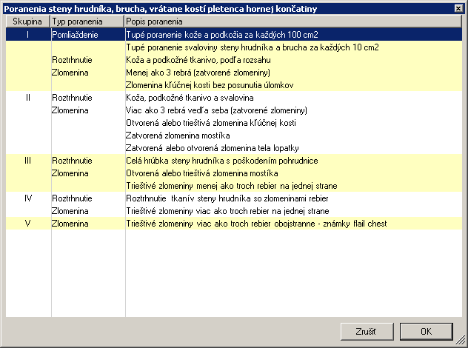

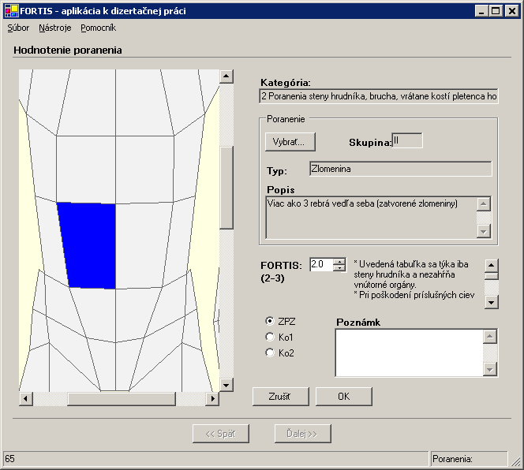
Fig. 8 -1,2 Example of classification tables and their use in the PC Fortis program
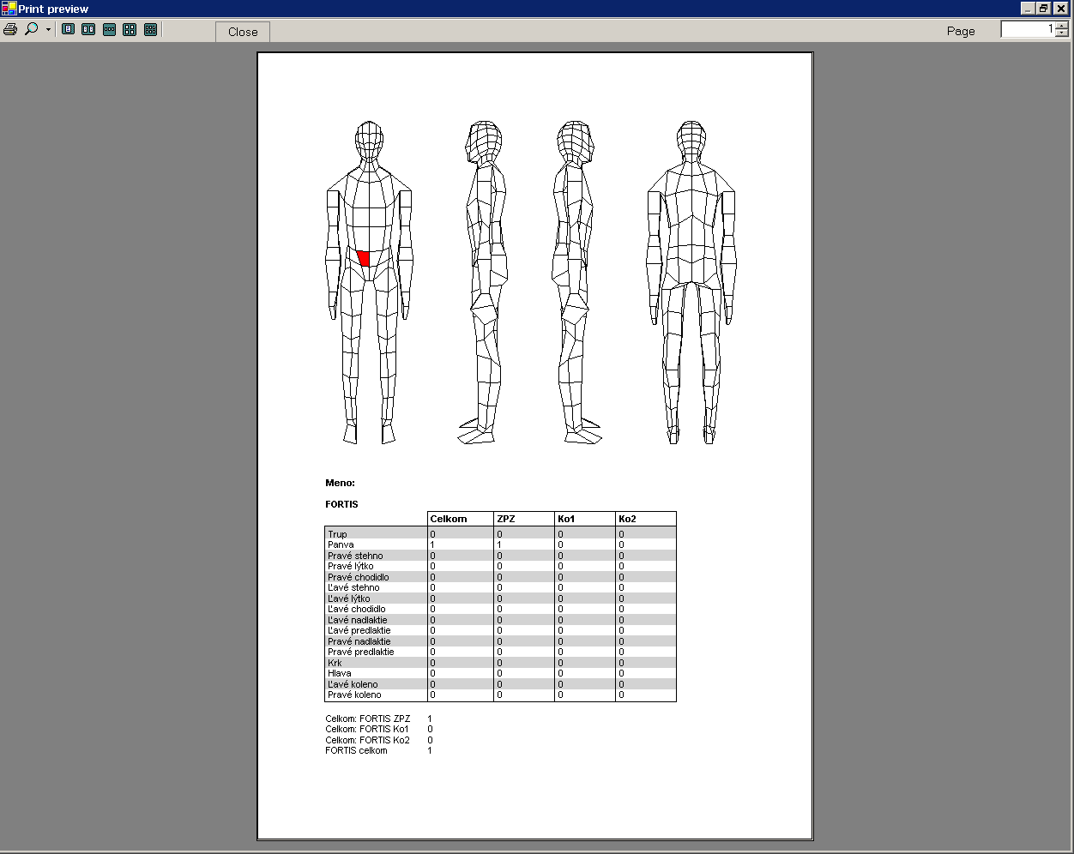
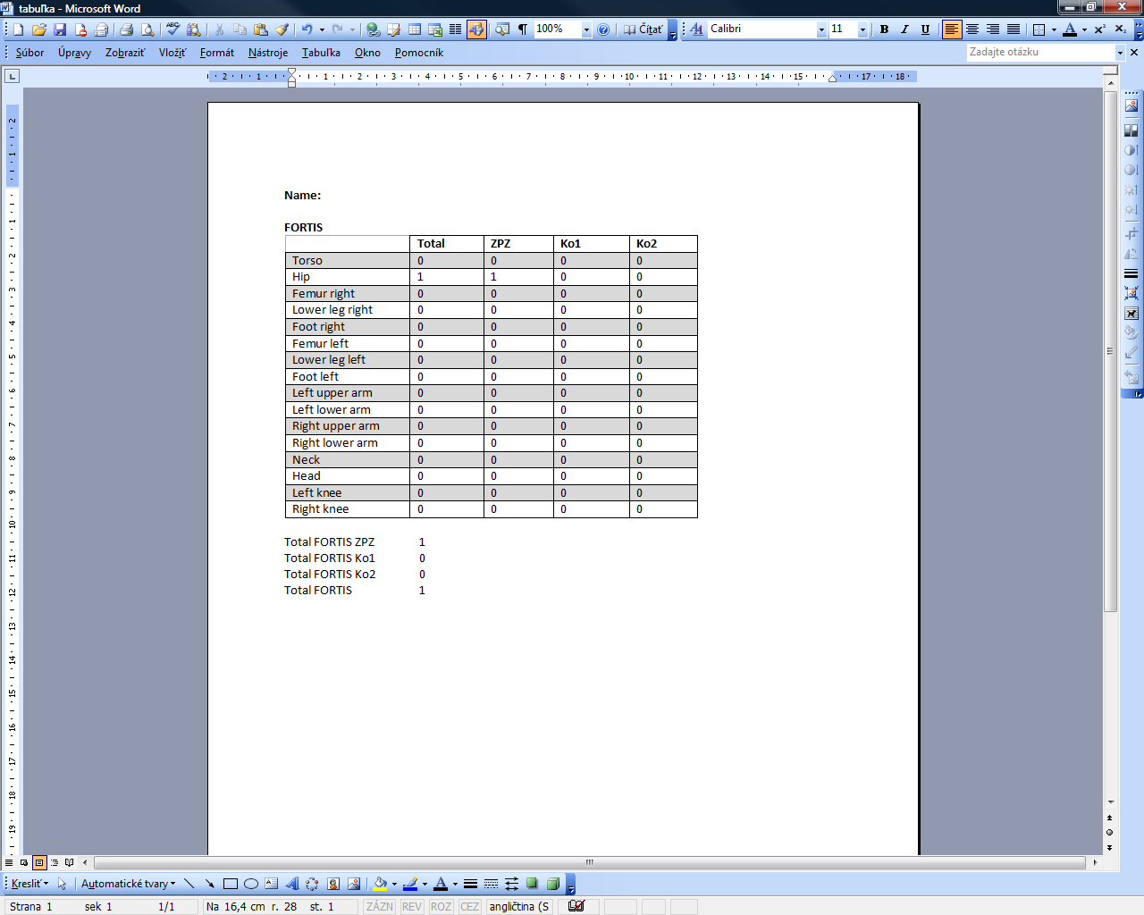
Fig. 9 Illustration of FORTIS output after classification of one injury
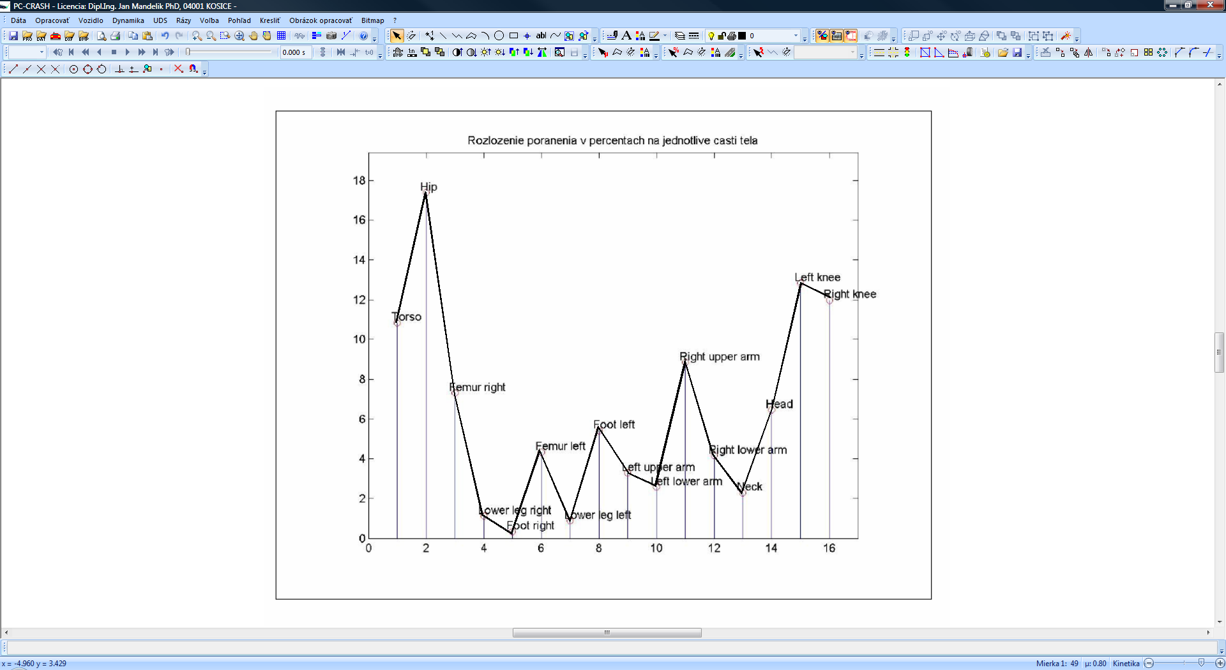

Fig.10 Individual signature of "Contact coefficients", calculated from the PC Crash for individual parts of the body, indexed 1-16, expressed as a percentage of the 30 km/h speed with 30º of the pedestrian’s body relative to the vehicle; 46-year old pedestrian. 75kg, 173cm, 4.6 km/h, vehicle Škoda Octavia 1,9D

